

Process Improvement Flowchart

# As-Is Process Flowchart Evaluation

**Select** a process from an organization you work for or are familiar with. You will use this process in your Week 2 and Week 4 Assignments as well.

**Create** a flowchart of the as-is process using Microsoft® Word, PowerPoint®, Visio®, or Excel®. Insert your flowchart below this line.

**Flow Chart of the As-Is Process**

The flow chart below is concerned with starting a new auto claim

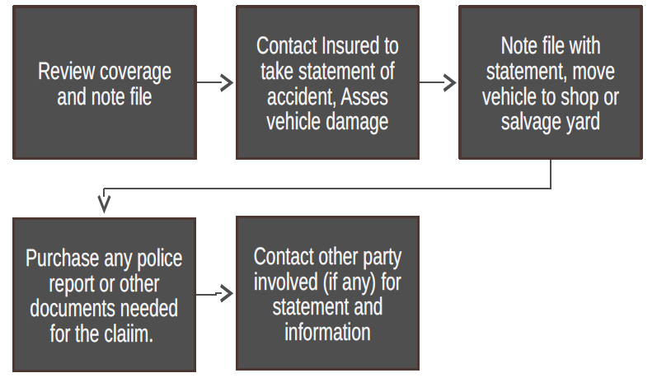

**Evaluate** the efficacy of your process using process improvement techniques. Write your evaluation below this line.

**Adopting Process Improvement in Evaluating the Efficacy of the Process**

As depicted by the flowchart, the process of getting started on an auto claim is substantive. I evaluated my process using the process improvement criteria and found that it can sustain itself because it is basic but efficient (Winkelmann & Weiß, 2017). The process is efficient as it flows from reviewing the coverage or the note file up to obtaining police reports and involving a third party. The process is therefore considered as straightforward forward the steps within the flow chart complement each other as we move towards the end goal of obtaining an auto claim (Pastinen, 2018). Although, the process would need some improvements within the steps where some additional information may be added to help achieve the purpose of the auto claim faster.

# Process Improvement Flowchart

**Determine** how the process can be improvedbased on the results of your evaluation.

***How can the Process be Improved?***

Since the acquisition of an auto claim takes such a hefty process, there is a need to make the details provided by the insured be accurate. Hence using the process improvement schematics, I would ensure the questions asked when inquiring about the insured are detailed enough to help obtain more precise data regarding such situations (Winkelmann & Weiß, 2017). Additionally, I would provide the insured, and the police interactions are as flawless as possible to promote the faster acquisition of auto claim sheets. Thus, the number of inquiries from the insured will decrease when they do random follow-up checkups.

**Define** metrics and measure the current process. Insert the metrics and measures below this line.

***Definition of Metrics and Measurement Present Processes***

Metrics of processes entail measurements that provide data concerning the ability to perform the status of different methods. Process metrics can be classified as flow time, inventory, and flow rate (Pastinen, 2018). Thus, process designers or observers can adopt such metrics in their analysis hence helping improve various processes when necessary.

**Use** process improvement techniques to improve the process. Create a flowchart of the improved process usingMicrosoft Word, PowerPoint, Visio, or Excel. Use your professional judgment to ascertain how the future process will perform according to your metrics. Insert new flowchart below this line.

**New Flow Chart**

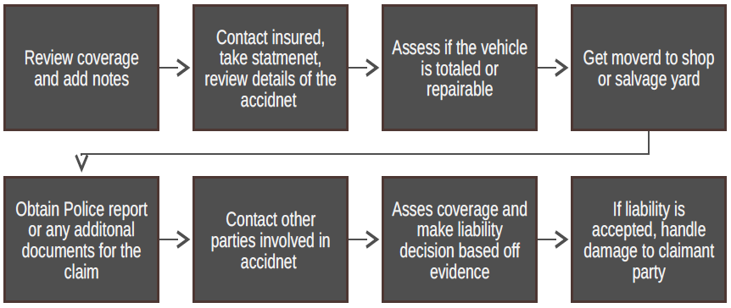

# Summary

**Write** a 350-word executive summary that includes the following:

* A brief description of the process based on the flowchart of processes current state
* The results of your process evaluation and how the weak points can be strengthened. Include a description of the process improvement technique(s) used.
* A brief description of process improvements based on the process of the future state
* How you anticipate the future process will perform based on metrics used to evaluate process current state
* A description of your process improvement project to achieve the process future state

**Insert** your summary below this line.

**Summary of the Process**

The process I chose on auto claims is an adjuster that ensures new claims are retrieved, and the insurance plans are prepared on time. Kick-starting the auto claim process necessitates the review of coverages as the initial step. We need to review the coverages because no claim will be issued if the coverages are not applicable (Pastinen, 2018). After obtaining valid coverage, there is a need to collect the insured statement of the event. Furthermore, the process follows with acquiring the police report and other relevant evidence on the claim to facilitating a chain movement of the established claim. Similarly, when evaluating the existing processes, certain details were obtained, which can be enhanced to ensure the auto claim process is more precise and smooth.

Similarly, during my evaluation, I observed a weak point within the process improvement. The weakness exists when detailed data is not available, resulting in multiple calls of inquiry and followed up by the insured. It thus adds another waiting period because the insured has to make several phone calls as the adjuster repairs the vehicle (Shields, 2020). It, therefore, emanates that the deficient information when conducting the profile reports will sabotage the auto claim obtaining process. The weakness can be overcome by ensuring only detailed information is collected by the adjuster for any unexpected data emergencies in the future.

The solution to this process improvement is to adopt a six-sigma process to ensure the problem is examined and solutions solicited. With regards to the process improvement, a guide to the improvement process explains that six-sigma entails gathering and evaluating information to reduce the cycle defects and time lags in the process (Shields, 2020). Moreover, the six-sigma process has the role of improving the customer's level of satisfaction through eliminating defects and time lags. Because there is a defined structure for the quality improvement process on how to collect information appropriately, the adjusters of the auto claim require more time to collect data for the insured; hence will save on time repairing vehicles and making phone calls on inquiry.

My anticipation about future processes is that they will have more precision and efficiency due to the new method of gathering information. The advantage of having more information is that the adjuster will incur phone calls regarding inquiries and, therefore, will be better positioned to make reliable decisions concerning the insured's claims (Pastinen, 2018). Generally, the process improvement process has assisted the whole flow of the auto claims process. Thus, it will help create effective methods to facilitate the quick completion of claims. Hence, customers' satisfaction will be enhanced by a higher margin for the auto claims services.

**References**

Pastinen, M. (2018). Design concepts of the high-performance process improvement process. *High-Performance Process Improvement*, 49–65. <https://doi.org/10.1007/978-3-642-10784-9_3>

Shields, G. (2020). Process metaphysics. *Process Studies*, *25*, 131–134. <https://doi.org/10.5840/process19962515>

Winkelmann & Weiß. (2017). Process flow chart. *SpringerReference*. <https://doi.org/10.1007/springerreference_7053>