To: XYZ eCommerce CEO

From: xxxxx

Date: January 15, 2022

Subject: The CEO's Challenge

Introduction
Some employees at XYZ eCommerce are using personal Dropbox (Shadow IT) without the knowledge and approval of the corporate IT department. Employees must stop storing eCommerce information on personal Dropbox on BYOD, and personal Drobox accounts organization systems must be removed to protect the organization and customers personal information.

Proposed Information System
BYOD policies and a more mobile workforce put new pressure on information technology and change how employees access company data. Dropbox has established itself as the undisputed leader in access to mobile files. Some employees in the XYZ organization start to use a non-sanctioned applications personal Dropbox account where the user keeps customer PI and other project documentation. XYZ can lose access to shadow cloud-based data, mainly when the user who owns the information leaves the company.
“Information architecture is the set of ideas about how all information in a given context should be organized.” (Info syst decision-making)
ManageEngine MDM Plus will be used to set up configuration settings, security commands and retrieve asset data over the air.
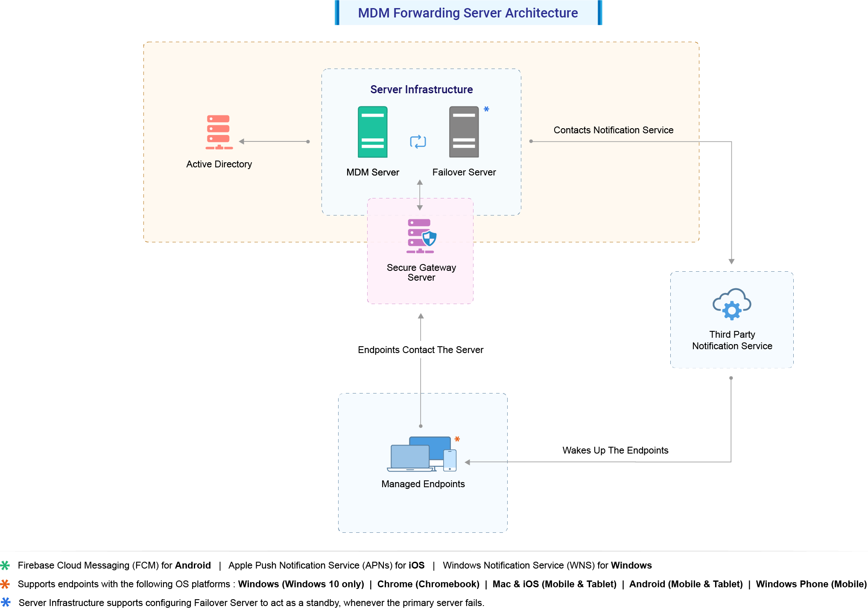
Figure 1. Title (Source: manageengine )
All communications from MDM Plus will be routed to mobile devices through intermediate services such as Apple Push Notification (APN) for Apple devices, Firebase Cloud Messaging (FCM) for Android devices, and Windows Push Notification Services (WNS) for Windows devices. A live TCP connection is established for the notification service. APN, FCM, and WNS act as intermediate services to wake up managed devices whenever an operation is performed from the MDM server. Thus, MDM will detect and notified any use of private Dropbox. (Figure-1)

Functions Important to Business
During the Covid-19 pandemic, XYZ eCommerce decide to allow employees to use BYOD. Bring your Device is the movement that has brought home and work life together in many ways. The benefits of having workers that can use their own mobile devices to perform company work are just too great to ignore. CIOs have incurred more extraordinary expenses and less worker productivity because of poor management and ineffective education on BYOD policies and practices. The poor leadership of XYZ resulted in a BYOD program that leaks company information, suffers security breaches and customer data losses, and runs up a bill far more significant than an organization-managed mobile device plan.

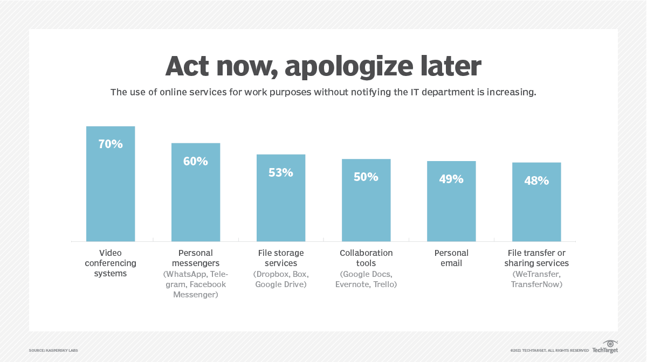Figure 2. Title (https://searchmobilecomputing.techtarget.com/)

The proposed Information framework will help XYZ organization to handle shadow IT issues. The framework suggests deploying a company-approved application to allow the IT department to control data. It only gives employees the access and functionality they need to be productive.

Shadow IT is a corporate issue that is not just about technology.

The CIO should discover, list, and categorize the IT resources of the corporate shadow into three categories:

1. Sanctioned

2. Prohibited

3. Authorized

Compiling this list should be part of XYZ organization's monthly security review. After collecting, you can deal with any piece of IT shadow. A suggested framework for dealing with shadow IT is for the CIO to meet with people who have acquired shadow IT capabilities and go through a discovery process to determine what to do about these products, including the following questions.

1. What is the history of this piece of shadow IT?

2. What does this Dropbox provide that our internal offerings do not offer?

3. Is there any current service IT can provide to satisfy these needs?

4. What shadow risk does the software incur?

5. What costs, budget, or resources does it require?

As far as possible, the discovery should be non-confrontational. The goal is to understand why IT overshadows IT and how it relates to or supports corporate IT in the future.

Once discovered, the CIO and the shadow IT user should advise and agree on how the organization supports unauthorized or prohibited software/services. Some possibilities could be:

· Move the shadow IT component to the Authorized list. I

· Replace the shadow IT with an existing IT function.

· Discontinue using the shadow IT service. It is too risky and too

· IT will support this shadow IT function.

· Other actions, as IT and the shadow IT user(s) decided upon.

This exploration aims to decide how to act on any part of shadow IT that is illegal or prohibited. Shadow IT affects people, their motivations, and some potentially vital business processes or information.

This exploration policy usually needs to be defined, validated, and supported at the C-Suite level to prevent turf wars before implementation. If the discovery process between CIO and IT shadow users is not resolved, it should be sent to C-Suite for resolution.

Data Management

According CIS500 Textbook; “Implementing data governance policies and procedures that outline the data management requirements can ensure safe and secure cloud computing.” XYZ should use Mobile Device Manager Plus (MDM) to increase BYOD security by protecting corporate data stored on these devices, and as a BYOD management solution for smartphones, tablets, and laptops, it works.

Data Types

XYZ Ecommerce company has different types of data such as Digital Shelf Data, eCommerce Product Data, Online Shopping Data, eCommerce Customer Data, and Ecommerce Sales Data. XYZ want to ensure that the data is high quality, correct, and useful. CIA tried will guide XYZ to have high quality data available at any time

Storage Methods

Databases are a vital tool for storing, managing, and retrieving information. They are also essential to building an e-commerce system. A well-structured database strengthens e-Commerce and handles all interactions within the system. After consulting with different departments and careful business analysis, XYZ's marketing department suggested using AWS Cloud Storage. AWS provides on-demand secure storage. The cost of AWS Cloud Storage is more beneficial to the company.

High performance, Simple, functional database structure, and High availability and scalability are vital to XYZ eCommerce. Based on these characteristics, the type of database will be a relational, NoSQL database, or a hybrid approach.
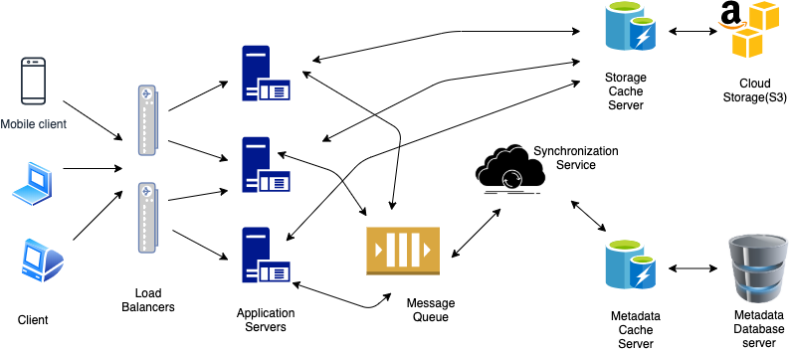

Figure 3. Title (AWS-Metadata)

The Metadata Database is responsible for storing metadata information of files and users. It also saves the copy of the files from tracking the history of changes made by users. We can use SQL as well as NoSQL DB. But using SQL makes sense because it has built-in support for ACID (atomicity, consistency, isolation, durability) features. If we have a strong use for NoSQL, we need to create a separate layer in the code responsible for maintaining the ACID NoSQL DB property. For SQL, we can use MySQL or amazons RDS; for NoSQL, we can use Amazon DynamoDB. The main point is that the synchronization service should be able to provide a fixed view of the files using this DB and should be able to send appropriate messages to the relevant customers. The information that we can store in the database is listed as file information objects and user information in the System API section above. (Figure-3)

Data Quality

Jenna Bunnell Senior Manager for Content Marketing at Dialpad says” Data quality is a measure of the accuracy and usefulness of a set of data. The exact definition of data quality will vary depending on the type of data used and what it is used for. Every business that uses data wants to make sure the data is quality, accurate and useful.

XYZ eCommerce requires data quality management, which refers to specific processes and data analysis that improve data quality, prevent data problems, and make data usable.

Transition of System Functions

The lack of policy and control to use BYOD had a significant negative impact on XYZ data. The negligence of some employees who used personal Dropbox led to leaks of company information, which ultimately damaged the company's reputation.

The IT department prepares and establish and implements firm policy to prevent employees from using personnel drop Box accounts. Also, IT department uses Mobile Device Manager Plus (MDM) to increase BYOD security by protecting corporate data stored on these devices and as a BYOD management solution for smartphones, tablets, and laptops.

In addition, the new system must conduct a monthly audit; Violators will be punished.

By implementing the proposed framework, the XYZ company's reputation will be maintained.

Evidence of Feasibility

“Feasibility is the measure of the tangible and intangible benefits of an information system”5

There are five type feasibility: Economic, Operational. Technical, Schedule and political. According to Mange Engine, MDM allows personal cluster devices into groups after which specific policies and apps can be distributed easily. In addition, the new system must conduct. Although drafting a BYOD policy and educating employees about the best practices can reduce the chances of data breaches and unauthorized data access, organizations must also consider the overall management of personally owned devices. The easiest way to manage a BYOD setup is using BYOD management solutions (BYOD MDM).

The feasibility and costs of the establish and implement the new policy and purchasing MDM plus for eCommerce employees’ devices are:

XYZ eCommerce has 10,000 employees
MDM Plus annual price per 10,000 on Cloud $39,195 with 1 technician.
Additional technicians (50): $ 5,995
Total annual Cost for purchasing and implementation of MDM Plus is:
$39,195 + 5,995 = $45,190
Herning IT stuff for Auditing and monitoring network and devices activities:
4 IT specialist 1 Security specialist
IT specialist salary: $125,000 x 4 = 500,000
Cybersecurity specialist: $140,000
Total new stuff salary = $500,000 + $140,000 = $640,000
Total feasibility Cost= $640,000+ 45,190 = $685,190

References
1.https://www.manageengine.com/mobile-device-management/bring-your-own-device-byod-management.html#manage
2. https://www.hysolate.com/learn/byod/byod-security-threats-security-measures-and-best-practices/
3. Info Syst Decision-Making. Available from: Strayer University Bookshelf, McGraw-Hill Create, [Insert Year of Publication].

4.https://www.bmc.com/blogs/shadow-it/

5.https://www.bigcommerce.com/blog/data-quality-ecommerce/#what-is-data-quality
6. https://www.manageengine.com/mobile-device-management/pricing.html

7. System Design Dropbox/Google Drive- WordPress

.

