Lesson 2 Commentary.
In this lesson, you will learn about how software, networks, and AI are changing the fundamental nature of organizations—that is, how organizations operate and compete.
As you complete Lesson 2, consider the following challenges. What structural changes and specific impacts on current organizational operating models, policies, infrastructure, systems, and human capital management strategy will the new ecosystem have on your industry and organization?
In this lesson, you will learn about the following topics:
- changing business model
- a new kind of operating model
- alignment of changing business model with a new kind of operating model
- how value creation, capture, and delivery are transforming
- experimentation to support learning
- removing the human bottleneck
You will also learn about what it means to put AI at the core of your organization. Furthermore, you will also be exposed to 20 AI in HR trends. Ant Financial, Ocado, and Peloton will be highlighted in our reading assignment. Please read this article published by the Harvard Business School
See link here: https://hbswk.hbs.edu/item/rethinking-business-strategy-in-the-age-of-ai
that provides insights into the genesis of Peloton.

Objectives:
After successfully completing this lesson, you should be able to do the following:
- Describe how software, networks, and AI are changing the fundamental nature of organizations.
- Discuss the changing business model and operating model for organizations.
- Identify several AI in HR trends relevant to your industry and organization and discuss the potential benefits and perils.
Other Readings: The wrong kind of AI? Artificial intelligence and the future of labour demand
https://academic-oup-com.ezaccess.libraries.psu.edu/cjres/article/13/1/25/5680462#

Age of AI
Lesson 2 encourages a deep dive into topics that are front and center for key organizational stakeholders including governance bodies, CEOs and the C-Suite, institutional investors, customers/clients, employees, suppliers, government, and architects of organizational strategy. You will be encouraged to think and rethink about what organizations will be required to do to survive and thrive in the age of AI. Furthermore, you will have an opportunity to explore the implications and potential roles of organizational architects of human capital management. The 20 AI in HR trends you will learn about should be viewed as a snapshot in time.
20 AI in HR TRENDS that YOU should KNOW about in 2020.
Website link: https://youtu.be/o-VpNaYNxNI
- Predictive Human Capital Tools powered by BEHAVIORAL ANALYSIS.
- Online on-demand AI-Enabled Platforms to enable REMOTE WORK.
- INTELLIGENT CHATBOTS to change the way HR interacts with candidates and employees.
- AI based recruiting to focus on ELIMINATING BIAS to build Inclusivity.
- Increased accountability with more TRANSPARENT TECH and Data-Driven HRMS.
- BETTER TEAMWORK with Tech-Enabled Omnichannel Collaborative Tools.
- Individualized Learning Plans on Interactive LMS to IMPROVE THE LEARNER EXPERIENCE.
- IMPROVED AND AGILE PROCESSES driven by AI to Elevate the Employee Experience.
- More Industry Data-Driven Benchmarking of COMPENSATION AND BENEFITS.
- More Involved Career-Pathing to EMPOWER TALENT MOBILITY.
- GAMIFICATION to Enable Learning and Skill-Based Measurements.
- Continuous Performance Management with REAL-TIME FEEDBACK and Review Mechanisms.
- AI Powered ON-THE-JOB SIMULATED TRAINING Tailored to Specific Needs.
- Enabling MOBILE WORKPLACES with Anytime-Anywhere Access.
- HUMAN AND AI COLLABORATION For Better Decisions.
- AI Dependent Data and Risk Management CLOUD-HOSTED SYSTEMS.
- The Rise of Super Jobs that Put Together The Best of Human Skills and AI abilities.
- AI IS VIEWED AS A PARTNER Rather than a Threat.
- Technology to be used to Create a CULTURE OF WELLBEING AND HAPPINESS at Work.
- INCREASE IN INCOME as AI Helps in Better Inflation-Friendly Wealth Management.
New digital technologies are emerging and being deployed at a breathtaking pace. For instance, in the field of health and wellbeing, AI is being used to power the delivery of digital mental health services to employees. Theoretically, these services can be provided in the privacy of your home and on a 24/7 basis to workforce members.
Look over the Northeast Business Group on Health's employer’s guide for insight on how they are handling it.
Answer the following. In this new ecosystem:
- What impact will a digital first business model have on the roles of HRER leaders and practitioners?
- What new competencies will HRER leaders and practitioners need to develop to operate effectively in a digital first business model?
- What impact will a digital first business model have on the HRER profession?
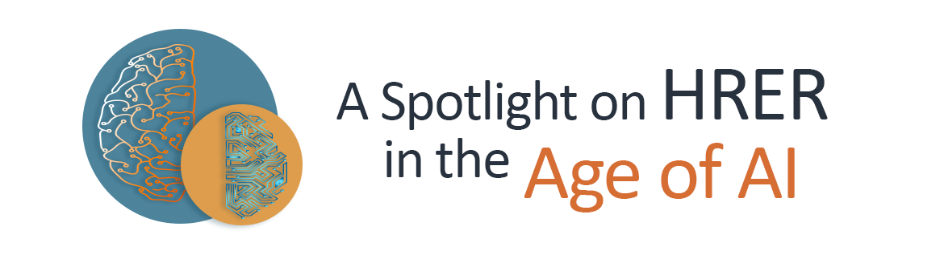
In this brief article titled Understanding the Role of Artificial Intelligence in Human Resources,
Link Here: https://www.linkedin.com/pulse/understanding-role-artificial-intelligence-human-vinjamuri/
Vinjamuri (2021) provides a perspective on how artificial intelligence and machine learning “are increasingly changing the trajectory of human resources, and the relationship between humans and machines is being redefined at workplaces every day” (para. 13).
This article provides foundational information that can be leveraged as you explore the 20 AI in HR trends.

References
Vinjamuri, S. R. (2021). Understanding the role of artificial intelligence in human resources. LinkedIn. https://www.linkedin.com/pulse/understanding-role-artificial-intelligence-human-vinjamuri/

