Website Link: https://www.wsws.org/en/articles/2021/12/29/appl-d29.html

Apple employees mount one-day strike on Christmas Eve to demand COVID-19 protections and better working conditions

Kevin Reed

29 December 2021
A group of Apple employees organized a walkout on Christmas Eve to demand improvements in wages, benefits and health and safety conditions during the pandemic. Approximately 50 Apple retail and corporate staff participated in the strike action across three states.
On Monday, Apple closed more than 20 of its retail stores, including in New York City, Washington D.C., Los Angeles, Houston and Miami, because a wave of COVID-19 cases among employees had left the stores understaffed. “We regularly monitor conditions and we will adjust our health measures to support the well-being of customers and employees,” Apple said in a statement.
An organization called Apple Together (@AppleLaborers) posted a tweet under the hashtag #AppleWalkout on December 23 announcing that the strike would take place the following day. The tweet said, “Calling all Apple workers and patrons! Tomorrow, December 24th, 2021, Apple workers are staging a walkout/callout to demand better working conditions.”
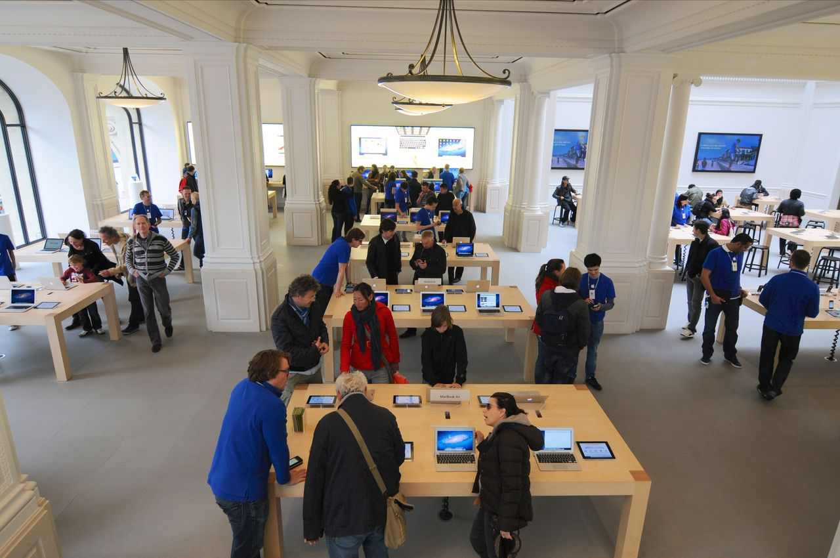
Apple Store in Amsterdam (photo by Reflexiste)
The post provided a link for employees to apply for strike pay and a graphic that said, “Don’t cross the picket line. We are Apple. We deserve a respectful workplace. We deserve paid sick time. We deserve protection on the frontlines. We deserve proper mental healthcare.” The post also said, “Demand that Apple upholds its image with your wallet. Don’t shop in stores. Don’t shop online.”
Janneke Parrish, a former corporate Apple employee who is helping the organizers of the strike, told the Huffington Post, “Apple workers are fed up with being unheard,” and that the strike aims to “make sure people are aware of how retail workers are being treated.” She also said Apple’s retail workers have “extremely limited sick leave” and that hazard pay is “the absolute least” that is owed to employees during the pandemic.
In a statement to the Daily Dot via Twitter, Apple Together said that the job action was prompted in part after a customer spit on an Apple employee in Jacksonville, Florida. The organizers said the customer was “not only not asked to leave—they were allowed back in the store repeatedly,” and “The employee who was assaulted was essentially told the customer did nothing wrong but has since been convinced to file a police report.”
Apple Together told the Daily Dot, “Upon hearing about the store’s plan to walkout, we decided to spread it further for support, in asking the public not to purchase Apple products today.” The group also cited “COVID surges” in Apple retail stores as a reason for the strike.
The Apple employee group refined its demands on the day of the strike in a tweet that said the workers were demanding hazard pay, living wage adjustment increases, health care premium coverage, more accessible paid leave, full benefits for part-time workers and protections from abusive customers. The tweet finished with a list of PPE items for the COVID pandemic: “N95 masks for all, sanitizing stations, appointments only, no loitering.”
As the most exploited section of Apple employees, the conditions facing the firm’s retail workers are no doubt untenable. The tech giant is the most valuable entity on Wall Street with a market capitalization of $2.94 trillion. Of the total of 154,000 employees, there are approximately 30,000 retail workers at 516 locations worldwide.
According to Glassdoor.com, these workers make between $19 and $25 at the 272 locations in the US. This compares to the average executive compensation at the Cupertino, California-based monopoly of $235,778. The compensation packages of the highest-paid executives are in the range of $24 million annually and Apple CEO Cook earned $265 million in 2020, the eighth highest-paid executive in the US.
At the same time, the competition among the tech giants for engineers and tech designers is intense and Apple has resorted to significant and unprecedented stock bonuses to keep staff from leaving for Facebook or Google. According to a report in Bloomberg, the recent bonuses “ranged from about $50,000 to as much as $180,000 in some cases. Many of the engineers received amounts of roughly $80,000, $100,000 or $120,000 in shares, said the people, who asked not to be identified because the program isn’t public.” Other engineers who did not receive the bonuses “believe the selection process is arbitrary. The value of some of the bonuses equaled the annual stock grant given to some engineering managers.”

Over the summer, Apple Together organized a protest around the hashtag #AppleToo, which was influenced by middle-class identity politics and had the stated aim of exposing “patterns of racism, sexism, inequality and abuse with the company.”
Increasingly, Apple employees, like their counterparts at Amazon, Google and Microsoft, are putting forward demands for improved wages, benefits and working conditions and highlighting the immense gap between the tech giant executives who have made billions during the pandemic and the workers who have risked their lives.
In April, Apple software engineer Cher Scarlett filed a complaint with the National Labor Relations Board against the company for engaging in “coercive and suppressive activity that has enabled abuse and harassment of organizers of protected concerted activity.” Scarlett had started a pay equity survey that was shut down by management on the grounds of privacy concerns.
The employees also lobbied the company to provide more flexible remote work options during the pandemic. While the company initially insisted that employees plan to return to the office by February 1, Apple announced on December 15 that the plan was being delayed indefinitely due to the pandemic surge.
Retail and technology workers at Apple and other Silicon Valley firms are right to take the initiative and organize independently of the companies and put forward and fight for their demands for improved wages, benefits and working conditions. However, as we have done in a recent report on the recent struggle mounted by Google employees, tech workers must be warned about the attempt by the official union organizations—such as the Communications Workers of America and other unions affiliated with the AFL-CIO—to co-opt their struggle and transform it into a prop for their alliance with the Democratic Party.
These organizations work to guarantee an accommodation with management that is beneficial to the profit interests of the giant corporations and secures for themselves a weekly dues checkoff that is taken out of employee paychecks. We call on Apple and other tech workers to contact the WSWS for assistance in building rank-and-file committees in every workplace to unite workers in other industries in the US and internationally. This effort must be based on the struggle to put an end to the capitalist profit system through the establishment of a global socialist economic structure that guarantees workers in every country a job with livable wages and benefits.

