Project Part 2 – Risk Assessment Plan
Student’s Name
Institution Affiliation
Professor’s Name
Course Name
Date

Project Part 2 – Risk Assessment Plan
Risk-Assessment Approaches
Risk assessment refers to the overall process which involves identifying hazards and risks factors with the potential to cause harm. It also determines suitable ways of hazard elimination or management. Rausand (2013) defined risk assessment as a means of assessing risks to be better prevented, reduced, and controlled. He also described risk as uncertainty and that risk assessment is particularly related to uncertainty, with the concept of probability. Often, there numerous risk assessment approaches. However, their effectiveness depends on different factors, including the ability of facilitators, recognized efficacy of scoring criteria, proven threshold for action, and the involvement of the right subject matter professionals in the evaluation. Further, risk assessment is also part of the larger risk management, as shown in the following figure.
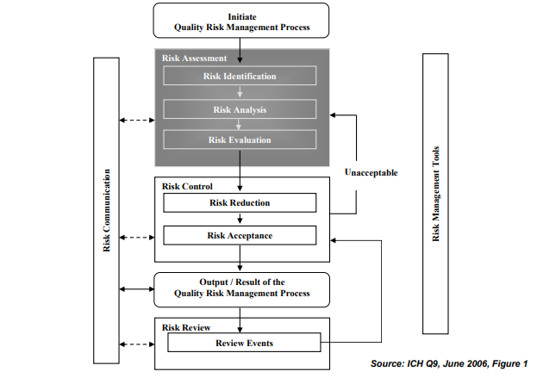
As revealed in the figure above, risk assessment fall under various classes or categories, including risk identification, risk analysis, and risk evaluation. Risk assessment approaches are preliminary hazard analysis (PHA), risk ranking and filtering, fault tree analysis (FTA), hazard analysis and critical control (HACCP), and failure mode effects analysis (FMEA). Van Westen et al. (2013) also provides more risk assessment approaches as shown in the following figure.
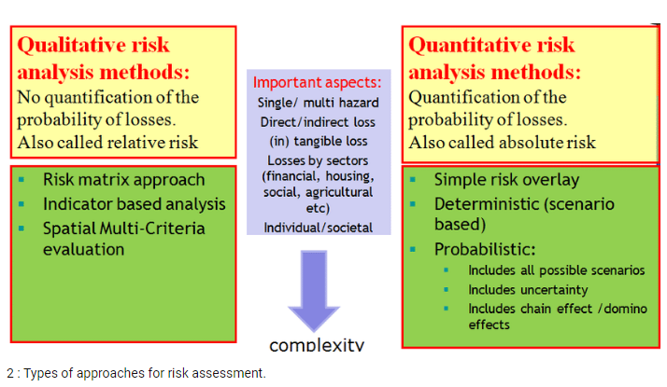
Source: Van Westen et al. (2013)

Qualitative Risk Assessment Outline
According to Yazar (2002), a qualitative risk assessment is a five step process that entails the following:
- Risk identification
– involving putting together a team, with the skills, to identify risk
- Risk evaluation
– entails isolating all possible risks, documenting, and analyzing them
- Risk ranking
- involves rating and prioritizing every risk based on their impact as well as probability of happening.
- Here, every risk is rated to establish if it is of high priority or it has a low concern.
- Risk reduction methods
- designing strategies to handle risks and reduce them based on their priorities
- Experts develop potential methods to address identified and ranked risks
- For each risk, solutions are provided and tested
- Monitoring and updating
- Here, every risk identified is monitored and re-evaluated
- It is never enough to recognize risks and developing solutions
- revising risks and their impacts to prevent their re-occurrence is essential

Introduction
Health Network, Inc., a fictitious healthcare firm is based in Minneapolis, Minnesota. It is a major organization, with more than 600 workers. The company makes $500 million in annual revenues. It also has additional locations, one in Portland and another in Virginia, which support a mix of different operations. Each of the company’s corporate facility is situated near a co-data center, with systems managed by third-party information center hosting vendors. The company has three major products; net pay, and net connect. The primary source of revenue for this firm is the net exchange, which manages secure electronic medical messages from customers. However, this organization’s prevailing risk-management system is out-of-date and requires a new one to remain operational and profitable. A risk-management plan analyzes risks and their impacts to an organization’s business. Hence, risk management plans remain fundamental because they assist companies to detect threats and system vulnerabilities. The purpose of this risk management plan is to identify Health Network, Inc. risks and recommend actions according to the specified CBA.
Risk Assessment Scope and Boundaries
Health Network, Inc.’s network system includes different components. It has three main products, with its net pay, an online platform portal, used in making secure payments or billing from customers. The company’s net connect is also an online directory for physicians, clinicians, doctors, and other medical professionals. With this directory, customers and other organizations can find various types of care at the right time and location. These products are subject to diverse security risks and threats, including cyber-crimes. For this reason, this organization needs a risk management plan, which can increase its opportunities and lesson threats to its operation. Hence, the risk assessment will offer threat mitigation measures. However, it will involve tracking the identified threats, detecting new ones, and determining the efficiency of the risk assessment plan throughout the project.
Data Center Assets and Activities to Assess
The data center assets and activities to be assessed includes but not limited to the following;
- Site locations – which will include the overall site analysis, such as assessing risks related to data location sites and proximity to the company’s facilities.
- Buildings – which will include assessing the architectural elements and will emphasis on the visual inspections of buildings’ critical areas.
- Critical systems – which will include assessing critical mechanical and electrical systems to establish consistency and possible vulnerabilities. This assessment will also include the evaluation of equipment conditions, capacity, tier levels, as well as maintainability.
- Communications – it will involve the evaluation of communication tools and systems. It will also focus on inspecting different fiber entrances, feeds, cable routes, and careers in the facility.
- Security – it will include assessing the facility’s security systems, with a major focus on assessing access controls, monitoring tools, cameras, and other types of systems in the company.
Relevant Threats and Vulnerabilities
Upon reviewing Health Network, Inc.’s current risk management plan, the organization faces the following threats;
- Loss of the company’s data because the hardware is being removed from the firm’s production systems
- Loss of the organization’s information due to lost or stolen firm-owned assets, including such assets as laptops, computers, and mobile devices.
- Loss of the company’s customers because of production outages resulting from different events, including poor software, change management, and natural disasters.
- Changes in the regulatory environment that might require diverse things and which could affect the company’s operations.
- Diverse internet threats because the organization’s products are basically assessed on the internet. There is a high probability of cyber-crimes happening, including hacking as well as phishing activities.
- Social engineering, where attackers might masquerade as genuine workers to obtain the organization’s sensitive healthcare information.
- Insider threats, with the company’s workers being involved in illegal activities, such as facilitating the company’s data loss.
- Broken authentication and session management, where attackers can exploit flows in the firm’s authentication and management functions to personate users.
- Utilizing components with recognized vulnerabilities, where attackers can exploit the firm’s weak components by scanning or using manual analysis.
- Hidden backdoor programs, where deliberately created security vulnerabilities can be used to gain the company’s systems.

Relevant Controls to Assess
Controls refer to measures designed and put in place to prevent or reduce the risk of harm to the organization’s critical assets. An effective risk assessment strategy must check the existing control measures and determine if more should be added. The main question for any risk strategy relates to how threats can be controlled. In any case, the risk assessment plan is not only long list of risks facing an organization but also how best to deal with such threats. As such, there are two common types of controls, including preventive and detective controls. With preventive controls, the focus is on preventing undesirable events from happening. Examples of these controls might include system controls stopping unauthorized access, segregation of duties, or dual entry of an organization’s sensitive managerial activities. On their part, detective controls seek to detect the undesirable events occurring in an organization. They can include exception reports or reviews from the management. The following table enlists different control categories, their description, as well as examples.
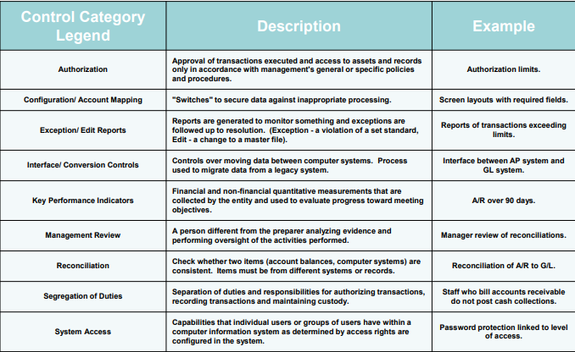
Key Roles and Responsibilities
Role | Duties/responsibilities
Project director | - Chairing risk assessment meetings and discussions.  - Coordinating risk managers to assess and determine risks and their effects  - Assigning risk classifications as well as tracing numbers.  - Identifying risk interdependencies in projects and assessing if risks come from internal or external sources.  - Assessing any new threats that are identified and adding them to the firm’s risk register.
Business Analyst | - Helps in recognizing and establishing the context, impact, timing, and priority of different risks.
Risk Manager (s) | - Escalating issues identified to the top management for actions.  - Monitoring and controlling risks that have been noticed.  - Determining the effect, timing, and level of risks.  - Liaising with management and project director to detect threats, contexts, and threat consequences.  - Formulating risk statements and advising on the correct course of actions.  - Reviewing and updating risk list as necessary as required.
Other key stakeholders | - Assisting in recognizing and detecting different contexts, impacts, as well as prioritizing different risks.

References
Van Westen, C. J., Damen, M. C. J., & Feringa, W. F. (2013). Training package on national scale multi-hazard risk assessment: theory book: e-book.
Yazar, Z. (2002). A qualitative risk analysis and management tool–CRAMM. SANS InfoSec Reading Room White Paper, 11, 12-32.

