**BCN 4575**

**Hydroelectric Energy**

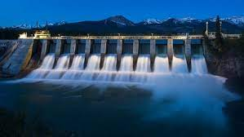

**Week 1: Homework Assignment 1**

Professor:

Student Name:

Date:

Assignment Description

Choose one of the Acts listed in Table 2-2 (page 92). Write a 1 to 2 page double-spaced paper on the Act that includes the following:



Start Here

|  |  |  |
| --- | --- | --- |
| Year of the Act | Name of the Act | Description of the Act |
|  |  |  |

A summary of the Act:

***Answer:***

The impacts of the act on existing (at the time) and future Hydropower projects

***Answer:***

Your thoughts and opinions of the Act, such as it was needed and justified, it hampered future hydropower projects, etc.

***Answer:***