College of Administrative and Financial Sciences

Assignment 3
Project Management (MGT323)
Deadline: 15/04/2021 @ 23:59

Course Name:Project Management | Student’s Name:
Course Code:MGT323 | Student’s ID Number:
Semester: II | CRN:
Academic Year:2020-21, II Term

For Instructor’s Use only
Instructor’s Name:
Students’ Grade:  Marks Obtained/Out of 5 | Level of Marks: High/Middle/Low

Instructions – PLEASE READ THEM CAREFULLY
- The Assignment must be submitted on Blackboard (WORD format only) via allocated folder.
- Assignments submitted through email will not be accepted.
- Students are advised to make their work clear and well presented, marks may be reduced for poor presentation. This includes filling your information on the cover page.
- Students must mention question number clearly in their answer.
- Late submission will NOT be accepted.
- Avoid plagiarism, the work should be in your own words, copying from students or other resources without proper referencing will result in ZERO marks. No exceptions. Assignment requires references.
- All answered must be typed using Times New Roman (size 12, double-spaced) font. No pictures containing text will be accepted and will be considered plagiarism).
- Submissions without this cover page will NOT be accepted.
Assignment Workload:
- This Assignment comprise of a Case Study.
- Assignment is to be submitted by each student individually.

Assignment Purposes/Learning Outcomes:
After completion of Assignment-3 students will able to understand the

- Define the concepts, theories and approaches of project management. (L.O-1.1)
- Recognize the steps of planning process in the project management. (L.O-1.2)
- Analyze to work effectively and efficiently as a team member for project related cases. (L.O-3.1)
- Evaluate to monitor and control the project. (L.O-3.2)

Assignment-3-Case Study

Assignment Question: (Marks 5)

Please read the Case-8.3 “Tham Luang Cave Rescue.” from Chapter 8 “Scheduling Resources and Costs” given in your textbook – Project Management: The Managerial Process 8th edition by Larson and Gray page no: 304-307 alsorefer to specific concepts you have learned from the chapter to support your answers.Answer the questions given below taken from the case study as deliverables where you should consider the milestones and technical requirements. Answers to all 3 Questions should be within 500 Words limit.

- How did the physical environment of the cave affect the rescue plan? (2 Marks)

- How did the rescue team respond to the risks of the project? (2 Marks)

- Some have called the rescue a miracle and that luck was the decisive factor. Do you agree? Explain. (1 Mark)
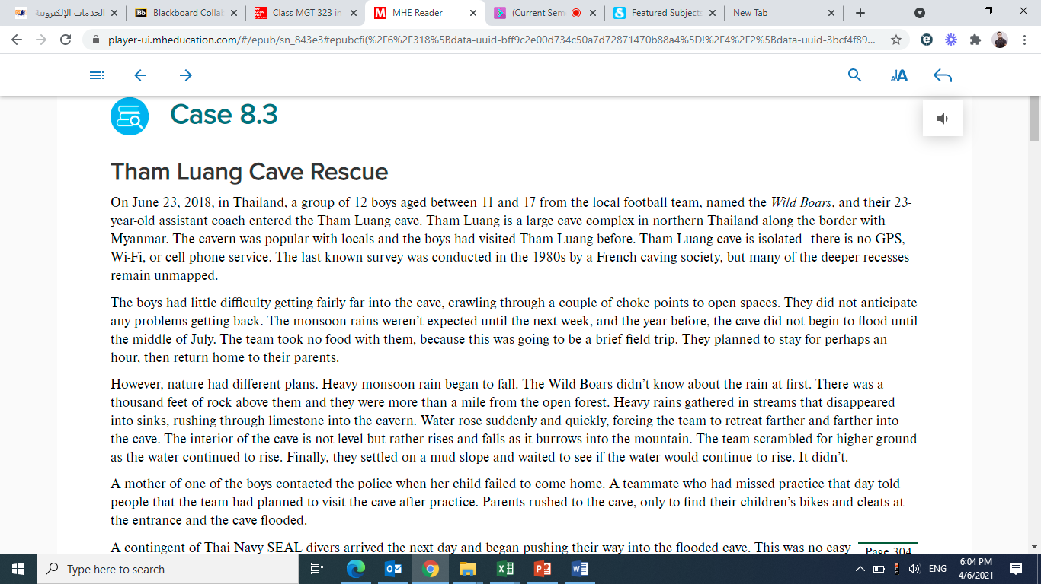

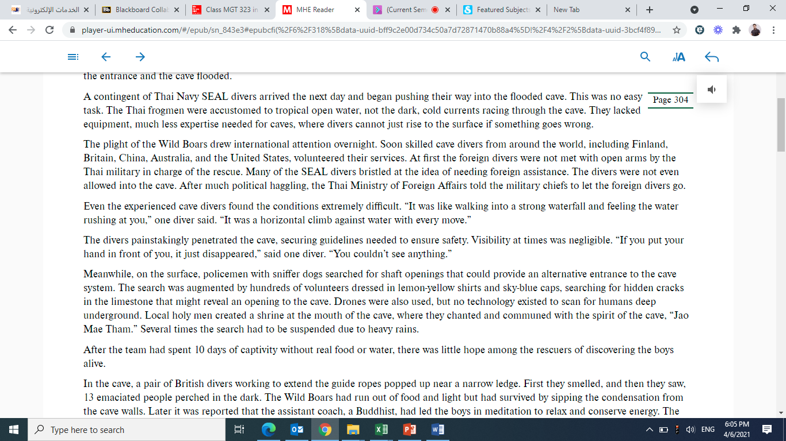

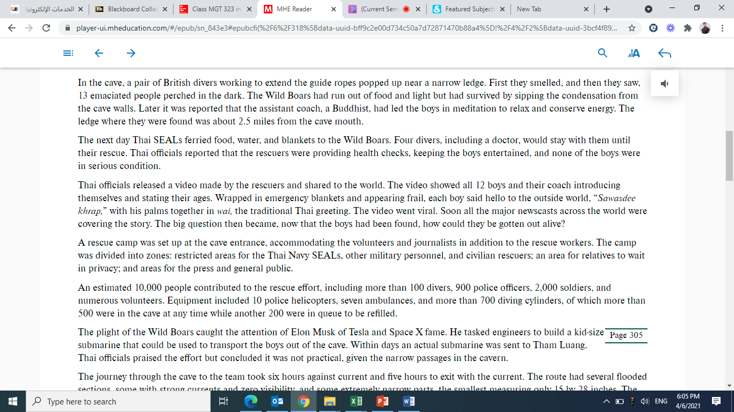

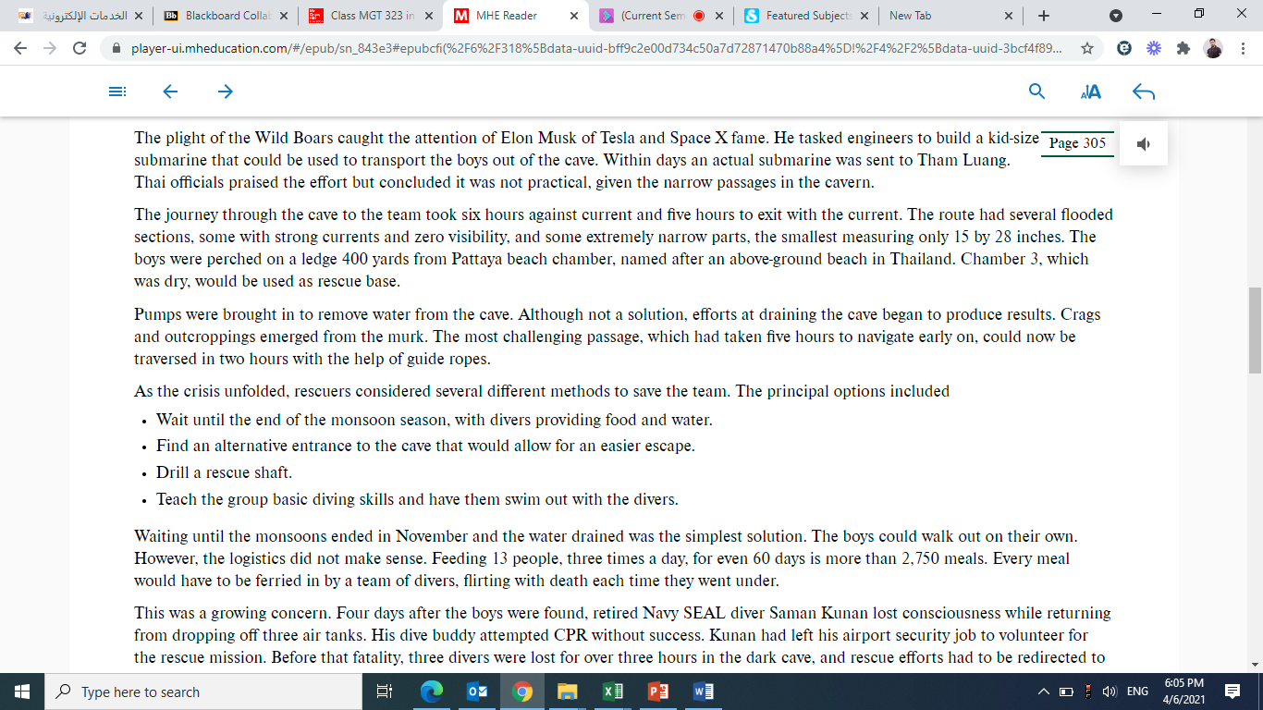
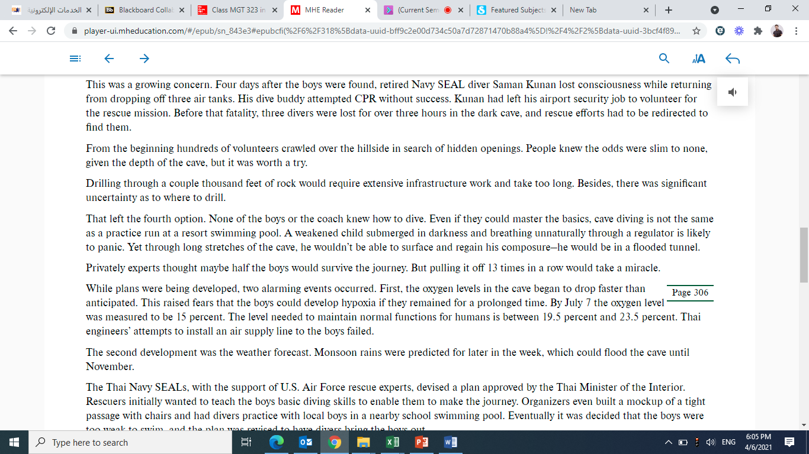
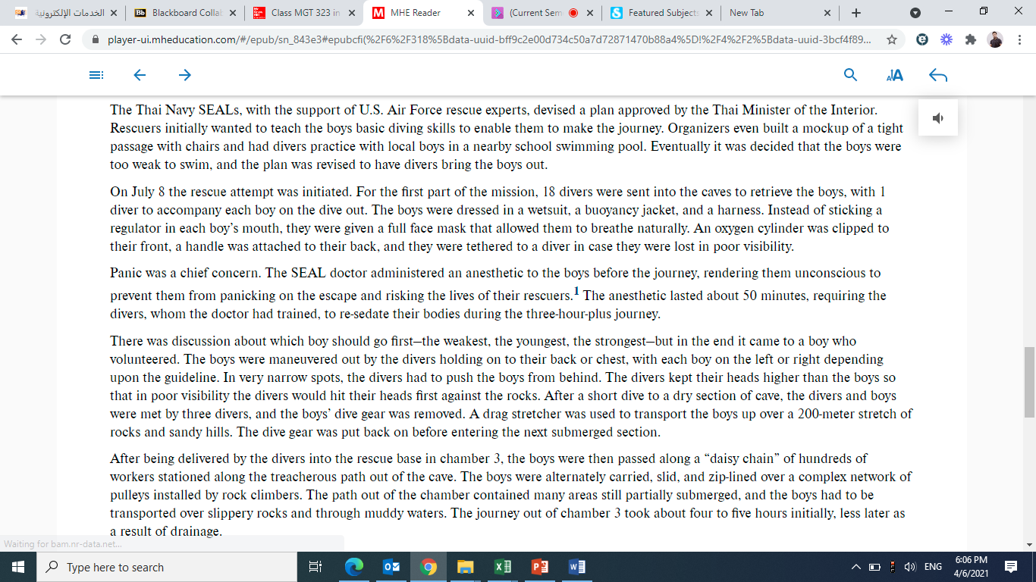
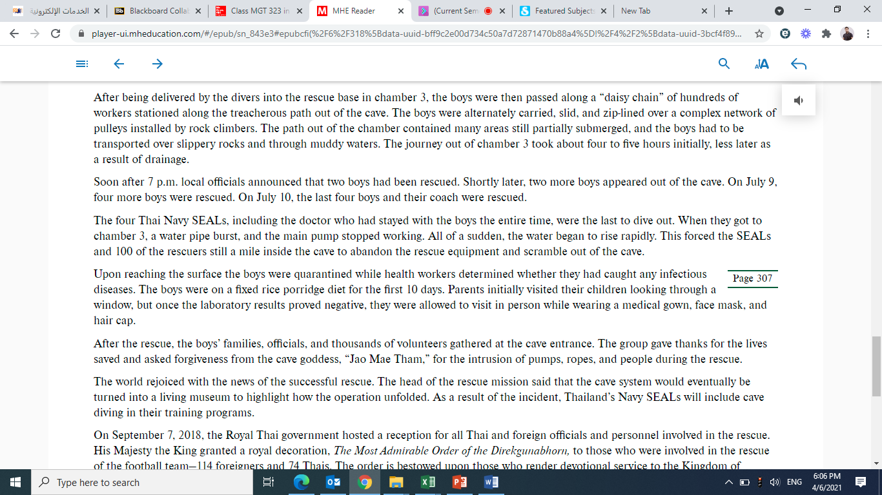
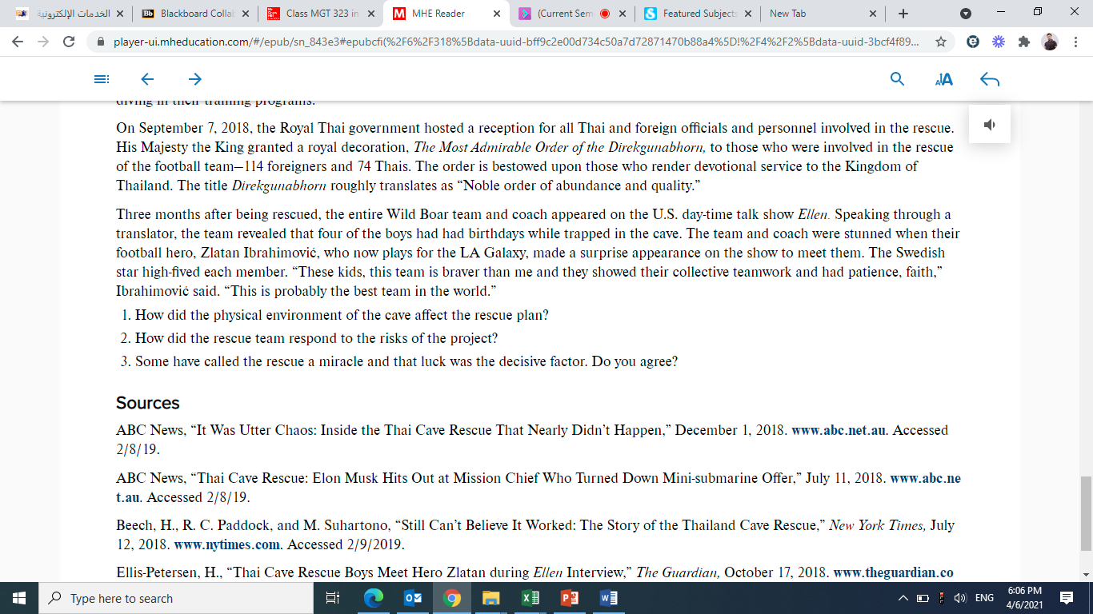
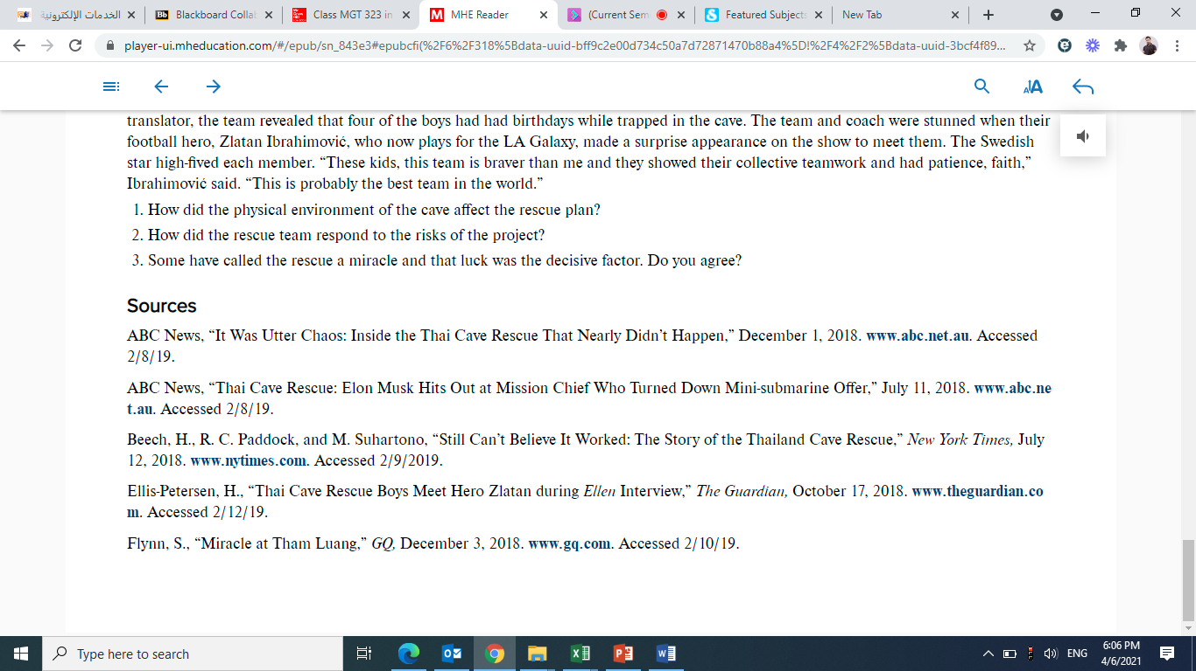
Answers:
1.
2.
3.

