**College of Administrative and Financial Sciences**

**Assignment 1**

**Project Management (MGT323)**

**Deadline: 04/03/2021 @ 23:59**

|  |  |
| --- | --- |
| Course Name:**Project Management** | Student’s Name: |
| Course Code:**MGT323** | Student’s ID Number: |
| Semester: **II** | CRN: |
| Academic Year:2020-21, II Term | |

**For Instructor’s Use only**

|  |  |
| --- | --- |
| Instructor’s Name:**Dr. Showkat Khalil Wani** | |
| Students’ Grade: Marks Obtained/Out of 5 | Level of Marks: High/Middle/Low |

**Instructions – PLEASE READ THEM CAREFULLY**

* The Assignment must be submitted on Blackboard (**WORD format only**) via allocated folder.
* Assignments submitted through email will not be accepted.
* Students are advised to make their work clear and well presented, marks may be reduced for poor presentation. This includes filling your information on the cover page.
* Students must mention question number clearly in their answer.
* Late submission will NOT be accepted.
* Avoid plagiarism, the work should be in your own words, copying from students or other resources without proper referencing will result in ZERO marks. No exceptions. Assignment requires references.
* All answered must be typed using **Times New Roman (size 12, double-spaced)** font. No pictures containing text will be accepted and will be considered plagiarism).
* Submissions without this cover page will NOT be accepted.

***Assignment Workload:***

* This Assignment comprise of a Case Study.
* Assignment is to be submitted by each student individually.

***Assignment Purposes/Learning Outcomes:***

After completion of **Assignment-1** students will able to understand the

1. Demonstrate a deep understanding of project management concepts and theories as well as approaches to project management (L.O-1.1)
2. Demonstrate an understanding of the project budgeting and cost control in project management (L.O-1.6, 4.1)
3. The ability to write a coherent report on project management case studies or new themes. (L.O-4.5)

***Assignment-1-Case Study***

**Assignment Question: (Marks 5)**

Please read the Case-2.1 “**Hector Gaming Company**.” from **Chapter 2 “**Organization strategy and Project Selection**”** given in your textbook – Project Management: The Managerial Process 8th edition by Larson and Gray page no: 61 alsorefer to specific concepts you have learned from the chapter to support your answers. Answer the following questions with 500 Words limit.

Peters has hired you as a consultant. She has suggested the following format for your consulting contract. You are free to use another format if it will improve the effectiveness of the consulting engagement.  
  
Provide a detailed action plan that attacks the problem. Be specific and provide examples that relate to HGC.  
  
1. What is our major problem?

2. Identify some symptoms of the problem.

3. What is the major cause of the problem?

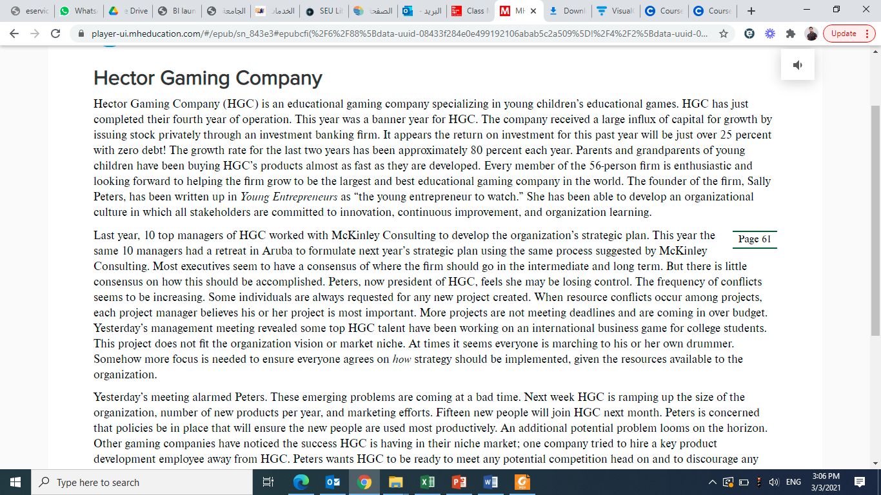

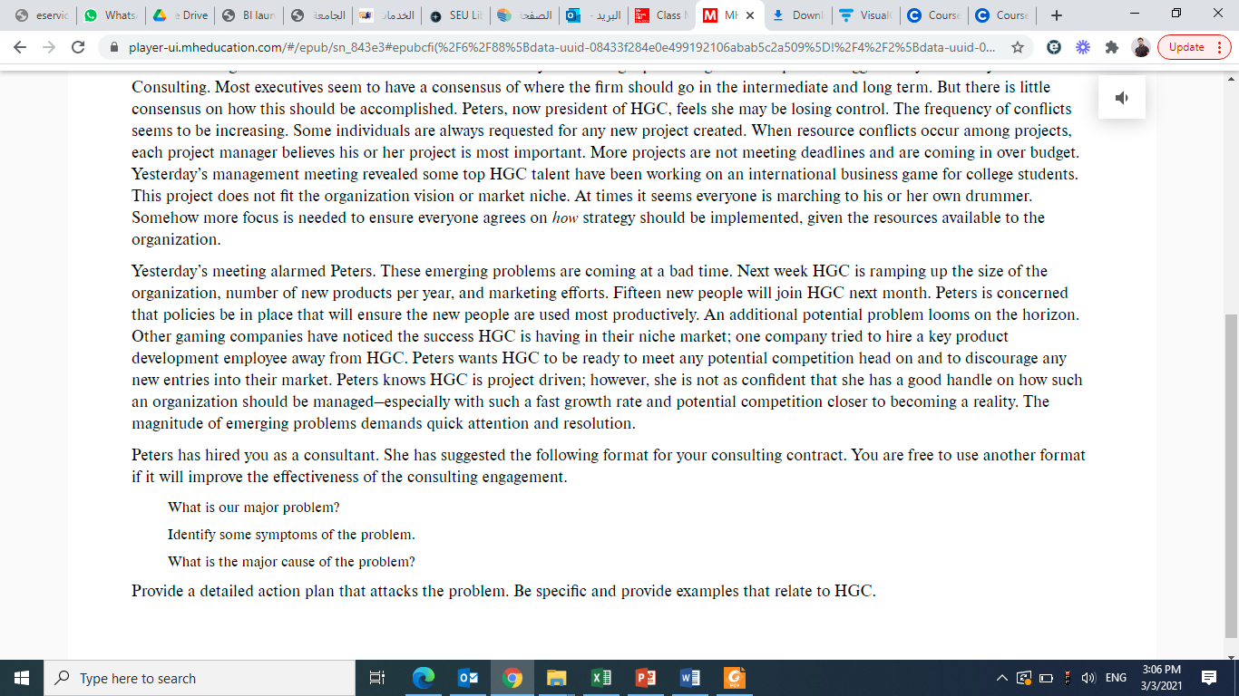

**Answers:**

**1.**

**2.**

**3.**