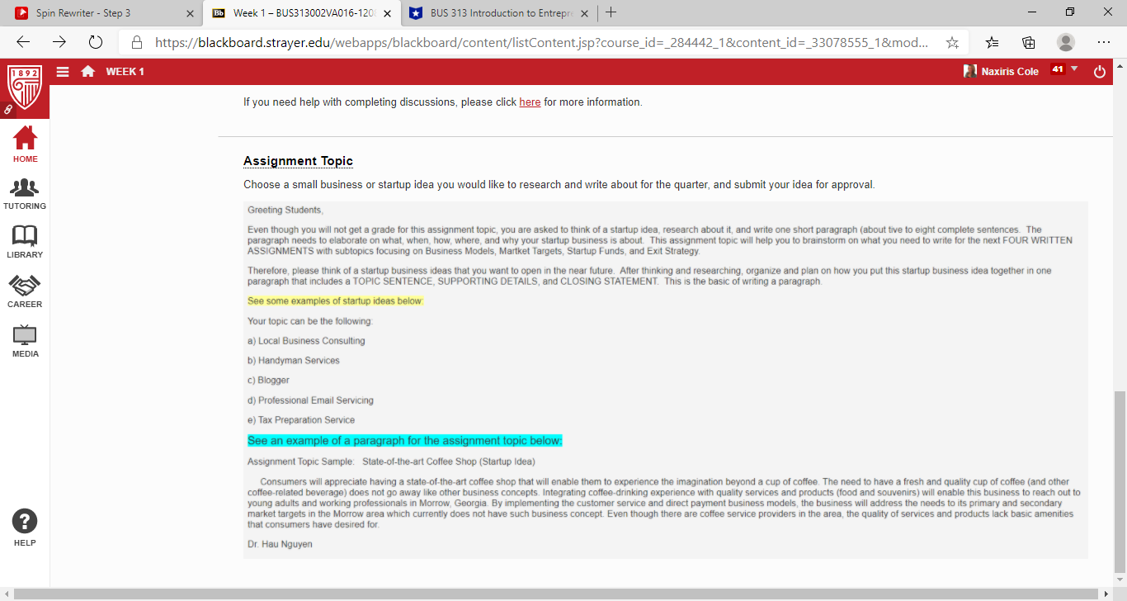

**Assignment 1: Business Models**

What is the best business model for the small business or startup you have chosen? In one page, outline at least three different business models and then select the best model for your business. Then, give a short statement explaining why this is the best model. Remember, you will take feedback from all submitted portions of your plan, revise, and then submit the final business plan in Week 9.

Write a one (1) page outline in which you:

1. Briefly describe three different business models.
2. Select the best business model for your business.
3. Create a short statement explaining why the business model you have chosen is the best model for your business. Give at least three supporting facts for your choice.

The specific course learning outcomes associated with this assignment are:

* Examine the process of innovating and developing ideas and business opportunities.
* Analyze different innovative business models to determine the best model for a specific venture.
* Analyze the management of a successful innovative company.
* Use technology and information resources to research issues in entrepreneurship.
* Write clearly and concisely about entrepreneurship using proper writing mechanics.