Resources: Professional Ethical Codes and The Role of Ethics Committees
- PRINT
- The Role of Ethics Committees
Most hospitals today have an ethics committee, which is a group composed of various staff members and other individuals from the local community. The committee consults with staff and hospital administrators on cases that pose particularly challenging ethical dilemmas, but it has other functions as well. Think about the following questions:
  - What are the primary duties of a hospital ethics committee?
  - When it comes to consultation, what sorts of cases does the committee advise on? Does the committee simply command what should be done in such cases?
  - In terms of professional roles, who usually sits on them?
  - Assess the value of ethics committees to your professional role.
  - If you have direct experience with ethics committees, what have you observed?
- Legal and Ethical Considerations
  - Chassin, M. R. (2013). Improving the quality of health care: Where law, accreditation, and professionalism collide. Health Matrix: Journal of Law-Medicine, 23(2), 395–407.
  - Aulisio, M. P., Moore, J., Blanchard, M., Bailey, M., & Smith, D. (2009). Clinical ethics consultation and ethics integration in an urban public hospital. Cambridge Quarterly of Healthcare Ethics, 18(4), 371–383.
  - The Joint Commission. (2016). Retrieved from https://www.jointcommission.org
    - Review the general information on the scope and purpose of this accrediting organization.

Resources: Optional Enrichment
- PRINT
- Ethical Issues: Epidemics and Pandemics
If you would like to learn more about ethical issues surrounding the challenges and disparities in health care for these populations you may want to read Optional Enrichment: Epidemic and Pandemic Considerations [DOC] for an overview of some of the considerations.
For further enrichment, you may wish to explore the following resources:
  - Munson, R. (2014). Intervention and reflection: Basic issues in bioethics (concise ed.). Boston, MA: Wadsworth. Available in the courseroom via the VitalSource Bookshelf link.
    - Chapter 12, "Epidemic! AIDS and HIV," pages 438-466.
  - Kinlaw, K., & Levine, R. (2007). Ethical guidelines in pandemic influenza [PDF]. Retrieved from http://www.cdc.gov/od/science/integrity/phethics/panFlu_Ethic_Guidelines.pdf

INTRODUCTION

Case Study: Tonya Archer
It is one thing to consider medical ethics in an abstract setting, but by their nature, medical ethics involve deeply personal and emotional situations. This activity asks you to consider a case in which the family’s wishes are in conflict with the medical advice they have been given. You will be asked to answer some questions at the end of this activity.

Tonya is admitted to the hospital

Tonya Archer is a fifteen year-old who has been admitted to Saint Anthony Medical Center for surgery to repair an ACL injury she suffered while playing softball. Tonya and her family have met with her surgeon and understand that while all surgery carries risks, this is a straightforward procedure that he has performed many times with no complications.
Post-surgical complications

The surgery goes as expected, but as Tonya is being transferred from the recovery room to her hospital room, she went into cardiac arrest. While Tonya received immediate medical attention, it took over seven minutes to restore cardiac function and the loss of blood circulation resulted in brain damage. During the attempt to resuscitate Tonya, she was intubated and placed on a ventilator. The medical staff has determined, though, that the loss of circulation caused brain death.

Doctors recommend ending life support
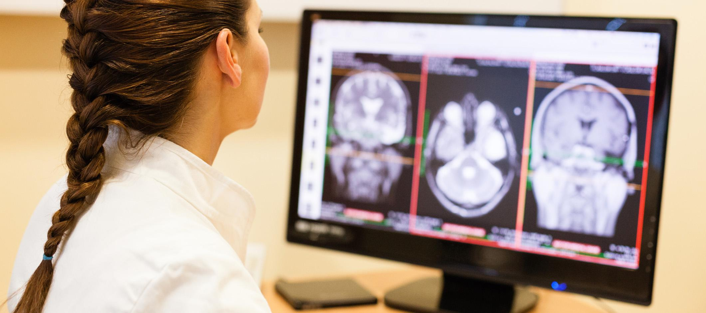

Tonya’s doctors explain to her family that the damage Tonya sustained is irreversible and that she suffered whole brain death, which means that there is no neurological function, even at the most basic functions such as respiration or cardiac function. They tell the family that the next step is to take Tonya off the ventilator. Tonya’s parents reaction is of steadfast refusal. They tell the doctor that they understand that Tonya has had a serious accident, but they point out that her body is warm, her heart is beating, and that she therefore is not dead.

Hospital administrator and medical ethicist

The doctors, hospital administrator, and the hospital’s medical ethicist tell the family that while the ventilator and other interventions can sustain the body’s functions, the damage done by the cardiac arrest will get worse and there is near certain expectation that Tonya will not recover any brain function. The family is told that there is no reasonable hope of benefit to Tonya by continuing ventilator and other treatment.
1
2
3
4
5

Reflection
Question 1 of 2
What are the most relevant end-of-life issues in health care ethics as they relate to this case?
Question 2 of 2
What should the hospital do? Should the hospital keep Tonya on life support as the parents desire, or should life support be removed because all medical evidence indicates whole brain death?
Reset Page
Submit

