Personality Essay

Abstract

Personality is one of the psychological constructs that still require much research because of the lack of clarity and agreement between different researchers concerning the topic (Burger, 4). However, there are some common beliefs on a personality that have been put together to come up with personality theories. Personality theories explain different personality traits. There are several personality theories: Freud's Psychanalysis Theory, Jung's Theory of Analytical Psychology, Adler's Theory of Individual Psychology, Horney's Psychoanalytic Social Theory, Klein's Object Relations Theory, Sullivan's Interpersonal Theory, Fromm's Humanistic Psychoanalysis, and Erikson's Post-Freudian Theory (Feist & Feist, 15). This paper aims at discussing major existing Theories of Personality and how they manifest in my life. These personality theories include Adler's Theory of Individual Psychology, Horney's Psychoanalytic Social Theory, and Klein's Object Relations Theory. The paper will also briefly discuss the agentic personality traits and the personality approaches that focus on the language process.

The Construct 'Personality'

Over the years, much research has been carried out on the construct of personality and the definitions, senses, and theories related to it. However, none of the researchers were able to settle on a textbook definition of the construct' personality'. According to Burger (4), personality is the constant behavioral traits and individual processes that take place within a person. The definition of personality is composed of two parts; constant behavioral traits and individual processes that take place within a person (Burger, 4). The constant behavioral traits are what make up the individual differences observed among people. Behavioral traits are the characteristics that contribute to the individual differences exhibited in human behavior, its stability, and differences over time and in different circumstances (Feist & Feist, 4). For instance, an individual who is known to be outgoing is expected to be outgoing tomorrow and the days to come. However, this does not mean that this person will always be outgoing. Change is expected in individual behavioral patterns. The processes that take place within a person include cognitive, emotional, and motivational processes. All these processes affect our feelings and actions (Burger, 4). These processes are the main reason why psychologists explore topics involving depression, happiness, information processing, and denial (Burger, 4).

The Scientific Definition of a Theory

According to psychologists, different individuals exhibit many similarities in individual processes. This finding has led to the development of personality theories (Boeree, 6). However, each individual reacts differently when interacting with others or when using them hence, contributing to our differences (Boeree, 6). According to Feist & Feist, (4), a theory consists of a set of interrelated assumptions that scientists use to compose testable hypothesis. One assumption cannot formulate a theory (Feist & Feist, 5). The existence of a theory depends on the presence of several similar assumptions that can be used to integrate several observations, which is what a theory does (Feist & Feist, 5). Assumptions are the components of a theory; however, they are not proven facts. They are merely accepted so that scientists can research to determine their validity. Logical deductive reasoning is the method used to formulate research hypotheses in this case (Feist & Feist, 5). The research hypotheses are not part of the theory but are derived from it. If the researchers use faulty logic to derive the hypotheses, then the research process will be null and void (Feist & Feist, 5). The hypothesis used for these research purposes must be testable.

Agentic Properties of Personality

Agentic personality traits are based on the belief that people can control their lives to produce positive results (Robitschek & Weigold, 2011). According to Bandura (1999), the agentic sociological view describes people as beings who reflect, organize, and regulate their actions. They are also proactive beings. This means that they are beings that are not shaped by their reactions to external events alone. The human ability to control one's affect, thought process, action, and motivation is possible through the processes of personal agency (Bandura, 1999). Human agency can be characterized into three major categories autonomous agency, emergent interactive agency, and mechanically reactive agency. According to social cognitive theory, people play a role in the operation of their lives. They do not sit back and observe the internal processes that are influenced by external factors (Bandura (1999).

The Theories of Personality

There are several personality theories that researchers in psychology have come up with to help make sense of the different personality traits exhibited by humans. They include Freud's Psychanalysis Theory, Jung's Theory of Analytical Psychology, Adler's Theory of Individual Psychology, Horney's Psychoanalytic Social Theory, Klein's Object Relations Theory, Sullivan's Interpersonal Theory, Fromm's Humanistic Psychoanalysis, and Erikson's Post-Freudian Theory (Feist & Feist, 15). This section of the paper will discuss Adler's Theory of Individual Psychology, Horney's Psychoanalytic Social Theory, and Erikson's Post-Freudian Theory.

Alfred Adler's Theory of Individual Psychology states three major assumptions: humans are motivated by social influences and their struggle to be successful or superior, people highly influence the process of their personality development, and their view of the future determines the present behavior of humans. (Feist & Feist, 65). According to Adler, every human's desires and aims are to feel important and belong (Feist & Feist, 66). He believed that when humans are encouraged, they feel appreciated and capable, so they are cooperative and feel connected to one another. When humans are discouraged, they may compete, withdraw from others, or even give up. This theory is used by counselors who found social interest to be directly proportional to mental health. Social interest is also linked to optimal wellbeing because acting in ways that benefit others is a reflection of neural integration and healthy genetic expression (Miller & Taylor, 2016).

Additionally, low levels of social interest are linked to criminal activity (Feist & Feist, 90). According to this theory, my personality type resulted from the success that I observed from my family members. I feel pressured to achieve that and more because I do not want to disappoint my family. Furthermore, I have a younger brother with Down's Syndrome, so he motivates me to work hard and make sure he never lacks. This explains my high level of conscientiousness or work ethic that is exhibited in my results from the personality test (Appendix B).

According to Karen Horney's Psychoanalytic Social Theory is based on the assumption that cultural and social processes, more so childhood experiences, play a major role in the development of one's personality (Feist & Feist, 169). According to her, the children who did not get the emotional and social support from their parents when younger develop basic hostility as they grow older and eventually suffer from basic anxiety (Feist & Feist, 169). This anxiety is often exhibited in three major ways: moving away from, towards, or against other people (Feist & Feist, (Feist & Feist, 169). Horney's theory has only triggered a few researchers to dig deeper and explore the Psychoanalytic Social Theory. Therefore, this theory lacks sufficient and recent research data to support its validity (Feist & Feist, 180). The theory cannot generate testable hypotheses that should be used for research purposes (Feist & Feist, 181). From Horney's theory, I identify as an individual who occasionally experiences negative emotions and feelings of anxiety (Appendix C). This can be attributed to the lack of emotional support from my parents when I was younger because my parents had to go through a divorce.

Erik Erikson's Post-Freudian Theory earned its name from its attempt to extend Freud's infantile studies into adolescence, adulthood, and old age (Feist & Feist, 241). According to Erikson, each stage presents different psychosocial challenges that lead to the development of one's personality (Feist & Feist, 241). From the adolescent stage, the psychosocial struggles, referred to as an identity crisis, plays a role in either the strengthening or the weakening of an individual's personality. Erikson's personality theory was applauded for ruling out the possibility of psychological development stopping during childhood. He was the first psychologist who emphasized the importance of one's identity (Feist & Feist, 265). His theory stimulated research related to adolescence, adulthood, and old age; specifically, life changes and parenting (Feist & Feist, 265). The main issue that most critiques address when it comes to this theory is the basis of the entire theory on ethics and not data (Feist & Feist, 267). According to Erikson's personality theory, I am a young adult male who exhibits natural reactions of worry and is easily upset (Appendix C). This can be explained by the concern that I feel for my younger brother with Down's Syndrome. I am also often in conflict with my siblings because they sometimes make alarming choices. I have worked hard to set a good example for them. I am also organized and responsible, all because I am the firstborn of my family (Appendix B). Growing up, I was conditioned to lead by example for my younger siblings.

Personality Approaches that Focus on Language Process

A language is a useful tool in the determination of an individual's lower-level personality trait (Boyd & Pennebaker, 2017). Basic psychological tendencies shed light on individual differences that are closely related to language use. Extroverts are found to use more common words compared to introverts (Boyd & Pennebaker, 2017). This means that the words used by extroverts contain fewer personal pronouns compared to those of introverts. As shown in Appendices A, B, and C, I took the Big Five Personality Test. My level of extraversion is quite low, which means that I am a reserved and quiet individual that derives joy from within myself.

References

123 Test, (2020). Personality Test. Retrieved August 13, 2020, from

https://www.123test.com/personality-test/

Bandura, A. (1999). *Social Cognitive Theory of Personality*. In L. Pervin & O. John (Ed.),

Handbook of personality (2nd ed., pp. 154-196). New York: Guilford Publications. (Reprinted in D. Cervone & Y. Shoda [Eds.], The coherence of personality. New York: Guilford Press.)

Boeree, C. G. (2006). *Personality Theories*. Hans Eysenck and Others. Retrieved August 13,

2020, from http://www.ship.edu/%7Ecgboeree/perscontents.html

Boyd, R. L. & Pennebaker, J. W. (2017). Language-Based Personality: A New Approach to

Personality in a Digital World. *Current Opinion in Behavioral Sciences,* 18, 63-68. DOI: http://dx.doi.org/10.1016/j.cobeha.2017.07.017

Burger, J. M. (2008). *Personality.* 7th Edition. Thomson Wadsworth. Belmont: CA.

Feist, G. J. & Feist J. (2006). *Theories of Personality*. 6th Edition. McGraw Hill. New York.

Miller, R., & Taylor, D. D. (2016). Does Adlerian Theory Stand the Test of Time: Examining

Individual Psychology from a Neuroscience Perspective. *The Journal of Humanistic Counselling,* DOI: 10.1002/johc.12028. Wiley.

Robitscheck, C. & Weigold, I. K. (2011). Agentic Personality Characteristics and Coping: Their

Relation to Trait Anxiety in College Students. *Am. J. Orthopsychiatry*, 81(2), 255-264. DOI: 10.1111/j.1939-0025.2011.01094.x

Appendices

Appendix A



Appendix B

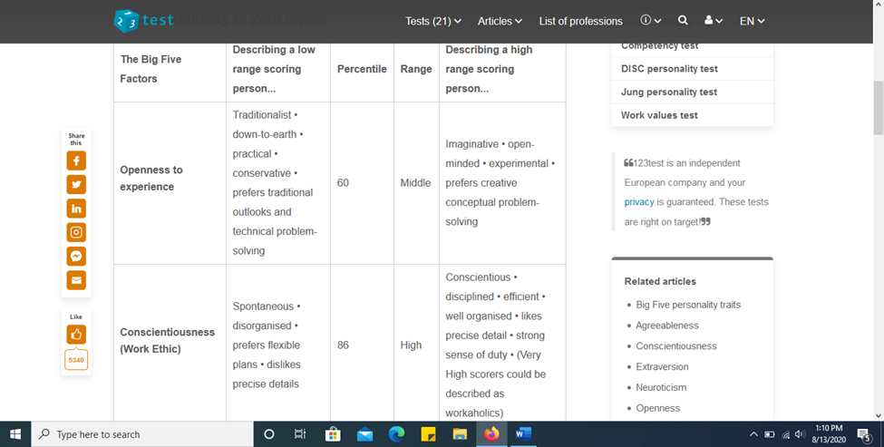

Appendix C

