Lecture:

Getting the Message Out Takes INTEGRATION

This week you begin to get a feel for what it is like to get the message out.  While we are all familiar (sometimes painfully) with the advertising messages that continually bombard us through the many different media, it's important to be aware that more now than ever there is a vital need for an integrated media and communication strategy. The foundation of a strong integrated marketing strategy requires a mix of advertising, branding, positioning and public relations in the right proportions so that they complement and build on each other. Take a minute to study the following figure from Roger Best's Market-based Management. Notice how the communication mix drives different channels with all the same goal -- to reach the customer. The concept of Push and Pull where information is either pushed out to the customer through intermediaries or information is used to pull customers directly through direct communication with them is an important part of your reading this week.

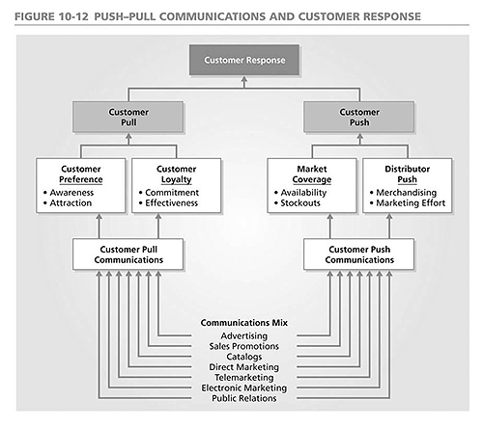

Now, take a look at the following graph from Unleashing the Power of PR. Both have the ultimate goal of reaching a customer or target audience and both show the impact of the communication mix. What similarities and differences do you see?  Notice how they complement each other and highlight different perspectives on delivering a message or converting a customer. Within PR, controlled vs. uncontrolled communication is an important distinction. This graph serves to highlight where each fits into the overall communication process.

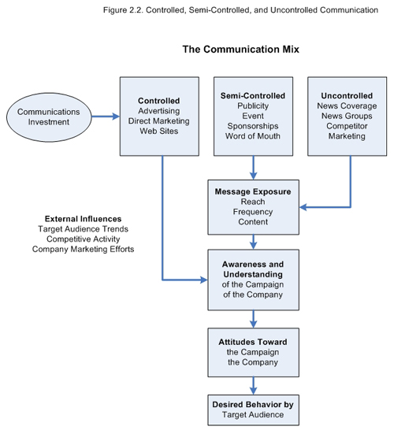

Notice the theme of integration? Remember that you can't have any of this without a good sense of the pricing strategy, the financial stability of the company, the environment around you and your internal structure . . . each of these diagrams emphasizes integration. As you begin to plan your communications strategy this week, make sure to take into account the need for integration not just with advertising and PR, but also with retail channels and the customer experience you intend to convey.

Email Marketing

Let's take a look at an increasingly common way for organizations to communicate with customers - email marketing.

People who have never worked in online marketing may tend to immediately associate email marketing with the term *spam*. Nevertheless, companies invest money into rigorous email marketing software as a major part of their customer relationship management program.

For example, [Oracle Eloqua (Links to an external site.)](https://www.oracle.com/marketingcloud/products/marketing-automation/index.html) is a well-known company that offers "Marketing Automation Campaigns for Businesses." Email marketers who contract this company see flow charts that follow the sales or sign up progress of every visitor who requests information or makes a purchase from a website. Afterward, the action of every individual user determines which email that person will automatically receive, as this is programmed into the flowchart of an email management service.

For example, in a well-programmed email marketing software, a user who requests information about a certain service may sign up for the service following an automated clarification email. At that time the user should be automatically taken out of the program that continues to send out email reminders. A savvy email marketer will also engage in AB testing to measure metrics such as open rates, click-through rates, and purchase rates: For example, a standard practice is to send out two promotional emails with different subject lines to two different sets of recipients. Email marketers will then analyze which subject line obtains the highest open rate. This becomes an iterative process

Email marketers must, of course, abide by legal and ethical standards. For example, the [CAN-SPAM Act (Links to an external site.)](https://www.ftc.gov/tips-advice/business-center/guidance/can-spam-act-compliance-guide-business) indicates an obligation to obviously unsubscribe people who request it and to account for the time, date and location upon which a person signed up to be added to an email list.

Reputation Management

Another way to manage communication with customers is managing the reputation of an organization.  How do customers and potential customers perceive your organization?

In the age when information is only a few seconds away through a Google search, negative search results can damage the reputation of a company or an individual, while decreasing sales, reputation, and profitability. Such negative information can be in the form of negative customer reviews on websites such as Yelp or unflattering news articles. There are reputation management companies that specialize in pushing negative information about an organization further down in the search results.

In order to have positive listings for a company or an individual, search engine experts create neutral reviews through multiple social media websites such as [LinkedIn (Links to an external site.)](https://www.linkedin.com/) and [Instagram (Links to an external site.)](https://www.instagram.com/), as well as through press releases that are widely distributed.

The cost of hiring an SEM (search engine manager) is expensive. It starts at $2000 on the low end for a private consultant and can easily run well over $5000 for a firm with a proven track record, depending on the level of expertise, expected results, and effort required.