Relationship between Consumer Behavior and Marketing Strategies

Tiffany Benson

Professor Shane

Marketing 554

02/03/2020

**Introduction**

Marketing strategies play a crucial role in ensuring that the company can reach its customers in both the local and foreign markets (Odaymat, 2018). Companies strive to gain a competitive advantage in the market by conducting market research to determine consumer behavior. Market research helps in understanding customer preferences, how they utilize the company products and the perceptions towards the firm’s brand. In this paper, I will address how Apple Inc. utilizes consumer behavior in pricing, distributing, and promoting its products in the market. Apple Inc. operates in a highly competitive electronics industry where companies such as Samsung pose significant market competition in both the local and international arena. Being an international brand, Apple has dominated the market over the years through sound marketing strategies and consumer behavior considerations.

**Understanding Consumer Behavior in Marketing Strategies**

Consumer behavior provides a strong pillar in which companies use to build a strong brand in the market. Companies that have achieved success have concentrated more on the ever-changing consumer behavior and the change in market dynamics. Thus, organizations are trying to keep updated about the changes by conducting market research for strategic marketing planning. In the case of Apple, the organization's success can be attributed to extensive customer behavior analysis to understand its needs. Development in technology and proliferation in the use of the internet has made consumer behavior analysis effective and efficient. Apple targets customers include people living in developed countries as well as those developing countries. The large market segmentation has provided a wider market for apple products, thus, enhancing the organization's sales and profits. In this era of technological advancement, customers have embraced the use of social media platforms where they share information and preferences regarding companies’ products (Yoganathen, 2018). social media has been a significant source of consumer behavior information where companies learn to change in preferences and perceptions.

**Use Social Media in Learning Consumer Behavior**

Apple has established a significant presence on all social media platforms where the marketing team interacts with customers across the world. Today, technology has enabled the company to reach a large number of customers at once with less cost. It is through social media that the Apple marketing team learns about consumer behaviors through social interaction and trends. Apple capitalizes in the highest number of internet users both in the U.S market and across the borders. in its marketing strategies, Apple Inc. uses Facebook, Twitter, YouTube, and Instagram to market for its products across the world. apart from marketing the company uses social media to collect data and in-depth knowledge about consumer satisfaction.



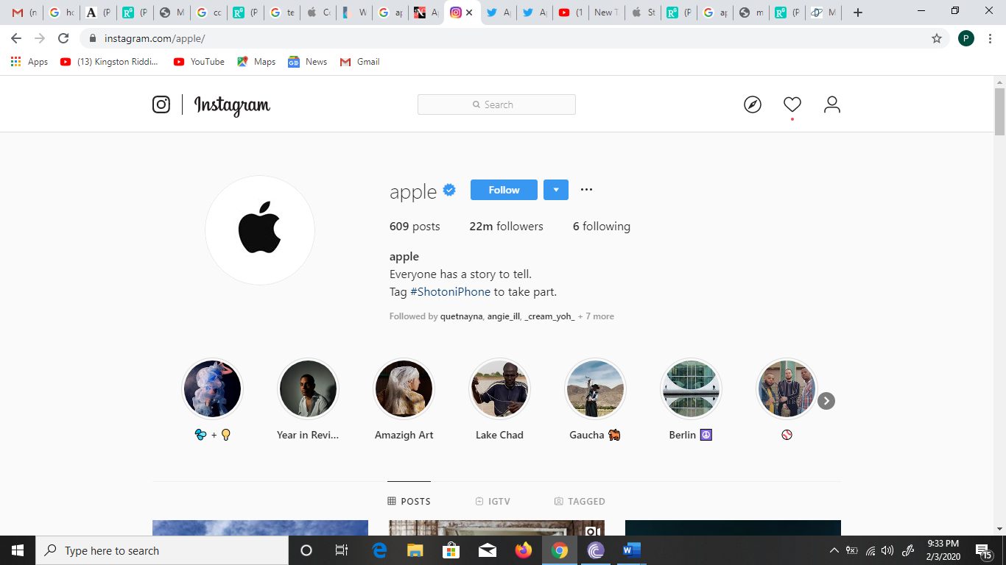





Apple has 3.9 million followers on twitter, 22 million followers on Instagram, more than 12 million followers on Facebook and more than 10 million YouTube subscribers. These number reveals that Apple has a large customer base on all its social media platforms. the company has leveraged on these numbers to gather information about customer reviews, experiences, advice, tips, preferences and warnings. Customer reviews provide crucial information about their perceptions regarding different products sold by the company. Sales of iPhone phones depend significantly on customers' online reviews. Over the years, Apple has invested greatly in innovation and new technology to ensure that it provides unique phones every year. The success of achieved in terms of sales of every iPhone model has been attributed to the customers' activities on social media (Odaymat, 2018). Before, the company releases the new model in market marketing research is done on social media platforms to determine customer preferences (Klieb, 2018). Online interactions are crucial in understanding customer behavior; thus, Apple uses an online platform such as twitter to interact with customers regarding the quality of the products and services. Besides, the organization can be aware of current trends in the electronics industry and consumer preferences through social media. For instance, Apple was able to develop a new iPhone model with a bigger screen to meet the current trends in the market. Consumers buying decision is also influenced by online interactions and social media marketing. Having a large online follower has played a vital role in helping Apple Inc. to grow its customers and boost sales. Social media marketing helped the company predict future changes in demand. In this case, Apple has always maintained discipline in production and meet customers' demand across the world by producing enough gadgets.

**Conclusion**

Understanding consumer behavior is crucial for the company it helps in formulating and planning marketing strategies that drive the firms towards success. Advancement in technology and proliferation in the use of the internet has created a channel in which the firms use in marketing. Apple Inc. is one of the firms that have benefited greatly from the use of online platforms in learning consumer behavior and the use of technology in producing quality products. social media platforms such as Facebook, Instagram, Twitter and YouTube provide a significant source for understanding consumer behavior.

# References

Klieb, D. V. (2018). Impact of Social Media on Consumer Behaviour. *International Journal of Information and Decision Sciences, 11*(3). doi:DOI: 10.1504/IJIDS.2019.10014191

Odaymat, R. (2018). Marketing Plan For Apple Inc. doi:DOI: 10.13140/RG.2.2.31248.25605

Yoganathen, P. P. (2018). Influence of social media marketing on consumer buying decision making process. *SLIS Student Research Journal 1*. Retrieved from https://www.researchgate.net/publication/326294733_