Science Fiction and Dystopian Literature

**Utopian vs. Dystopian Fiction**

The utopian vision in literature was first explored by Sir Thomas More in his *Utopia*, a socio-political satire written in Latin in 1516. Later authors used this definition to come to mean an idealized or perfect society where all live in harmony and under ideal conditions. Other authors like Jonathan Swift’s *Gulliver’s Travels*, used a fictional utopian society to create a satire about the politics of their period. A **utopian** society is a place that by its very definition is impossible to attain as it would be a place of perfection. The opposite vision of that vision is **dystopian**

**Dystopian Literature**

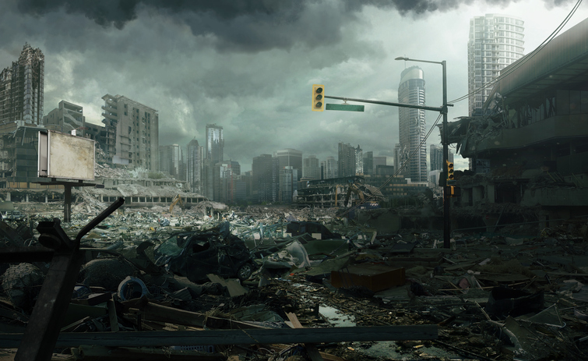

What was the dystopian vision of humanity's future? Dystopian literature can be seen in many science fiction novels of the 20th century as humanity moved into the technological age. Many feared the industrial revolution would erode man's highest ideals and man would be ruled by the machines he created. In reading and comparing works like George Orwell's 1984 and other modern novelists like Ray Bradbury's Fahrenheit 451 or Aldous Huxley's Brave New World, we are shown visions of a future where corporations run the world and survival depend on adhering to "Big Brother's" decrees on what is acceptable.

How do you relate our society to the dystopian author's view of what would come of the 21st century? Perhaps you are more familiar with the genre as it relates to popular 21st-century fiction. Margaret Atwood’s *The Handmaid’s Tale*, Suzanne Collins’ *Hunger Games Trilogy*, James Dash’s *Maze Runner*, Lois Lowry’s *The Giver*, and Veronica Roth’s *Divergent* series are all considered dystopian fiction. All of these novels were also translated into multiple languages and transformed by way of films, which also had a global audience that seemed to grow ever more fascinated with an imagined dystopian future.

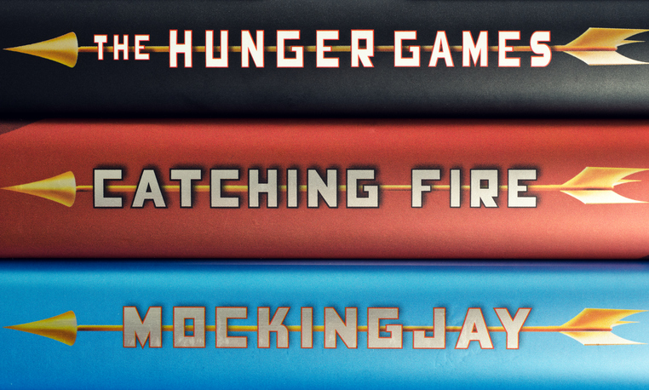

Modernist dystopian literature had its beginnings in the 19th century with an E.M. Forester short story, *The Machine Stops*, written in 1888 and published in 1909. This work is usually considered the first work of true dystopian literature. H.G. Wells, *The Time Machine*, written in 1895, is also considered one of the “pioneer dystopian” novels, along with *We*by Russian author, Yevgeny Zamyatin, published in 1921. All of these stories had this in common: They take place in a future ruled by a totalitarian government where individual freedom is a long-dead notion, and the state rules absolute over humanity. To stray from the path of the state is to court certain death in these societies.

Often, a dystopian future is imagined after a third World War, or another apocalyptic event has happened. The fictional protagonist is usually a strong believer in the totalitarian government, but through a series of events becomes disillusioned and rebels against the rules that such a society has deemed essential for survival in this post-apocalyptic world. Dystopian fiction is also often **didactic**fiction where the attitude and beliefs of the author are evident as the novel strives to teach a moral lesson, usually compassion or an overall warning for society as in Orwell’s *Animal Farm*and*1984*.

**George Orwell [1903–1950]**

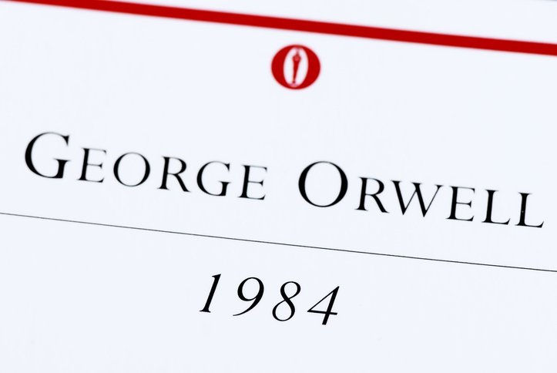

Other modernist authors like George Orwell (*Animal Farm*and*1984)* honed the craft of the dystopian novel and merged it with an even newer genre, that of science fiction. Due to the popularity and wide acceptance of dystopian literature as a genre, the term "Orwellian" has come into the English vocabulary as meaning a policy of controlling the general public by propaganda, surveillance, misinformation, denial of truth, and manipulation of the past (history).

In *1984*, Orwell described a totalitarian government that controlled all thought by controlling language. With this novel, the word “doublethink” was created. It means holding two contradictory belief systems at the same time. Other words that came from the novel are ‘’newspeak” meaning to use a vocabulary meant to confuse the public and “thought police” meaning a police state where all dissenting thought is suppressed by “Big Brother” who monitors every citizen at all times for infractions or subversive behavior. Government rights supersede the individual's right to privacy or the right to dissent. Any dissent is met by a death sentence in dystopian fiction.

**Utopia: The Perfect Nowhere**

While watching the video below, pay particular attention to how the utopian ideals filtered their way into modernism and the reasons the sub-genre of dystopian fiction came into popularity with modern authors and audiences.

**References**

Woodcock, G. (2018). George Orwell: British author. In *Encyclopedia Britannica.*Retrieved from https://academic-eb-com.ezproxy.rasmussen.edu/levels/collegiate/article/George-Orwell/57505