Type Your Name Here

Introduction to Psychology

November 22, 2019

**CASE STUDY ASSIGNMENT INSTRUCTIONS**

Gloria has recently graduated college and started a new job. Her coworkers seem very nice, and Gloria has gotten to know Lakeisha and Reggie the best.

Reggie is a friendly older man who often talks about his plans for retirement in five years. He likes to make people laugh but often jokes about his struggles to learn new programs and technology.

Gloria and Lakeisha have been assigned to work on a project together. Lakeisha is very organized and has prepared a list of to-do items along with due dates. She even color-coded the list to indicate which partner will do each item. Gloria, who is more laid-back, feels a bit uncomfortable with this micromanaging from Lakeisha, who has only been at the job a few months longer than she has. Gloria wonders if Lakeisha thinks she is either lazy or stupid, and she does not look forward to working on this project. In the past, Gloria attempted to communicate her feelings with a co-worker; however, her coworker told Gloria that she needed to put her feelings aside and just do the work assigned to her.  As Gloria ponders having a conversation with Lakeisha, she starts to feel overwhelmed and thinks she might have to ask to be removed from this project.

Still, she and Lakeisha have connected because they are both single mothers of teenagers. Gloria confides in Lakeisha about her 16-year-old son who has started making poor choices and is currently grounded for sneaking out of the house and getting drunk at a party the night before a big exam.

The company recently informed the team that there will be a compliance test on new safety policies, which employees will need to pass in order to keep their jobs. The company has provided materials to study as well as optional practice exams. Gloria and Lakeisha have signed up to take the first practice test. Reggie, however, jokes that he will probably wait until the night before the test to read the material. As the date of the test approaches, Reggie becomes increasingly nervous. He makes frequent comments about how hard it is for him to learn a different way of doing the jobs that he has been doing for years, joking that “you can’t teach an old man new tricks.”

1. **Gloria’s son is making poor decisions. Given what you have learned about a) brain development and b) social development in Chapter 3:**

**Explain why Gloria’s son is making those poor decisions.** Given what you have learned in Chapter 3 about brain development and social development, explain why Gloria’s son is making poor decisions. (Use page 3.4 for brain development and page 3.6 for social development).

**Discuss specific strategies Gloria can implement to help her son make better choices.** What specific strategies can Gloria use to help her son make better decisions? (Hint: pages 3.7 and 3.17 have resources to help)

**Use specific concepts related to development and self-regulation to explain why these strategies would be effective.** From what you have learned about human development and self-regulation, why do you think these strategies will be effective?

(Hint – based on what you offered as a suggestion in question 2, why would that strategy help Gloria’s son)

1. **Reggie is demonstrating a fixed mindset. How is Reggie’s mindset affecting the way he prepares for the new compliance test?** How does Reggie’s mindset affect the way that he prepares for the compliance test? (Hint: page 7.6 will help you learn about mindset)

**Use *brain plasticity* (neuroplasticity) to explain how Reggie can start to develop a growth mindset.** Use *brain plasticity* (neuroplasticity) to explain how Reggie can start to develop a growth mindset. What can Reggie do to actually change his brain so that he can adopt a growth mindset approach? (Hint: page 7.6 will be a great resource for this question)

**Suggest study strategies for Reggie so that he will be prepared for the compliance test. Use specific concepts from Chapter 4 to explain why these strategies will be effective.** Suggest at least three study strategies that Reggie can use to study for the compliance test. Based on what you have learned about memory in Chapter 4, explain why these would be effective study techniques.  (Hint: page 4.15 has suggestions to improve your memory)

1. **Consider Gloria and Lakeisha’s different approaches to the project. On which of the Big 5 personality traits do they most differ?** What are the big five personality traits? When thinking about the big five personality traits, on which ones do Gloria and Lakeisha differ the most? (Hint: page 3.12 helps you learn about the big five traits)

**Give advice to Gloria on how she can use emotional regulation and cognitive reappraisal to work with Lakeisha.** Give some advice to Gloria. How can she use emotional regulation to work more effectively with Lakeisha? Give at least two things that Gloria can do and provide a rationale for why these will be effective. (Hint: Pages 6.4 and 6.11 have resources to help with this question)

**Page 3.4**

ADOLESCENCE

How is adolescence defined, and how do physical changes affect developing teens?

Many psychologists once believed that childhood sets our traits. Today’s developmental psychologists see development as lifelong. As this life-span perspective emerged, psychologists began to look at how maturation and experience shape us not only in infancy and childhood, but also in adolescence and beyond. Adolescence—the years spent morphing from child to adult—starts with the physical beginnings of sexual maturity and ends with the social achievement of independent adult status. In some cultures, where teens are self-supporting, this means that adolescence hardly exists.

G. Stanley Hall (1904), one of the first psychologists to describe adolescence, believed that the tension between biological maturity and social dependence creates a period of “storm and stress.” Indeed, after age 30, many who grow up in independence-fostering Western cultures look back on their teenage years as a time they would not want to relive, a time when their peers’ social approval was imperative, their sense of direction in life was in flux, and their feeling of alienation from their parents was deepest (Arnett, 1999; Macfarlane, 1964).

But for many, adolescence is a time of vitality without the cares of adulthood, a time of rewarding friendships, heightened idealism, and a growing sense of life’s exciting possibilities.

PHYSICAL DEVELOPMENT

Adolescence begins with puberty, the time when we mature sexually. Puberty follows a surge of hormones, which may intensify moods and which trigger a series of bodily changes.

EARLY VERSUS LATE MATURING

Just as in the earlier life stages, the sequence of physical changes in puberty (for example, breast buds and visible pubic hair before menarche—the first menstrual period) is far more predictable than their timing. Some girls start their growth spurt at 9, some boys as late as age 16. Though such variations have little effect on height at maturity, they may have psychological consequences: It is not only when we mature that counts, but how people react to our physical development.

For boys, early maturation has mixed effects. Boys who are stronger and more athletic during their early teen years tend to be more popular, self-assured, and independent, though also more at risk for alcohol use, delinquency, and premature sexual activity (Conley & Rudolph, 2009; Copeland et al., 2010; Lynne et al., 2007). For girls, early maturation can be a challenge (Mendle et al., 2007). If a young girl’s body and hormone-fed feelings are out of sync with her emotional maturity and her friends’ physical development and experiences, she may begin associating with older adolescents or may suffer teasing or sexual harassment (Ge & Natsuaki, 2009). She may also be somewhat more vulnerable to an anxiety disorder (Weingarden & Renshaw, 2012).

THE TEENAGE BRAIN

An adolescent’s brain is also a work in progress. Until puberty, brain cells increase their connections, like trees growing more roots and branches. Then, during adolescence, comes a selective pruning of unused neurons and connections (Blakemore, 2008). What we don’t use, we lose.

As teens mature, their frontal lobes also continue to develop. The growth of myelin, the fatty tissue that forms around axons and speeds neurotransmission, enables better communication with other brain regions (Kuhn, 2006; Silveri et al., 2006). These developments bring improved judgment, impulse control, and long-term planning.

Maturation of the frontal lobes nevertheless lags behind that of the emotional limbic system. Puberty’s hormonal surge and limbic system development help explain teens’ occasional impulsiveness, risky behaviors, and emotional storms—slamming doors and turning up the music (Casey et al., 2008, 2013). No wonder younger teens (whose unfinished frontal lobes aren’t yet fully equipped for making long-term plans and curbing impulses) may succumb to the tobacco corporations, which most adult smokers could tell them they will later regret. Teens actually don’t underestimate the risks of smoking—or fast driving or unprotected sex. They just, when reasoning from their gut, weigh the immediate benefits more heavily (Reyna & Farley, 2006; Steinberg, 2007, 2010). Teens find rewards more exciting than adults do. So they seek thrills and rewards, without a fully developed brake pedal controlling their impulses (Figure 2).

FIGURE 2

Impulse Control Lags Reward Seeking

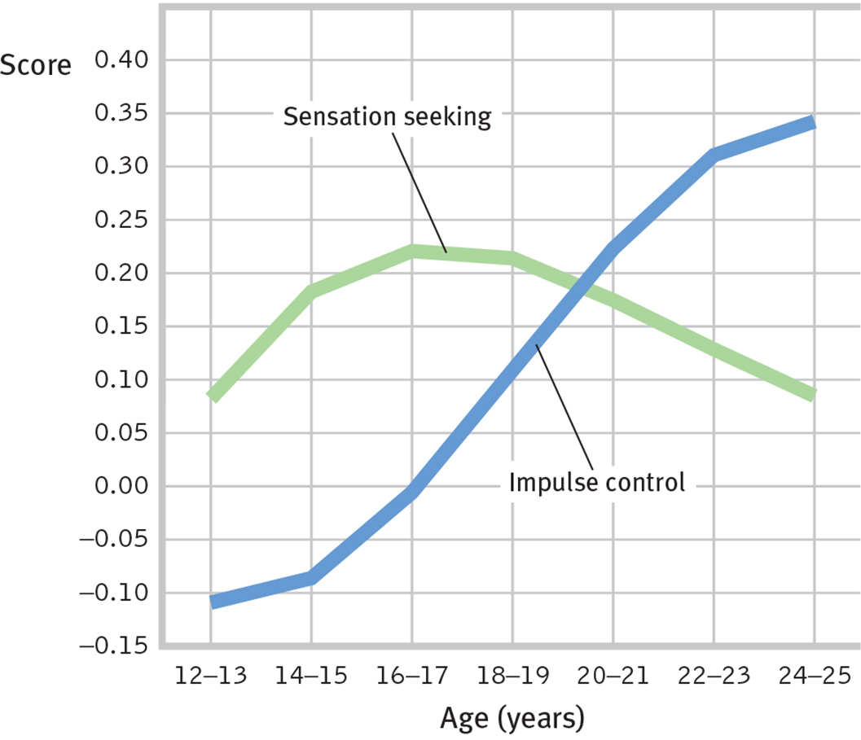

National surveys of more than 7000 American 12- to 24-year-olds reveal that sensation seeking peaks in the mid-teens, with impulse control developing more slowly as frontal lobes mature. (National Longitudinal Study of Youth and Children and Young Adults survey data presented by Steinberg, 2013.)

So, when Junior drives recklessly and struggles academically, should his parents reassure themselves that “he can’t help it; his frontal cortex isn’t yet fully grown”? They can take hope: Brain changes underlie teens’ new self-consciousness about what others are thinking and their valuing of risky rewards (Barkley-Levenson & Galván, 2014; Somerville et al., 2013). And the brain with which Junior begins his teens differs from the brain with which he will end his teens. Unless he slows his brain development with heavy drinking—leaving him prone to impulsivity and addiction—his frontal lobes will continue maturing until about age 25 (Crews et al., 2007; Giedd, 2015). They will also become better connected with the limbic system, enabling better emotion regulation (Steinberg, 2012).

In 2004, the American Psychological Association (APA) joined seven other medical and mental health associations in filing U.S. Supreme Court briefs arguing against the death penalty for 16- and 17-year-olds. The briefs documented the teen brain’s immaturity “in areas that bear upon adolescent decision making.” Brain scans of young teens reveal that frontal lobe immaturity is most evident among juvenile offenders and drug users (Shannon et al., 2011; Whelan et al., 2012). Thus, teens are “less guilty by reason of adolescence,” suggested psychologist Laurence Steinberg and law professor Elizabeth Scott (2003; Steinberg et al., 2009). In 2005, by a 5-to-4 margin, the Court concurred, declaring juvenile death penalties unconstitutional. In 2012, the APA offered similar arguments against sentencing juveniles to life without parole (Banville, 2012; Steinberg, 2013). Once again, the Court, by a narrow 5-to-4 vote, concurred.

THE POINT TO REMEMBER *Teens find rewards more exciting than adults do. So they seek thrills and rewards, without a fully developed brake pedal controlling their impulses.*

**Page 3.6**

SOCIAL DEVELOPMENT IN ADOLESCENCE

What are the social tasks and challenges of adolescence?

Theorist Erik Erikson (1963) contended that each stage of life has its own psychosocial task, a crisis that needs resolution. Young children wrestle with issues of trust, then autonomy (independence), then initiative. School-age children strive for competence, feeling able and productive. The adolescent’s task is to synthesize past, present, and future possibilities into a clearer sense of self (Table 3). Adolescents wonder, “Who am I as an individual? What do I want to do with my life? What values should I live by? What do I believe in?” Erikson called this quest the adolescent’s search for identity.

TABLE 3

Erikson’s Stages of Psychosocial Development

|  |  |  |
| --- | --- | --- |
| **Stage (Approximate Age)** | **Issue** | **Description of Task** |
| *Infancy* (to 1 year) | Trust vs. mistrust | If needs are dependably met, infants develop a sense of basic trust. |
| *Toddlerhood* (1 to 3 years) | Autonomy vs. shame and doubt | Toddlers learn to exercise their will and do things for themselves, or they doubt their abilities. |
| *Preschool* (3 to 6 years) | Initiative vs. guilt | Preschoolers learn to initiate tasks and carry out plans, or they feel guilty about their efforts to be independent. |
| *Elementary school* (6 years to puberty) | Competence vs. inferiority | Children learn the pleasure of applying themselves to tasks, or they feel inferior. |
| *Adolescence* (teen years into 20s) | Identity vs. role confusion | Teenagers work at refining a sense of self by testing roles and then integrating them to form a single identity, or they become confused about who they are. |
| *Young adulthood* (20s to early 40s) | Intimacy vs. isolation | Young adults struggle to form close relationships and to gain the capacity for intimate love, or they feel socially isolated. |
| *Middle adulthood* (40s to 60s) | Generativity vs. stagnation | In middle age, people discover a sense of contributing to the world, usually through family and work, or they may feel a lack of purpose. |
| *Late adulthood* (late 60s and up) | Integrity vs. despair | Reflecting on their lives, older adults may feel a sense of satisfaction or failure. |

**Page 3.7**

PARENT AND PEER RELATIONSHIPS

How do parents and peers influence adolescents?

As adolescents in Western cultures seek to form their own identities, they begin to pull away from their parents (Shanahan et al., 2007). The preschooler who can’t be close enough to her mother, who loves to touch and cling to her, becomes the 14-year-old who wouldn’t be caught dead holding hands with Mom. The transition occurs gradually, but this period is typically a time of diminishing parental influence and growing peer influence.

As Aristotle long ago recognized, we humans are “the social animal.” At all ages, but especially during childhood and adolescence, we seek to fit in with our groups (Harris, 1998, 2002). Teens who start smoking typically have friends who model smoking, suggest its pleasures, and offer cigarettes (J. S. Rose et al., 1999; R. J. Rose et al., 2003). Part of this peer similarity may result from a selection effect, as kids seek out peers with similar attitudes and interests. Those who smoke (or don’t) may select as friends those who also smoke (or don’t). Put two teens together and their brains become hypersensitive to reward (Albert et al., 2013). This increased activation helps explain why teens take more driving risks when with friends than they do alone (Chein et al., 2011).

By adolescence, parent-child arguments occur more often, usually over mundane things—household chores, bedtime, homework (Tesser et al., 1989). Conflict during the transition to adolescence tends to be greater with first-born than with second-born children, and greater with mothers than with fathers (Burk et al., 2009; Shanahan et al., 2007).

For a minority of parents and their adolescents, differences lead to real splits and great stress (Steinberg & Morris, 2001). But most disagreements are at the level of harmless bickering. With sons, the issues often are behavior problems, such as acting out or hygiene; for daughters, the issues commonly involve relationships, such as dating and friendships (Schlomer et al., 2011). Most adolescents—6000 of them in 10 countries, from Australia to Bangladesh to Turkey—have said they like their parents (Offer et al., 1988). “We usually get along but...,” adolescents often reported (Galambos, 1992; Steinberg, 1987).

Positive parent-teen relations and positive peer relations often go hand in hand. High school girls who had the most affectionate relationships with their mothers tended also to enjoy the most intimate friendships with girlfriends (Gold & Yanof, 1985). And teens who felt close to their parents have tended to be healthy and happy and to do well in school (Resnick et al., 1997). Of course, we can state this correlation the other way: Misbehaving teens are more likely to have tense relationships with parents and other adults.

Although heredity does much of the heavy lifting in forming individual temperament and personality differences, parents and peers influence teens’ behaviors and attitudes.

When with peers, teens discount the future and focus more on immediate rewards (O’Brien et al., 2011). Most teens are herd animals, talking, dressing, and acting more like their peers than their parents. What their friends are, they often become, and what “everybody’s doing,” they often do.

Part of what everybody’s doing is networking—a lot. Teens rapidly adopt social media. U.S. teens typically send 30 text messages daily and average 145 Facebook friends (Lenhart, 2015). They tweet, post videos to Snapchat, and share pictures on Instagram. Online communication stimulates intimate self-disclosure—both for better (support groups) and for worse (online predators and extremist groups) (Subrahmanyam & Greenfield, 2008; Valkenburg & Peter, 2009). Facebook, from a study of all its English-language users, reports this: Among parents and children, 371 days elapse, on average, before they include each other in their circle of self-disclosure (Burke et al., 2013).

For those who feel excluded by their peers, whether online or face-to-face, the pain is acute. “The social atmosphere in most high schools is poisonously clique-driven and exclusionary,” observed social psychologist Elliot Aronson (2001). Most excluded “students suffer in silence. . . . A small number act out in violent ways against their classmates.” Those who withdraw are vulnerable to loneliness, low self-esteem, and depression (Steinberg & Morris, 2001). Peer approval matters.

Parent approval may matter in other ways. Teens have seen their parents as influential in shaping their religious faith and in thinking about college and career choices (Emerging Trends, 1997). A Gallup Youth Survey revealed that most shared their parents’ political views (Lyons, 2005).

Howard Gardner (1998) has concluded that parents and peers are complementary:

*Parents are more important when it comes to education, discipline, responsibility, orderliness, charitableness, and ways of interacting with authority figures. Peers are more important for learning cooperation, for finding the road to popularity, for inventing styles of interaction among people of the same age. Youngsters may find their peers more interesting, but they will look to their parents when contemplating their own futures. Moreover, parents [often] choose the neighborhoods and schools that supply the peers.*

This power to select a child’s neighborhood and schools gives parents an ability to influence the culture that shapes the child’s peer group. And because neighborhood influences matter, parents may want to become involved in intervention programs that aim at a whole school or neighborhood. If the vapors of a toxic climate are seeping into a child’s life, that climate—not just the child—needs reforming.

THE POINT TO REMEMBER *Adolescence is typically a time of diminishing parental influence and growing peer influence.*

**Page 3.12**

THE BIG FIVE FACTORS

Which traits seem to provide the most useful information about personality variation?

Today’s trait researchers believe that simple trait factors, such as the Eysencks’ introversion–extraversion and stability–instability dimensions, are important, but they do not tell the whole story. A slightly expanded set of factors—dubbed the Big Five—does a better job (Costa & McCrae, 2011). If a test specifies where you are on the five dimensions (conscientiousness, agreeableness, neuroticism, openness, and extraversion; see Table 4), it has said much of what there is to say about your personality. Around the world—across 56 nations and 29 languages in one study (Schmitt et al., 2007)—people describe others in terms roughly consistent with this list. The Big Five may not be the last word. Some researchers report that basic personality dimensions can be described by only one or two or three factors (such as conscientiousness, agreeableness, and extraversion) (Block, 2010; De Raad et al., 2010). But for now, at least, five is the winning number in the personality lottery (Heine & Buchtel, 2009; McCrae, 2009).

TABLE 4

The “Big Five” Personality Factors

|  |  |  |
| --- | --- | --- |
| **(*Memory tip*: Picturing a CANOE will help you recall these.)** | | |
| Disorganized | ←*C*onscientiousness→ | Organized |
| Careless | Careful |
| Impulsive | Disciplined |
| Ruthless | ←*A*greeableness→ | Soft-hearted |
| Suspicious | Trusting |
| Uncooperative | Helpful |
| Calm | ←*N*euroticism (emotional stability vs. instability)→ | Anxious |
| Secure | Insecure |
| Self-satisfied | Self-pitying |
| Practical | ←*O*penness→ | Imaginative |
| Prefers routine | Prefers variety |
| Conforming | Independent |
| Retiring | ←*E*xtraversion→ | Sociable |
| Sober | Fun-loving |
| Reserved | Affectionate |

*Source: Adapted from McCrae & Costa (1986, p. 1002).*

The Big Five is currently our best approximation of the basic trait dimensions. This “common currency for personality psychology” (Funder, 2001) has been the most active personality research topic since the early 1990s, as researchers have explored these questions and more:

* *How stable are the Big Five traits?* One research team analyzed 1.25 million participants ages 10 to 65. They learned that personality continues to develop and change through late childhood and adolescence. Up to age 40, we show signs of a *maturity principle*: We become more conscientious and agreeable and less neurotic (emotionally unstable) (Bleidorn, 2015; Roberts et al., 2008). Great apes show similar personality maturation (Weiss & King, 2015). After age 40, our traits stabilize.
* *How heritable are these traits?* Heritability (the extent to which individual differences are attributable to genes) generally runs about 40 percent for each dimension (Vukasović & Bratko, 2015). Many genes, each having small effects, combine to influence our traits (McCrae et al., 2010).
* *How do these traits reflect differing brain structure?* The size of different brain regions correlates with several Big Five traits (DeYoung et al., 2010; Grodin & White, 2015). For example, those who score high on conscientiousness tend to have a larger frontal lobe area that aids in planning and controlling behavior. Brain connections also influence the Big Five traits (Adelstein et al., 2011). People high in openness have brains that are wired to experience intense imagination, curiosity, and fantasy.
* *Have levels of these traits changed over time?* Cultures change over time, which can influence shifts in personality. Within the United States and the Netherlands, extraversion and conscientiousness have increased (Mroczek & Spiro, 2003; Smits et al., 2011; Twenge, 2001).
* *How well do these traits apply to various cultures?* The Big Five dimensions describe personality in various cultures reasonably well (Schmitt et al., 2007; Vazsonyi et al., 2015; Yamagata et al., 2006). “Features of personality traits are common to all human groups,” concluded Robert McCrae and 79 co-researchers (2005) from their 50-culture study.
* *Do the Big Five traits predict our actual behaviors?* Yes. If people report being outgoing, conscientious, and agreeable, “they probably are telling the truth,” reports McCrae (2011). For example, our traits appear in our language patterns. In text messaging, extraversion predicts use of personal pronouns. Agreeableness predicts positive-emotion words. Neuroticism (emotional instability) predicts negative-emotion words (Holtgraves, 2011). (In the next section, we will see that situations matter, too.)

By exploring such questions, Big Five research has sustained trait psychology and renewed appreciation for the importance of personality. Traits matter.

**Page 3.17**

HOW CAN WE HELP TEENS MAKE GOOD DECISIONS?

The following video clip, taken from a longer TED Talk, offer insight into the biology of the teenage brain. Thanks to powerful brain imaging technology that developed in the last two decades, neuroscientists can now see the brain as it develops throughout adolescence and can compare teen brain activity to adult brain activity. The speaker, Dr. Sarah-Jayne Blakemore, will use terms you learned in Chapters 2 and 3 as she discusses specific areas of the brain that are still developing well into adolescence.

<https://youtu.be/6zVS8HIPUng>

**Page 4.15**

IMPROVING MEMORY

How can you use memory research findings to do better in this and other courses?

Biology’s findings benefit medicine. Botany’s findings benefit agriculture. So, too, can psychology’s research on memory benefit education. Here, for easy reference, is a summary of some research-based suggestions that could help you remember information when you need it. The SQ3R—Survey, Question, Read, Retrieve, Review—study technique used in this webtext incorporates several of these strategies:

Rehearse repeatedly. To master material, use distributed (spaced) practice. To learn a concept, give yourself many separate study sessions. Take advantage of life’s little intervals—riding a bus, walking across campus, waiting for class to start. New memories are weak; exercise them and they will strengthen. To memorize specific facts or figures, Thomas Landauer (2001) has advised, “Rehearse the name or number you are trying to memorize, wait a few seconds, rehearse again, wait a little longer, rehearse again, then wait longer still and rehearse yet again. The waits should be as long as possible without losing the information.” Reading complex material with minimal rehearsal yields little retention. Rehearsal and critical reflection help more. It pays to study actively.

Make the material meaningful. You can build a network of retrieval cues by taking text and class notes in your own words. Apply the concepts to your own life. Form images. Understand and organize information. Relate the material to what you already know or have experienced. As William James (1890) suggested, “Knit each new thing on to some acquisition already there.” Restate concepts in your own words. Mindlessly repeating someone else’s words won’t supply many retrieval cues. On an exam, you may find yourself stuck when a question uses phrasing different from the words you memorized.

Activate retrieval cues. Mentally re-create the situation and the mood in which your original learning occurred. Jog your memory by allowing one thought to cue the next.

Use mnemonic devices. Associate items with peg words. Make up a story that incorporates vivid images of the items. Chunk information into acronyms. Create rhythmic rhymes (“i before e, except after c”).

Minimize interference**.** Study before sleep. Do not schedule back-to-back study times for topics that are likely to interfere with each other, such as Spanish and French.

Sleep more. During sleep, the brain reorganizes and consolidates information for long-term memory. Sleep deprivation disrupts this process.

Test your own knowledge, both to rehearse it and to find out what you don’t yet know. Don’t be lulled into overconfidence by your ability to recognize information. Test your recall using the multiple-choice questions found on each page. Outline sections on a blank page. Define the terms and concepts found in the material before looking up their definitions. Take practice tests; the websites and study guides that accompany many texts are a good source for such tests.

**Page 6.4**

TWO PATHWAYS FOR EMOTIONS

ZAJONC, LEDOUX, AND LAZARUS: DOES COGNITION ALWAYS PRECEDE EMOTION?

But is the heart always subject to the mind? Must we always interpret our arousal before we can experience an emotion? Robert Zajonc (1923–2008) [ZI-yence] didn’t think so. Zajonc (1980, 1984) contended that we actually have many emotional reactions apart from, or even before, our conscious interpretation of a situation. Perhaps you can recall liking something or someone immediately, without knowing why.

For example, when people repeatedly view stimuli flashed too briefly for them to interpret, they come to prefer those stimuli. Unaware of having previously seen them, they nevertheless like them. We have an acutely sensitive automatic radar for emotionally significant information; even a subliminally flashed stimulus can prime us to feel better or worse about a follow-up stimulus (Murphy et al., 1995; Zeelenberg et al., 2006).

Neuroscientists are charting the neural pathways of emotions (Ochsner et al., 2009). Our emotional responses can follow two different brain pathways. Some emotions (especially more complex feelings like hatred and love) travel a “high road.” A stimulus following this path would travel (by way of the thalamus) to the brain’s cortex (Figure 1a below). There, it would be analyzed and labeled before the response command is sent out, via the amygdala (an emotion-control center).

But sometimes our emotions (especially simple likes, dislikes, and fears) take what Joseph LeDoux (2002) has called the “low road,” a neural shortcut that bypasses the cortex. Following the low road, a fear-provoking stimulus would travel from the eye or ear (again via the thalamus) directly to the amygdala (Figure 1b). This shortcut enables our greased-lightning emotional response before our intellect intervenes. Like speedy reflexes (that also operate apart from the brain’s thinking cortex), the amygdala reactions are so fast that we may be unaware of what’s transpired (Dimberg et al., 2000).

FIGURE 1

The Brain’s Pathways for Emotions

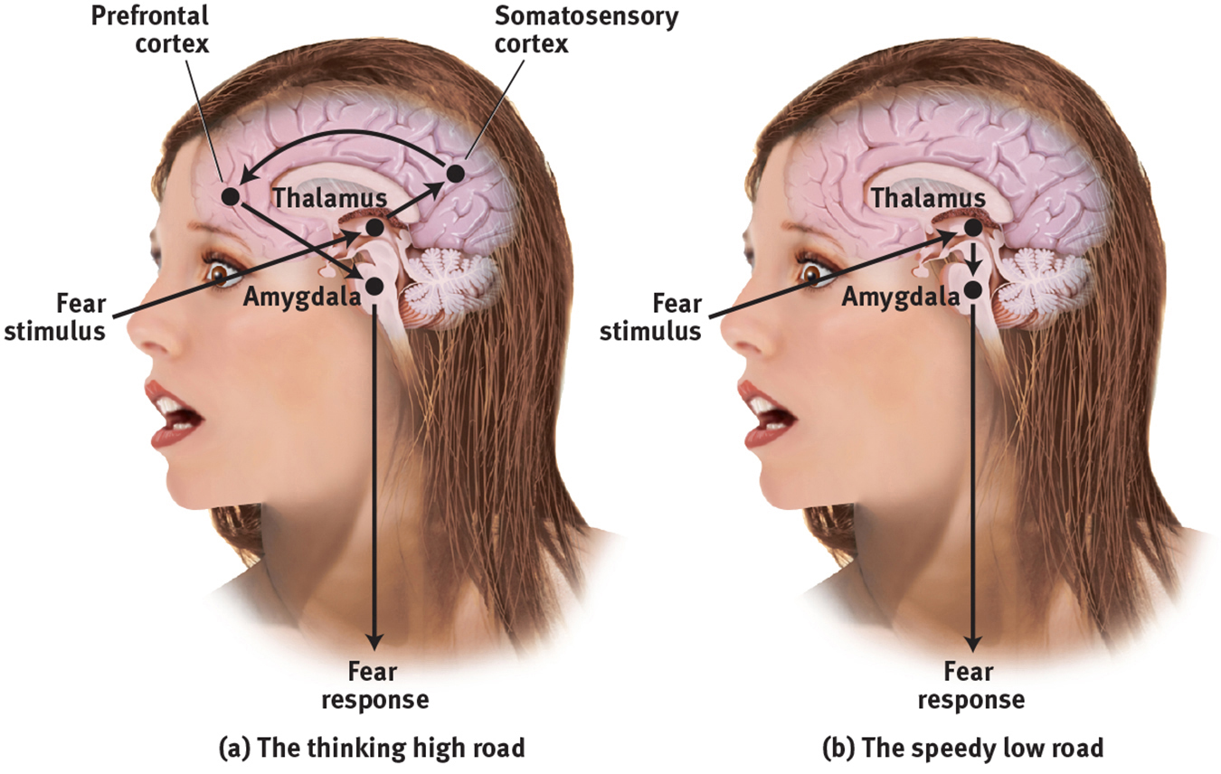

In the two-track brain, sensory input may be routed (a) to the cortex (via the thalamus) for analysis and then transmission to the amygdala, or (b) directly to the amygdala (via the thalamus) for an instant emotional reaction.

The amygdala sends more neural projections up to the cortex than it receives back, which makes it easier for our feelings to hijack our thinking than for our thinking to rule our feelings (LeDoux & Armony, 1999). Thus, in the forest, we can jump at the sound of rustling bushes nearby, leaving it to our cortex to decide later whether the sound was made by a snake or by the wind. Such experiences support Zajonc’s belief that some of our emotional reactions involve no deliberate thinking.

Emotion researcher Richard Lazarus (1991, 1998) conceded that our brain processes vast amounts of information without our conscious awareness, and that some emotional responses do not require conscious thinking. Much of our emotional life operates via the automatic, speedy low road. But, he asked, how would we know what we are reacting to if we did not in some way appraise the situation? The appraisal may be effortless and we may not be conscious of it, but it is still a mental function. To know whether a stimulus is good or bad, the brain must have some idea of what it is (Storbeck et al., 2006). Thus, said Lazarus, emotions arise when we appraise an event as harmless or dangerous, whether we truly know it is or not. We appraise the sound of the rustling bushes as the presence of a threat. Later, we realize that it was “just the wind.”

FIGURE 2

Two Pathways for Emotions

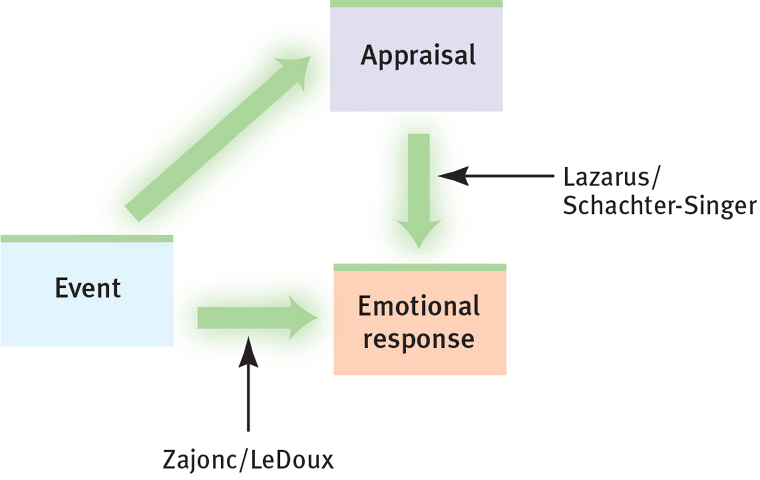

Zajonc and LeDoux emphasized that some emotional responses are immediate, before any conscious appraisal. Lazarus, Schachter, and Singer emphasized that our appraisal and labeling of events also determine our emotional responses.

So, as Zajonc and LeDoux have demonstrated, some emotional responses—especially simple likes, dislikes, and fears—involve no conscious thinking (Figure 2). When I [ND] view a big spider trapped behind glass, I experience fear even though I “know” the spider can’t hurt me. Such responses are difficult to alter by changing our thinking. Within a fraction of a second, we may automatically perceive one person as more likeable or trustworthy than another (Willis & Todorov, 2006). This instant appeal can even influence our political decisions if we vote (as many people do) for a candidate we like over the candidate who expresses positions closer to our own (Westen, 2007).

But our feelings about politics are also subject to our conscious and unconscious information processing—to our memories, expectations, and interpretations. When we feel emotionally overwhelmed, we can change our interpretations (Gross, 2013). Such reappraisal often reduces distress and the corresponding amygdala response (Buhle et al., 2014; Denny et al., 2015). Highly emotional people are intense partly because of their interpretations. They may personalize events as being somehow directed at them, and they may generalize their experiences by blowing single incidents out of proportion (Larsen & Diener, 1987). Thus, learning to think more positively can help people feel better. Although the emotional low road functions automatically, the thinking high road allows us to retake some control over our emotional life. Together, automatic emotion and conscious thinking weave the fabric of our emotional lives. (Table 1 summarizes these emotion theories.)

TABLE 1

Summary of Emotion Theories

|  |  |  |
| --- | --- | --- |
| **Theory** | **Explanation of Emotions** | **Example** |
| *James-Lange* | Emotions arise from our awareness of our specific bodily responses to emotion-arousing stimuli. | We observe our heart racing after a threat and then feel afraid. |
| *Cannon-Bard* | Emotion-arousing stimuli trigger our bodily responses and simultaneous subjective experience. | Our heart races at the same time that we feel afraid. |
| *Schachter-Singer* | Our experience of emotion depends on two factors: general arousal and a conscious cognitive label. | We may interpret our arousal as fear or excitement, depending on the context. |
| *Zajonc; LeDoux* | Some embodied responses happen instantly, without conscious appraisal. | We automatically feel startled by a sound in the forest before labeling it as a threat. |
| *Lazarus* | Cognitive appraisal (“Is it dangerous or not?”)—sometimes without our awareness—defines emotion. | The sound is “just the wind.” |

THE POINT TO REMEMBER *Although the emotional low road functions automatically, the thinking high road allows us to retake some control over our emotional life.*

**Page 6.11**

A VICIOUS CYCLE

Emotions have a strong and often lasting effect on our thoughts, beliefs, and behaviors. Our ability to manage our emotions is often referred to as emotional regulation. It is a complex process that we develop throughout life as we learn how to identify the emotions we are experiencing, understand the physiological reactions related to those emotions, and develop skills to manage the behavioral expression of the emotions. Good emotional regulation strategies are linked to increased happiness and improved mental health, and are also important in the decision-making process.

Emotions, thoughts, and behaviors are all linked together and affect each other, as illustrated in the figure below. This cycle of interpreting a situation, identifying the emotion, and deciding how to act can be hijacked if a person is experiencing depression or anxiety because his or her negative or fearful thoughts will already be in place and searching for confirmation.

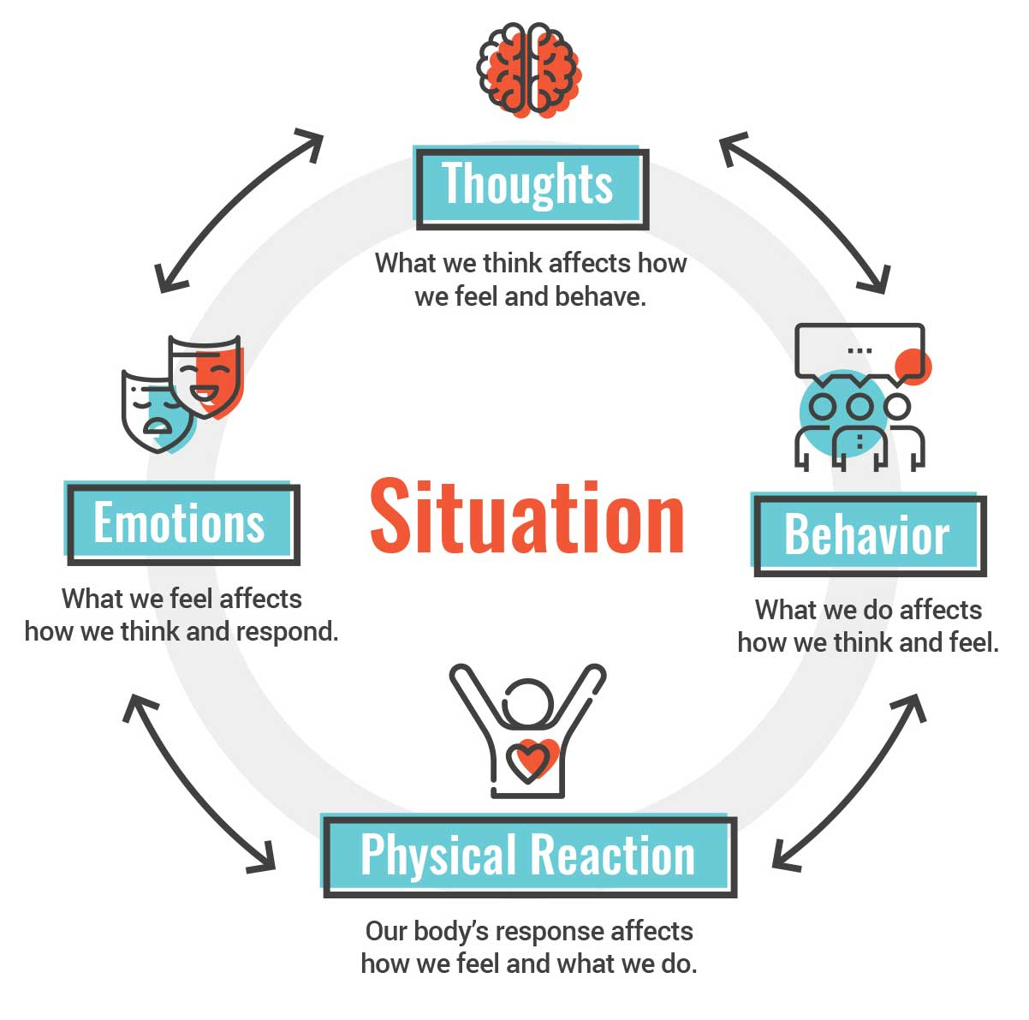

Consider how this emotion-thought-behavior cycle might play out for a person (we’ll call her Cassandra) who receives some negative feedback from a manager at work. Even though she doesn’t suffer from depression or anxiety, Cassandra may still think, “I’m so embarrassed and stupid. I’m going to get fired.” She experiences unpleasant physical reactions such as increased heart rate and difficulty sleeping, which is interpreted as fear the next morning, and she decides to stay home to avoid feeling this way around her manager. Instead of relieving her discomfort, this behavior reinforces her feelings of worthlessness and anxiety over the possibility of getting fired. In this situation, the strategy Cassandra used to regulate her emotions (missing work) is not effective. And the vicious cycle is likely to continue.

TIPS FOR REGULATING EMOTIONS

This vicious cycle can, if left unchecked, develop into a pattern of thought and behavior. Unless Cassandra does something differently, or changes the way she thinks about the situation, each time that she avoids embarrassment and anxiety around her manager by missing work, the initial thought of failure is also reinforced. Regulating emotions involves regulating the other components in the cycle as well:

* Regulating thoughts. When you first notice yourself becoming upset, try to identify the emotion and the thoughts that are driving that emotion. Some questions that may help include:
  + How would someone else interpret this? Am I seeing this clearly or do I need to reappraise my thoughts?
  + If I am feeling fearful, what is it that I’m really afraid of? What is the likelihood that what I’m afraid of will actually happen?
  + Instead of thinking of the worst that could happen, what is the best that could happen in this situation?
* Regulating behaviors. When we are in a vicious cycle of emotional dysregulation, we often react instead of carefully responding, or may forget to take notice of any positive behaviors or achievements. Here are some habits that may help:
  + Stop and think before you act. Ask yourself if your emotional interpretation of the situation is either correct or reasonable and if your response is appropriate to the situation. You may find that you need to choose a different behavioral response than the one you initially wanted to react with. Notice that sometimes regulating your behavior requires regulating your thoughts first.
  + Congratulate yourself for small accomplishments in a positive direction. Did you go to work when you wanted to stay home? Own that and praise yourself. Did you implement one of the strategies that your manager suggested during your review? Recognize yourself as an awesome employee who wants to work hard!
* Regulating the body. We all know it is true—and easier said than done—that a healthy body is important for healthy emotional regulation. The vicious cycle of emotional dysregulation can create physiological symptoms that make decision-making difficult. It can also interfere with sleep or make us feel too tired to exercise, or even make us crave unhealthy foods. Here are some tips that may help:
  + Calm the body before making a decision or responding to a situation. If the body is in a heightened state, it is more likely to rely on the emotional areas of the brain to interpret the situation instead of the rational areas. Taking some deep breaths or a brief walk to “shake it off” will help you regulate your body so that you can better regulate your thoughts and behaviors.
  + You don’t have to go on a strict diet, but instead can pick one meal a day to enjoy fresh and healthy foods. Notice the way your body feels afterward and recognize that good feeling as a reward. Notice, also, how the body responds when you consume a lot of sugar, caffeine, or alcohol.
  + Move, everyday, in a way that you find enjoyable. A brief walk outside can do wonders for your body, your thoughts, and your emotions. A few jumping jacks can snap you out of a bad mood. Don’t push yourself too hard if you’re not used to exercising; just enjoy the movement and notice how your body and your feelings are uplifted.

**Page 7.6**

The concept of mindset focuses on how people’s beliefs about the basic workings of human ability affect their perseverance. According to Dweck’s website, “In a fixed mindset, people believe their basic qualities, like their intelligence or talent, are simply fixed traits” (n.d.). Students with a fixed mindset believe that you’re either smart or you’re not, and they tend to be more easily discouraged when they encounter a difficult task. Those with a growth mindset, on the other hand, tend to persevere through difficult tasks because they understand that accomplishment takes effort and that most people who have achieved high levels of success were able to do so only through hard work and practice.

Our belief about whether intelligence and ability are fixed also influences our expectations and interactions with other people. Teachers and managers with a fixed mindset are less helpful and provide more negative feedback to struggling students or employees (Dweck, 2008). They view failure or struggle as an indication of low intelligence. Teachers and managers with a growth mindset, on the other hand, look at failure and struggle as a challenge and an opportunity to improve. They set high expectations and goals and recognize that their own role isn’t simply to judge but to help their students or employees reach those goals. Because they believe that any of their students or employees can become more productive or more creative, teachers and managers with a growth mindset take the time to provide good feedback to guide them. Dweck also recognizes that companies can have mindsets that affect the culture and growth of the company: Companies with a growth mindset are more likely to value their employees as individuals and to encourage employees to discuss new ideas and opportunities.

MINDSET AND FEEDBACK

Our mindset, like our self-efficacy, is influenced by the feedback we receive from others. When children hear phrases like “Great job on your test! You’re so smart!” or “She’s a natural athlete,” they may internalize the message that ability or intelligence is fixed. Not only do people hearing this type of praise develop a fixed mindset, they also miss out on feedback about specific skills that lead to success—like the hours someone spends deliberately studying, or the days spent determinedly practicing batting drills. If we have a fixed mindset, we will have less motivation, especially on challenging tasks, because we will interpret failure as proof that our ability is low and always will be.

Specific feedback, however, teaches children that their ability is continually improving. Difficulty on a challenging task is not evidence of low intelligence but a chance to learn something new. A game loss is not the result of inherently low ability but serves as motivation to improve specific skills.

MINDSET AND NEUROPLASTICITY

Thirty years ago, it was assumed that the brain was essentially finished developing by adulthood. However, neuroscience has proven that the brain is constantly rewiring itself and growing connections in response to our experiences. We call this ability neuroplasticity, or brain plasticity. Scientists originally developed the term to explain how the brain can create new brain cells (neurogenesis) and reorganize some functions, even after brain damage. Today, Dweck uses the concept of neuroplasticity to explain growth mindset.

Every time we learn something new, our brain creates new connections between neurons; these connections are known as synapses. When we practice, rehearsing knowledge and skills over time, these connections are strengthened through the formation of myelin, a fatty substance that surrounds the axons of the neurons fired during practice. This myelin results in faster communication between neurons, meaning that the next time we recall or perform a skill, we will be able to do so faster or more accurately. When we learn and practice, we physically change our brain.

Dweck has studied what happens when children are taught to think about the brain like a muscle. After all, just like a muscle becomes stronger with exercise and effort, the brain grows through challenge and practice. She found that when children learn that practice grows and strengthens the brain, their mindset begins to change and their performance in school improves. This improvement is most dramatic in students who had a fixed mindset and had previously struggled in school.

References

Myers, D. (2017). Psychology (4th ed.). Asheville, NC: Soomo Learning. Available from hMp://www.webtexts.com