DERIVATIVES

Name

Institution

Date

Statement of objectives

The objective of derivative trading and investment is to generate profits and hedge against the risks in the market. The plan is to increase the portfolio by 50% in the next three months. This entails trading in options, entering into futures contracts, swaps and credit derivatives. This will not only allow me access to cheaper credit but will enable me to leverage the portfolio and generate increased returns. The primary underlying assets in my portfolio will be stocks. Other assets include indices, currencies, commodities, and currencies. Therefore, there is need to predict and estimate the future prices of this financial instruments. I will avoid investing blindly. Instead, I will use ratio analysis to understand the leverage, profitability, turnover, and liquidity of a company as part of my fundamental analysis. This will assist in determining how a stock will perform in the coming quarter and financial period. Besides, I will analyze the financial statements and the historical charts performance to predict the future trends based on those in the past. Technical analysis will assist me in day trading and speculation of options. I will also join a group of investors with a similar interest in a forum where we can share ideas. There will be financial constraints due to the small size of my portfolio. The proposed trading strategies include going long or short on futures, bull or bear spread, covered put and call, straddle, strangle and butterfly spread. This paper looks at a derivatives simulation.

The portfolio will consist of derivatives and other investments. Stocks will account for more than half of the entire value. Options will take a proportion of 30% whereas future contracts will amount to 10%. The remainder is allocated to cash and other derivatives. The steps I will take in trading is to make sure that I fully understand the underlying assets. This will entail a lot of research and buying of data from some of the stock market data vendors. The analyst reports will provide an excellent secondary information that can play a vital role in decision making. Besides, the efficiency theory assumes that the market players have all the information behavior and patterns. I will research and make sure I have real-time information of the market and other financial instruments in my portfolio and the underlying assets. I will use methods such as the option pricing models to establish the value of a derivative. This will assist in determining whether I should put my premium on a call or put option. Besides, I will be keen on the interest rates and foreign exchange rates that will be helpful especially where currencies are the underlying assets. I will also ensure I fully understand the behavior and relationship between the strike price, exercise price, and their expiration. Besides, knowledge of how the call and put options will behave and their effect is crucial in deciding the type of hedging and risk measure to take.

Step 3

I will analyze a stock and try to predict how it will trade afterward. I will buy put options when I think the prices will fall or plummet when the market is optimistic. However, I would choose to pay premiums for the call options. I will also go long on futures when I expect the prices to rise soon. This may be after a company has reported good profits or the market is in a bull run. However, I will go short on the futures when the market is in a bear run, a company has announced losses, a fall in profits or there is a change in policy that has financial implications on a firm. In case things don’t work out, I will resort to bull and bear spread. The bull spread strategy will entail purchasing options with a lower strike price and sell those with a higher price. This will be done when the prices are rising. When the prices are in a bear, I will resort to a bear spread. This comprises of buying the options with a higher strike price and selling ones with a lower strike price. Besides, in times when I am uncertain of the way, the underlying assets will perform I will resort to taking up the straddle strategy. This entails holding call and put options that have a similar expiration date and strike price and that are purchased at the same premium. Besides, I could also resolve the use of strangling strategy that involves holding both call and put options that have the same maturity and expiration date but different strike prices. In the time when I think the market is very volatile, I will resort to using the butterfly spread strategy. I will also cover both my call and put options. A covered call involves going long in an asset and selling a call option on the underlying asset to increase returns.

The cost of carrying model will assist in understanding the relationship between the spot and forward price and the cost of carrying. The costs to be taken into perspective includes the financial costs, interest expenses on loan, bonds and margin accounts. All these have to be taken into account when deciding whether to purchase a future contract or not. The option pricing models are essential in determining the valuation of the financial instrument. The Black Scholes pricing model assumes that the markets are efficient, there are no premiums in the purchase of options, the volatility, and the risk-free rate is constant, and there are no dividend payments (Franke, Härdle & Hafner 2008). The variables taken into consideration include the underlying price, options strike price, time to expiration, the risk-free rate, and the implied volatility. The dynamic hedging involves a look into various terms and issues that will affect the returns generated by a derivative. The difference between the market price and the strike price may not be the only things that are looked at when the gains are computed. There is need to look at the effect of Vega that entails the changes in volatility in the market. Gamma that has to be looked into in cases where the stock rallies or plummets in a specific direction. The Delta looks at how price changes whether lower or higher affects the pricing of an option (Leung & Sircar, 2015).

**Cost of carry model for futures**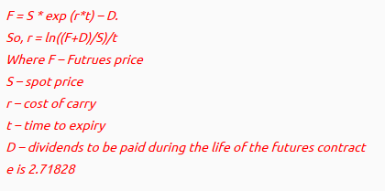

We invested in a future that had a spot rate of 1100 at a rate of 8%. The fair value of the 90 days future is estimated at

S= $20 r= 8% t= 1 months

F= 1100*2.71828*8*(1/12) = 1993.41

We invested in this future because it had a higher valuation than the spot rate.

**Black Scholes model**

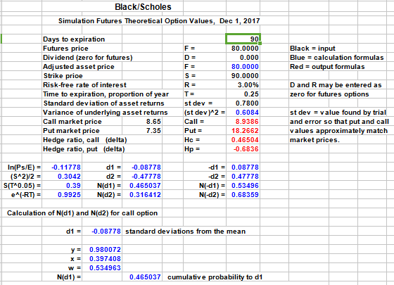

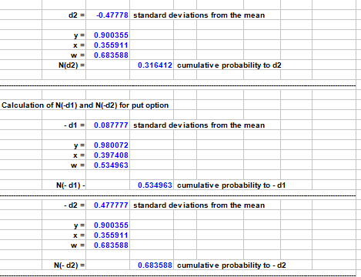

We bought the future as its price of $80 was lower than the value $90 we obtained from the black Scholes model.

**Implied Volatility**

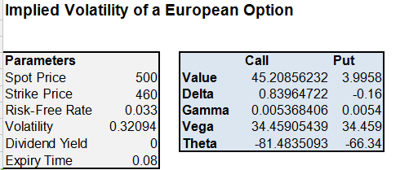

It is evident that the delta, gamma, Vega, and theta have resulted in the value of the call option being 45.20 while that of a put option is 4.00 (Implied Volatility in Excel, 2012).

The strategic timing, I used to be the stock closure date. I was sure that the share would be trading at a very lower price immediately it goes ex-div hence I will buy the call options. Besides, I would buy the put option when the share was nearing its book closure. At this time those practicing dividend investing would be looking to take a position in the stock. The result would be an increase in demand and the market price per share. I would buy a call option at such times. Besides, when taking positions in future contracts, I would time the announcements of the exchange rates by the Federal Reserve as this will have a direct impact on a majority of the foreign exchange. I would also time a week after a financial year of a profitable company as they are bound to release their financial statements that will result in an upside trend in the market share price. The introduction or abolishment of capital gains is likely to affect the share prices. I will buy 50% of the derivatives in the first trade and the remaining half in the following deal. This will give me time to change my decision in case of a change in the market factors.

I overtraded probably out of a frenzy. I failed to control my emotions in the market and ended up buying naked put and call options. I paid no attention to the fundamentals and was unable to follow my trading strategy. As a result, my portfolio lost more than 10% of its value. I also failed to stick to the allocation of various assets in my portfolio. Consequently, I leveraged the portfolio up to 20%. This resulted in increased financial costs that made me exercise some options and futures before their expiry date. However, I learned, and my strategies enabled me to manage the risk and earn good returns. As a result, I was able to increase the value of my portfolio by 5%. It was great watching most of the derivatives in the green. The covered call and covered put generated superior performance as it shielded the portfolio from the market volatilities. The use of Black Scholes model and other pricing model assisted me in finding the real value of the options. I was able to purchase such derivatives hence making a good return.

Conclusion

The simulation was an eye-opener. Having traded in stocks and bonds, I learned that the derivatives encompass a different spectre of knowledge. There was a need to come up with the right trading strategy that would not only yield excellent returns but also shield the portfolio from the price fluctuations in the market. One of my findings was that the gamma, Theta, Vega, and Delta influenced the returns made on the options. Besides, I discovered that various models could be used to estimate the price of an option. The taking up of the credit derivative and other loans was a poor decision as it forced me into exercising the derivatives before their maturity to pay up and service the loans. Furthermore, a more considerable portion of the returns was eaten up by the financial costs. I look forward to learning and participating in such simulations in the future.

References

Calculate Implied Volatility in Excel. (2012). Retrieved from <http://investexcel.net/implied-volatility-excel/>

Franke, J., Härdle, W. K., & Hafner, C. M. (2008). Black-Scholes Option Pricing Model. *Statistics of Financial Markets: An Introduction*, 73-115.

Leung, T., & Sircar, R. (2015). Implied volatility of leveraged ETF options. *Applied Mathematical Finance*, *22*(2), 162-188.