**Journal**

The Importance of Remaining Self-Aware in Groups

Next week you will learn about group facilitation, so it is important to reflect on self-awareness broadly, and specifically in group settings.

Reflect on your level of self-awareness and on the character and nature of your self-awareness.

How has your self-awareness informed and influenced what you have learned in this course so far?

What can you do to improve in this area?

Share your reflections and ideas in a journal entry consisting of 400-600 words.

**Resources**

**Required References**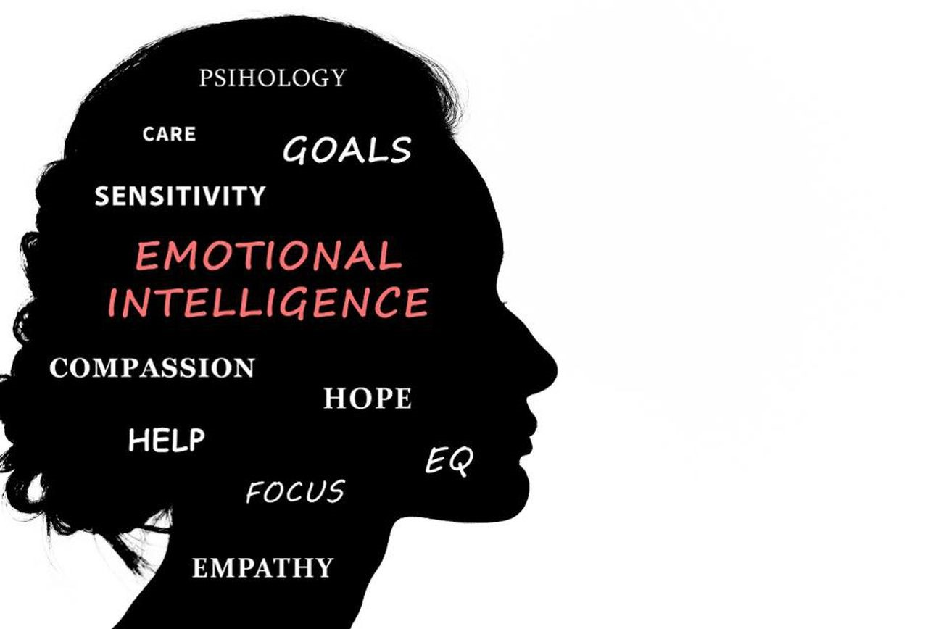

Chapman, A. (2014). Emotional intelligence [Web page]. Retrieved from https://www.businessballs.com/building-relationships/emotional-intelligence-eq-1991/

(Links to an external site.)

Queendom. (n.d.). Emotional intelligence text [Web page]. Retrieved from http://www.queendom.com/tests/access_page/index.htm?idRegTest=3037

(Links to an external site.)

EQI.com. (n.d.). Definition of emotional intelligence [Web page]. Retrieved from http://eqi.org/eidefs.htm#Innate

(Links to an external site.)

Goleman, D. (n,d.). Emotional intelligence [Web page]. Retrieved on January 10, 2016, from http://www.danielgoleman.info/topics/emotional-intelligence/

(Links to an external site.)

Kahn Academy. (2014, February 15). Self-concept, self-identity, and social identity: Individuals and society [Video file]. Retrieved from https://www.youtube.com/watch?v=PaA0mLVQd3k

Institute for Health and Human Potential (IHHP). (n.d.). Test your emotional intelligence [Web page]. Retrieved from http://www.ihhp.com/free-eq-quiz/

(Links to an external site.)

Weis, W. L., Hanson, L., & Arnesen, D. W. (2009). The use of training groups in raising self and social awareness and enhancing emotional intelligence. Journal of Organizational Culture, Communications and Conflict 13(2), 83-103.

Recommended References

Masland, L. C., & Lease, A. M. (2013). Effects of achievement motivation, social identity, and peer group norms on academic conformity. Social Psychology of Education: An International Journal, 16(4), 661-681. <http://dx.doi.org/10.1007/s11218-013-9236-4>

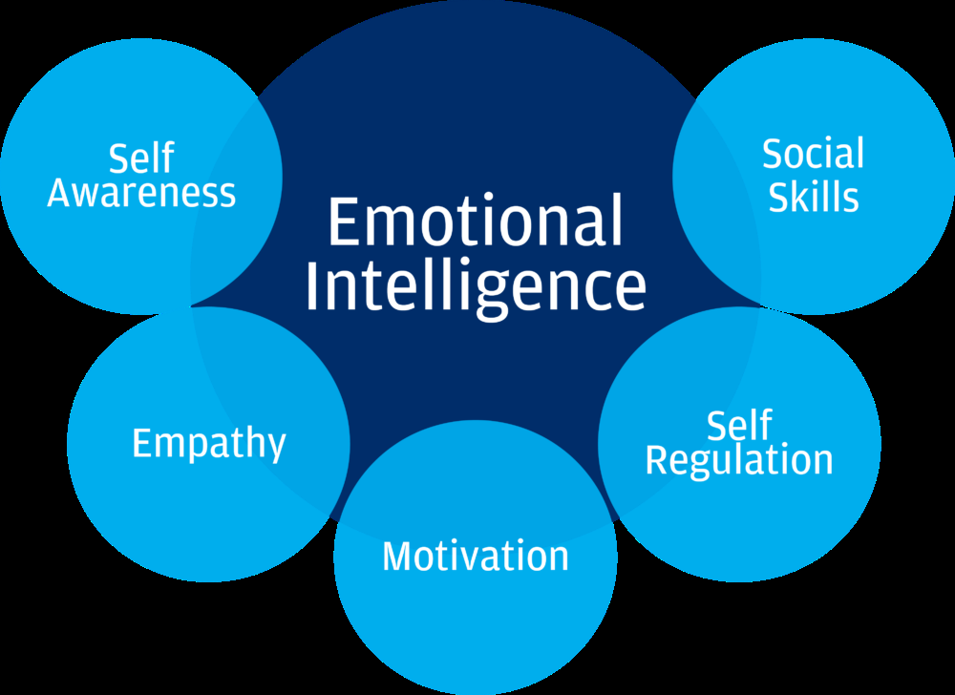

Source: Cognitive institute. (n.d.). Retrieved from, <https://www.cognitiveinstitute.org/get-smart-about-emotional-intelligence/>

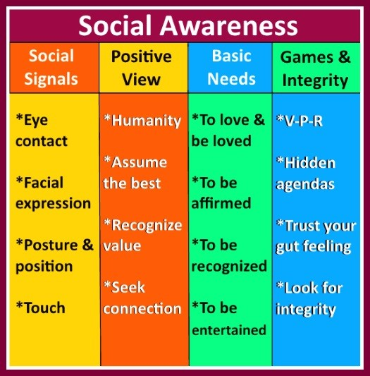

Source: Social awareness. (n.d.). Retrieved from, [https://www.google.com/search?q=social+awareness&client=firefox-b-1-ab&source=lnms&tbm=isch&sa=X&ved=0ahUKEwiP49jzu7DjAhWKg1QKHbjNDYcQ_AUIECgB&biw=1440&bih=691#imgrc=sUujrjCZLZ8O4M: (Links to an external site.)](https://www.google.com/search?q=social+awareness&client=firefox-b-1-ab&source=lnms&tbm=isch&sa=X&ved=0ahUKEwiP49jzu7DjAhWKg1QKHbjNDYcQ_AUIECgB&biw=1440&bih=691#imgrc=sUujrjCZLZ8O4M:)

Check out this video on how diversity fuels group emotional intelligence explained by no other than the EQ GURU himself, Daniel Goleman.

[https://hbr.org/video/2851426213001/how-diversity-fuels-group-emotional-intelligence  (Links to an external site.)](https://hbr.org/video/2851426213001/how-diversity-fuels-group-emotional-intelligence)

Watch this video to learn how to be a better leader by working on your emotional intelligence. How well do you regulate your emotions in professional settings under stress?:

<https://youtu.be/pt74vK9pgIA>

<https://youtu.be/-hoo_dIOP8k>

<https://youtu.be/tGdsOXZpyWE>