**Discussion**

Emotional Intelligence

Read the required materials on emotional intelligence (EQ) and take the EQ assessment.

Do not post your results.

For your initial post to this discussion:

Teach the class: Explain what you have learned about EQ.

Then, expand on the following questions:

Did you discover something that you were not aware of before in relation to your own emotional intelligence?

How does your emotional intelligence impact (a) your current or future career in human services and (b) your performance in groups?

What can you do to continue to improve in this area?

Be sure to cite and reference your work in APA format and Provide your peers with helpful sources that you find online that are intended to help enhance self-awareness and emotional intelligence.

Resources

**Required References**

Chapman, A. (2014). Emotional intelligence [Web page]. Retrieved from [https://www.businessballs.com/building-relationships/emotional-intelligence-eq-1991/ (Links to an external site.)](https://www.businessballs.com/building-relationships/emotional-intelligence-eq-1991/)

Queendom. (n.d.). Emotional intelligence text [Web page]. Retrieved from [http://www.queendom.com/tests/access_page/index.htm?idRegTest=3037 (Links to an external site.)](http://www.queendom.com/tests/access_page/index.htm?idRegTest=3037)

EQI.com. (n.d.). Definition of emotional intelligence [Web page]. Retrieved from [http://eqi.org/eidefs.htm#Innate (Links to an external site.)](http://eqi.org/eidefs.htm#Innate)

Goleman, D. (n,d.). Emotional intelligence [Web page]. Retrieved on January 10, 2016, from [http://www.danielgoleman.info/topics/emotional-intelligence/ (Links to an external site.)](http://www.danielgoleman.info/topics/emotional-intelligence/)

Kahn Academy. (2014, February 15). Self-concept, self-identity, and social identity: Individuals and society [Video file]. Retrieved from https://www.youtube.com/watch?v=PaA0mLVQd3k

Institute for Health and Human Potential (IHHP). (n.d.). Test your emotional intelligence [Web page]. Retrieved from [http://www.ihhp.com/free-eq-quiz/ (Links to an external site.)](http://www.ihhp.com/free-eq-quiz/)

Weis, W. L., Hanson, L., & Arnesen, D. W. (2009). The use of training groups in raising self and social awareness and enhancing emotional intelligence. *Journal of Organizational Culture, Communications and Conflict* *13*(2), 83-103.

**Recommended References**

Masland, L. C., & Lease, A. M. (2013). Effects of achievement motivation, social identity, and peer group norms on academic conformity. *Social Psychology of Education: An International Journal, 16*(4), 661-681. http://dx.doi.org/10.1007/s11218-013-9236-4

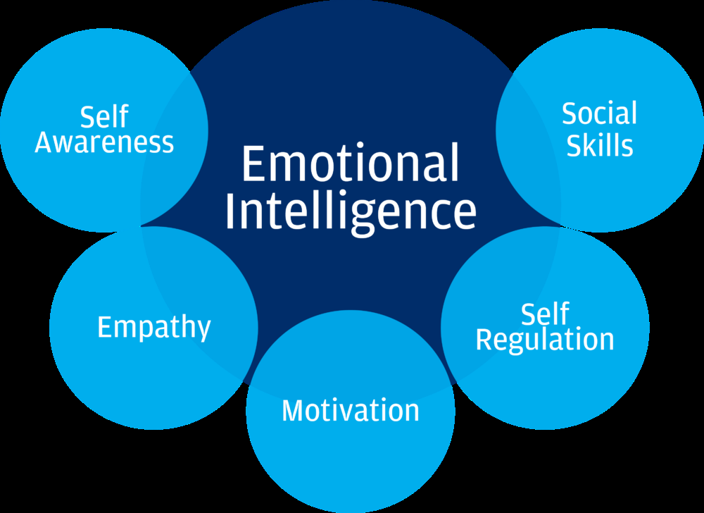

Source: Cognitive institute. (n.d.). Retrieved from, <https://www.cognitiveinstitute.org/get-smart-about-emotional-intelligence/>

Watch this video to learn how to be a better leader by working on your emotional intelligence. How well do you regulate your emotions in professional settings under stress?:

<https://youtu.be/pt74vK9pgIA>

<https://youtu.be/-hoo_dIOP8k>

<https://youtu.be/tGdsOXZpyWE>

