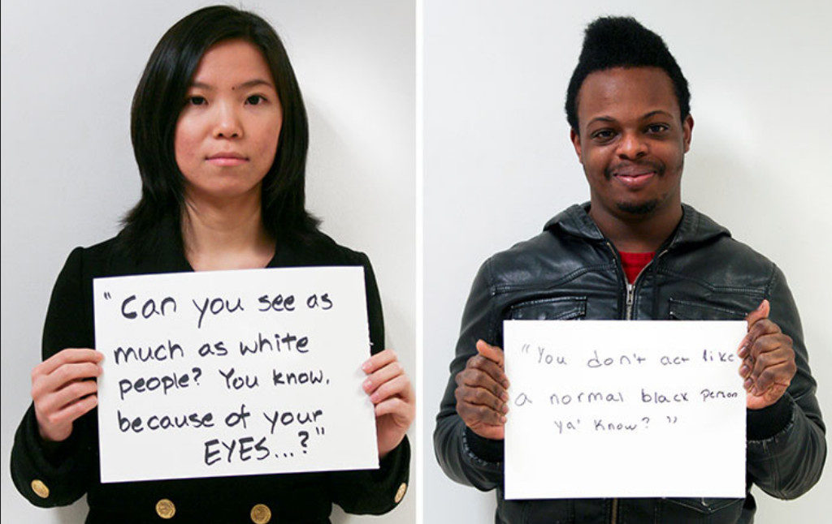

*Racial Microaggressions*

Concepts:

Implicit (Unconscious) Bias

Microaggression

Prejudice

Discrimination

This unit continues to explore the relationship between race, power, and privilege by examining how racial prejudice and discrimination are enacted at different levels, including the individual and implicit; interactional; and institutional representational level. New research on the role of bias at the unconscious, or implicit (unintentional) level has indicated how this form of discrimination has effects in how students are treated in schools, citizens are treated by police, and patients are treated by doctors. Along with this week’s readings, these concepts indicate how deeply embedded racial privilege and discrimination are in all aspects of life, largely in ways that are unacknowledged, with great social impact. As renewed (though not new) discussions and protest has centered around the public display of Confederate monuments that celebrate those who fought to keep slavery legal. These monuments were erected at various points throughout history, including during the Civil Rights movement in the 1960’s, 100 years after the end of the Civil War. Additionally, there has been constant protest and critique of these monuments since they were erected, due to the lack of representation of other people’s histories in the same honor. Herbert Blumer analyzes how this group membership, or allegiance, happens through forms of racial prejudice and the seeing other groups in oppositional, and inferior ways. Current trends indicate that hate crimes have increased, and that white nationaliists movements have been growing, exemplified by the “Unite the Right” rally in Charlottesville, VA in August 2017 which included many self-identified white supremacist groups, in which one protestor was killed. ([Unite the Right Rally](https://en.wikipedia.org/wiki/Unite_the_Right_rally))

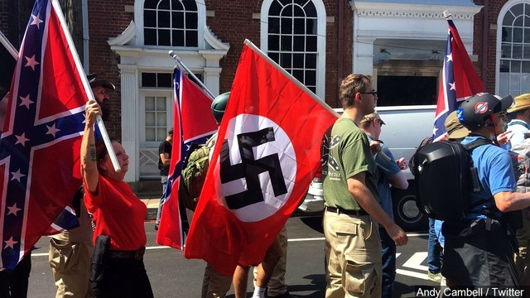

With this personal and group identity formation around forms of racial superiority, sociologists identify the variances in forms of discrimination between the implicit and the explicit levels, particularly in how they can be mitigated. Implicit bias and microaggressions are the results of being socialized in racialized society, while explicit identification and espousal of white supremacy, and the promotion of white idealism while deliberately diminishing the racial intent in monuments and ‘heritage’ arguments, all contribute to the racial stratification system, albeit, in different ways. Without knowing how we participate in racial discrimination at the implicit and interactional level through microaggressions, no attempt to change these behaviors can be made. Arguing that culture and heritage are justifications for things like monuments and symbolic forms fails to acknowledge the systemic inequality that exists in which ideologies and representations contribute to. Greater visibility of white supremacy movements creates greater fear and discord among groups that are already targeted and marginalized.

**Resources:**

[Microaggressions](https://www.youtube.com/watch?v=BJL2P0JsAS4)

[“If Microaggressions Happened to White People” MTV News](https://www.youtube.com/watch?v=KPRA4g-3yEk)

[Microaggressions](https://sph.umn.edu/site/docs/hewg/microaggressions.pdf)

[Study: Black Students More Likely Seen as Gifted by Black Teachers](https://indianapublicmedia.org/stateimpact/2016/05/19/gifted-black-teachers/)

[“The Loss”. Implicit Bias in Doctor’s Diagnosis](https://themorningnews.org/article/the-loss)

[“FBI: Spike in US Hate Crimes for Third Year in a Row](https://www.bbc.com/news/world-us-canada-46189391)

[Podcast: Onate’s Foot. Story of controversial debate between European descendant and Native American tribes in the design of a new monument.](https://99percentinvisible.org/episode/onates-foot/)

[“You Won’t Believe What the Government Spends on Confederate Graves”](https://www.theatlantic.com/politics/archive/2013/07/government-spending-confederate-graves/277931/)

[Kirwan Institute: Understanding Implicit Bias](http://kirwaninstitute.osu.edu/research/understanding-implicit-bias/)