Plato Notes Day 3: The Crito

The Crito takes place in the jail cell holding Socrates and will soon be the place of Socrates death. There are only two persons in the dialogue, Crito and Socrates. Crito is also present in the Phaedo, the dialogue by Plato that depicts the final moments of Socrates’ life and his drinking of the hemlock. The Phaedo opens with Crito and Socrates returning from a bath together, suggestive of the close and personal relation existing between these two figures.
Upon entering the cell, Crito finds Socrates sleeping and is astonished by how peacefully Socrates can rest just days before he is to die. The peacefulness of Socrates’ slumber is a reminder of what he had told us earlier in the Apology, namely that he has nothing to fear in death. The question is never whether one will live, but how one is to live well. Much later, the painter, David, will depict this serenity and resoluteness of Socrates in the painting below.

Death of Socrates: Jacques-Louis David, 1787

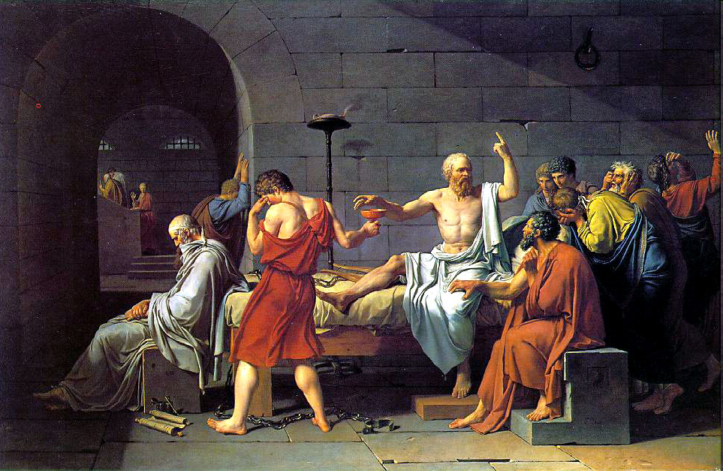

The person in the red toga is the jailer handing Socrates the hemlock. Impressive is how little concern Socrates has for the poison and cares more of speaking of matters philosophical. That Socrates is discussing philosophical matters is suggested by his finger pointing upward, toward that which is eternal and true – the matter of the highest philosophical interest. There are chains on the floor noting that Socrates is not forced to drink the hemlock and accepts his fate willingly. The love and admiration of those around are without question and we can assume that it is Crito with his tender hand upon Socrates’ knee. Can you pick out Plato? Notice the pen and scroll on the ground below the man in white. Here is Plato, the writer, unable to watch and even write of the scene. It is too much for him to bear.
Returning now to the Crito, the reason for Crito’s visit becomes apparent. Crito beseeches Socrates to escape. The argument seems quite straight forward. Socrates has been wrongly convicted and sentenced to death. Crito provides all the means necessary for escape. Socrates ought to go.
The dialogue, as we know, does not turn out this way and ends with Socrates demonstrating the moral reasons why he must face his punishment, even though it is unjust. These reasons for Socrates’ refusal to escape will serve as the first part of the first short papers and we will want to spend some time looking at these reasons in some detail. But, before we get to Socrates’ argument, I want to turn our attention to Crito’s.
In the brief exchange before Crito gives his reasons why Socrates ought to escape, it is made clear that the arguments will concern whether escaping is the right and just action to take in this situation. Socrates makes clear that he is not concerned with whether it is the popular thing to do or how others will perceive him. The moral and universal character of these arguments continues in Socrates’ own arguments for staying. Both Crito and Socrates are not arguing on behalf of this one case, but whether a person ought to die when wrongly convicted. It is first and foremost a question of one’s moral obligation, what ought one do.
Crito’s argument for why Socrates’ ought to escape appears in the passages below. For sake of precision and clarity, I want to divide his argument up into two kinds. I call the first argument, the argument from harm, and the second, the argument from duty. In his argument from harm, Crito is attempting to show that more harm is caused if Socrates stays than if he leaves. These different harms are mentioned in the following passage:

Cr. Yes: the meaning is only too clear. But, O! my beloved Socrates, let me entreat you once more to take my advice and escape. For if you die I shall not only lose a friend who can never be replaced, but there is another evil: people who do not know you and me will believe that I might have saved you if I had been willing to give money, but that I did not care. Now, can there be a worse disgrace than this- that I should be thought to value money more than the life of a friend? For the many will not be persuaded that I wanted you to escape, and that you refused.
Soc. But why, my dear Crito, should we care about the opinion of the many? Good men, and they are the only persons who are worth considering, will think of these things truly as they happened.
Cr. But do you see. Socrates, that the opinion of the many must be regarded, as is evident in your own case, because they can do the very greatest evil to anyone who has lost their good opinion?
Soc. I only wish, Crito, that they could; for then they could also do the greatest good, and that would be well. But the truth is, that they can do neither good nor evil: they cannot make a man wise or make him foolish; and whatever they do is the result of chance.
Cr. Well, I will not dispute about that; but please to tell me, Socrates, whether you are not acting out of regard to me and your other friends: are you not afraid that if you escape hence we may get into trouble with the informers for having stolen you away, and lose either the whole or a great part of our property; or that even a worse evil may happen to us? Now, if this is your fear, be at ease; for in order to save you, we ought surely to run this or even a greater risk; be persuaded, then, and do as I say.
Soc. Yes, Crito, that is one fear which you mention, but by no means the only one.
Cr. Fear not. There are persons who at no great cost are willing to save you and bring you out of prison; and as for the informers, you may observe that they are far from being exorbitant in their demands; a little money will satisfy them. My means, which, as I am sure, are ample, are at your service, and if you have a scruple about spending all mine, here are strangers who will give you the use of theirs; and one of them, Simmias the Theban, has brought a sum of money for this very purpose; and Cebes and many others are willing to spend their money too. I say, therefore, do not on that account hesitate about making your escape, and do not say, as you did in the court, that you will have a difficulty in knowing what to do with yourself if you escape. For men will love you in other places to which you may go, and not in Athens only; there are friends of mine in Thessaly, if you like to go to them, who will value and protect you, and no Thessalian will give you any trouble.
In this passage, you will find the harms caused if Socrates stays and the harms caused if he escapes. The strategy here by Crito is to emphasize the harm caused if he stays and downplay the harm caused if he escapes. If Crito is able to show that more harm is caused by Socrates staying, then he has shown why Socrates ought to escape. One ought always do that which brings about the least amount of harm. When it is time to Socrates to take up the argument and defend himself, he will return to this question of harm once again. It will be his task to show that more harm is caused if he were to escape.
The next part of Crito’s argument concerns the types of duties Socrates has. Duties are precisely that which one ought to do and can be framed in this type of language (“one ought to…”). Crito lists these duties in the following passage:
Nor can I think that you are justified, Socrates, in betraying your own life when you might be saved; this is playing into the hands of your enemies and destroyers; and moreover I should say that you were betraying your children; for you might bring them up and educate them; instead of which you go away and leave them, and they will have to take their chance; and if they do not meet with the usual fate of orphans, there will be small thanks to you. No man should bring children into the world who is unwilling to persevere to the end in their nurture and education. But you are choosing the easier part, as I think, not the better and manlier, which would rather have become one who professes virtue in all his actions, like yourself. And, indeed, I am ashamed not only of you, but of us who are your friends, when I reflect that this entire business of yours will be attributed to our want of courage. The trial need never have come on, or might have been brought to another issue; and the end of all, which is the crowning absurdity, will seem to have been permitted by us, through cowardice and baseness, who might have saved you, as you might have saved yourself, if we had been good for anything (for there was no difficulty in escaping); and we did not see how disgraceful, Socrates, and also miserable all this will be to us as well as to you. Make your mind up then, or rather have your mind already made up, for the time of deliberation is over, and there is only one thing to be done, which must be done, if at all, this very night, and which any delay will render all but impossible; I beseech you therefore, Socrates, to be persuaded by me, and to do as I say.

There are at least four different duties that Crito mentions here. Again, Socrates will have to return to this part of the argument later when defending his actions. He will have to show that he is indeed doing what he ought to do, following his duties by staying.
In the next notes, I will focus on Socrates’ argument. See the assignment tab for the assignment that concerns the Crito and the discussion in these notes.

Plato Notes Continued
Socrates’ Argument Why Breaking the Law is Unjust

Our attention now turns to Socrates and his response to Crito. Socrates’ argument will ultimately show that it is never just to break a law, even if the law itself is unjust or unfair. This argument will serve as the first part of the first long paper of the semester. We need to keep in mind both the argument itself and any objections we may have of the argument.
Before we reach the actual argument, there are a couple of points Socrates needs to make clear. The first of these is the meaning of the argument. Socrates states:

Soc. Very good; and is not this true, Crito, of other things which we need not separately enumerate? In the matter of just and unjust, fair and foul, good and evil, which are the subjects of our present consultation, ought we to follow the opinion of the many and to fear them; or the opinion of the one man who has understanding, and whom we ought to fear and reverence more than all the rest of the world: and whom deserting we shall destroy and injure that principle in us which may be assumed to be improved by justice and deteriorated by injustice; is there not such a principle?
Cr. Certainly there is, Socrates.

Hence, the matter to consider is not whether the decision is popular or whether the majority agree, but whether it is just. Important to note here is Socrates’ criticisms of democracy and any belief that maintains the true and just is relative to the majority decision. The standard of truth and justice lies above and beyond the opinion of the many. Our decisions about how to act should always be dictated by the objective standards of truth and justice.
This comment is necessary to refocus the argument. Crito was very concerned about how others would view him. Socrates, the philosopher and just person, is only concerned about what the just thing to do is. This means, any criticisms of Socrates must concern the logic of the argument, not some personal feelings or character traits. Whether or not Socrates ought to escape depends solely on the rightness of the action. Thus, it is not a question of what Socrates the individual should do, but what should anyone do. So, if you find yourself convicted of a crime you did not commit or if you find yourself living in a state that has unjust laws, you must obey laws.
The second preparatory comment concerns the character of a just individual. Again, Socrates states:
Soc. Are we to say that we are never intentionally to do wrong, or that in one way we ought and in another way we ought not to do wrong, or is doing wrong always evil and dishonorable, as I was just now saying, and as has been already acknowledged by us? Are all our former admissions which were made within a few days to be thrown away? And have we, at our age, been earnestly discoursing with one another all our life long only to discover that we are no better than children? Or are we to rest assured, in spite of the opinion of the many, and in spite of consequences whether better or worse, of the truth of what was then said, that injustice is always an evil and dishonor to him who acts unjustly? Shall we affirm that?
Cr. Yes.
Soc. Then we must do no wrong?
Cr. Certainly not.
Soc. Nor when injured injure in return, as the many imagine; for we must injure no one at all?
Cr. Clearly not.
Soc. Again, Crito, may we do evil?
Cr. Surely not, Socrates.
Soc. And what of doing evil in return for evil, which is the morality of the many-is that just or not?
Cr. Not just.
Soc. For doing evil to another is the same as injuring him?
Cr. Very true.
Soc. Then we ought not to retaliate or render evil for evil to anyone, whatever evil we may have suffered from him. But I would have you consider, Crito, whether you really mean what you are saying. For this opinion has never been held, and never will be held, by any considerable number of persons; and those who are agreed and those who are not agreed upon this point have no common ground, and can only despise one another, when they see how widely they differ. Tell me, then, whether you agree with and assent to my first principle, that neither injury nor retaliation nor warding off evil by evil is ever right. And shall that be the premise of our agreement? Or do you decline and dissent from this? For this has been of old and is still my opinion; but, if you are of another opinion, let me hear what you have to say. If, however, you remain of the same mind as formerly, I will proceed to the next step.

Socrates point is rather straightforward: A just person never harms another, even when harmed. This statement follows directly from the nature and character of a just individual. The character of a just person is so constituted that it is impossible for him or her to ever harm another. Harming others stands in direct opposition of one’s character. Yet again, the argument is placed in the context of the question of justice. Two wrongs never make a right. We must always discover in every act, what the just thing to do is.
Let us now take up Socrates’ argument. Socrates must refute Crito in respect to both of his arguments. Socrates must show that more harm is caused if he escapes and that by staying he is in fact remaining true to the different duties. The main conclusion remains, breaking a law, no matter how unjust the law may be, is always unjust.
Socrates begins his argument by imagining a conversation with the state. What Crito had failed to account for in his argument was the potential harm that may incur as a result of Socrates’ escape. Using the state has his interlocutor, Socrates argues that in escaping he would threaten the very existence of the state.
Soc. Then consider the matter in this way: Imagine that I am about to play truant (you may call the proceeding by any name which you like), and the laws and the government come and interrogate me: "Tell us, Socrates," they say; "what are you about? are you going by an act of yours to overturn us- the laws and the whole State, as far as in you lies? Do you imagine that a State can subsist and not be overthrown, in which the decisions of law have no power, but are set aside and overthrown by individuals?"
How is this possible? How could one individual threaten the whole state? The idea, according to Socrates, is that by leaving he is setting a precedent for others then to follow. The precedent in this case is one can break the law when it does not suit one. Power and the respect for the law are at the foundation of the state. Without these two elements, the state is a meaningless institution.
Crito buys the argument and agrees with Socrates that to escape would threaten the existence of the state. So, Socrates has at least shown that there is one type of harm Crito failed to consider in his initial argument. The question now concerns whether this harm is greater than the harms caused if Socrates stays and dies. In other words, what is more important, the life of the individual or the existence of the state? Socrates then proceeds to give three reasons as to why the state is of greater importance than the individual.
The first reason is that the state is responsible for the very existence of the individual. Without the state, as Socrates argues, one’s parents would never have met and consequently one would never have been born. So, the state is responsible for creating a place for people to meet, get married and have a family. Certainly children are born where government or a state do not exist. But the two people who are one’s parents would have never met and had the opportunity to raise a family.
The second reason is similar to the first. Socrates concludes that the state is also responsible to the nurture and care one receives in the state. For example, without the law and order of the state, there would be no books, no writing, no education and other aspects of culture. Not only does one owe one’s life, but also the formation of one’s character. Without the nurturing and education provided by the state, one could not be who one is. Again, in terms of importance and foundation, the state is greater than the individual.
The final reason follows from the argument as a whole. The state, as mentioned above, is the establishment of law and order. What distinguishes the Greeks or other civilized people from the barbarians (the stateless and lawless people) is the existence of law and order. Law and order are precisely that which distinguishes the barbaric from the civilized (and Greek). Crito had argued earlier that it is just to escape. Socrates is no arguing that the very possibility of justice rests on the existence of law and order. Without law and order there is no justice or even chance of justice ever taking root.
This is what life is like for the barbarians. There is no justice, only brute force and might. Law and order provide the means by which to order one’s life in accord with rules that do not rest on physical might, but reason. Hence, it is impossible to change the unjust rules and laws if there is no law and order. The present laws may in fact be unjust and unfair, but for there to be any hope of ever changing these laws, there must be law and order. Where there is not state, there is no hope for justice.
What is one to do when the state is unjust? The only action a person ought to take against the state, even if one is wrongly accused, is to persuade the government to change. All other action threatens the existence of law and order. Reason is the only legitimate and just means of protest and social change. Not only does the use of reason alone preserve the existence of the state, but it begins to demonstrate the power of reason as an alternative to the power of physical force. If there is ever to be a just state with just laws and leaders, the leaders and citizens need to be educated and thus make decisions based upon reason. In taking physical action against the state such as breaking the law, one is only demonstrating the power of physical force. Physical force teaches nothing other than fear. For there to be true respect for the law and for there to be truly just laws, reason must be the force of the state.
Our next two thinkers, Dr. King and Malcolm X have very different ideas regarding the just means of protest and civil disobedience. The comparison of these three thinkers on the question of the proper means of civil disobedience is the subject of our first paper. In the next week, we will see how these other two thinkers criticize Socrates’ method and distinguish their methods from each other. The question remains the same, however. What are the just means of protesting and changing an unjust law or rule?
The remainder of the dialogue concerns the specific duties Crito first recognizes. Socrates refutes each of these. For instance, he argues that he is caring more for his children by preserving the state than by escaping. Again, the state provides the institutions and resources for the formation of one’s character. His children would not have such an opportunity in other states, states that would see Socrates as a trouble maker and one who has no respect for the law. I invite you to see how Socrates answers Crito’s earlier objections.
This then concludes the notes from the Crito and Plato in general. Of course, we will be returning to Plato for the remainder of the course, particularly over the next couple of weeks.

