Design and Construction Phase

May 24, 2020

**Design and Construction Phase**

The project is set to create a solution that will enable Amazon to overcome the issues of using enormous data from various sources. Operating in the AI field, Cloud computing, eCommerce, and digital streaming, the company is affected by the aspect of high data and need to make the right analysis to ensure that its use in the decision-making process (Rui & Lyytinen, 2019). In this case, designing a project that will promote knowledge management is key to the success of the company. The system will make it possible for the company to manage, retrieve, analyze, and use the data by making necessary statistics that will ensure progress in it.

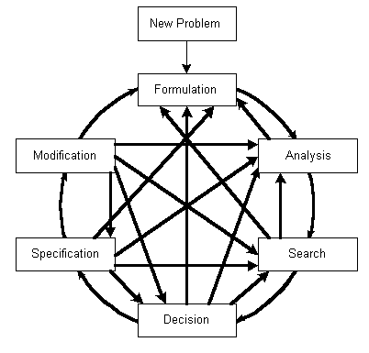

**Layout and architecture**

The project will apply a Conceptual Design Process. This will include the system for a development that provides for logical development and including a specific policy that's helpful in problem-solving. In this case, the project team will need to consider how the process within the system will work to create the system to respond to that (Feng & Song, 2016). Generally, being data management systems, knowledge management projects will need to follow a specific aspect of including a proper streamlining of processes. This approach will help in ensuring that the idea of knowledge management is well controlled and implemented through the system so that objectives can be met.

**Human factors**

In the design phase, people in the team will be responsible for the success of the project. Thus, roles must be allocated with the aspect of making the right design that meets the expectations and requirements of the firm. The data management must be achieved as planned. The design will set a significant backbone of the whole project. There is a need to have a focus on the elements of the projects, and this makes it a significant influence that determines how well the implementation plan will be.

**Road map**

In developing a road map for the data, the team will have to make a consideration of project plans, architecture, and strategy used overall. The road map will consider the activities to be followed in the development process and include them in the design plans (Houshmand & Amani, 2017). It will have to consider the six fundamental foundations of knowledge management are human resources, organizational structure, external environment, management as well as leadership, corporate culture, and IT. In this case, the team handling the design needs to consider the scheduling of activities that will be created later.

**IT Strategy**

The selection of strategy will have to consider what the system will select types of knowledge. In this case, knowledge will be gained from the SAS analytical as well as involving the sharing aspects (Houshmand & Amani, 2017). in the development of knowledge, sharing culture transfer equipment is considered. Also, the system must be designed to ensure that it interacts with a knowledge basis.

**References**

Feng, S. C., & Song, E. Y. (2016). Information modelling of conceptual design integrated with process planning. *Proc. of ASME DETC/DFM*.

Houshmand, M., & Amani, M. (2017). A Road Map for Knowledge Management Systems Design Using Axiomatic Design Approach. In *MATEC Web of Conferences* (Vol. 127, p. 01022). EDP Sciences.

Rui, Z., & Lyytinen, K. (2019). How do ventures become more innovative? The effect of external search and ambidextrous knowledge integration. European Journal of Innovation Management.