Week 3 - Assignment

Diversity in Groups Article Analysis

Select one published article from any of the online databases listed in the Library that presents research on any type of diversity issue discussed in Chapter 6 of the required text. Some examples are racial, ethnic, gender, sexual orientation, or generational diversity in groups.

Your assignment for this week is to summarize and evaluate the main points or theses of the article. Specifically:

* Summarize the article and its main point(s) or argument(s).
* Identify the methodology and design (example: qualitative and phenomenological) of the research undertaken or put forth.
* State and discuss the implications and meaning of the results.
* Provide your evaluation of the study, critiquing its findings and, if relevant, stating and defending your position on the issue.
* Explain how the research study could be improved or what you might have done differently and why.
* Explain how this research expands the knowledge base on diversity and groups.
* Explain how this research relates to what we are learning in class.

Your paper:

* Should be 850-1,100 words in length.
* Should conform to APA style, 6th edition.

Resources

**Required Text**

Adams, K., & Galanes, G. (2017). [*Communicating in groups: Application and skills*](https://ashford.instructure.com/courses/47245/modules/items/2394804)*(10th ed.).*New York, NY: McGraw-Hill

* Chapter 5: Becoming a Group
* Chapter 6: Working with Diversity in the Small Group

**Required References**

Human Metrics. (n.d.). Jung Typology Test [Web page]. Retrieved from [http://www.humanmetrics.com/cgi-win/jtypes2.asp  (Links to an external site.)](http://www.humanmetrics.com/cgi-win/jtypes2.asp)

Keirsey.com. (n.d.). Welcome to the Keirsey Temperament Sorter (KTS-II) [Web page]. Retrieved from [http://www.keirsey.com/sorter/register.aspx  (Links to an external site.)](http://www.keirsey.com/sorter/register.aspx)

McConnell, K. (2014, November 21). Leveraging your personality in the workplace: Understanding your Myers Briggs core type [Video file]. Retrieved from https://www.youtube.com/watch?v=--I5UZ0LvjY



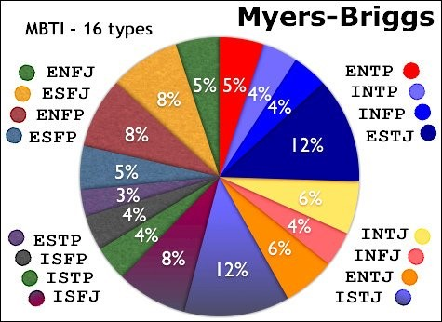

Source: [https://owlcation.com/social-sciences/The-4-Temperaments-of-the-16-Personality-Types (Links to an external site.)](https://owlcation.com/social-sciences/The-4-Temperaments-of-the-16-Personality-Types)

Check out this article:

<https://www.tcii.gov.nl.ca/regionaldev/CCB/Group_Dynamics/CCB_GroupDynamicsGuide.pdf>