**Company Analysis and Evaluation Project**

**Sandra Lindsey**

**Liberty University**

**BUSI 601**

**May 26, 2020**

**Introduction**

Coca-Cola is one of the largest beverage companies in the world. The company is found all over the globe, making its products available to a vast number of the global population. The company has been in existence for the last 133 years. It has 500 brands with over 4000 product lines. The company’s global headquarters are located in Atlanta Georgia. As of 2019, the company had over 86,000 employees globally with annual revenue of 37.27 billion US dollars worldwide (Coca-Cola Company, 2020). The company has grown from a small beverage company to world domination over the years. The purpose of this report is to look at the SWOT analysis for the company and the key success factors that have made the company such a huge success.

**Coca-Cola’s SWOT Analysis**

|  |  |
| --- | --- |
| **STRENGTHS** | **WEAKNESSES** |
| * Strong brand image * World domination- in over 200 territories * Strong marketing and advertising * Robust global infrastructure and distribution * Strong Financial presence * Large product portfolio | * High product costs thus higher prices than competitors * Reliance on carbonated drinks market * Brand/product failures * Lack of diversification * Negative publicity |
| **OPPORTUNITIES** | **THREATS** |
| * Growth of bottled water consumption (Dasani) * Growing demand in emerging markets * Diversification in health drinks * Aggressive acquisitions | * Competition * Changing consumer preferences * Growing health conscious mind of consumers |

**Coca-Cola’s Balanced Score Card**

|  |  |  |  |
| --- | --- | --- | --- |
| **AREAS OF OBJECTIVES** | **MEASURES** | **TIMELINE** | **RESPONSIBILITY** |
| **Consumers**   * Customer Loyalty |  |  |  |
| Consumer survey results | Annually | Customer Relations Officer (CRO) |
| * Customer Satisfaction | Consumer survey results | Annually | CRO |
| * Brand Recognition | Industry reports | Annually | CRO |
| **Employees**   * Quality and service training |  |  |  |
| Webinars and On site | Annually | HR Managers |
| * Employee Satisfaction | Employee surveys | Annually | HR Managers |
| **Operations**   * Product diversification |  |  |  |
| Number of acquisition  Number of new product | Yearly | Product Development Officer |
| **Business Ethics**   * Reduction of Waste |  |  |  |
| Volume of recyclable materials | Quarterly | Global environmental Officer |
| * Ethics Training | Number of training sessions | Quarterly | Human Resource Manager |
| **Financials**   * Ratio Analysis |  |  |  |
| Industry reports in comparison to competitors | Yearly | Chief Financial Officer |
| * Revenues | Consolidated Financial Statements | Quarterly | Vice President |
|  |  |  |  |

Source: (Blocher, Stout & Cokins, 2010, pp. 42-52)

**Critical Success Factors**

As seen above, Coca-Cola is one of the most successful companies in the beverage industry and it is the most recognized brand in the industry worldwide. The dominance of the company sets high standards for competitors who want to enter the beverage market. There are many factors that attribute to the success of the company. Below some critical success factors that directly affect the overall success of the company.

Marketing

Coca-Cola as a company has one of the best advertising and marketing strategies compared to many other companies on the globe. The company could be said to be the founding father of product advertisements and modern-day marketing models. The company was among the pioneers for advertising techniques that were used to capture the attention of the audience and at the same time lure the audience to purchase the products of the company. The company's marketing reflects its products and what the consumers think when they are consuming the product brand (Singaram et al., 2019). The brand and image are set in the minds of the consumer. For instance, we have a set mindset that Coca-Cola products are associated with 'good times' which is part of their marketing and advertising slogan.

The marketing factor is selected as it is critical in consumer acquisition. Coca-Cola as a company is dependent on the purchases made by the consumers. Without enough people in the markets, then the company would not be as successful as it is. Consumer acquisition is thus very vital to any organization dealing with products they will offer in any market. Companies such as Coca-Cola thus advertise and market their products to; acquire new customers, entice existing and new customers to purchase their products, and to create awareness of the products they have in the market. Marketing is directly proportional to the revenues of the company. A successful marketing campaign always leads to increases in company revenues.

Globalization

Today's most successful businesses are those that have scaled their products to a global level. Globalization increases the market share of the company and thus its revenues. Globalization is a strategy that Coca-Cola has used over the years to gain world dominance ads a carbonated drinks manufacturer. The adoption of business technology has enabled companies to go to all lengths of the world and at the same time efficiently manage business processes. Globalization enables companies to serve diversified markets and thus have greater product portfolios to meet such markets. Globalization is a key success factor in that it increases the company's revenues and also shields the company from risks such as economic risks. An excellent example is if Coca-Cola was only operating in one country and the country hits and economic crisis. The company will also be hit hard by the crisis and might even collapse. Globalization thus ensures success by leveraging more than one economy. Failure in one sector will not necessarily mean a failure in the other (Sahu, Deng & Mollah, 2018).

Innovation

Innovation leads to the constant development of products that meet the needs of the consumer. Coca-Cola is a constantly innovative company and comes up with new brands and products every now and then. The constant change in global markets makes innovation and creativity an essential part of the company. Innovation is a key success factor in that it helps to effectively achieve the growth goals of a company. Innovation is also a way through which a company maximizes the return on investment to its shareholders. Innovation enables the company to stay competitive despite the dynamic nature of markets and consumer preferences.

Financial Strengths

Financial strengths enable companies to carry out business activities efficiently. The availability of finances is a key success factor in that every business activity such as processing, manufacturing, and human labor requires such resources to function well (Charmi, 2010). The company has strong cash flows that enable it to carry out other activities such as innovation, marketing, and entry into new markets.

Large Product Portfolio

A huge product portfolio means that the company has many brands and products in the market. The success of such brands leads to the success of the entire company. The above success factors us essential in the case study of Coca-Cola in that the company has a wide range of products and brands which attribute to its success. The product portfolio is important in assessing the success of a company in that it affects the rates of investments within the company, especially for public companies that require outside investments. Investors take product portfolios as a critical factor for assessing the success of a company.

Strong Brand Recognition

Coca-Cola is one of the oldest beverage brands and precisely one of the most recognized brands on the planet. Brand recognition creates value for the company and thus creates a competitive advantage in the market. The stronger a brand is the higher its market shares and its revenues (Charmi, 2010).

**Evaluation of Critical Success Factors (CSFs) in Coca-Cola**

Marketing is one of the critical success factors that Coca-Cola is doing perfectly. The marketing campaigns that the company employs stick in the minds of the consumers. In its marketing, the company emphasizes on the brand over the product. Its advertisements show that it does not sell coke or other products in a bottle, but sells 'happiness' in each bottle that the consumer purchases. Its advert of 'good times' as seen above sticks in the mind of the consumer and they associate the product with a good lifestyle. The success of the company's marketing is attributed to its simplicity, personalization of the intended message and its aim is to sell experience other than a product in a bottle (Oganga, 2013). The success of the marketing strategy is measured through the revenues that the company generates in relation to marketing expenditures. It is also measured by the developed perception of the brand through consumer surveys.

Coca-Cola has had continuous innovation. To cover the growing and changing consumer preferences, the company has developed new products. The company is venturing into the energy and fruit juice market to cater to the health-conscious needs of the consumer. One of the most renowned innovative products of the company is the Monster brand and the Minute Maid brands which satisfy the changed preferences of the consumer. The company has also developed sparkling water for consumers that want the after the task of a soft drink but do not want to consume sugary and cola products (Insolia et al., 2018). Coca-cola is thus achieving the above CSF and using it to increase the market share of the company's brands and also retain revenues.

Coca-cola achieves globalization by having operations in many countries. The company is in over 200 territories and thus its products are globalized. Its product in each territory meets the needs and preferences of that market. A Coca-Cola product in the United States is not the same as that which will be found in China. The company has employed globalization of the organization as a whole and has also tailored products to specific markets. Coca-Cola Company also has a huge brand portfolio with over 500 brands. Under those brands, the company has over 4,000 products (Singaram et al., 2019). The above enable it to meet customer expectations and increase consumer satisfaction. The brand image that the company has is also positive. Most consumers perceive the company to be one that offers value through its products. Through interviews with consumers and employees within the company, it is clear that they see the company as the best in the beverage industry. The perception that the brand is prestigious increases consumer loyalty and their wanted association with the brand.

Coca-Cola is financially strong. Its revenues as of 2019 stood at 37.27 billion US dollars. With such revenues, it is easy for the company to invest in product innovation and also global expansion and management of its business. Below is a consolidated financial statement for the company (Coca-Cola Company, 2020).

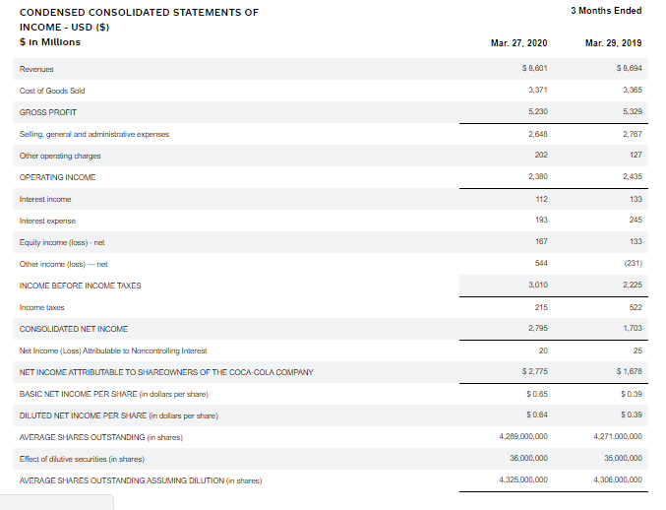

**Conclusion**

Coca-Cola Company has various success key factors such as marketing, innovation, globalization, financial strength, product portfolio, and strong brand among others. With such factors, the company becomes a success in any market that they venture into. Through analysis of the company, it is clear that Coca-Cola achieves most of the CSFs thus an explanation for its continued success over the years.

References

Blocher, E. J., Stout, D. E., & Cokins, G. (2010). *Cost management: A strategic emphasis*. Includes index.

Charmi. (2010, February 16). *Coca Cola*. Share and Discover Knowledge on LinkedIn SlideShare. <https://www.slideshare.net/charmip/coca-cola-3199731>

Coca-Cola Company. (2020). *Financial information*. The Coca-Cola Company. <https://investors.coca-colacompany.com/financial-information>

Coca-Cola Company. (2020). The Coca-Cola Company: Refresh the World. Make a Difference. <https://www.coca-colacompany.com/>

Insolia, G. E., Schubert, H. U., Goldman, J. E., Sadeghi, F. F., Patel, N., & Kolls, B. (2018). *U.S. Patent No. 9,865,023*. Washington, DC: U.S. Patent and Trademark Office.

Oganga, O. M. (2013). performance measurement practices and maintenance improvement among coca cola bottling plants in Kenya. *MBA dissertation, School of Business, University of Nairobi, Nairobi*.

Sahu, N., Deng, H., & Mollah, A. (2018). Investigating the critical success factors of digital transformation for improving customer experience. In *International Conference on Information Resources Management (CONF-IRM)*. Association For Information Systems.

Singaram, R., Ramasubramani, A., Mehta, A., & Arora, P. (2019). Coca Cola: A study on the marketing strategies for millenniums focusing on India. *International Journal of Advanced Research and Development*, *4*(1), 62-68.