**GOVT2306, 1ST SUMMER, 5-WEEKS**

**PROF. JOHN BEN SUTTER**

**MANDATORY WRITING ASSIGNMENT**

**Instruction on How to Write Your Essay**

**Your Life During the Pandemic: A Personal Essay**

How are you and your family dealing with the COVID19 crisis?

Write an essay discuss the effect the pandemic and accompanying social and economic changes resulting from the nationwide effort to stem the spread of the virus has had on you, your family, and your friends.

You are to write about how are you dealing with it, about how it has affected your daily life on an economic level, a social level, a personal level, and how it has affected your family and your community of friends?

Select three articles from the list I’ve provided you to use in your personal essay to underscore your discussion. See page 4 of your instructions for the articles from which you can choose the articles.

YOU WILL NEED TO ADDRESS IN YOUR ESSAY THE FOLLOWING QUESTIONS:

*Has your employment been affected?

*Has your personal economy been affected?

*How has your social life been affected?

*How has your academic life been affected?

*How have your plans for your future been affected?

*How well do you think the government—federal, state (Texas), and local (county and city) responded to control the spread of the virus and protect you and your family?

*Do you know anyone with COVID19?

*What precautions are you taking to protect yourself from the virus?

*Are you taking precautions to avoid becoming infected and then passing the virus on to the members of your family, particularly your parents and grandparents who are more susceptible to severe reactions if infected?

*Are you aware that medical specialists are finding that young people can develop serious medical conditions (including stroke) if infected with COVID19 virus?

*Are you worried about your health?

*Are you worried about your family’s health?

*What precautions are members of your family taking to protect themselves and others?

*Do you meet with your friends outside of your home?

*Do you go to parties and other social events?

*Do you wear a mask regularly?

*Do you wear gloves when outside the home?

*Have you been to the beach?

*What do you plan to do on the Fourth of July?

*How has your education been affected by the coronavirus pandemic?

*Are you going into a classroom anywhere or are all your classes online entirely now?

*If you have only online classes, have you decided if you prefer online classes or on-campus face-to-face classes? Why?

*Have you or any member of your family been tested for COVID19? How long did you wait?

*Are your friends taking precautionary measures such as social distancing, wearing a face mask, wearing gloves when shopping, washing hands often for 20sec periods each time

*Some people believe this is all a hoax and refuse to take any precautions? Is this your position? Why or why not?

*If you are ***not*** taking any precautions but do believe there is a virus (because you believe in science and medicine) killing thousand around the world, why? Do you believe you have some immunity (such as “I’m young. I’m not going to get sick.” or “If I pray God will kill the virus and not let it kill me.” or some other reason…explain the reason.)

*Do you think President Trump is doing a great job regarding the pandemic…an utterly lousy job….or something in-between?

*Same for Texas Gov. Greg Abbott…Great?...good?...so-so?...lousy?

*How about Texas Lt. Gov. Dan Patrick? You might want to read this article and maybe use it in your paper. Words that fall from Gov. Patrick’s mouth are sometimes rather, well, odd. This article doesn’t require a subscription: <https://thehill.com/homenews/state-watch/505417-texas-lt-governor-hits-fauci-he-doesnt-know-what-hes-talking-about>

Let me try to write what I’d say if I could talk to you in the classroom: “Ain’t nobody gonna see what you write ‘cept you and me. If somebody reads your paper and it ain’t you or me doin’ it, it’s ‘cause you let ‘em read it… ‘cause I ain’t gonna let anybody see your paper. Nope, nuh uhh.” So, know you can be honest when writing this. And know that I respect you and your beliefs because you are my student. It’s an honor to be teaching you. I have a responsibility to you and I will protect your privacy and respect your beliefs.

*If you follow my instructions,*

*if you meet or exceed the required word-count of 625 words,*

*if you use three of the sources in your paper (and cite the source anytime you use a quote or paraphrase information from an article you cite that article by name and publication), and*

*if you do a fairly decent job of writing (i.e., you put some thought and effort into your work and proof-read your paper b4 submitting it,*

*if you do all that you will earn a good grade!*

Your paper must have, at a **minimum** **625 words**. That is not a lot. Your paper was originally going to require a minimum word count of 2,000 words. Because of the delays in posting it, I have been revising it down so you can readily do the assignment in the time allotted. The paper I assigned my 2305 classes has a 750-word requirement. But your paper is going up later than theirs so you get an added bonus of only having only a 625-word-count requirement. You, of course, may exceed the minimum word count. And you’re likely to get an even better grade if you do. But even it its only 625 words, do a decent job on the paper and you’ll earn a good grade.

*Starting with the next page, you have a list of articles from which to choose to include in your paper. You need to select three. You may, IF you have time and the interest to do so, select more for use in your paper. You MUST cite to the source…the newpaper’s name, the article title, date of publication…whenever you use a quote from the article or use paraphrased material from the article.*

**NEWPAPER AND MAGAZINE ARTICLES FROM WHICH TO CHOOSE FOR YOUR PAPER**

**GOVT2306**

**CHOOSE THREE OF THE FOLLOWING ARTICLES TO USE IN YOUR PAPER**

(You can pick from each article one or more points to support some aspect of your paper; for any of the three articles you choose, you do not need to use all of the article’s content in your paper; just use what you need to make a point in support of some aspect of your essay. *IF you have the time and interest, you may use more than three articles in your paper, but you are not required to do so.*)

________________________________________________________________________________

***The New York Times***

**As Virus Surges, Younger People Account for ‘Disturbing’ Number of Cases**

People in their 20s, 30s and 40s account for a growing proportion of the cases in many places, raising fears that asymptomatic young people are helping to fuel the virus’s spread.

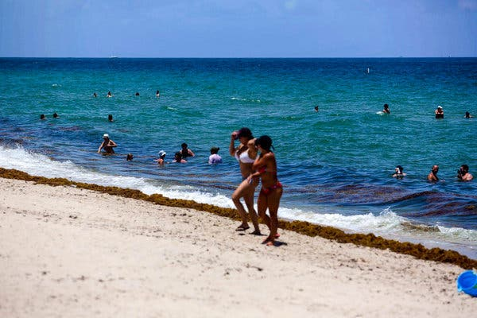

Swimmers at the beach on Thursday in Fort Lauderdale, Fla. The median age of Floridians testing positive for the coronavirus has dropped from 65 in March to 35 now, officials said. Credit...Saul Martinez for The New York Times

**By**[**Julie Bosman**](https://www.nytimes.com/by/julie-bosman)**and**[**Sarah Mervosh**](https://www.nytimes.com/by/sarah-mervosh)

Published June 25, 2020Updated June 27, 2020

CHICAGO — Younger people are making up a growing percentage of new coronavirus cases in cities and states where the virus is now surging, a trend that has alarmed public health officials and prompted renewed pleas for masks and social distancing.

In Arizona, where [drive-up sites are overwhelmed](https://www.nytimes.com/2020/06/25/upshot/virus-testing-shortfall-arizona.html) by people seeking coronavirus tests, [people ages 20 to 44 account for nearly half](https://www.azdhs.gov/preparedness/epidemiology-disease-control/infectious-disease-epidemiology/covid-19/dashboards/index.php) of all cases. In Florida, which breaks records for new cases nearly every day, the median age of residents testing positive for the virus has dropped to 35, down from 65 in March.

And in [Texas, where the governor paused](https://www.nytimes.com/2020/06/25/us/texas-coronavirus-cases-reopening.html) the reopening process on Thursday as hospitals grow increasingly crowded, young people now account for the majority of new cases in several urban centers. In Cameron County, which includes Brownsville and the tourist town of South Padre Island, people under 40 make up more than half of newly reported cases.

**LATINOS AND THE VIRUS**

[*Rates of coronavirus infection among Latinos have risen rapidly across the United States.*](https://www.nytimes.com/2020/06/26/us/corona-virus-latinos.html?action=click&module=RelatedLinks&pgtype=Article)

“What is clear is that the proportion of people who are younger appears to have dramatically changed,” said Joseph McCormick, a professor of epidemiology at UTHealth School of Public Health in Brownsville. “It’s really quite disturbing.”

The pattern is drawing notice from mayors, governors and public health officials, and comes as a worrisome sign for cities and institutions as they look to the fall. The rise in cases among younger people could complicate the plans of leaders who are eager to open schools and universities, resume athletic events and return to normal life and a fully functioning economy.

The increases could reflect a simple reality: Since many states have reopened bars, restaurants and offices, the coronavirus has been allowed to spread more widely across communities, including to more young people. But people in their 20s and 30s are also more likely to go out socializing, experts say, raising concerns that asymptomatic young people are helping to spread the virus to more vulnerable Americans at a time when cases are surging dangerously in the South and the West.

Dr. Robert Redfield, the director of the Centers for Disease Control and Prevention, said on Thursday that younger people have helped fuel the increase in known coronavirus infections — and that in the past, many of those infections went undiagnosed.

“Our best estimate right now is that for every case that was reported, there actually were 10 other infections,” he said.

No single answer fully accounts for the surge of cases among young people, who are less likely to be hospitalized or die from the coronavirus than older people.

“Is it the governor’s reopening? Is it Memorial Day? Is it the George Floyd demonstrations? Is it going to the beach?” said Eric Boerwinkle, dean of the UTHealth School of Public Health in Houston. “We don’t really know, but it is probably all of those things that are contributing.”

The United States recorded 36,975 new cases on Wednesday, a new high point in daily cases as the country confronted a new stage of the crisis two months after the previous high in late April. The resurgence is most immediately threatening states that reopened relatively early in the South and the West. Alabama, Florida, Oklahoma, South Carolina and Texas all reported their highest single-day totals this week, as did Montana and Utah, and cases were rising in 29 states on Thursday.

Adriana Carter, 21, is among the newly infected.

**TWO STATES, DIFFERENT OUTCOMES**

[*With infections surging in Florida while they retreat in New York*](https://www.nytimes.com/2020/06/26/nyregion/florida-new-york-coronavirus.html?action=click&amp;module=Spotlight&amp;pgtype=Homepage&action=click&module=RelatedLinks&pgtype=Article)*, the two states and their governors reflect the shifting course of the pandemic.*

For many weeks this spring, she said, she took steps to limit her exposure, eating many of her meals at her apartment in San Marcos, Texas, and wearing a mask when going in and out of stores. At the one Black Lives Matter protest she attended, most people were in masks.

But after a particularly long week of juggling online summer classes and her job at an eye clinic, Ms. Carter took a risk one Saturday night in early June and met a friend at the Square, a popular bar district downtown. Though they were careful to avoid the most crowded spots, they chose not to wear masks as they sipped drinks inside and endured the hot Texas weather.

Days later, her friend woke up feeling ill. Both tested positive for the virus.

“We were told we could go out to bars,” she said, adding that she had been careful to quarantine since she learned that she had been exposed. “It’s very unusual for anyone in their 20s to stay at home all the time — not giving any excuses or anything, but I just think we are all just trying to do the best we can.”

The new cases among young people may appear to be a departure from the early days of the pandemic when infections in nursing homes were spiraling out of control, and the virus appeared at higher rates among older people in New York City.

Experts cautioned that the seemingly new prevalence among young people may be, in part, a reflection of more widely available testing. But the growing numbers of people hospitalized in states like North Carolina and Texas also suggest increased transmission of the virus.

Even now, people younger than 50 are being hospitalized at a far lower rate than people older than that, [according to C.D.C. data](https://www.cdc.gov/coronavirus/2019-ncov/covid-data/covidview/index.html).

While the effect of the coronavirus on younger people “may not be highly associated with hospitalization and death,” Dr. Redfield said, “they do act as a transmission connector for individuals that could in fact be at a higher risk.”

In Florida, which has emerged as a particularly concerning hot spot, reopened bars have been a source of contagion among young people. The state shut down the Knight’s Pub, a popular bar near the University of Central Florida in Orlando, after 28 patrons and 13 employees were infected.

In Miami-Dade County, the number of known coronavirus cases among 18- to 34-year-olds increased fivefold in a month, to more than 1,000, Mayor Carlos Gimenez said this week.

“They’re thinking they’re invincible,” he said, adding that many of the infected have no symptoms.

They are at higher risk, though, if they are overweight or have diabetes or other medical conditions, he said. About a third of the coronavirus patients at the public Jackson Health System were from that age group, and about half had a high body mass index, Mr. Gimenez said.

Gov. Ron DeSantis described “a real explosion in new cases” among younger people. “Part of that is just natural,” he said. “You kind of go and you want to be doing things. You want to be out and about. The folks who are older and would be more vulnerable are being a bit more careful.”

In fact, some experts believe that a decision by older people to stay home and exercise caution to avoid the virus may, in part, help explain why young people appear to be an increasing portion of new cases.

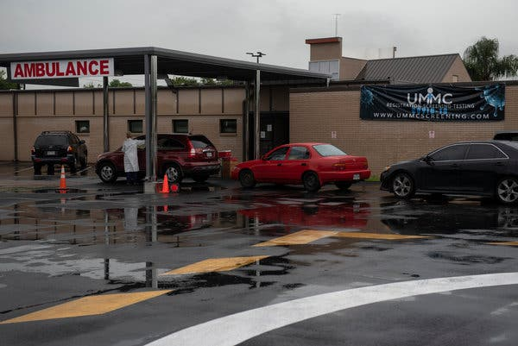

People waited in their cars at a drive-through coronavirus testing site at United Memorial Medical Center in Houston on Thursday.Credit...Callaghan O'Hare for The New York Times

In Dallas County, people between the ages of 18 and 40 have made up 52 percent of newly reported cases since the beginning of June, a jump from the 38 percent that young people represented in March, [according to county data](https://www.dallascounty.org/Assets/uploads/docs/hhs/2019-nCoV/COVID-19%20DCHHS%20Summary_062320.pdf).

Click to access an article from the *TEXAS TRIBUNE:*

“Texas reports more than 8,000 new cases of coronavirus, more than doubling new case counts from two weeks ago,” TEXAS TRIBUNE

<https://apps.texastribune.org/features/2020/texas-coronavirus-cases-map/?utm_source=Editorial%3A+Texas+Tribune+Master&utm_campaign=d7ce90a27a-trib-newsletters-rss-coronavirus&utm_medium=email&utm_term=0_d9a68d8efc-d7ce90a27a-101230397&mc_cid=d7ce90a27a&mc_eid=b94abd8a90>

# “Internal messages reveal crisis at Houston hospitals as coronavirus cases surge,” TEXAS TRIBUNE

<https://www.texastribune.org/2020/07/01/coronavirus-texas-houston-hospitals-cases-surge/?utm_source=Editorial%3A+Texas+Tribune+Master&utm_campaign=d7ce90a27a-trib-newsletters-rss-coronavirus&utm_medium=email&utm_term=0_d9a68d8efc-d7ce90a27a-101230397&mc_cid=d7ce90a27a&mc_eid=b94abd8a90>

*Free access to Texas Tribune*

***The New York Times***

***Coronavirus May Pose a New Risk to Younger Patients: Strokes***

Doctors have reported a flurry of cases in Covid-19 patients — including a healthy 27-year-old emergency medical technician in Queens. After a month in the hospital, he is learning to walk again.

**By**[**Roni Caryn Rabin**](https://www.nytimes.com/by/roni-caryn-rabin)

* Published May 14, 2020, Updated June 3, 2020

Ravi Sharma was doubled over on his bed when his father found him. He’d had a bad cough for a week and had self-quarantined in his bedroom. As an emergency medical technician, he knew he was probably infected with the [coronavirus](https://www.nytimes.com/interactive/2020/06/03/burst/coronavirus-risk-gym-surfaces-bike.html).

Now, Mr. Sharma, 27, could not move the right side of his body, and could only grunt in his father’s direction. His sister, Bina Yamin, on the phone from her home in Fort Wayne, Ind., could hear the sounds.

“Call 911,” she told her father. “I think Ravi’s having a stroke.” She was right.

Over the next few hours, doctors at a Queens hospital worked frantically to break up a blood clot blocking an artery to Mr. Sharma’s brain. But the doctors were puzzled.

Mr. Sharma was far too young for a stroke. He worked out every day and didn’t have diabetes, high blood pressure or the kinds of medical conditions that can set the stage for strokes in young adults, which are rare.

Neurologists in New York City, Detroit, New Jersey and other parts of the country have reported a flurry of such cases. Many are now convinced that unexplained strokes represent yet another insidious manifestation of Covid-19, the illness caused by the new coronavirus.

The cases add to evidence that the coronavirus attacks not just the lungs, but also the kidneys, brain, heart and liver. In rare cases, it seems to trigger a life-threatening inflammatory syndrome in children.

“We’re seeing a startling number of young people who had a minor cough, or no recollection of viral symptoms at all, and they’re self-isolating at home like they’re supposed to — and they have a sudden stroke,” said Dr. Adam Dmytriw, a University of Toronto radiologist who is a co-author of [a paper describing patients who suffered strokes related to Covid-19](https://www.medrxiv.org/content/10.1101/2020.05.03.20077206v1). The paper has not yet been peer reviewed.

Though many of those patients had diabetes and hypertension, none had heart risks known to increase the odds of a stroke. Many were under age 65. For some, stroke was the first symptom of coronavirus infection, and they postponed going to the emergency room, fearing exposure.

Of 10 patients described in Dr. Dmytriw’s paper, two died because the coronavirus attacked their lungs, and two men — a 46-year-old and a 55-year-old — were killed by strokes.

Doctors at Mount Sinai Health System in New York have also seen an unusual number of young stroke patients, saying they [treated five such patients with Covid-19](https://www.nejm.org/doi/full/10.1056/NEJMc2009787) during a recent two-week period. The medical center typically sees only one stroke patient under the age of 50 every three weeks, Dr. Johanna Fifi, a neurologist, and her colleagues noted in a letter in The New England Journal of Medicine.

*_____________________________________________________________________*

**KHOU-TV**

**“Call for statewide mask mandate in Texas amid COVID-19 surge;** Medical experts continue to stress that wearing a mask or face covering is among the best ways to stay safe.

Author: Jason Miles

Published: 4:18 PM CDT July 1, 2020

Updated: 5:53 PM CDT July 1, 2020

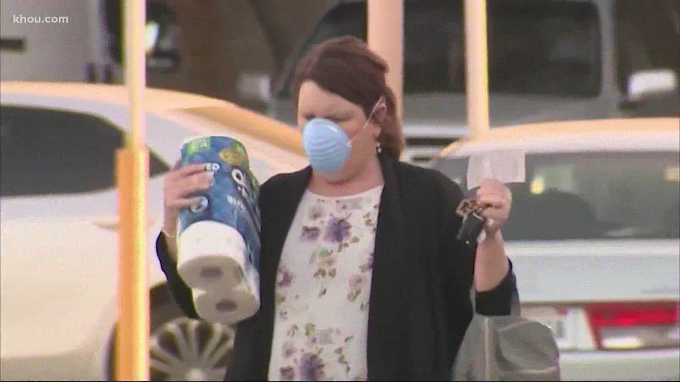

Volume 90%

HOUSTON, Texas — A properly fitting mask or face covering continues to be part of the prescribed method of helping to control COVID-19.

"It should fit snuggly over your mouth and your nose," said Dr. James McDeavitt with Baylor College of Medicine in Houston.

McDeavitt considers mask usage, social distancing and good hygiene more important than ever as new cases surge.

"We need to change behavior fairly rapidly," said McDeavitt. "Because the changes we make today, based on the incubation period of the virus, aren’t going to show up for another two weeks.”

The Texas Democratic Party urged Gov. Greg Abbott to issue a statewide mask mandate during a virtual news conference on Wednesday morning.

Meanwhile, Texas set a new single-day record with 8,076 new COVID-19 cases.

"A mandate for wearing masks is the most effective thing we can do to stop the spread of this coronavirus,” said state Rep. Donna Howard of Austin.

Abbott previously issued an executive order banning local governments from penalizing people who don’t wear masks in public.

But he did not oppose newer rules, like those in Harris County, that require face coverings inside businesses.

Right now, 10 rural counties in Texas have zero positive cases of COVID-19, according to Texas Department of State Health Services data.

Many others have very low numbers compared to metro areas.

That's why some say putting all counties in one basket through a statewide order is not needed.

County judges in Polk and Trinity counties told KHOU 11 News there’d be no way for them to enforce a mask mandate anyway.

"But certainly today, based on the science and scientist opinions, there’s no question that people should be masking in public spaces,” said Dr. McDeavitt.

He said that advice applies regardless of what the official rules may or may not say.

[Find out more about county case numbers here](https://txdshs.maps.arcgis.com/apps/opsdashboard/index.html#/ed483ecd702b4298ab01e8b9cafc8b83).

**WEBMD NEWS BRIEF**

# Fauci Urges Mask Use, Says Young at Great Risk

By [Brenda Goodman, MA](https://www.webmd.com/brenda-goodman)

June 29, 2020 -- In its first press conference in nearly two months, members of the White House Coronavirus Task Force acknowledged Friday that COVID-19 cases are rising again across the South, but stressed that the country was in a much better position to handle the increase than it was just a few months ago.

Vice President Mike Pence, who is leading the task force, said the U.S. was in better shape to weather a new uptick in cases thanks to new therapeutics like the drugs remdesivir and dexamethasone, expanded hospital capacity, increased testing, and greater domestic production of personal protective equipment.

Members of the task force also issued a warning to younger adults, who make up the majority of the new infections.

“A risk for you is not just isolated to you. If you get infected, you are innocently or inadvertently responsible for propagating the pandemic,” said Anthony Fauci, MD, director of the National Institute for Allergy and Infectious Diseases.

Fauci said that while the outbreak may seem to be blooming only in certain cities or counties, everyone needs to continue to be vigilant because “We are all interconnected. We can’t get away from that.”

Fauci stressed that while younger adults who are infected may not wind up in the hospital or dying at the same rates as the elderly, they can spread the infection to others whose bodies aren’t capable of fighting it off.

“That may be somebody’s grandmother, grandfather, uncle who’s on chemotherapy or aunt who’s on radiation or a child who has leukemia,” Fauci said.

Fauci, Deborah Birx, MD, coronavirus response coordinator, Robert Redfield, MD, director of the CDC, and HHS Secretary Alex Azar, each wore masks to the briefing. Pence did not.

“We say to every American, particularly those in counties and states that are being impacted with rising cases, now is the time for everybody to continue to do their part,” Pence said.

“None of us would want to bring the disease back to our parents or grandparents, moms or dads,” he said.

He recommended Americans practice good hygiene, wash their hands, avoid touching their faces, disinfect frequently, stay home if they feel sick and to check temperatures and isolate. He did not mention wearing a mask in public.

When asked by a reporter if he had a message about masks, Pence declined to answer, saying instead that people should follow the guidance from their state and local health officials.

**DALLAS MORNING NEWS**

# Feds planning to ‘blitz’ test in Texas to find young adults silently spreading COVID-19

## **People under age 39 make up a growing share of positive coronavirus cases in Dallas County, public health officials say.**

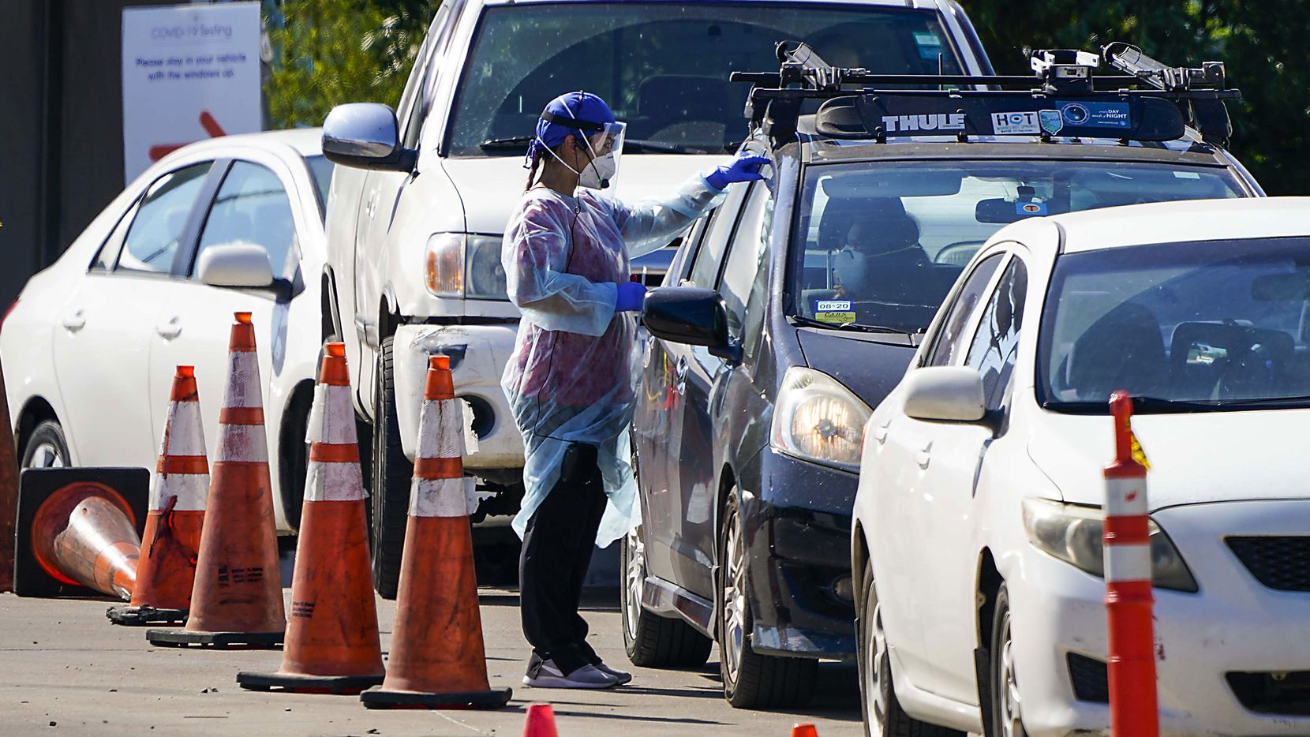

A healthcare worker interacts with motorists at a drive-thru COVID-19 testing facility Wednesday, June 17, 2020, in Dallas. The COVID-19 testing center in South Dallas is a partnership between the City of Dallas, Dallas County, CitySquare and Kroger Health.

By [Allie Morris](https://www.dallasnews.com/author/allie.morris@dallasnews.com)

**1:48 PM on Jul 1, 2020 — Updated at 8:22 PM on Jul 1, 2020**

AUSTIN — Federal officials are developing plans for a “blitz” of testing in Texas and other states to find young adults who have no symptoms and may be unknowingly spreading the coronavirus.

The effort would target people under age 35 in “moderate sized” communities, which have not yet been named.

“The strategy would be to surge test,” Admiral Brett Giroir, the Assistant Secretary for Health at the U.S. Department of Health and Human Services said in a press call Wednesday.

“You would do the number of tests you do in a month in just a few days, to try to make sure we identify these asymptomatics and get a better handle on them.”

The department is currently in discussions with state health officials in Texas, Florida and Louisiana, Giroir said.

The announcement comes as new coronavirus cases and hospitalizations are surging in Texas to their highest levels since the pandemic began. On Wednesday the state reported 8,076 new cases. It’s the the first time Texas crossed 8,000 cases, an increase of more than 1,000 from Tuesday’s record number.

In addition, the 6,904 lab-confirmed COVID-19 patients in Texas hospitals hit a record high for the third day in a row.

[[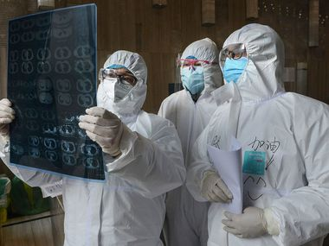](https://www.dallasnews.com/news/public-health/2020/03/03/everything-you-need-to-know-about-the-new-coronavirus/)](https://www.dallasnews.com/news/public-health/2020/03/03/everything-you-need-to-know-about-the-new-coronavirus/)

[PUBLIC HEALTH](https://www.dallasnews.com/news/public-health)

### [What you need to know about coronavirus, plus a map of every case in Texas](https://www.dallasnews.com/news/public-health/2020/03/03/everything-you-need-to-know-about-the-new-coronavirus/)

BY WIRE SERVICES AND [TOM STEELE](https://www.dallasnews.com/author/tom-steele)

People under age 35 are driving up the case counts and many likely have mild symptoms or none at all, Giroir said.

More than half the cases reported in Dallas County since June 1 have been diagnosed in young adults between the ages of 18 and 39, public health officials said.

In an effort to slow the spread, Gov. Greg Abbott shut down bars last week and also reduced the capacity at restaurants to 50%. In mid-June, he [**scolded 20-year-olds for not wearing masks**](https://www.dallasnews.com/news/public-health/2020/06/15/texas-gov-greg-abbott-scolds-20-somethings-for-not-wearing-masks-taking-coronavirus-too-lightly/)or following social distancing guidelines. While some cities and counties are now requiring masks inside businesses, Abbott has not mandated that everyone wear one in public.

It is not clear when the testing surge would begin, who would be targeted or how officials would ensure compliance. The Texas Division of Emergency Management confirmed the state is working with federal officials to increase testing in Texas and said more details will be coming soon.

Abbott’s office did not respond to a request for comment.

Demand for coronavirus testing has surged in recent weeks and is [**challenging labs’ ability to keep up.**](https://www.dallasnews.com/news/politics/2020/06/30/overwhelming-demand-for-covid-19-tests-long-waits-for-results-hamper-texas-effort-to-control-spread/) In Dallas County, some test results are taking a week or more to come back. Any delays in results make it harder to track down others who may have come into contact with an infected person.

Giroir said doing contract tracing on large numbers of asymptomatic, young adults is difficult.

“That is different than going into a meat packing plant or to a factory where somebody has a sickness and you know who they ate lunch with, who’s on that assembly line,” he said. “So it’s a different situation.”

The state has already undertaken [**efforts to surge test**](https://www.dallasnews.com/news/public-health/2020/06/14/delays-in-test-results-frustrate-local-efforts-to-stem-spread-of-covid-19-in-texas/) in nursing homes, meat packing plants and jails — all known breeding grounds for the virus.

While young adults are less likely than older people to develop severe cases of COVID-19, they still can. At least two dozen people under age 40 have died from the disease in Texas, [**according to state data**](https://txdshs.maps.arcgis.com/apps/opsdashboard/index.html#/ed483ecd702b4298ab01e8b9cafc8b83). But that’s likely an undercount because the current data captures information for less than 30% of the state’s 2,424 deaths to date.

In Dallas County, a Dallas woman in her 20s was one of seven deaths reported Wednesday, along with 544 new COVID-19 cases.

**HOUSTON CHRONICLE**

# *Harris County young adults contracted COVID-19 at higher rates over the past month, leading to a massive spike*

[*Samantha Ketterer*](https://www.houstonchronicle.com/author/samantha-ketterer/)*and*[*Jordan Rubio*](https://www.houstonchronicle.com/author/jordan-rubio/)*June 27, 2020 Updated: June 28, 2020 7:46 p.m. HOUSTON CHRONICLE*

*2*

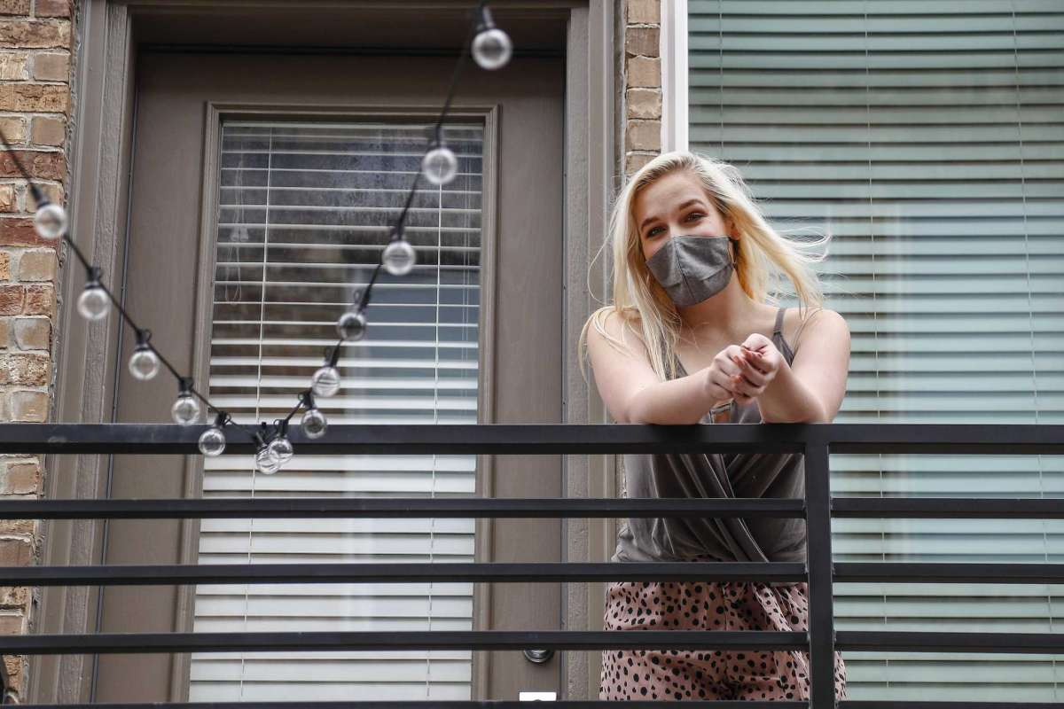

*1of2Peyton Chesser contracted COVID-19 earlier this month, two days after going to a cycle studio. She’s not sure if she picked it up there for sure, but she says she’s been really careful and has really only left the house to go to the grocery store. Photographed on her balcony, Saturday, June 27, 2020, in Houston .Photo: Karen Warren, Houston Chronicle / Staff photographer*

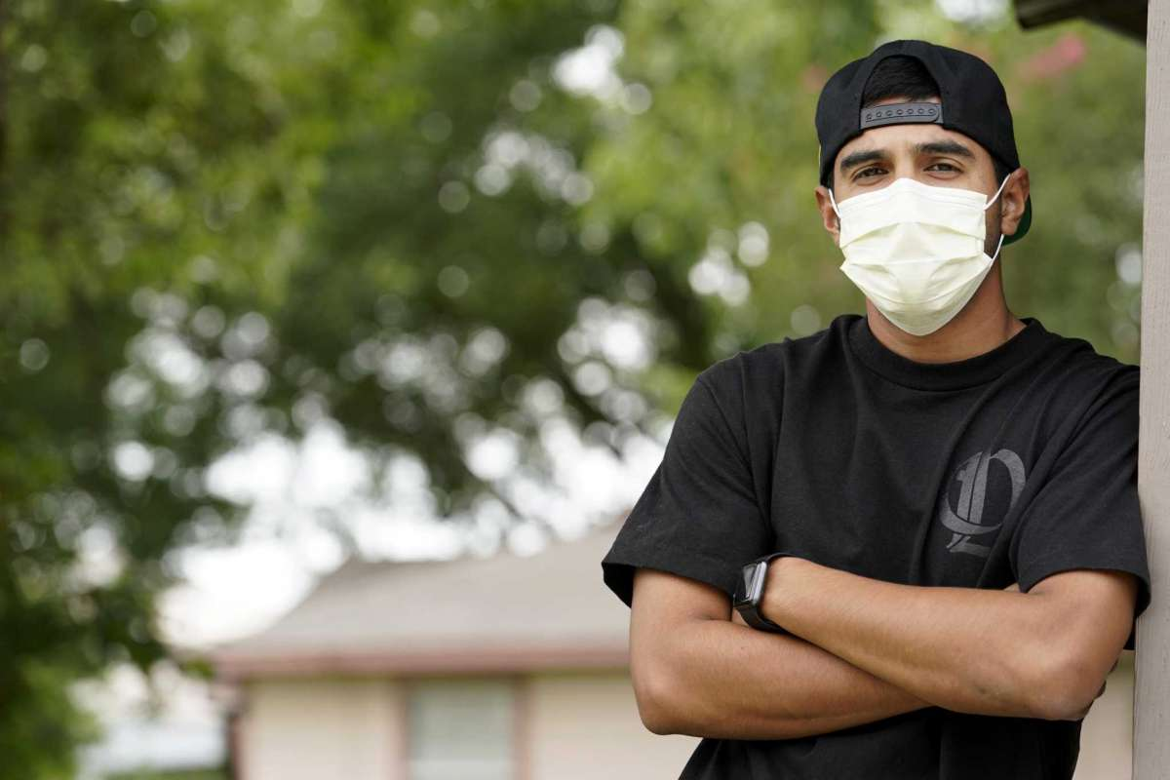

*2of2Dom Frisko, who contracted COVID earlier this month and is using social media to warn others, is shown Saturday, June 27, 2020, in Houston.*

Peyton Chesser played it safe for weeks, rarely leaving her apartment even as she watched her peers venturing to gyms and flocking to bars in Houston’s midtown.

Eventually, she caved. The 23-year-old law student attended one class at her cycle studio, and she developed COVID-19 symptoms just two days later.

The diagnosis turned Chesser into another case in a growing trend: Harris County’s young adults contracted COVID-19 at higher rates than all other age groups over the past month, leading to a massive spike in coronavirus cases that has sprung the area into its highest [“Code Red” threat level](https://www.houstonchronicle.com/news/houston-texas/houston/article/harris-county-hidalgo-threat-level-stay-at-home-15368478.php).

The number of reported coronavirus cases has tripled in Harris County since mid-May. People 20 to 29 made up nearly a quarter of all new cases, according to a Houston Chronicle analysis of Harris County Public Health data.

That group now accounts for more than a fifth of the county’s total confirmed cases, up from a little more than 16 percent May 15.

People ages 30 to 39 made up roughly the same amount, making those two age groups the largest drivers of the increase — mirroring state and national trends that place younger people at the center of the dramatic surge.

Chesser lamented that she might have picked up the disease the first time she went to a nonessential business — it wasn’t worth it, she said. But she doesn’t fault the studio, and she finds it hard to blame millennials when it is legal to enter the establishments that they frequent.

“You can’t allow the state’s leadership and government to say that something is all right to do ... and then get upset with them for doing what they were allowed to do,” she said. “They failed people.”

As the state moved forward with reopening, Houston physicians watched with concern as case numbers skyrocketed in June, even while [patients in their hospitals seemed less ill](https://www.houstonchronicle.com/news/houston-texas/houston/article/hospital-coronavirus-surge-non-ICU-beds-spike-15350915.php).

Given that the disease generally affects young people less seriously, medical leaders realized that young people could be at the root of the uptick. Citing their own lack of completed studies, they have declined to say whether young people are definitively driving the increase, but they agreed that all signs pointed in that direction.

“I don’t mean to be throwing the 20-somethings under the bus,” said Houston Health Authority director Dr. David Persse. “It’s real.”

## **‘Nature of the beast’**

While people of all ages have been getting sick from the coronavirus, there has been a significant increase in the number of cases for people ages 20 to 29, according to local health data, with more than 4,000 newly reported cases in that age group since mid-May.

On the other hand, people 40 and older, while still seeing an increase in the number of cases, constitute a smaller portion of the overall number compared with their younger counterparts. They went from making up 55 percent of all cases to a little more than 46 percent as of June 26.

That’s ultimately good news for older people who are more vulnerable to the disease, but the rise in young adult cases is preventable by going out less or wearing masks more, said Dr. Roberta Schwartz, executive vice president of Houston Methodist.

“I think that we’re doing a very good job in Houston, or a better job, of keeping our elderly protected,” she said. “But there are far more millennials and younger people out and about.”

Young adults who are less at risk of serious complications from the disease also have a false sense of security, Persse said, making them more likely to assess their own personal risk and take a chance.

“Now is the worst time to think that way,” Persse said. “Some 20-somethings are going to get sick with a capital S.”

Several Houston hospitals could not immediately provide data on hospitalization rates among people in their 20s or 30s, but executives said they have seen young people in ICUs and intubated. In some cases, they are discharged with long-term lung damage, Persse said.

Despite the surge in cases, younger people are not dying of the virus anywhere close to the rate of older people. Only two people under 30 have died from COVID-19 in Harris County, and they both had an underlying health condition, according to local health data. Seven people between 30 and 39 have died from coronavirus.

As of June 26, people 60 and older make up more than 80 percent of the county’s 361 deaths despite making up less than half of the county’s 27,000-plus confirmed cases.

Some of that discrepancy in death rates has naturally led to a feeling of indestructibility in millennials, said James McDeavitt, senior vice president and dean of clinical affairs at Baylor College of Medicine. Coupled with young people’s greater needs for social interaction, he said, it’s easy to see how people in their 20s are contributing so heavily to the increase.

“It’s not a moral failing on the part of people,” he said. “It’s just the nature of the beast.”

## **‘You kind of get comfortable’**

Dom Frisko, 28, took the end of the statewide stay-at-home order as a sign that the situation was improving.

*[[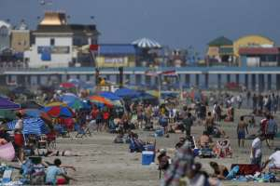](https://www.houstonchronicle.com/news/houston-texas/houston/article/Coronavirus-concerns-prompt-city-of-Galveston-to-15380533.php?source=nlp)](https://www.houstonchronicle.com/news/houston-texas/houston/article/Coronavirus-concerns-prompt-city-of-Galveston-to-15380533.php?source=nlp)*

###### ***[NICK POWELL](https://www.houstonchronicle.com/news/houston-texas/houston/article/Coronavirus-concerns-prompt-city-of-Galveston-to-15380533.php?source=nlp)***

#### **[Galveston beaches to close for July 4th weekend amid sharp rise...](https://www.houstonchronicle.com/news/houston-texas/houston/article/Coronavirus-concerns-prompt-city-of-Galveston-to-15380533.php?source=nlp)**

He watched an increasing number of people leave their homes without getting sick. He didn’t know anyone with COVID-19, either.

“Maybe it’s not as bad as they say,” he said.

On June 7, he came down with the disease, experiencing fever, body aches, and later, a loss of taste and smell. It’s hard to know where he contracted the coronavirus, but he said it was likely one of three places: in Kemah, at a bar, or at the gym.

At all of the spots, masks were scarce and people didn’t always follow social distancing guidelines, Frisko said.

“At first I would go out and I had a mask on, and you see nobody’s wearing a mask,” he said. “You kind of get comfortable.”

Now, as cases continue to skyrocket in Houston and across Texas, state leaders are reinstating measures to combat the spread.

Gov. Greg Abbott [ordered bars to be closed](https://www.houstonchronicle.com/politics/texas/article/Gov-Abbott-closes-all-bars-in-Texas-coronavirus-15368523.php) by noon Friday, and he has scaled back restaurant occupancy from 75 to 50 percent. Texas had surpassed 5,100 COVID-19 hospitalizations, with more than 1,800 of them in the 25-county region in Southeast Texas, according to the Southeast Texas Regional Advisory Council.

Chesser and Frisko are waiting for negative test results while self-isolating at home. Both of them are open about their COVID-19 diagnoses, posting about their experiences and fielding questions from friends on social media.

Moving forward, they each said they plan to be more careful. Studies aren’t conclusive on whether they will maintain immunity, and they don’t want to spread the virus to anyone else.

“I’m going to question myself, ‘Do I need to go to this place or not?’” Frisko said. “I just want to be more safe for other people.”

**CBS NEWS** *July 1, 2020, 8:34 AM*

***“Young adults unconcerned by coronavirus "may be killing other people," doctor warn***

Young people are out enjoying the warmer weather across the country, but according to health officials, they also might be spreading and contracting the [coronavirus](https://www.cbsnews.com/feature/coronavirus/). As people pack into parks, beaches, restaurants, bars and even concerts, cases are rising in at least 37 states, with surges among young people linked to everything from fitness classes to summer fraternity parties.

"I'm not too scared of getting sick," said Chris Clarici in San Francisco.

"I just personally don't care," said a young person in Boston. "I haven't got sick yet."

Experts have warned that attitude is dangerous.

"They may be indirectly hurting people by infecting someone who then infects someone, who then infects someone who's vulnerable," Dr. Anthony Fauci, the nation's top infectious disease expert, said last week.

In Arizona, nearly half of coronavirus cases are people 20 to 44 years old. Last week, President Donald Trump spoke at a rally in the state where the crowd of around 3,000 people was mostly young and maskless.

In Hays County, Texas, about 30 miles outside of Austin, young adults make up more than half of all cases. In Florida, a coronavirus hotspot, the highest number of cases are among people between the ages of 25 and 34 years old.

"If I get it, then, you live with your consequences," said Bojan Atanasovski, a 25-year-old West Palm Beach resident.

Atanasovski, who works as a salesman, said he wears a mask in places where it's required but he doesn't want coronavirus to stop him from living life.

"I need something to unwind," he told "CBS This Morning" lead national correspondent David Begnaud. "Some people like reading. Some people like working out. ... I like, you know, going and seeing other people as well. Now, if I had to go out and do that with a face mask, right, if they required it to wear a face mask, sure, I'll do that. But if they don't require it, I would choose not to."

Dr. Charles Lockwood, the senior vice president of University of South Florida Health, said he has observed a change in coronavirus cases over the last few weeks.

"The age of cases is what is most remarkable. That has been dropping steadily," he said.

Lockwood has administered more than 300 coronavirus tests and is alarmed by the spike among young people.

"It really is consistent with what we've been observing, which is incredible noncompliance with wearing face masks, social distancing, particularly among young adults and teenagers," he said.

Lockwood recognized that young people have "a different way of looking at life."

"The problem is that while you may not die and you may not even know you're sick, you may be killing other people," he said.

Sophia Carrion, who lives with her parents in Los Angeles, said she's strict about social distancing and wearing a mask.

"If my parents were to get sick, ... I would not be able to live with myself," she said.

The 23-year-old has a message to young people not taking the virus seriously.

"It's not just about you. I think that's a big mindset people have, like, 'Oh, if I get it, I'll be fine, it's just the flu.' Maybe, but you don't want to pass it to someone who could be more vulnerable or more susceptible," she said.

Carrion said she thinks young people have a bad reputation and pointed out that there are also older people who don't wear masks or social distance.

While young people are less likely to be hospitalized or die of COVID-19, last week, two 17-year-olds died from the virus in Florida.

*© 2020 CBS Interactive Inc. All Rights Reserved.*

**The New York Times**

***How Is the Coronavirus Outbreak Affecting Your Life?***

How are you staying connected and sane in a time of social distancing?

**By**[**Jeremy Engle**](https://www.nytimes.com/by/jeremy-engle)

Published March 20, 2020, Updated March 24, 2020

The coronavirus has changed how we [work](https://www.nytimes.com/2020/03/12/smarter-living/wirecutter/work-from-home-if-boss-doesnt-want-you-coming-in.html), [play](https://www.nytimes.com/2020/03/16/sports/coronavirus-canceled-youth-sports.html) and [learn](https://www.nytimes.com/interactive/2020/03/10/us/covid-19-seattle-washington-home-schooling-remote.html): Schools are closing, sports leagues have been canceled, and many people have been asked to work from home.

On March 16, the Trump administration [released new guidelines](https://www.nytimes.com/2020/03/16/world/live-coronavirus-news-updates.html) to slow the spread of the coronavirus, including closing schools and avoiding groups of more than 10 people, discretionary travel, bars, restaurants and food courts.

How are you dealing with these sudden and dramatic changes to how we live? Are you practicing social distancing — and are you even sure what that really means?

In “[Wondering About Social Distancing?](https://www.nytimes.com/2020/03/16/smarter-living/coronavirus-social-distancing.html)” Apoorva Mandavilli explains the term and offers practical guidance from experts:

**What is social distancing?**

Put simply, the idea is to maintain a distance between you and other people — in this case, at least six feet.

That also means minimizing contact with people. Avoid public transportation whenever possible, limit nonessential travel, work from home and skip social gatherings — and definitely do not go to crowded bars and sporting arenas.

“Every single reduction in the number of contacts you have per day with relatives, with friends, co-workers, in school will have a significant impact on the ability of the virus to spread in the population,” said Dr. Gerardo Chowell, chair of population health sciences at Georgia State University.

This strategy saved thousands of lives both during the Spanish flu pandemic of 1918 and, more recently, in Mexico City during the 2009 flu pandemic.

The article continues with expert responses to some common questions about social distancing. Here are excerpts from three:

**I’m young and don’t have any risk factors. Can I continue to socialize?**

Please don’t. There is no question that older people and those with underlying health conditions are most vulnerable to the virus, but young people are by no means immune.

And there is a greater public health imperative. Even people who show only mild symptoms may pass the virus to many, many others — particularly in the early course of the infection, before they even realize they are sick. So you might keep the chain of infection going right to your own older or high-risk relatives. You may also contribute to the number of people infected, causing the pandemic to grow rapidly and overwhelm the health care system.

If you ignore the guidance on social distancing, you will essentially put yourself and everyone else at much higher risk.

Experts acknowledged that social distancing is tough, especially for young people who are used to gathering in groups. But even cutting down the number of gatherings, and the number of people in any group, will help.

**Can I leave my house?**

Absolutely. The experts were unanimous in their answer to this question.

It’s O.K. to go outdoors for fresh air and exercise — to walk your dog, go for a hike or ride your bicycle, for example. The point is not to remain indoors, but to avoid being in close contact with people.

You may also need to leave the house for medicines or other essential resources. But there are things you can do to keep yourself and others safe during and after these excursions.

When you do leave your home, wipe down any surfaces you come into contact with, disinfect your hands with an alcohol-based sanitizer and avoid touching your face. Above all, frequently wash your hands — especially whenever you come in from outside, before you eat or before you’re in contact with the very old or very young.

**How long will we need to practice social distancing?**

That is a big unknown, experts said. A lot will depend on how well the social distancing measures in place work and how much we can slow the pandemic down. But prepare to hunker down for at least a month, and possibly much longer.

In Seattle, the recommendations on social distancing have continued to escalate with the number of infections and deaths, and as the health system has become increasingly strained.

“For now, it’s probably indefinite,” Dr. Marrazzo said. “We’re in uncharted territory.”

Abdullah Shihipar writes in an Opinion essay, “[Coronavirus and the Isolation Paradox](https://www.nytimes.com/2020/03/13/opinion/coronavirus-social-distancing.html),” that while social distancing is required to prevent infection, loneliness can make us sick:

A paradox of this moment is that while social distancing is required to contain the spread of the coronavirus, it may also contribute to poor health in the long run. So while physical isolation will be required for many Americans who have Covid-19 or have been exposed to it, it’s important that we don’t let such measures cause social and emotional isolation, too.

The Health Resources and Services Administration cautions that loneliness can be as damaging to health as smoking 15 cigarettes a day. Feelings of isolation and loneliness can increase the likelihood of depression, high blood pressure, and death from heart disease. They can also affect the immune system’s ability to fight infection — a fact that’s especially relevant during a pandemic. Studies have shown that loneliness can activate our fight-or-flight function, causing chronic inflammation and reducing the body’s ability to defend itself from viruses.

The essay continues:

For solutions, we can look to countries where people have been dealing with coronavirus for some time. As the BBC reported, people in China are turning to creative means to stay connected. Some are streaming concerts and gym classes. Others are organizing virtual book-club meetings. In Wuhan, people gathered at their windows to shout “Wuhan, jiayou!” which translates to “Keep fighting, Wuhan!” A business owner packed 200 meals for medical workers, while a villager in a neighboring province donated 15,000 masks to those in need.

For those of us who know people, especially elderly people, who may be isolated, get connected. Check in daily and look for ways to spend time together, either through a FaceTime or WhatsApp call, through collaborative gaming or just by using the telephone.

It concludes:

It may provide some comfort to know that thousands of other people are going through the same thing, and as in China, collective coping strategies will emerge. TikTok videos, memes, stories, essays and poems about living in isolation will all become part of the culture. We could come out of this feeling more connected to each other than before.

***The New York Times***

**Facing Adulthood With an Economic Disaster’s Lasting Scars**

Those entering the job market in a downturn may never catch up in pay, opportunities or confidence.

**By**[**Eduardo Porter**](https://www.nytimes.com/by/eduardo-porter)**and**[**David Yaffe-Bellany**](http://www.nytimes.com/by/david-yaffe-bellany)

Published May 19, 2020, Updated May 20, 2020

Matthew Henderson couldn’t be entering the job market at a worse time. As a senior at Loyola University, he spent the spring semester interning as a trade policy analyst at the British Consulate in Chicago. But his chances of turning that opportunity into a permanent job after graduation ran headlong into the coronavirus pandemic.

Now Mr. Henderson is at home with his family in South Bend, Ind., unemployed and considering jobs at Costco and Target to help pay off $24,000 in student loans. “I’m in this bubble of anxiety,” said Mr. Henderson, who just turned 21. “I have to pay these, but I have no money to pay them.”

Saddled with debt, and entering a job market devastated by the pandemic, he and millions of his contemporaries face an exceptionally dicey future.

Young adults, especially those without a college degree, are particularly vulnerable in recessions. They are new to the job market — with scant on-the-job experience and little or no seniority to protect them from layoffs. A large body of research — along with the experience of those who came of age in the last recession — shows that young people trying to start their careers during an economic crisis are at a lasting disadvantage. Their wages, opportunities and confidence in the workplace may never fully recover.

And in the worst downturn in generations — one with no bottom in sight — the pattern is beginning to play out with a vengeance. From March to April, employment dropped by a quarter for workers 20 to 24 years old, and 16 percent for those 20 to 29. That compares with about 12 percent of workers in their 50s.

In an [article for Lawfare](https://www.lawfareblog.com/world-war-covid-19-who-bleeds-who-pays), a blog about law and national security, the historian David Kennedy and the retired general Karl Eikenberry likened the current crisis to wartime, when elders send the young to fight and die. “It is the young — indebted students and struggling mortgagors, parents supporting families paycheck to paycheck, precarious recent graduates and anxious first-time job seekers — whose lives will be most deeply scarred,” they wrote.

For some younger workers, this is the second blow in barely a decade. An [analysis by the McKinsey Global Institute](https://www.mckinsey.com/industries/public-sector/our-insights/covid-19-and-jobs-monitoring-the-us-impact-on-people-and-places) noted that “the generation that first entered the job market in the aftermath of the Great Recession is now going through its second ‘once-in-a-lifetime’ downturn.”

Molly Zerjal, a 32-year-old in St. Louis, lost a communications job at Wells Fargo during the last downturn. Now, Ms. Zerjal works in marketing at a different financial firm, and she’s afraid it could happen again.

“I’m not an essential worker: marketing and communications is a ‘nice to have,’” she said. “Every day, I’m like, ‘Oh, God, what could happen today?’ It’s like P.T.S.D.”

The question is what kind of scars this will leave in the hearts, minds and pockets of younger people.

Jordan Haggard, 33, graduated from Oklahoma State University in 2009 in the depths of the recession. The job market was dire: When she applied for a job at McDonald’s, she never heard back.

Ten years later, Ms. Haggard works as an office manager for a small publishing company in Seattle. She has kept her job during the pandemic, even as some colleagues have been furloughed. But she still feels the effects of 2009.

“I know I will never be able to afford a home in Seattle or even live by myself without a roommate or two,” Ms. Haggard said. “Life is different from the one I was told about or imagined.”

Indeed, Jesse Rothstein of the University of California, Berkeley, [followed college graduates](https://eml.berkeley.edu/~jrothst/workingpapers/rothstein_scarring_052019.pdf) who entered the labor market after the 2008 financial crisis. By 2018, those who had landed jobs in 2010 and 2011 had a lower employment rate than people at the same age who graduated before the recession hit, and those working earned less.

The effects are likely to persist. Lisa B. Kahn, an economics professor at the University of Rochester, tracked young white men who graduated from college from 1979 to 1988, a period that included the double-dip recession of the early 1980s. Over the next two decades, [she found,](https://pdfs.semanticscholar.org/a16a/033a9b71bc7eeafe5419053ae608fd3368a3.pdf?_ga=2.129414732.1352823761.1588859993-1755115163.1588859993) they got stuck in low-quality, low-pay jobs. Even after the economy recovered, they had a hard time moving into better jobs.

The causes seem varied. Recession graduates, with limited opportunities, will start in jobs that are a worse fit. Once the economy recovers, they will compete for jobs with people who have more experience. In addition, Ms. Kahn noted, recession graduates seem more risk averse. “People that graduate into a recession don’t change jobs as often as people that graduate into booms,” she noted. And these job changes are one of the best ways to get a raise.

The difficult start shadowed many through their careers. Till von Wachter of the University of California, Los Angeles, and Hannes Schwandt of Northwestern University followed Americans who entered the labor market in 1981 and 1982, during the largest postwar recession up to that time.

They not only earned less in midlife. They were also less likely to be married or to have children, and more likely to die young, recording higher mortality rates starting in their 30s — driven by heart disease, lung cancer, liver failure and drug overdoses — what two Princeton scholars, Anne Case and Angus Deaton, have called “deaths of despair.”

And, of course, young workers without a college degree are likely to fare even worse. “Recessions, in general, widen inequality,” Ms. Kahn said. “The more disadvantaged groups — minorities, the young, those with less education — are the hardest hit.”

In the coronavirus pandemic, the lopsided impact of business shutdowns on the young risks opening a generation gap with their elders who are more likely to die of the disease.

The diverging interests could affect policy as soon as this summer. In a [research paper](https://www.nber.org/papers/w27046) published last month, Dirk Krueger of the University of Pennsylvania and three colleagues estimated that people past retirement age would choose to close a much larger share of nonessential businesses and keep them closed, while younger workers in those shuttered businesses have the most to lose. “The conflict between the old and the young is severe,” Mr. Krueger noted.

The asymmetric aftershocks of this pandemic are likely to ripple across society far into the future.

Jordan Meier, who just graduated from the University of Missouri, has been hunting for a job as a reporter since February. Despite a strong résumé, she’s been able to find only a summer internship offering $250 a month, barely enough for her car payments, and no full-time prospects beyond that.

“You work for years, you go through school, and you get to this point where you’re preparing to get a job,” she said. “And now I can’t do that. It’s very frustrating.”

“It’s not something I feel like any of my professors, my parents or really anybody has any knowledge about,” she added. “They never had to deal with it.”

**HOUSTON CHRONICLE**

**July 1, 2020**

*TMC [Texas Medical Center] hospitals go into Phase 2 surge plans as ICU capacity exceeds 100 percent*

[Todd Ackerman](https://www.houstonchronicle.com/author/todd-ackerman/)

July 1, 2020 Updated: July 1, 2020 9:15 p.m.

2

Texas Medical Center executives and Harris County health officials predict that as COVID-19 cases and hospitalizations continue to rise, the Houston area will effectively return to stay-at-home status as many businesses close due to sickness.

With the number of intensive-care patients now exceeding capacity, Texas Medical Center hospitals have begun implementing COVID-19 surge plans that leaders thought might not be necessary after numbers fell far short of projections in April and May.

The hospitals this week began opening additional beds — both intensive care and regular floor beds, some new, some converted — to accommodate a surge in COVID-19 patients that has grown exponentially in the past two weeks. The actions followed the hospitals’ collective ICU bed volume topping 100 percent capacity Wednesday.

“It’s actually possible that we could become the next New York City,” said Roberta Schwartz, president of Houston Methodist Hospital. “I can’t believe we’re now staring down the barrel of that gun.”

Schwartz noted that Methodist’s COVID-19 volumes are expected to approach 600 by the end of the week; its high dating back a month or more was about 260. Memorial Hermann hit 719 cases Wednesday; it was in the mid-150s in mid-May.

<https://www.houstonchronicle.com/news/health/article/TMC-hospitals-go-into-Phase-2-surge-plans-as-ICU-15380224.php>

**HOUSTON CHRONICLE**

Houston coronavirus updates: What you need to know for July 1

[Rebecca Hennes](https://www.houstonchronicle.com/author/rebecca-hennes/)July 1, 2020

68

Tuesday marked the highest single-day increase in COVID-19 cases for the state to date with more than 7,000 new cases reported, according to the Houston Chronicle's data team.

From Monday to Tuesday, cases had risen by 4.9 percent, or 7,726 cases, to a total of 164,724 statewide. The statewide total has more than doubled since the end of May, and the rolling average for new cases is now at 5,866.9 cases. An additional 42 new deaths were reported,

In the Houston region, cases have doubled since the end of May; there are now 43,673 confirmed cases in the region, a 2.8 percent increase from Monday. Harris County saw a 2.3 percent increase, or 693 new cases, and is now at 31,422 cases total. Three more deaths were reported in the Houston region; the death count is now at 534.  
   
As of Tuesday evening, 6,533 people have been hospitalized with COVID-19 across Texas. There are 13,711 beds available and 5,561 ventilators still available.

Harris County is [under a face mask order through Aug. 26](https://www.chron.com/coronavirus/article/Houston-coronavirus-updates-What-you-need-to-15376259.php) and residents are encouraged to stay home except for essential needs.  The order mandates county businesses to require customers and employees to wear a mask and includes a $1,00o fine for violators.

*NOTE: The numbers included in this report represent a one-day change in confirmed cases from Monday, June 29 to Tuesday, June 30. It is still unclear how many of the state's new cases can be attributed to jail inmates from the Texas Department of Criminal Justice*

**THE NEW YORK TIMES**

[Opinion](https://www.nytimes.com/section/opinion)

# Refusing to Wear a Mask Is Like Driving Drunk

Republicans talk a good game about “personal responsibility.” It’s time for President Trump’s supporters to actually display some.

**By**[**Nicholas Kristof**](https://www.nytimes.com/column/nicholas-kristof)

Opinion Columnist

* July 1, 2020

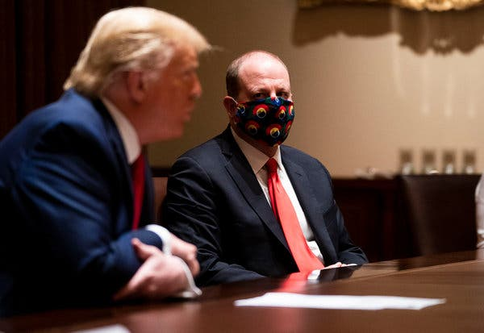

President Trump in May with Gov. Jared Polis of Colorado.

As the coronavirus rages out of control across much of the United States, Americans are acting curiously helpless.

If we had been this passive in 1776, we would still be part of Britain. Yet even as we prepare to celebrate the Fourth of July, we don’t seem willing to assert independence from a virus that in four months has killed more Americans than the Korean, Vietnam, Gulf, Afghanistan and Iraq wars did over 70 years.

Here’s the simplest of steps we could take: Wear a face mask.

In the United States, mask-wearing lags, particularly [among men](https://www.nytimes.com/2020/06/02/health/coronavirus-face-masks-surveys.html), compared with some other countries. A poll [finds](https://psyarxiv.com/tg7vz) that many American men regard the wearing of face masks as “a sign of weakness,” and President Trump’s refusal to wear them has suggested that he perceives that masks are for wimps.

Trump may now be switching gears, for he [told](https://www.forbes.com/sites/jackbrewster/2020/07/01/im-all-for-masks-trump-says-in-change-of-tune/#2751da3c2122) Fox Business on Wednesday that he’s “all for masks” and would wear one if he were “in a tight situation with people.” He shouldn’t waste time: He should tweet a photo of himself in a mask and call on supporters to wear masks as well. Refusing to cover one’s face is reckless, selfish behavior that imperils the economy and can kill or endanger innocent people.

[A review](https://www.thelancet.com/journals/lancet/article/PIIS0140-6736(20)31142-9/fulltext#%20) of 172 studies in The Lancet medical journal found that “face mask use could result in a large reduction in risk of infection.” [An article](https://www.healthaffairs.org/doi/10.1377/hlthaff.2020.00818) in Health Affairs found that state mask mandates, which cover about half the population, may have averted more than 230,000 coronavirus infections.

For one study this year, [reported](https://www.researchgate.net/publication/341779100_Surgical_mask_partition_reduces_the_risk_of_non-contact_transmission_in_a_golden_Syrian_hamster_model_for_Coronavirus_Disease_2019_COVID-19) in Clinical Infectious Diseases, researchers placed hamsters with the coronavirus in cages next to those without the virus, and found that when surgical masks were used as a barrier between the cages infections plunged by more than half.

Or take a lesson from East Asian countries, where mask-wearing is more common as a sign of courtesy, that have managed to contain the virus. [Dr. Kwok-Yung Yuen](http://www.microbiology.hku.hk/02_HKU_Staff_Prof_KY_Yuen.html), an infectious diseases specialist at the University of Hong Kong, told me that a crucial reason for Hong Kong’s success against Covid-19 (less than [one death per million](https://www.worldometers.info/coronavirus/country/china-hong-kong-sar/) inhabitants, compared with [385 per million](https://ourworldindata.org/grapher/total-covid-deaths-per-million) in the United States) is that 97 percent of Hong Kong residents wear masks.

“Masking is a sign of responsible civility,” Yuen told me.

Hong Kong, like some Asian countries, distributes masks free. The United States should do the same, for the cost is negligible compared with hospitalization.

A University of Washington computer model [suggests](http://www.healthdata.org/news-release/new-ihme-covid-19-model-projects-nearly-180000-us-deaths) that 33,000 American lives could be saved from Covid-19 between now and Oct. 1 if more people wore masks. The implication is that inconsiderate Americans unwilling to wear them could in the next few months kill thousands of their neighbors.

“We need to do everything we can to increase mask usage,” said [Kate Grabowski](https://www.jhsph.edu/faculty/directory/profile/3094/mary-kathryn-grabowski), an epidemiologist at Johns Hopkins University. But she added: “People shouldn’t see masks as a silver bullet. They’re not going to be 100 percent effective at preventing transmission.”

So even with masks, we also need distancing, hand-washing, contact tracing and bans on large assemblies. I’m also a big believer in more widespread sewage testing to provide an early warning that the virus is in the neighborhood.

To be sure, we need more research, and masks vary in effectiveness. N95 respirators work very well — so much so that they make breathing difficult. Disposable surgical masks are more comfortable though less protective, and cloth masks are reusable but less effective.

Masks protect your neighbors, but a new Goldman Sachs report finds that expanding mask mandates could also help the American economy.

“A national face-mask mandate could potentially substitute for renewed lockdowns that would otherwise subtract nearly 5 percent from G.D.P.,” Goldman Sachs said. “The economic benefit from a face-mask mandate and increased face-mask usage could be sizable.”

Republicans seem to be coming around. Vice President Mike Pence earlier eschewed masks but now [says](https://abcnews.go.com/Politics/mandatory-mask-rulestrump-insists-personal-choice/story?id=71519019) that wearing them “is just a good idea.” Senator Marco Rubio urged, “Just wear a damn mask.” Representative Liz Cheney tweeted a photo of her father, former Vice President Dick Cheney, wearing one, with the hashtag #realmenwearmasks. Good for them!

But Trump has resisted. Republicans talk a good game about “personal responsibility,” so it’s time for Trump to display some — and to call on his supporters to wear masks as well. As we celebrate our independence, this is how they can show patriotism, protect the economy and save the lives of their neighbors.

The White House press secretary, Kayleigh McEnany, deflects questions about Trump and masks by insisting that mask-wearing is simply a “personal choice.”

No, it’s not. Refusing to wear a mask is no more a “personal choice” than is drinking all evening and then stumbling into your car and heading down the road. In a time of plague, shunning a face mask is like driving drunk, putting everyone in your path in danger.