This assignment will help you synthesize the course content and apply it to the analysis of the primary texts. Instead of briefly answering the questions as you did in the first 5 response papers, this paper is a complete, full essay. It should be approximately 5 pages long and include an introductory paragraph with a well-developed and specific thesis statement, well developed analysis paragraphs discussing and comparing a painting and one other media form, and a concluding paragraph summing up the main ideas of your essay.
For this assignment,
- Choose one painting from the list below and one other work of your choice (literature, photography, advertising, music, or film) from the same time period as the painting you selected.
- Analyze both the painting and your chosen work in terms of a formal (technical) analysis and a historical/contextual (how these works represent the cultural values of the time period they were created in) analysis. You should also include a contextual comparison about how these different media forms represent the time period in similar and/or different ways.)
- Be sure to include specific descriptive details from your works to support your analysis. This is an analysis of a painting and another work. Do not lose your discussion of the works themselves. Be sure to include supporting details from your works.
Remember, it is not enough to summarize or describe what the works are about. You must also say something about them – that is, you must analyze and historicize them, by suggesting how the content makes sense as coming from a particular time and/or place. Details and descriptions are important in supporting your analysis.
- This is NOT a research paper! You should not include any biographical or researched information regarding your painting, 2nd media form, or the creators of these works.
- All papers will be submitted on line and will be checked for plagiarism, so make sure that all work is your own. Any paper that is legitimately matched with other source material without proper citations will be assigned a grade of zero (no second chances).

Paintings to choose (one) from: (Larger images available in PowerPoint)
Progressive Era: Joseph Stella, Brooklyn Bridge, 1919
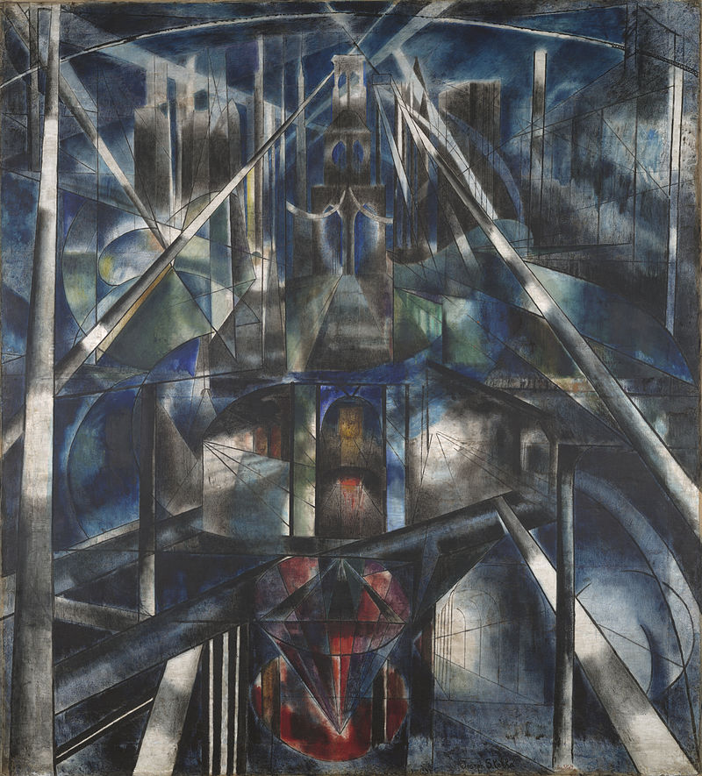
Harlem Renaissance: Aaron Douglas, Song of the Towers, 1934
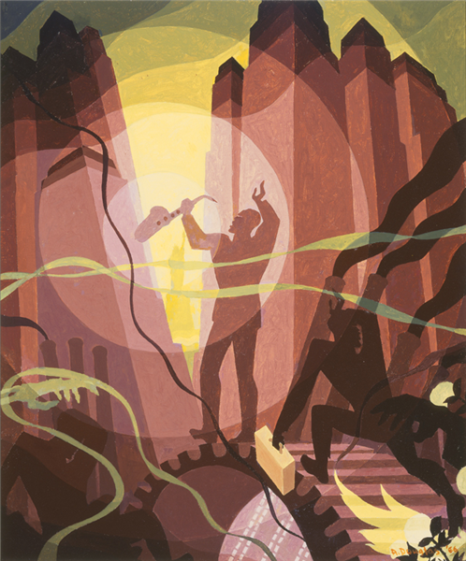
1920’s: Thomas Hart Benton, City Activities with Dancehall, 1930
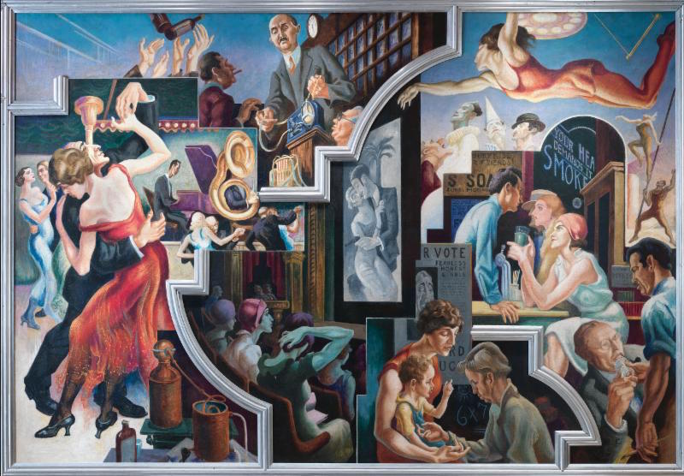
Great Depression Era: Joseph Paul Vorst, Sharecroppers’ Revolt, 1939
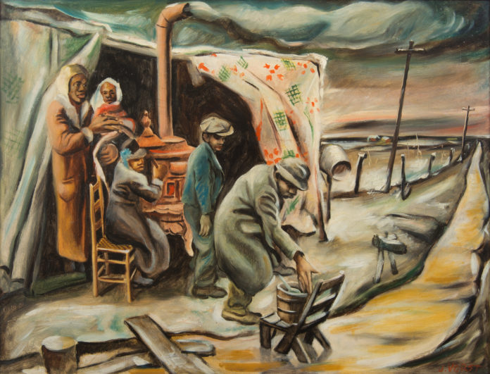
1940’s: Norman Rockwell, The Homecoming Marine, 1945
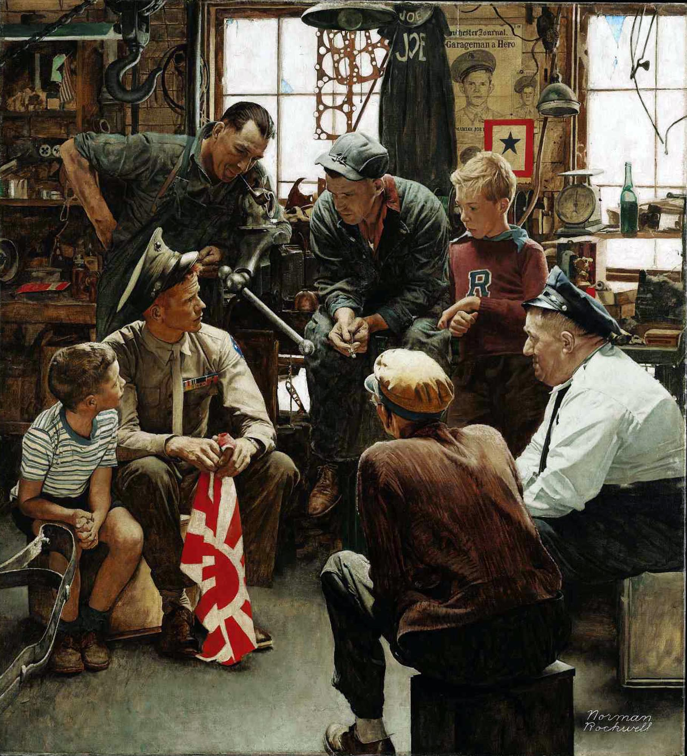
1950’s: Richard Hamilton, Just What Was It that made Yesterday’s Homes so Different so Appealing, 1956
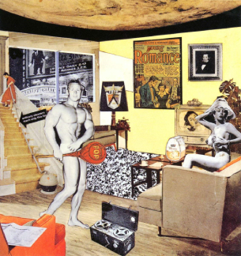

Civil Rights and Feminist Movements: Faith Ringgold, The Flag is Bleeding, 1967
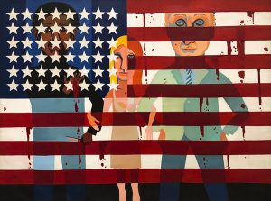

1970’s: Ralph Fasanella, Mill Worker (Night Shift), 1976
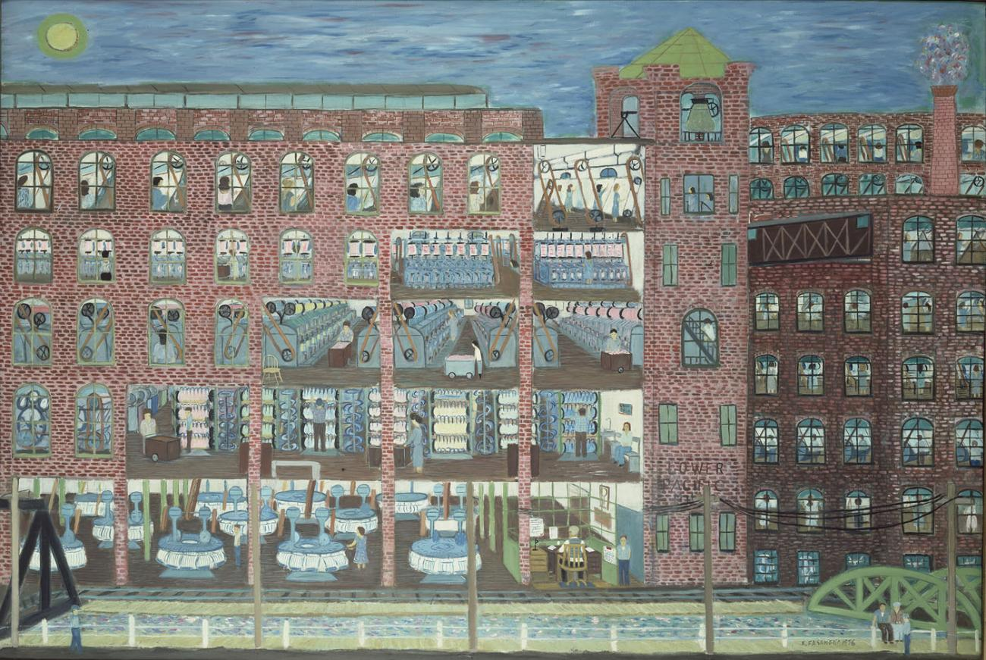
1980’s and 1990’s: Jean-Michel Basquiat, In Italian, 1983

