Proposal

STUDENT PROFESSIONAL ORGANIZATION:

FOX ADULT STUDENTS AT TEMPLE

Submitted To:

FOX SCHOOL OF BUSINESS

Laura K. Broomell, Assistant Director of Enrollment Management

Kate Markowitz, Director of Enrollment Management

HOWARD GITTIS CENTER

Phillip Smith, Director for the Office of Student Activities

Submitted By:

Joe Six-Pack

Accounting Major

April 4, 2019

**EXECUTIVE SUMMARY**

The Fox School of Business should start a new Student Professional Organization (SPO) due to the difficulties adult students face because they cannot currently attend SPO meetings. The meetings occur on weekdays meaning adult students cannot attend due to their obligations outside of school. Adult students may have work responsibilities as well as other life circumstances that can interfere with professional development and educational objectives. Without an alternative time to attend an SPO meeting, adult students feel behind and become dissatisfied with their options post-graduation. Creating a new SPO for the adult student body will resolve these issues and lead to:

* Higher engagement in the Fox community
* Better employer and employee satisfaction
* Improved reputation for Temple University
* Higher graduation rate for adult students

The Fox Adult Students at Temple (F.A.S.T.) can quickly be set up to operate within eight months. F.A.S.T. will need to budget $1,125 for initial start-up costs to provide marketing tools, professional development seminars, and speaker fees. Costs can be subsidized through a $10 membership fee and fundraising. If Temple does not create this organization, it risks the chance to increase student engagement and the growing opportunity to market towards adult students with nontraditional paths.

**PROBLEM: ZERO SPO REPRESENTATION FOR ADULT STUDENTS AT FOX**

Although adult students make up 25% of the student population at Temple (see **Exhibit 1**), there is no SPO centered around the development of adult students within the 33 Fox SPOs (see **Exhibit 2**). Adult students are unable to meet the required number of SPO meetings scheduled from 12:00 P.M. - 12:50 P.M. Employment and family obligations outside of school prevent adult students from fulfilling active membership requirements for the current SPOs (see **Exhibit 3**). The inability to attend meetings results in missed opportunities for adult students to network with key recruiters for their prospective career. According to the Association of American Colleges & Universities, adult students make up 38% of all college students across the United States (Ross, 2011). Adults students are students over the age of 24 and are often referred to as nontraditional students (Ross, 2011). Other universities have addressed this issue by forming Non-Traditional Student Organizations (NTSO), but an adult student organization focused solely on business and professional development do not yet exist (see **Exhibit 4**). Fox School of Business contributes to this issue by lacking programs focused on the adult student population.

**PROPOSAL: START A NEW STUDENT ORGANIZATION**

Fox should start a new student organization called Fox Adult Students at Temple University (F.A.S.T.) to offer adult students an opportunity to be part of a business-minded organization. This opportunity will motivate adult students to become more involved in the Temple community while strengthening the relationship between Temple and its affiliates through successful graduates.

The solution for this issue is to hold weekly meetings at 6:30 P.M. in the evening at Alter Hall to allow adult students alternative opportunities to attend SPO meetings. Meetings will also be scheduled on WebEx to involve adult students who are unable to physically attend. Each meeting will either consist of a presentation or workshop to help adult market themselves for their professional career. F.A.S.T. will seek out successful business leaders who faced similar educational obstacles while completing their undergraduate degrees to present as guest speakers during meetings. Part of F.A.S.T.’s mission is to promote overcoming adversity in education for students who have unique life circumstances.

F.A.S.T.’s objective is to heavily recruit adult students, but it is open to students of all ages and backgrounds. It is ideal to allow all students to obtain membership to promote and develop communication skills with people of all ages. To get the full experience of F.A.S.T. at Temple, it is recommended for students to become involved by fulfilling membership requirements. Distinguished members should be rewarded and recognized for their efforts. Thus, to provide incentives and build team morale, rewards will be point-based explained below.

Each semester, members must collect 10 points to qualify as an active member. Members will not be able to rollover their points into the next semester, as it will reset at the beginning of each semester. The number of points will be distributed on a three-point scale as described below:

* One point: Attend a meeting
* Two points: Attend a career development workshop or a networking event
* Three points: Attend a community service event

Members who earn over 15 points will be eligible for leadership positions. Points will be tracked by scanning QR-codes with the Suitable App at events (see **Exhibit 5**), then transferred to an updated Google sheet after each event. Students must maintain active membership in order to attend social events and team-building activities with business professionals for a more personal networking connection. Active member-exclusive events include Escape the Room Philly and F.A.S.T. Softball Event.

**IMPLEMENTATION PLAN** (see **Exhibit 6**)

With the end of the semester approaching, F.A.S.T. should begin the initial stages of recruiting members and fulfilling Temple University’s requirements for becoming an official student organization. The proposed seven-month timeline is shown below (Temple, 2019):

**April- May**

* Recruit 10 members
* Draft constitution
* Recruit potential faculty advisor
* Connect with business leaders (specifically former nontraditional students)

**June - July**

* F.A.S.T. Summer Retreat and Philadelphia Scavenger Hunt
* Define member dues at $10
* Plan fundraiser
* Complete Temple’s student organization basics workshop

**August - October**

* New Student Organization Presentation with Phillip Smith at the Office of Student Activities
* Meet with Fox SPO leadership and Presidents Council to network
* Market F.A.S.T. to Fox students
* Present to Kate Markowitz and Laura K. Broomell for official Fox SPO recognition

**BUDGET** (see **Exhibit 7**)

The initial cost of $1,125 includes:

* Stationary fees include: writing materials and paper - $100
* Advertising fees include: fliers- $100
* Speaker fees include: transportation to and from Temple - $100
* Meeting Room fee include: room rental fees - $250
* F.A.S.T. Softball Event fee include: equipment rental - $125
* Escape the Room Philly fee include: admission price - $250
* Pretzel fee include: weekly snacks for meetings - $200

The $10 member fee will cover a portion of F.A.S.T. expenses. F.A.S.T. plans to hold a professional headshot fundraiser for five dollars. Temple Student Government can allocate the remaining costs (Temple, 2019).

**BENEFITS OF PROPOSAL**

F.A.S.T. will promote the professional growth of adult students at the Fox School of Business. Adult students will have opportunities to become involved with an SPO through evening and online meetings. The modest cost of implementing F.A.S.T. will be insignificant compared to the benefits. F.A.S.T. will increase graduation rates for adult students and improve Temple’s reputation to the public.

* **Higher Engagement in the Fox Community:** F.A.S.T. has a duty to promote the wellness of the student body and it’s surrounding communities. Many students who become involved with F.A.S.T. will have leadership opportunities in the organization to lead engagements and develop the skills to work with others.
* **Better Employer Satisfaction:**  Recruiters tend to seek out unique skillsets from past work experience and professional development workshops.
* **Improved Reputation for Temple:** The rates of adult students entering college to further their career continues to increase each year (Ross, 2011). Temple’s focus on this demographic can help increase enrollment rates and improve the university’s reputation.
* **Adult Students Graduating at Higher Rates:** Adult students attend college at a later stage in life face many obstacles that can slow down their progress of obtaining a degree. A focused path with support from other adult students will increase their chance for success.

**CONCLUSION AND RECOMMENDATIONS**

Fox should start Fox Adult Students at Temple as an official Student Professional Organization. Many adult students have difficulty maintaining active memberships and attending SPO meetings from 12:00pm-12:50pm. F.A.S.T. will address these issues by scheduling SPO meetings in the evening. **The total cost to start this new organization is up to $1,125 over a seven-month period.**

Starting this new SPO focused on adult students will increase engagement in the Fox community while creating opportunities for professional development and networking. In addition, F.A.S.T. will address issues and concerns adult students have while attending college with a support group. If this proposal is approved, the F.A.S.T. will begin to create awareness begin recruiting efforts starting April 8, 2019, to be part of a new SPO on campus.

**Sources**

College Factual. Organization at Temple Survey: How Diverse Is Temple University?

<https://www.collegefactual.com/colleges/temple-university/student-life/diversity/#chart-age-diversity>

Penn State. (n.d.) Adult Learner Programs & Services <https://studentaffairs.psu.edu/adults>

Ross, J. (Winter 2011) AACU. Research on Adult Learners: Supporting the Needs of A Student

Population that is No Longer Traditional. Retrieved February 26th, 2019 from:<https://www.aacu.org/publications-research/periodicals/research-adult-learners-supporting-needs-student-population-no>

Serb. (n.d.) Who Is the Adult Learner?

* [http://www.sreb.org/general-information/who-adult-](http://www.sreb.org/general-information/who-adult- learner)

[learner](http://www.sreb.org/general-information/who-adult- learner)

Suitable. (n.d.) Home. <https://www.suitable.com/>

Temple University. (n.d.). Starting a New Organization. Retrieved February 26th, 2019 from:

<https://studentactivities.temple.edu/starting-new-organization>

Temple University. (n.d.) Student Professional Organization. Retrieved April 3rd, 2019 from :

https://www.fox.temple.edu/student-professional-organizations/

Temple University. (n.d.) Temple University Fact Book. Retried March 10th, 2019 from:

<https://www.temple.edu/ira/documents/data-analysis/Fact-Book/TU_Fact_Book_2016-2017.pdf>

University of Colorado. (n.d.) Non-Traditional Student organization.

<https://www.colorado.edu/studentgroups/ntso/>

University of Richmond. (n.d.) University Of Richmond News.

<https://news.richmond.edu/features/article/-/1790/returning-to-school-adult->students-represent-growing-trend-in-educational-community.html

University of Shippensburg. (n.d.) The Office Of Nontraditional Student Services.

<https://www.ship.edu/dean_of_students/NonTraditional/>

**APPENDIX**



Source: Serb Source: University of Richmond

**EXHBIT 1 – STUDENT DEMOGRAPHICS**

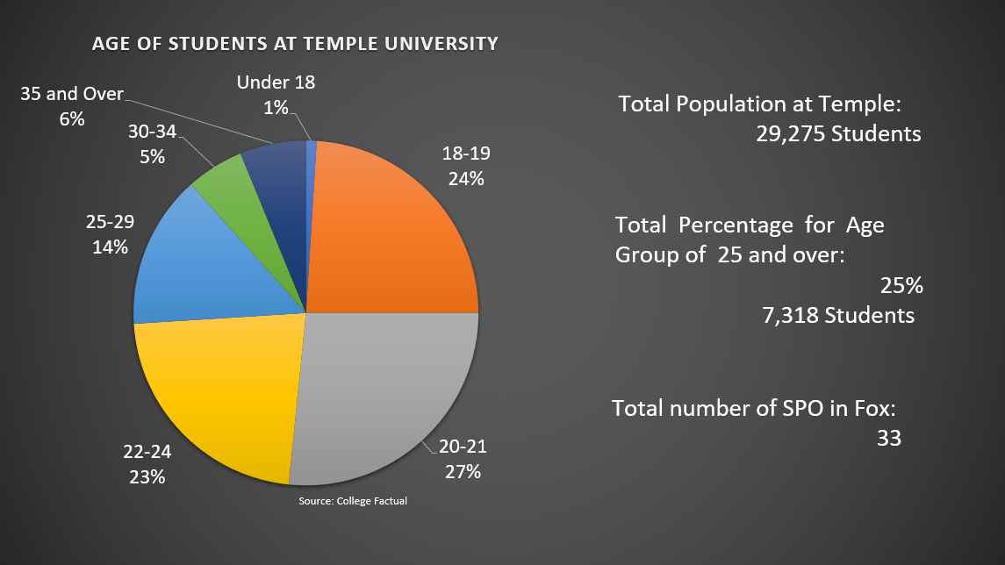

**EXHIBIT 2 – FULL LIST OF STUDENT PROFESSIONAL ORGANIZATIONS AT TEMPLE**

|  |  |
| --- | --- |
| American Marketing Association | International Business Association |
| Art of Business | Temple Real Estate Organization |
| Ascend | National Association of Black Accountants |
| Association for Information Systems | Net Impact |
| Association of Latino Professionals For America | Professional Sales Organization |
| Ambler Accounting Professional Society | Temple Economics Society |
| Business Honors Student Association | Phi Alpha Delta Pre-Law Fraternity, International |
| Beta Alpha Psi | Phi Beta Lambda, National Business Fraternity of FBLA-PBL |
| College Council | Society for Human Resource Management |
| Entrepreneurial Students Association | Society for Human Resource Management - Ambler Campus |
| Fashion & Business | Student CPT |
| Financial Management Association | Temple University Health Leadership Organization |
| Financial Planning Association | TAMID |
| Fox Accounting Association | Temple University Investment Association |
| Fox Graduate Student Association | Temple University Supply Chain Association |
| Gamma Iota Sigma | Toastmasters |
| Institute of Management Accountants |  |

**EXHIBIT 3 – EXAMPLE OF ACTIVE MEMBERSHIP REQUIREMENT FOR SPO**

 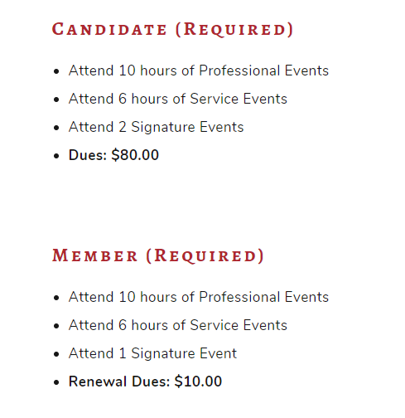

**EXHIBIT 4 – UNIVERSITIES WITH ADULT STUDENT ORGANIZATION**

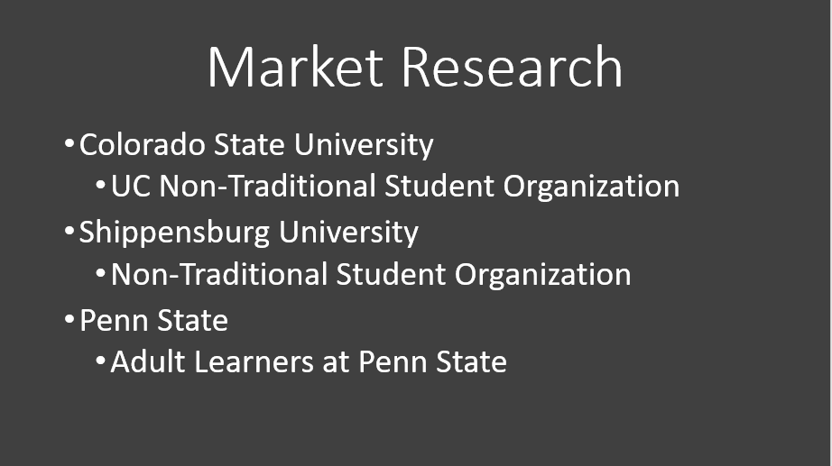

**EXHIBIT 5 – SUITABLE APP FOR ATTENDENCE TRACKING**

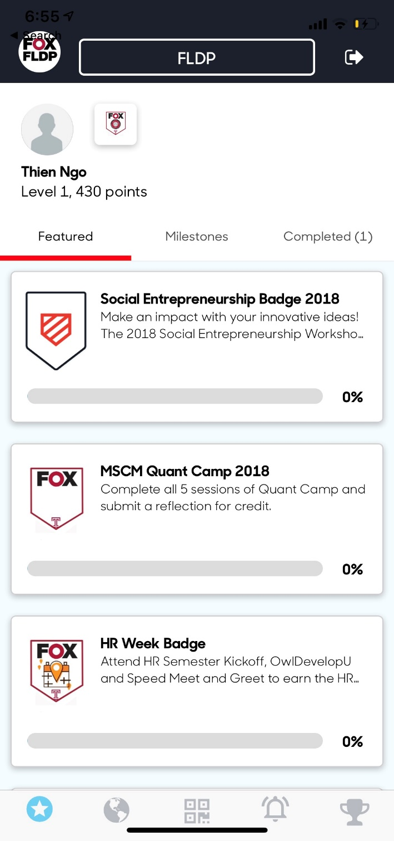

**EXHIHIBIT 6 - F.A.S.T. IMPLEMENTATION TIMELINE**

**EXHIBIT 7 – F.A.S.T. BUDGET**

|  |  |
| --- | --- |
| **Fox Adult Students at Temple SPO Expenses** | **Total** |
| Stationary | $100 |
| Advertising | $100 |
| Speaker Fees | $100 |
| Meeting Room Fee | $250 |
| Pretzels | $200 |
| Escape the Room Philadelphia | $250 |
| F.A.S.T. Softball Event | $125 |
| **Total Cost** | **$1,125** |