Facility Planning: Doctor’s Office
Jonathan Schellhorn
04/13/2020
HCS/446
Professor Jennifer Huff

Facility Planning: Doctor’s Office
Steps Taken
The steps taken involved listing all the essential services that would be needed in a doctor’s office to ensure that activities were run smoothly. This involves considering the needs of patients, nurses, doctors, and other staff working in a doctor’s office such as medical laboratory technicians. It also involved ensuring that all the essential rooms required would be placed at advantageous locations.
Successes and Challenges
Some of the successes involved ensuring that patient would get adequate privacy, incorporating more than one examination, consultation, and doctor’s room to ease traffic in the facility. The only challenge experienced was based on placement of the laundry and housekeeping room.
Doctor’s Office Design
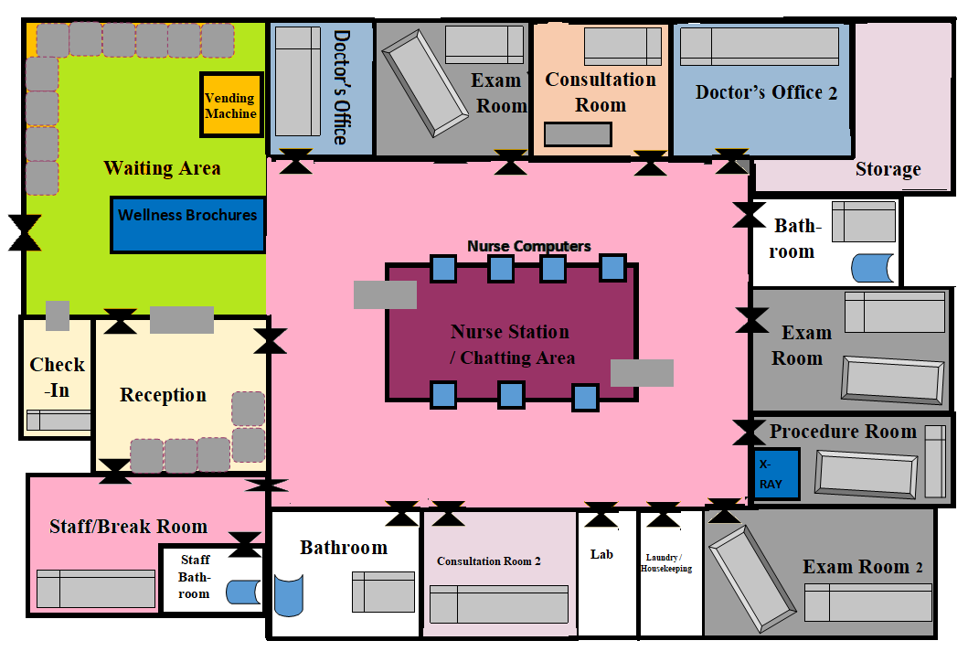
Considerations
The placement of the nurse station at the middle ensures that patients, nurses, and doctors can easily access the nurse station for inquiries or file retrievals. It also ensures that nurses can access all the room in the facility easily. The open design of the waiting area ensures that nurses can easily observe the patients at the waiting area. This ensures that they notice patients who might require emergency services or those who may pass out (Brewer, Carley, & Benham-Hutchins, 2018). The vending machine in the waiting area was placed there to offer the patients and their family members’ access to healthy snacks (Pechey, Jenkins, Cartwright, & Marteau, 2019). The staff break room and staff bathroom were placed next to each other to ease accessibility.
The two bathrooms near the examination room were meant for patients. They ensured that patients who were required to offer a urine or stool sample could easily access the bathrooms. The storage room was meant for laboratory equipment, radiology equipment, oxygen cylinders, suctions, and other mechanical equipment. The placement of the laundry room near the examination room ensured that dirty linens rom the examination room could be cleaned and changed easily. A section of the room was also meant for waste disposal.

References
Brewer, B. B., Carley, K. M., & Benham-Hutchins, M. (2018). Nursing Unit Design, Nursing Staff Communication Networks, and Patient Falls: Are They Related? Health Environments Research & Design Journal, 11(4), Retrieved from https://journals.sagepub.com/doi/10.1177/1937586718779223.
Pechey, R., Jenkins, H., Cartwright, E., & Marteau, T. M. (2019). Altering the availability of healthier vs. less healthy items in UK hospital vending machines: a multiple treatment reversal design. Interational Journal of Behavioral Nutrition and Physical Activity, 16, 772. Retrieved from https://ijbnpa.biomedcentral.com/articles/10.1186/s12966-019-0883-5.

