**Consumer Behavior / Buyer Behavior – Assignment 1**

Date of issue – 8 March 2020

**Background**

Rituals and routines are highly subjective and culture specific. For example: A Saudi Arabia breakfast can be different from western one in terms of food selections, time of day and favored locations.

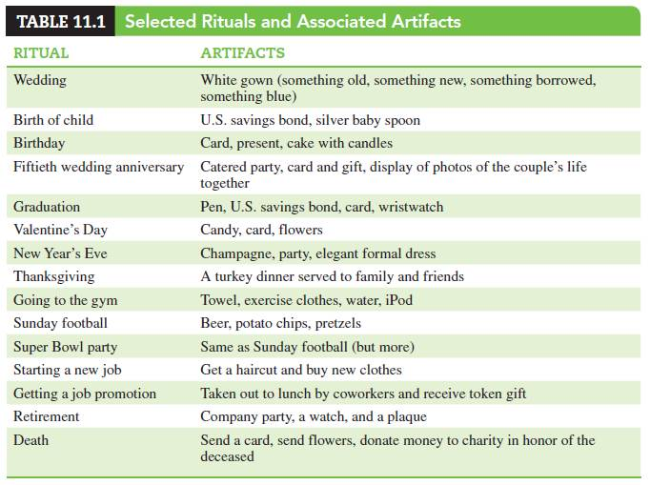

**Main Tasks**

1. Choose five rituals from the above mentioned list, try to identify and compare the major differences in Rituals and Routine of two different countries by preparing a list of respective feature and offer a suitable explanation.
2. How do marketers make strategies and target audiences based on rituals? Explain with two examples.

**Report Format**

1. Title (Understanding Cultural Differences)
2. Detail of findings (main tasks)
3. Conclusion (main lesson learnt from the assignment)
4. Sources of information

*Report should not be more than five (5) pages.*

**Marking Scheme**

Total marks = 10

1. Introduction to the report (2.0)
2. Detail of findings (5.0)
3. Conclusion (2.0)
4. Overall presentation style (1.0)

**Last date for Submission**:- 2 April 2020

**WARNING !!**

Please Note:

1. DO NOT COPY FROM YOUR FRIEND - Anybody found copying will BE PENALISED.
2. MARKS will be deducted for Late Submission of report.