Apple Research Paper
Name
Institution Affiliation

Apple Research Paper
Stock Market Exchange
Founded in the year 1976, this company has grown over time to become one of the largest and most profitable firms in the world today. It deals with products such as digital music players, personal computers, media devices, and mobiles, among others. Its major segments include Europe, China, America, Japan, and the rest of the Asian region. Some of the renowned Apple products include Apple television, Apple watch, among others. The company is listed in NASDAQ under the name AAPL. With its stocks traded in this market, people have two options when trading Apple stocks here. Firstly, they can purchase shares in organizations on the exchanges where they are listed, including NASDAQ. For example, a client can buy Apple’s stocks here, and thus, owning a share in Apple. When purchasing Apple’s stocks, as described above, customers engage in long-term investment, mainly because they can wait until such a time when the firm’s stock increases over time. Secondly, customers can also trade a contract for difference, commonly referred to as CFD, on Apple’s shares. With this approach, they can speculate the price variances of the underlying assets, without claiming ownership of the assets.
Worth of Stock Activity for Apple
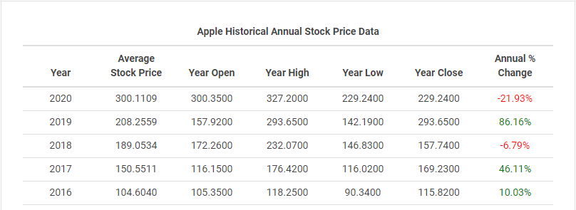
From the above, retrieved from macrotrends.com, Apple’s average stock price for 2018, 2019, and 2020 included 189.0534, 208.2559, and 300.1109, respectively (Macrotrends.net, 2020). The average for the three years would be found by adding these averages and dividing the sum by three, as shown below. Equally, from the above table, the firm’s low price was 169.23 in 2017 while the high price was 327.2 in 2020 per share.
Year | Stock Averages
2018 | 189.0534
2019 | 208.2559
2019 | 300.1109
Three-year average | 232.4734

Apple Stock Split
It is no doubt that Apple’s stock has often outperformed others, including the S&P 500, in the market. In attempts to understand and appreciate Apple’s stock returns, a breakdown of its stock split account becomes vital. Indeed, the company has split its stock over the past since its inception in 1976. In particular, it has split its stock four times, with the first split happening in June 16^{th,} 1987, in a ratio of 2:1. At this time, the price before this split stood at $79. The second split occurred on June 21^{st,} 2000, with a split ratio of 2:1. Before this split, Apple’s price stood at $111. The third split occurred in February 2005, with a split ratio of 2:1 like in the previous two divisions. The last division took place on June 9^{th,} 2014, with a split ratio of 7.1. Noticeably, this time around, the price before the split was $656, a higher value compared to the other three instances. In essence, whereas such divisions help to encourage more investments, they never affect the firm’s market capitalization. With these actions, existing shareholders often benefit the most by owning more shares. While stock divides might fail to increase share prices, they can usually contribute to increased share prices. Equally, by making stocks available to new investors, the demand for such shares can grow, causing share prices to appreciate and company capitalization to increase in effect.
Shares Outstanding and If I can invest in Apple
Shares outstanding imply authorized, issues, and bought shares by investors. In Apple’s case, the firm’s outstanding shares over the last quarter stood at 4, 384 million. When looking at this company’s historical data, it is clear that there was a decline from 4, 443 million in the last quarter, suggesting that the company bought back shares. From the above analysis, Apple deserves a spot in my portfolio. By and large, Apple is not only a household name, but it is an organization that I am familiar with, and I would certainly invest in its stock. As a profitable and promising firm, investing in Apple is the best decision I would ever make.

References
Macrotrends.net. (2020). Apple – 40-year stock history. Retrieved from https://www.macrotrends.net/stocks/charts/AAPL/apple/stock-price-history

