Chapter 2 case application:
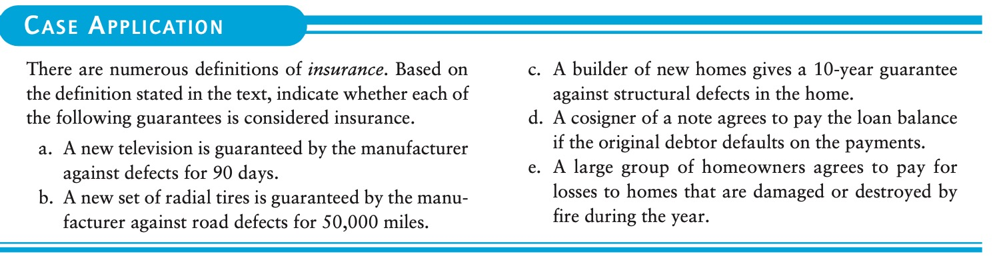

There are numerous definitions of insurance. Based on the definition stated in the text, indicate whether each of the following guarantees is considered insurance.
a. A new television is guaranteed by the manufacturer against defects for 90 days.
b. A new set of radial tires is guaranteed by the manu- facturer against road defects for 50,000 miles.
c. A builder of new homes gives a 10-year guarantee against structural defects in the home.
d. A cosigner of a note agrees to pay the loan balance if the original debtor defaults on the payments.
e. A large group of homeowners agrees to pay for losses to homes that are damaged or destroyed by fire during the year.

