A Comparative Analysis of Immigration Reform under the Obama and the Trump Administration and the Effect this Reform has on the Poultry Industry in Mississippi.

By:
Shequite Johnson

Instructor:
Dr. Johnny B. Gilleylen Sr., Ph.D.
Advance Research I
PPAD 796

October 8, 2019

Outline

Title: A Comparative Analysis of Immigration Reform under the Obama and the Trump Administration and the Effect this Reform has on the Poultry Industry in Mississippi.
- Background of the Problem
- Immigration Reform
- Border Security and Immigration Reform Act of 2018
- Poultry Industry in Mississippi
- Problem Statement
- People affected
- The cause of the problem
- Reasons why past approaches to Immigration Reform Have Been Unsuccessful
- Research Questions
- Research Hypothesis
- Research Rationale
- Research Methodology
- Research Design
- Data sources
- Limitations
- Delimitations
- References
- Appendices

Table of Contents

Outline 2
Table of Contents 3
Background of the Problem 4
Immigration Reform 4
Border Security and Immigration Reform Act of 2018 5
Poultry Industry in Mississippi 7
Problem Statement 9
People Affected 10
The Cause of the Problem 11
Reasons why past approaches to Immigration Reform Have Been Unsuccessful 12
Research Questions 13
Research Hypothesis 13
Research Rationale 13
Research Methodology 14
Research Design 14
Data sources 14
Limitations 14
Delimitations 15
References 15
Appendices 18

Background of the Problem

Undocumented Hispanics in the south usually work in poultry and sawmills, industries that require hard work for relatively low wages. For a long time, these industries did not ask for papers, and this made them suitable and attractive for this segment of the population (Guan et al., 2015). Foreign workers and specifically Latinos constitute a crucial part of the farm workforce. Foreign workers have, however, been a contentious part of the US economy for generations. Since the establishment of the first migrant labor program in the US in the World War I era, the government has struggled in balancing the needs of the agricultural industry with the interests of the country’s domestic workers. The temporary work visas have been very infective since the government has been unable to keep track of these visas as well as account for the high numbers of undocumented workers (Rickard, 2015). The guest work visas have increased from 400,000 in 1994 to over 900,000 in 2018. The Trump administration on taking office, however, intended to reform these programs to stay true to the slogan of "Buy American Hire American" that became popular during the campaign season. The administration's approach to immigration has, however, sparked extensive debates due to their harsh and inhumane treatment of immigrants. With the harsh and unfair treatment of immigrants in place, it makes you wonder, what is the governments true intention and how would the immigration reform policies affect people of color.

Immigration Reform

Temporary work programs were introduced to deal as a response to the labor shortage that followed World War I and II. Laborers from Mexico were recruited to work in the agricultural sector. During this time, Mexican immigrants served as an asset the United States and its economy and they were not seen as a treat. After the war, however, the government began to enact regulations. For instance in 1952 to govern immigrant labor; lead to the Immigrant and Nationality Act of 1952 (Rickard, 2015). This piece of legislation started the implementation of the H2 visa; the H1B visa was introduced in 1990 to cater for children and spouses.
Criticism of temporary work programs is based on the argument that companies take advantage of these programs to hire foreign workers over domestic workers since they are willing to accept lower wages (Guan et al., 2015). These concerns emanate from the fact that these programs are very poorly regulated. The system has also been found to be inefficient since it incentivizes employers to hire a massive pool of unauthorized immigrants since they are cheaper and do not require any paperwork. The agricultural worker program had no numerical cap; in 2018, 196,000 visas were issued to immigrant workers. However, the estimated number of hired farmworkers’ in the US lies between 800,000 and 1.3 Million (Stuesse, 2018).
The US Department of Agriculture estimates that half of these farmworkers are undocumented, which ends up tying this issue to immigration enforcement. The difficulty of working legally in the US increases the number of people working illegally or overstaying their Visas. Furthermore, this state of affairs exposes foreign workers to exploitation and maltreatment. Foreign workers can, for instance, not be able to negotiate for higher wages or improved working conditions, whereas US citizens can negotiate for higher wages or improved working conditions.
President Trump has been on a mission to reduce both legal and illegal immigration and approach immigration. His goals included a merit-based format to become United States citizens. He has, however, struggled to get the support he needs from Congress. However, in 2017, he issued an executive order requiring all federal agencies to evaluate immigration policies to protect the US workforce and ensure that the H1B visas were only issued to most skilled and qualified applicants (Jenkins, 2018). Due to this directive, the number of H1B visa denial doubled in 2018. His approach to immigration culminated in the form of the Border Security and Immigration Reform Act of 2018.

Border Security and Immigration Reform Act of 2018

The Border Security and Immigration Reform Act of 2018 fundamentally transformed the immigration system in the US from a randomized format to a merit-based system. It was intended to address the systemic issue of illegal immigration by fixing the loopholes that existed in the immigration sector (Petty, 2018). This reform had the following directives:
- Increase border security and secure $25 Billion to build a wall and infrastructure on the Southern border of the United States
- Empower the Department of Homeland Security with tools they could use to prevent illegal immigration and human smuggling for instance by having the authority to detain criminal aliens who are considered dangerous
- End the Visa lottery system in favor of a first-in-line system which would end the per-country cap on employment-based green cards and increase the cap on family-sponsored green cards from 7 to 15%
- Create a legislative solution for children who were brought to the country illegally without the creation of a unique pathway to citizenship. This reform would, for instance, allow the Deferred Action for Childhood Arrivals (DACA) population a chance to earn legal status
- Create a merit-based system that would favor individuals with the skills, qualifications and work experience that are beneficial to the US
- Amend the current laws to ensure that parents and their children are not separated when they are caught on the border (Richards, 2018).
This reform was, however, found to be very partisan since it largely perpetuated the conservative agenda without having consideration of the liberal’s perspective. This bill, therefore, did not address the core issues related to immigration leading to it being one of the worst voted pieces of legislation pertaining to the issue of immigration (Richards, 2018)

Poultry Industry in Mississippi

Poultry in Mississippi is the state's most affluent agricultural commodity bringing in about $2.5 billion per year and employing over 25,000 people. Thousands of immigrants from Mexico, Honduras, Argentina, Guatemala, and other Latin American countries make their way to Mississippi to work in the poultry industry. These immigrant laborers have played in part in bringing success to companies such as Koch foods and Peco foods, which make billions of dollars in revenue. For years, chicken plants in Mississippi experienced labor shortages as they struggled to get American workers to work in this industry. Turnover rates went as high as 90%, while the absenteeism rate on the night shift was at 50% (Petty, 2018). When Hispanic immigrants arrived in the state, they were willing to take up these jobs in this labor-intensive field. The Occupation Safety and Health Administration observes that workers in this industry are exposed to quite a several hazards such as long hours, dangerous chemicals, loud noises, and dangerous machinery. Injury rates are at double the rate of the whole private industry sector, making this industry one of the most dangerous employers (Petty, 2018). Even though the working conditions are, the wages are not reflective of this fact since these employees make only slightly above minimum wage. These undocumented immigrants are, however, willing to withstand these conditions since it is hard to get employment without papers, and conditions in the home country are far worse.
During the 90s, as the influx of Latino immigrants came into Mississippi, they were faking documents to show their employers, with time; however, the employers no longer asked for papers. As a result, between 1990 and 2000, the Latino population in Mississippi increased by 1000% concentrated in Scott county, which is essentially the epicenter of the poultry industry. Since then, census data indicates that this population has doubled. The undocumented immigrants became a critical part of the local, state, and national economies. In the past, politicians have advocated for immigration reform that would enable them to be able to remain in the country legally. However, since the election of President Donald Trump, anti-immigration reform threatens their continued participation in the state’s economy. Under this administration, US Immigration and Customs Enforcement (ICE) has quadrupled its efforts in conducting workplace investigation and paperwork audits. As a result, in 2018, there were 2,304 undocumented workers arrested up from only 311 in 2017 (Petty, 2018).
The intensity and number of raids have steadily grown in the last few months. Those arrested and released are issued trackers to monitor their movements and contend with court cases since some have been accused of committing federal felonies about possessing fraudulent social security cards. Child Protective Services take Their children, and some parents have been unable to reunite with them. The immigrants are therefore living on edge since they are expecting raids to occur at any given moment. They have also lost their job and are unable to find work while they are awaiting their immigration hearings. The raids have therefore led to many hardships in immigrants' households since bills are piling up with no source of income in sight. Since the chicken plants are now requiring documentation, they have locked out the undocumented workers who make up most of the industry's workforce. There is skepticism as to whether these plants can be able to replace the labor that has been wiped out by the ICE raids. The workers have been told that they cannot work until their immigration cases have been resolved, with the existing backlog in immigration cases, the immigrants may have to wait for months or even years for their cases to be heard (Richards, 2018).

Problem Statement

Ineffective immigration laws have consistently raised costs for the agricultural sector. The high number of restrictions accompanied by high costs ends up incentivizing the immigrants to move to informal underground economies. By making the lawful employment of immigrants expensive, the government has created unauthorized immigration (Gonzalez, 2015). The H2 guest work visa has been the source of legal foreign agricultural workers. Over the years, however, this program has been very underutilized due to complex rules and costs associated with sponsoring immigrants. The H2 visas that offer temporary agricultural workers have no quota. However, only 2% of the agricultural labor force use this program due to the inspection, fees paperwork, and minimum wage requirements that end up making it too expensive for farmers (Engstrom, 2017).
The increase in the level of control and restrictiveness has created an environment where unauthorized immigration thrives. Labor-intensive agriculture in the US is therefore likely to collapse without the constant stream of lower-skilled workers who are willing to accept wages that Americans consider too low. Undocumented immigrants have, for a long time, filled the labor gaps that have been prevalent in the poultry industry in Mississippi, however with the increased number of ICE raids, the stability of this labor is now being threatened. The Trump administration has taken a tough stance on immigration, and the increased enforcement is affecting poultry farmers since there are experiencing a lot of labor shortages (Martin, 2017).
Immigration reform is, therefore, making it difficult for an industry that is already struggling to recruit and retain employees. American workers are not willing to work in this labor-intensive, low paying industry, and hence, most of these jobs are done by undocumented immigrants. However, with the impending threat of ICE raids, the pending immigration cases, the arrest, detainment, and deportation of undocumented immigrants, most of the Hispanic workforce is afraid to go to work or just unable to work. ICE raids threats, therefore, put the industry on the verge of decline, mainly because this industry is unable to obtain legal immigrant workers. Position for meat cutters and farmworkers have already started opening up. According to the bureau of labor statistics, these job openings make up for 12% of all in-state job openings (Philbin et al., 2018). The largest industry in the state of Mississippi is, therefore, under threat of decline due to immigration reform. This study will, therefore, investigate how immigration reform has affected the poultry industry in Mississippi under Obama and the Trump administration

People Affected

The people affected by this problem are:
- Farmers and employers who may experience labor shortages because the vast labor pool of immigrant workers that have supported their industry is slowly declining
- Undocumented immigrant workers are exposed to exploitation and abuse since there no laws governing the underground economy in which they work. In Mississippi, there was even a class lawsuit against Koch Foods brought forward by the US Equal Employment and Opportunity Commission, accusing the company of intimidation, harassment, and exploitation of undocumented workers. Managers at the plant were accused of sexually and physically assaulting Hispanic employees and threatening to turn then into the authorities if they were to come forward and report their abuse (Stuesse, 2018)
- Domestic US workers who are under the impression that foreigners steal their jobs and the affect American wage levels

The Cause of the Problem

As stated above, the cause of the problem happens to be ineffective and inflexible immigration policies. Some of these policies include:
- The 1986 Immigration reform and control act were supposed to make the employment of undocumented immigrants difficult by fining firms that either intentionally or unintentionally hired illegal immigrants. By making it harder for immigrants to get employment, the government hoped that fewer of them would immigrate. This act, however, ended up creating 3 million unauthorized workers and hence facilitating the formation of an underground economy since immigrant labor was still crucial to the country's industries.
- The Illegal Immigrant Reform and Immigration Responsibility Act (IIRIRA) of 1996, on the other hand, created stricter penalties for undocumented workers and even introduced E-verify to check identity information of employees and permanently exclude undocumented workers from the workforce. This program, however, ended up being highly inaccurate, costly, and plagued with bureaucratic problems. In the end, it was, therefore, ineffective.
- In 2006 the secure fence act was passed, which saw the construction of a 700-mile fence along the southeast border of the US at the cost of $1.5 Billion. This measure also proved to be unsuccessful. The Bush administration applied harsher punishments such as jail time, and being banned from lawful entry.
- In 2009 The US Immigration and Customs Enforcement (ICE) became more vigilant and expanded the inspections and audits of businesses I9 forms. They found very many companies to violate the country's immigration laws, and the fines in 2011 totaled $ 10, 463, 988, which was 16 times higher than the fines of 2008 (Stuesse, 2018). The federal government also directed local and state law enforcement agencies to play a hand in enforcing the federal immigration laws, this also proved to be unsuccessful since it was optional.
- In 2018 the most significant attempt at immigration reform under the Trump administration was through the Border Security and Immigration Reform Act of 2018. Even though the bill did no pass enforcement by ICE has been increased.

Why have Past Approaches to Immigration Reform Been Unsuccessful?

The only approach to immigration that has been successful was during World War 1 and the Bracero Program of World War II. Sucess was because immigration was less regulated, and there were also very few steps required to hire immigrant labor making this system efficient while also ensuring there were no unnecessary burdens on the workers (Nowrasteh, 2013). The current policies on immigration are impeded by expensive regulation, restrictive laws, and uncaring bureaucracy that has made it impossible for a market between US employers and foreign labor to operate efficiently. Some of the problems brought about by these policies include; the existence of numerical caps on guest-worker visas, the complicated process of extending a guest worker visa, the legal penalties faced immigrant workers who opt to switch employers, and the inability of workers and employers to negotiate benefits. Immigration laws have therefore been unable to create a broad and flexible temporary workers' programs to suit the needs of American industries. Due to this, an informal economy has developed between employers and immigrant workers. An informal economy is likely to continue if changes are not made. This informal economy will only end once a legal solution for temporary employment is found. It is only then that immigrant workers will be able to work in a lawful and more transparent market. Instead of focusing on enforcing short-sighted laws, the government should work towards developing a cheaper, legal open guest workers program (Nowrasteh, 2013).

Research Questions

- What are the differences in the arrests, detainment, and deportation of immigrant workers in Mississippi between the Obama and Trump administration?
- Which approach was taken on immigration between the Obama and Trump administration?
- What interconnections exist between immigration and the poultry industry in Mississippi?
- What recommendations can be made on areas of improvement for policy framework?

Research Hypothesis

- Arrests, detainment, and deportation of immigrant workers is higher in the Trump administration
- Immigration policies are ineffective in both Obama and Trump administrations
- A connection exists between immigrant labor and performance in the poultry industry in Mississippi.

Research Rationale

Despite the importance of Immigrant labor to the poultry industry of Mississippi, no extensive research has been conducted to understand the impact of the vigorous enforcement and attempts at reform on immigration by the Trump administration on this industry. By comparing the current state of the industry with the state of the industry during the Obama administration, it will be possible to determine whether policies being implemented by the Trump administration will continue to cause damage to the largest industry in the state of Mississippi. With this information, it will be possible for representatives in Mississippi to have irrefutable facts they can use to oppose various reforms on immigration that are likely to continue bringing harm to the industry and the immigrant community of Mississippi. Furthermore, it will be possible to determine the most appropriate approach to immigration that will ensure that the poultry industry continues to thrive and hence, ensure the continued employment of many residents of the state.

Research Methodology

Research Design

This study will make use of a similar research design to observe the different treatment of immigration by the Obama and Trump administration and how this treatment affected the poultry industry in Mississippi. This study will seek to establish the causal contributions to the issue of immigrant workers under different regimes.

Data sources

Secondary data will be used in the study, which will be provided by immigration services and journal articles.

Limitations

The objective of this study is to examine the issue of immigration under the Obama and Trump administration. While examining those issues, the goal is to determine how policies enacted under these presidents and how they affected the poultry industry in Mississippi. The study will, therefore, only focus on the poultry industry in Mississippi between the years of 2008 and 2019. The study will also not make use of primary data but will instead focus on secondary data in regards to the issue. The critical issue with secondary data will not be having first-hand accounts of the key stakeholders which can provide incredible insight into the issue

Delimitations

Even though primary data may be unavailable, the study will make use of a wide array of sources such as journals, news reports, and immigration data from credible sources that will provide a holistic perspective on the issue.

References

Engstrom, D. W. (2017). Hispanic immigration at the new millennium. In Hispanics in the United States (pp. 31-68). Routledge.
Gonzalez, G. G. (2015). Guest workers or colonized labor?: Mexican labor migration to the United States. Routledge.
Guan, Z., Wu, F., Roka, F., & Whidden, A. (2015). Agricultural labor and immigration reform. Choices, 30(4), 1-9.
Jenkins, B. (2018). Who pays for our cheap meat? The impact of modern meat production on slaughterhouse workers: Considerations for tourists. In Tourism Experiences and Animal Consumption (pp. 42-57). Routledge.
Martin, P. (2017). Immigration and Farm Labor: From Unauthorized to H-2A for Some?. Washington, DC: Migration Policy Institute.
Nowrasteh, A. (2013). How to make guest worker visas work. Cato Institute Policy Analysis, (719).
Petty, A. (2018). Scratching Out a Living: Latinos, Race, and Work in the Deep South by Angela Stuesse.
Philbin, M. M., Flake, M., Hatzenbuehler, M. L., & Hirsch, J. S. (2018). State-level immigration and immigrant-focused policies as drivers of Latino health disparities in the United States. Social Science & Medicine, 199, 29-38.
Richards, T. J. (2018). Immigration reform and farm labor markets. American Journal of Agricultural Economics, 100(4), 1050-1071.
Rickard, B. J. (2015). On the political economy of guest worker programs in agriculture. Food policy, 52,1-8.
Stuesse, A. (2018). When They're Done with You: Legal Violence and Structural Vulnerability among Injured Immigrant Poultry Workers. Anthropology of Work Review, 39(2), 79- 93.

Appendices

For the period between October 2017 and September 2018, immigration stands out as the only federal crime with more non-citizens arrested than citizens.
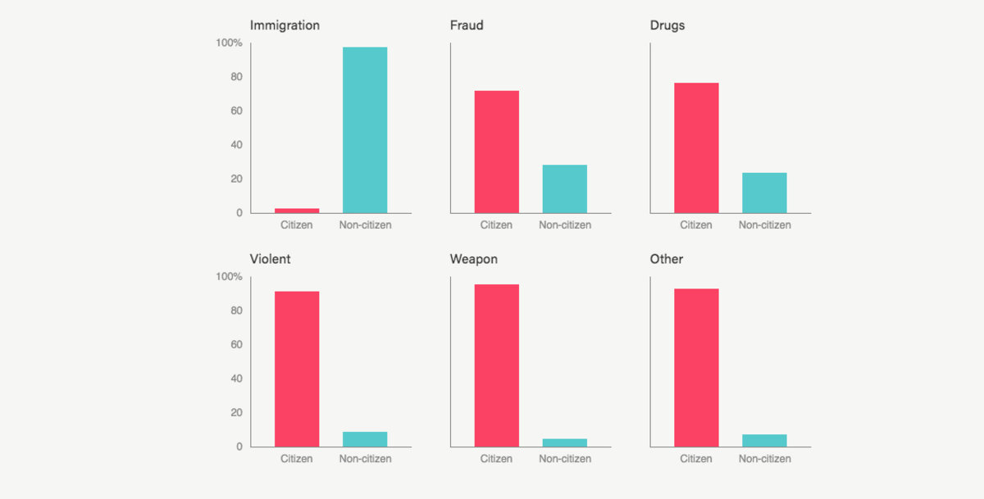
Source: Bureau of Justice Statistics

Number of Immigrants crossing the US border and nationality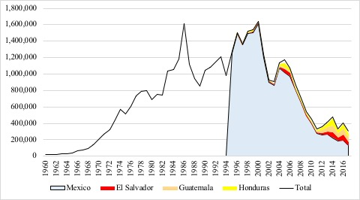
Source: US Customs and Border Security
ICE Enforcement and Removal Operations in the first year of Trump's presidency
