**C**HAPTER **13 Developing Visual Art Centers**

***Learning Outcomes***

**After you have read this chapter, you will be prepared to:**

• Describe the approaches to and stages of art development

• Discuss multiple ways that the art center enhances children’s development

• Demonstrate the ability to design effective art centers both indoors and outdoors

• Choose art materials and activities that will assist children to meet art standards

• Describe multiple ways that teachers facilitate learning in the art center

*It is National Arbor Day, and three early childhood programs nestled in the Rocky Mountains have responded by including activities focused on trees. At Kiddie World, the teacher has substituted pine boughs for paintbrushes at the easel. She has also added pinecones to the collage materials. At ABC Academy, the teacher is instructing small groups of children to follow her directions in drawing evergreen trees by overlapping a series of triangles. At the Nature Preschool, children are drawing their own evergreen trees. They first examine the tree growing outside their program by touching and smelling the needles, sap, and bark. They make casts of the bark and then use magnifying glasses to explore the bark, needles, and sap more intimately. Finally, they sit outside and make pencil sketches of the tree.*

Visual arts are basic to humanity, existing in all cultures and dating back to prehistoric cave drawings. Art influences all aspects of our lives, including the design of our clothing, buildings, vehicles, and toys. Through the arts we decorate, communicate, and express ourselves aesthetically ([Koster, 2015](https://content.ashford.edu/books/Bullard.8406.19.1/sections/ref#ch13ref29)). Art is also a tool for thinking and inquiry, allowing children to “make their theories and ideas visible, take new perspectives, represent and explore emotions, and to study properties of the physical world” ([Pelo, 2007](https://content.ashford.edu/books/Bullard.8406.19.1/sections/ref#ch13ref37), p. 110). As children create and share art, they also learn about others’ perspectives and ideas.

13.1 Approaches to and Stages of Children’s Art

Approaches to Art

In the opening scenario, the programs demonstrate three approaches to art: noninterventionist, production-oriented, and art as inquiry.

Noninterventionist Approach.

The teacher at Kiddie World is using a noninterventionist approach to art. This might also be referred to as a process-oriented approach. In this approach, the teacher provides a variety of materials and encourages free exploration. Children are totally in charge of what they produce, with the process being the focus. The teacher views her primary role as providing encouragement and support for individuality. The belief underlying this approach is that children, given the right environment, will naturally develop artistic skills ([Kindler, 1995](https://content.ashford.edu/books/Bullard.8406.19.1/sections/ref#ch13ref26)). Exploration of art elements and media, often a preferred approach in early childhood, is an important goal for early childhood. However, teachers must be observant and know when to facilitate experiences in a more guided manner so that children are able to effectively use the arts as a tool for thinking, inquiry, and communication. Many artists contrast the noninterventionist approach to that used for verbal language, where adults model conversations, stimulate and challenge children, and present new language tasks. If adults were to take the same hands-off approach to learning language as some do to art, children would be extremely delayed in learning to talk.

Production-Oriented Approach.

The teacher at ABC Academy is using the production-oriented approach (or product approach). In this approach, the children complete prescribed teacher-directed art projects. There is little room for individuality. The focus of the activity is on producing a product that is predetermined by the teacher. When children are presented with models to copy, they will often use this identical form extensively, stunting their further development. For example, in drawing trees they will use the triangle method that they have been taught. They do not need to examine trees, think about the branches on the trees, or decide how to represent this three-dimensional object in a two-dimensional form. Teachers who use this method might plan art around holidays, planning one-time activities with no continuity or developmental progression ([Bresler, 1995](https://content.ashford.edu/books/Bullard.8406.19.1/sections/ref#ch13ref4)). Because the production-oriented art approach stifles creativity as well as cognitive and artistic growth, it is considered developmentally inappropriate ([Copple & Bredekamp, 2009](https://content.ashford.edu/books/Bullard.8406.19.1/sections/ref#ch13ref10)).

Teachers may provide production-oriented art because of their discomfort with art methods and processes. Additionally, some teachers use this approach so that they have products to send home to parents. Many parents were raised in schools where crafts or patterned activities were sent home as art and so they expect that their child will also come home with these. We can improve our own and families’ understanding of creative art through sponsoring art workshops and guest speakers at the program. Rather than sending home production-oriented art, we can show the progress in children’s art at home visits or parent–teacher conferences. We can also attach notes to children’s artwork explaining what children have learned. Some teachers have developed notes and have them ready to attach at the appropriate time. For example, Bonnie teaches children who are ages two through four. She has a note prepared when children first draw a tadpole person. “Today, Hope drew a tadpole person (a head with legs extending from it). People in all cultures and throughout history have drawn tadpole people as their first attempts to draw a person. This is an exciting step in Hope’s development.”

Art as Inquiry Approach.

At the Nature Preschool, the teacher is using the inquiry approach to art. The art as inquiry approach involves active investigation. As children engage in art, they deepen their knowledge about art techniques as well as the art subject or topic. In this approach, art is viewed as a language to communicate thoughts, ideas, and feelings. The art is often related to an in-depth project with the children using art to express their knowledge. In the beginning stages, children still spend time exploring media and elements. However, teachers also scaffold children’s learning by providing background experiences on the topic and through teaching art techniques. In this approach, children often revisit their artwork, allowing them to learn more about art, while deepening their knowledge of the world ([Spodek, 2006](https://content.ashford.edu/books/Bullard.8406.19.1/sections/ref#ch13ref43)). They will also revisit their ideas using multiple media. For example, in To Make a Portrait of a Lion, a video documenting a project at Reggio Emilia, children made field sketches of a lion statue, created paintings of the lion, and made the lion in clay.

The art approach that teachers promote is influenced by culture as well as individual preference and education. For example, in some cultures, children might receive instruction on art techniques at a younger age.

Stages of Art in the Early Childhood Years

Several experts have studied the stages of children’s art. Perhaps the most famous has been Victor Lowenfeld. We will examine the stages that Lowenfeld and Brittain ([1987](https://content.ashford.edu/books/Bullard.8406.19.1/sections/ref#ch13ref31)) found in children’s art, focusing on the early childhood years.

Scribble Stage.

The scribble stage typically occurs before the age of four and is often considered to be primarily kinesthetic. Children do not preplan their artwork or begin with a subject in mind. This stage is further divided into three substages: random, controlled, and naming. During the random scribble stage, children use their whole arm and may even draw off the paper. When children enter the controlled scribble stage, they begin to use their wrist. This allows them to make smaller marks and have more control in placing lines on their paper. During the naming scribble stage, children make a variety of different lines and shapes. They also begin to name their scribbles. Often children will begin to draw and then decide the scribble looks like something. They will then add further detail to enhance the appearance.

Preschematic Stage.

In the preschematic stage, which typically occurs between ages four and seven, visual ideas are developing. At the beginning of this stage, children will often draw tadpole people, characterized by a head with lines coming directly from it, representing legs and sometimes arms. Tadpole figures are found in children’s artwork throughout the world and have been documented in children’s drawings for more than 100 years ([Lasky & Muderji, 1980](https://content.ashford.edu/books/Bullard.8406.19.1/sections/ref#ch13ref30)). In the preschematic stage, children often use a larger size for those things that are most important, powerful, or impressive to them. For example, a child who is fearful of a dog may draw a dog that is very huge with disproportionately large teeth.

Schematic Stage.

Children at the schematic stage, which typically occurs between the ages of seven and nine, have developed a schema for the way an object looks and may make the object the same each time they draw it. In this stage, children use baselines and skylines, and show beginning awareness of perspective. Many children will use “X-ray” drawings at this stage, drawing what they know rather than what they see. For example, they may draw clothes on a person but also draw the body underneath. Or, they may draw a person in profile but show both eyes. See [Figure 13.1](https://content.ashford.edu/books/Bullard.8406.19.1/sections/ch13lev1sec1#ch13fig01) to see an example of each stage of art.

Children who have rich art experiences continue to progress through additional art stages as they mature (dawning realism, pseudorealism).

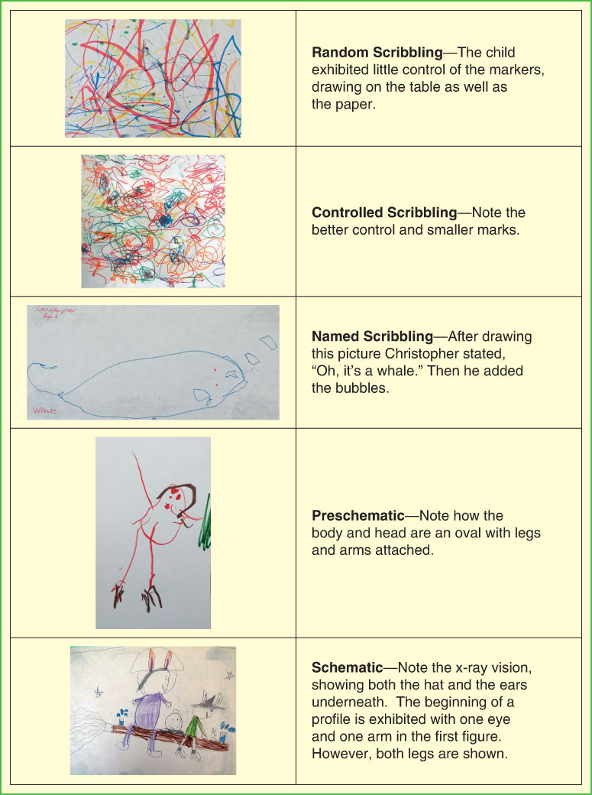

FIGURE 13.1 Stages of Art

13.2 How the Art Center Enhances Children’s Development

In many elementary schools, especially low-income schools, the arts are being cut ([Armario, 2012](https://content.ashford.edu/books/Bullard.8406.19.1/sections/ref#ch13ref1)). However, longitudinal studies show that children from low-income families who have high levels of art participation have better grades, test scores, high school and college graduation rates, and civic engagement than their peers who have low levels of art education ([Catterall, Dumais, & Hampden-Thompson, 2012](https://content.ashford.edu/books/Bullard.8406.19.1/sections/ref#ch13ref6)). When children participate in art they increase their artistic knowledge, skills, and creativity while enhancing emotional, social, cognitive, and physical development. They also are more likely to develop a “love of the arts” when they are exposed to art at a young age.

Artistic Development

Although most children will not choose to be professional artists when they become adults, they will nevertheless be surrounded by images. To be literate in today’s world, one must be able to understand, analyze, and critique these images. Through early childhood art, children can increase observation skills, learn art techniques, begin to understand the relationship of art to culture and history, and learn to appreciate and enjoy images and art. They will also have the experience of joy that comes from creating unique products ([West, 2006](https://content.ashford.edu/books/Bullard.8406.19.1/sections/ref#ch13ref48)).

Although the arts are often the first subjects to be eliminated when there are school funding cuts, Hetland and Winner ([2001](https://content.ashford.edu/books/Bullard.8406.19.1/sections/ref#ch13ref23)) make the following important point: “Cultures are judged on the basis of their arts; and most cultures and most historical eras have not doubted the importance of studying the arts” ([Hetland & Winner, 2001](https://content.ashford.edu/books/Bullard.8406.19.1/sections/ref#ch13ref23), p. 5).

Creative Development

Art enhances creativity, which is crucial for innovation and adaptation. Creative people have the ability to see multiple solutions to a problem, employ original thoughts, and use their imagination. As a field, art promotes these skills, encouraging unique and divergent responses and diverse ways of looking at things. Many early childhood teachers previously thought the best way to enhance creativity in the arts was to use the noninterventionist approach. However, we have now come to realize the power and possibilities in the art as inquiry approach. As stated by HMIE ([2006](https://content.ashford.edu/books/Bullard.8406.19.1/sections/ref#ch13ref24)), a group in Scotland who researched creativity,

As pupils acquire experience, develop skills, and broaden their knowledge and understanding, they are able to use their increased control of materials, movements, media, and ideas to demonstrate a more mature level of creativity. Ironically, in contrast with the view that a climate of “anything goes” is conducive to creativity, the opposite is the case. Higher levels of creativity usually result from an interaction of considerable knowledge and skill with a willingness to innovate and experiment. (p. 3)

However, there is growing concern that creative thinking scores of children have decreased significantly. The Torrance Test of Creative Thinking (TTCT) measures creative thinking and has been administered to over 270,000 participants, beginning in the 1960s. Alarmingly, the tests reveal that there has been a steady decline in creativity scores since 1990, with the greatest drop in creativity in the K–3rd grade age range. The author states, “The results indicate younger children are tending to grow up more narrow-minded, less intellectually curious, and less open to new experiences” (Kim, 2011, p. 292). She speculates that this is due to overstructured schedules and a push for academics, resulting in less free play time.

Additionally, research reveals that divergent thinking, the ability to creatively generate multiple solutions or ideas, decreases as children progress through school. Land and Jarmin tested 1,600 children—first in preschool, then in elementary school, and finally in high school. When the group of children were tested as preschoolers, 98% were considered to be geniuses in divergent thinking. The test was repeated when the children were 8 to 10 years old, and only 32% of the children still reached the genius stage. When the children were tested as 14- and 15-year-olds, only 10% still tested in the genius range for divergent thinking. Preschoolers who once had the ability to think in divergent ways had lost this ability through their school years ([Robinson, 2005](https://content.ashford.edu/books/Bullard.8406.19.1/sections/ref#ch13ref38)). While thinking divergently is only one characteristic needed for creativity, it is critical, since the other characteristics of creative thinking are built upon this skill. It is crucial that we encourage divergent thinking in the arts, as well as in all curricular areas in the classroom.

ImagesWatch the video to see an example of why conformity in art is discouraged. How did this teacher negatively affect the young boy’s creativity?

<https://www.youtube.com/watch?v=jamtKsgmP_I>

According to Robinson and the National Advisory Committee on Creative and Cultural Education ([1999](https://content.ashford.edu/books/Bullard.8406.19.1/sections/ref#ch13ref33)), four characteristics are necessary for an activity to be defined as a creative process: thinking imaginatively; being purposeful; generating an original thought, idea, or product; and having this thought, idea, or product valuable in relationship to the task or objective. As we plan our art environments, we need to think about these characteristics. Children who have learned the artistic techniques needed to represent their ideas, and have the opportunity to explore topics and media in-depth, to revisit and add to their work, and to examine the same idea in different media, are more likely to embody these four characteristics.

Emotional Development

Art experiences can also assist children’s emotional development. As children participate in art activities they gain self-confidence, feel pride in their work, and experience success. Art allows children to express strong emotions that they may have difficulty verbalizing. It may provide the child and others with insights into the child’s thoughts and feelings, thus allowing for conversation and further discussion. For example, Gross and Clemens ([2002](https://content.ashford.edu/books/Bullard.8406.19.1/sections/ref#ch13ref21)) discuss how preschoolers in their class used drawings, paintings, and clay models to reenact the destruction of the twin towers in New York. Reenacting the scene was therapeutic for many children, allowing them to feel a sense of control, and opening up dialogue with the other children and adults in their lives.

Social Development

As children examine art from various artists in different time periods and diverse cultures, they have the opportunity to learn about and to appreciate similarities and differences. They come to understand that people have both similar and unique values.

In many classrooms, children also have the opportunity to collaborate with others on murals and other large art projects. Again, children learn about diverse views, practice negotiation, and have tangible proof of how their work, when combined with others, can create something beautiful.

Cognitive Development

Science and Math.

Through art, children learn about the world, record thoughts and ideas, and enhance academic learning. “Artmaking is a form of inquiry and way of learning about oneself and the world” ([Tarr, 1997](https://content.ashford.edu/books/Bullard.8406.19.1/sections/ref#ch13ref44), p. 2). For example, as a child observes a flower and then draws a sketch, he notices details he may not have considered before. Slight imperfections in the petals raise questions. What caused the holes in the petals? Why are some petals turning brown while others are not? He notes that the petal is a graduated color and must determine how he will portray this. When the child is done, he shares his work with others. “Through sharing and gaining others’ perspectives, and then revisiting and revising their work, children move to new levels of awareness” ([Edwards & Springate, 1995](https://content.ashford.edu/books/Bullard.8406.19.1/sections/ref#ch13ref13), p. 1). Children use process skills in art that they also use in math and science. They pose and solve problems, organize thoughts, and reflect on their learning. They learn about properties of materials and experiment with cause and effect. Through art children see items from different vantage points and explore spatial concepts that are critical skills in geometry. Research confirms that studying visual arts is linked to enhanced geometric reasoning (Winner & Vincent-Lancrin, 2013).

Literacy.

As with written language, the visual arts involve recording a thought or idea that then can be conveyed to someone else. For this reason, art is often considered the child’s first written language ([Koster, 2015](https://content.ashford.edu/books/Bullard.8406.19.1/sections/ref#ch13ref29)). In addition, children’s first writing efforts and storytelling are often related to the pictures they have drawn.

The arts can also enhance children’s verbal language. Art can be a catalyst for rich dialogue among children and between the child and the teacher. Additionally the arts, like all fields of study, have a specific vocabulary that the child learns as she interacts with more knowledgeable peers or the teacher.

As children carefully study and discuss their art and the art of others, they are developing visual perception or ‘visual thinking,’ a cognitive process that takes images and gives them meaning” ([Koster, 2005](https://content.ashford.edu/books/Bullard.8406.19.1/sections/ref#ch13ref27), p. 5). The child will also use these skills in reading.

Physical Development

Art develops large and small muscles and eye–hand coordination. Unlike prescribed writing or art exercises, creative art provides a motivating climate for children to practice and perfect motor control. Some teachers use production-oriented art as a way of promoting fine motor control. However, children are typically more passionate about their own creative art. Therefore, they are often more committed to the repeated practice that is needed to master the skills.

As children participate in art they have opportunities to increase artistic skills, enhance creativity, and develop emotional, social, cognitive, and physical skills. However, for optimal development, the teacher must use the inquiry approach to art and must establish an environment that is conducive to learning. How does a teacher develop an art center that stresses the art as inquiry approach?

13.3 Designing an Effective Art Center

Designing Effective Indoor Art Centers

Art does not occur in only one area of the room; instead it is embedded throughout the environment. Children learn about art from picture books, pictures on the wall in other areas of the room, and the aesthetics of the room itself. However, it is also important to have a dedicated area where children can focus on producing and studying art. Art centers can be a separate room such as the atelier in the Reggio Emilia schools or they can be a center in the classroom. Whether a separate studio or a corner nook, art centers need to be places of inquiry and wonder. To provide this, we need a space with:

Plenty of natural and artificial light.

Easy clean-up with linoleum or tile floors, covered or easy-to-clean tables, and a close proximity to water.

A quiet space that allows for focus and attention.

Ample space so that children have room to create large projects and so that several children can work at a time.

Space for drying creations and storing ongoing work. At the North Idaho College Children’s Center, teachers have a trellis hanging horizontally from the ceiling over the art table. This creates a differentiated art space, and the top of the trellis is used as a drying rack.

Space for displaying art creations (both two- and three-dimensional).

An abundance of diverse materials. There may be a limited number of materials when children are first introduced to a medium. However, to allow for in-depth exploration and enhanced creativity, the range of materials should expand with the children’s experiences.

High-quality, authentic materials and tools in good working condition. Poor-quality tools inhibit children from expressing their talent. For example, trying to control the line of paint when the brush will not keep a point can frustrate children’s efforts to create the picture they are envisioning. Clogged glue bottles or scissors that don’t cut can also be very frustrating.

Safe and nontoxic materials. Just because an art material is for sale does not mean it is safe or nontoxic. You can find certified product lists at the Art and Creative Materials Institute (ACMI), or you can look for the ACMI-certified nontoxic label. You can also request a Materials Safety Data Sheet from the manufacturer so that you can review the material yourself.

Uncluttered, organized shelves so that children have easy access to materials.

Aesthetically displayed materials that invite children to investigate and use the media. As we are teaching children about aesthetics, we need to model it in the environment. Materials can be displayed in baskets, transparent bowls, and in beautiful containers. You can organize materials by color palette. For example, color crayons or color pencils can be displayed in clear jars. Each jar can contain

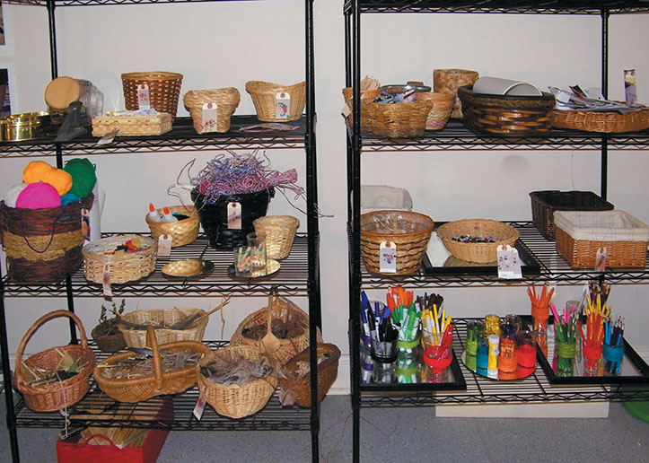

In this art center, materials are displayed in baskets and glass and organized by color palette. Notice how the mirrors reflect the materials and add to the aesthetics of the center.

Julie Bullard

a different color with many hues represented. Mirrors can be used to reflect the materials in a different way.

An abundance of reference materials and materials for inspiration. Especially when children are creating representational drawings, it is important to provide them with real-life objects, pictures, photos, and reference books to use as resources. Even adult artists, who have years of observational training and increased ability to remember detail, use references when creating pictures. In addition, reference materials provide opportunities for children to examine and appreciate art.

Storage for replenishing supplies.

Designing Effective Outdoor Art Centers

The outdoor environment provides inspiration for artists, an abundance of natural materials that can be used to create art, and space for large and messy projects. The outdoors is also a wonderful place for permanent displays of children’s art. Ideally, the outdoor art center is a permanent center, with ample storage for needed supplies. However, if this is not possible, a tote or bag can be used to transport needed materials outdoors. Following are some examples of outdoor art ideas:

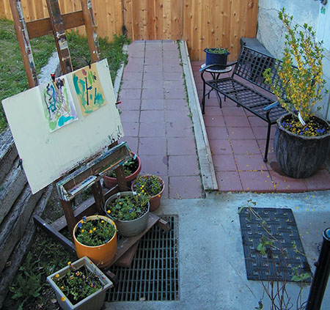

This outdoor art center at Curious Minds: Early Care and Education Center is adjacent to the indoor art studio, allowing children to use either space. The adjustable art easel can accommodate either very small or very large pieces of paper.

Julie Bullard

An easel placed under a tree can be used for quietly painting or drawing.

A chalkboard with a bucket of colored chalk can be placed in the playhouse.

A collage center can be created that is stocked with natural items (pinecones, twigs, dried berries, flower petals, seedpods, or nuts). Children can go on nature walks to replenish their supplies.

A clay center can provide opportunities for making casts of trees, flowers, and pinecones as well as other clay creations.

An outdoor loom stocked with natural materials (dried grasses, supple sticks) creates an invitation to weave.

A sculpture center that includes a variety of similar items (bicycle parts, appliance parts, or different sizes and shapes of wood) provides opportunities for large sculptures.

An art sack or tote that contains clipboards, paper, pencils, and markers encourages children to make representational drawings.

Sand, ice, and snow can provide the media for transitory sculptures.

Teachers can also display children’s artwork to decorate the playground. For example, at Mentor Graphics Child Development Center, children working with an artist used strips of painted roofing paper to create three-dimensional art by weaving the strips through the fence. At the Helen Gordon Child Development Center, children created gigantic murals that were painted on a canvas and then covered with a polymer to protect them. Children and families at one program create and decorate stepping stones as a beginning of the year activity. The stepping stones are then used throughout the play yard as walkways and around trees and gardens.

13.4 Materials and Activities for the Art Center That Will Assist Children to Meet Art Standards

When developing your art center either indoors or outdoors, it is also important to consider art goals. The National Coalition for Core Art Standards includes four overarching anchor standards for all the art disciplines and for all students, regardless of age.

Appropriate Principles, Materials, and Activities for Meeting the Goal of Creating and Presenting Art

To meet the goals of creating and presenting art it is important to keep three important principles in mind. First, provide materials that can be transformed. Second, allow adequate time to explore each new art media, tools, or element. Third, encourage children to engage in in-depth artwork through revisiting. Keeping these in mind, you will want to plan the materials and experiences that you will provide. Art centers for young children will typically contain materials for drawing, painting, modeling, and creating sculptures and collages. Each of these media has different affordances, or differing physical properties and abilities to be transformed by a child’s desire to represent an idea ([Forman, 1994](https://content.ashford.edu/books/Bullard.8406.19.1/sections/ref#ch13ref17), p. 38).

Provide Art Materials That Can Be Transformed.

As mentioned in the opening story, production-oriented or patterned art is developmentally inappropriate in early childhood. Patterned art tends to produce nearly identical looking products. In some cases, the teacher has precut much of the product and the child’s role is to assemble the pieces. For example, children create snowmen by gluing teacher-made construction paper circles together.

|  | Artistic Process | Anchor Standards |
| --- | --- | --- |
| Creating | Conceiving and developing new artistic ideas and work. | Generate and conceptualize artistic ideas and work. Organize and develop artistic ideas and work. Refine and complete artistic work. |
| Performing, presenting, and producing | Performing: Interpreting and presenting artistic ideas and work (dance, music, theatre). Presenting: Interpreting and sharing artistic work (visual arts). Producing: Realizing and presenting artistic ideas and work (media arts). | Select, analyze, and interpret artistic work for presentation. Develop and refine artistic techniques and work for presentation. Convey meaning through the presentation of artistic work. |
| Responding | Understanding and evaluating how the arts convey meaning. | Perceive and analyze artistic work. Interpret intent and meaning in artistic work. Apply criteria to evaluate artistic work. |
| Connecting | Relating artistic ideas and work with personal meaning and external context. | Synthesize and relate knowledge and personal experiences to make art. Relate artistic ideas and works with societal, cultural, and historical context to deepen understanding. |

National Core Arts Standards © 2014 National Coalition for Core Arts Standards. Rights administered by the State Education Agency Directors of Arts Education. Dover, DE. [www.nationalartsstandards.org](http://www.nationalartsstandards.org) All rights reserved.

Whenever you choose an art project, you should consider whether you are expanding or limiting creativity and the cognitive thought process. For example, many teachers have children make caterpillars out of egg cartons. While children are allowed to decorate the caterpillars any way they wish, is this the best way to encourage children to closely observe caterpillars, to think about how caterpillars look, to decide what media would be best to create the caterpillar, or to contemplate how to capture the fluffiness of the caterpillar? Epstein and Trimis ([2002](https://content.ashford.edu/books/Bullard.8406.19.1/sections/ref#ch13ref15)) urge us to choose art projects carefully. A good rule of thumb is to avoid art materials that are “cute or novel.” Instead, choose art materials that can be transformed and used by the child to express an idea or feeling ([Epstein & Trimis, 2002](https://content.ashford.edu/books/Bullard.8406.19.1/sections/ref#ch13ref15)).

Allow Adequate Time to Explore Each New Media, Tool, or Element.

When creating art, children first need the opportunity for in-depth experimentation with art media, tools, and elements. Teachers need to help children become competent in the use of art media so they can express ideas and thoughts in the way they intended. As mentioned earlier, when children are first introduced to a media or tool, it is important to begin with a limited number of materials, allowing children to explore and master them before gradually introducing more materials ([Spodek, 2006](https://content.ashford.edu/books/Bullard.8406.19.1/sections/ref#ch13ref43)). “We must be careful in our zeal to provide children with a variety of art materials and experiences, we do not shortchange their time with each one” ([Epstein & Trimis, 2002](https://content.ashford.edu/books/Bullard.8406.19.1/sections/ref#ch13ref15), p. 45). For example, Latoya, a teacher of three-year-olds, introduces children to tempera paint by giving them just one color. After children have thoroughly explored this color, she adds white paint so that children can create a range of tints of this color. Eventually she adds additional colors. As children become proficient, she also provides additional types of paper and brushes.

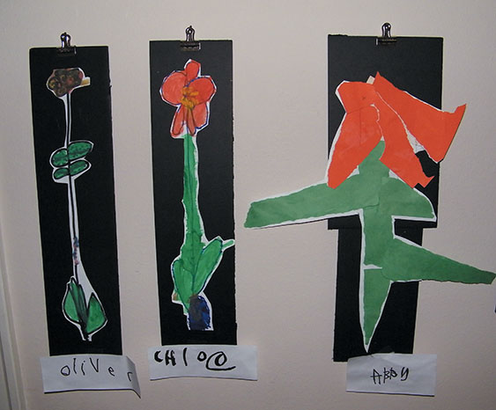

The children revisited their work and created their flower in different media, allowing these 3- and 4-year-old children to become more proficient with art materials while also revising their theories about flowers.

Julie Bullard

Encourage In-depth Artwork Through Revisiting.

Art experiences need to be thoughtfully planned to encourage in-depth artwork. The practice in some programs of an art activity each day does not allow children the in-depth development of the skills they need to portray their thoughts and ideas adequately. Repetition with media, revisiting the same piece of art, and creating an idea in different media contribute to deeper learning and enhanced artistic outcomes.

Revisit Media.

To become proficient, children need many opportunities to use media over an extended period of time. This will allow children to move beyond exploration, which is the first phase when someone is introduced to a new media such as clay or watercolors.

Revisit Artwork.

Just like professional artists, children need the opportunity to revisit their work. They also need the opportunity to determine when their art is complete. Artists often begin with a sketch, work on a number of pieces at once, revisit, and find ideas from a number of sources ([Tarr, 1997](https://content.ashford.edu/books/Bullard.8406.19.1/sections/ref#ch13ref44)). Most artists also name their work. Encouraging children to create names or titles for their creations helps them to reflect upon their art and is another way for children to revisit their work.

Revisit Ideas Using Different Media.

Revisiting ideas through different media also helps children to reflect. When children use different media, they are challenged to think about the idea they are expressing in different ways. For example, a child might create a sketch of a caterpillar, then paint a picture of a caterpillar, and then create the caterpillar out of clay. Each media allows the child to represent his knowledge in a unique way and creates new questions and deeper thought. Todd was creating a caterpillar out of clay. He decided to use wire to represent the hairs on the caterpillar. This involved cutting the wire and placing each hair individually, causing him to focus on the hair. He had many questions. Does the hair grow straight up or does it curl slightly at the end? Are the hairs on all the caterpillars the same? Do they go in circles around the body or are they random? After closely observing the caterpillars for a length of time, he began to work. Forman ([2006](https://content.ashford.edu/books/Bullard.8406.19.1/sections/ref#ch13ref18)) suggests that to increase children’s knowledge of their learning after they have created in different media, they should circle back and revisit their first drawing. “Children draw to learn as opposed to merely learn to draw. Children are revising their theories, not simply revising the accuracy of a copy” ([Forman, 2006](https://content.ashford.edu/books/Bullard.8406.19.1/sections/ref#ch13ref18), p. 36).

Provide Materials and Activities for Drawing.

Children gain inspiration for drawing from a variety of sources: observation, experiences, memory, and their imagination ([Bartel, 2006](https://content.ashford.edu/books/Bullard.8406.19.1/sections/ref#ch13ref2)). However, their drawings are more in-depth when they are observing rather than relying on memory (Colbert & Taunton, [1988](https://content.ashford.edu/books/Bullard.8406.19.1/sections/ref#ch13ref8)). To assist children in observational drawings, it may be helpful to provide observational tools, such as magnifying glasses to observe fine details. A cardboard tube or a viewfinder can help to narrow the child’s focus. Mirrors can also be a helpful tool, allowing children to see objects from a different view. Additionally, like artists, children need the real object, as well as representations of the object, for inspiration while drawing.

TIP

You can make your own viewfinder by cutting the center from an 8″ square rigid piece of cardboard. Make the frame about 2″ wide. This creates a 4″ interior square. Children can hold the viewfinder at eye level and look through it or place it on a picture to narrow the viewpoint.

Esmeralda, like many teachers, begins each year with a study of self. In the art area, she provides photos of each child and his or her family. She also provides photos that focus on one facial feature, for example, a close-up photo of eyes, ears, or teeth for each child. Mirrors of different sizes are available throughout the art area. Magnifying glasses for close examination are also available. On the walls of the art area are framed pictures from famous artists: Gainsborough’s The Blue Boy, Durveger’s Alone, and Cassatt’s Two Children Playing on a Beach. A viewfinder is hung next to each reproduction to assist children in narrowing focus. She also provides a three-dimensional bust and a hardwood 12″ manikin for children to study.

The children make self-portraits beginning with sketches. Esmeralda adds skin tone paper and markers for the children to use if they wish. They then produce their portraits in paint and wire. Ultimately, the children make clay busts of themselves. They mix paints to match their skin tones and give each child’s paint a creative, descriptive name (chocolate syrup, nutmeg, root beer float). They use these mixtures to paint their clay busts.

Esmeralda also adds a variety of costumes to the dramatic play area to help children extend the discovery of self. Children experiment with new identities through wearing the costumes—and often capture their transformations through their art.

Art centers for preschool and early-elementary-aged children should contain many types of drawing tools. Each tool has unique characteristics, allowing children to use them for different purposes. See [Figure 13.2](https://content.ashford.edu/books/Bullard.8406.19.1/sections/ch13lev1sec4#ch13fig02) for a description of the materials. At a minimum, the center should contain different types of pencils, markers, chalk, and crayons. These drawing materials are also typically available throughout the classroom to encourage writing, drawing, and sketching. For example, drawing materials and paper in the block area encourage the children to preplan their buildings and to document their buildings after they create them.

Provide Materials and Activities for Painting.

Tempera, watercolor, acrylic, and finger paints are appropriate for preschool and early-elementary-aged children and should be available in the art center. See [Figure 13.3](https://content.ashford.edu/books/Bullard.8406.19.1/sections/ch13lev1sec4#ch13fig03) for a description of each of these types of paint. An easel set up in the art center with a variety of paint hues provides an appropriate surface while enticing children to paint. Rather than using a child’s easel, the Helen Gordon Child Development Center uses an adult wooden adjustable easel finding that it is aesthetic and accommodating of both larger and smaller pieces of paper.

Even very young children can use tempera paint and an easel. For example, the Birge Nest room in Early Head Start, serving children from birth to age three, has an easel with several colors of paint that is continually available to children.

In many programs, children are encouraged to draw their pictures before painting them, allowing them to preplan their creations. The drawing may be made several days before or immediately before painting. Pencils and other drawing materials placed near the easel provide an invitation for children to draw before painting if they have not already done so.

You will want to give children many opportunities to explore paint. You might begin by exploring these questions. How does paint work on different types of surfaces?

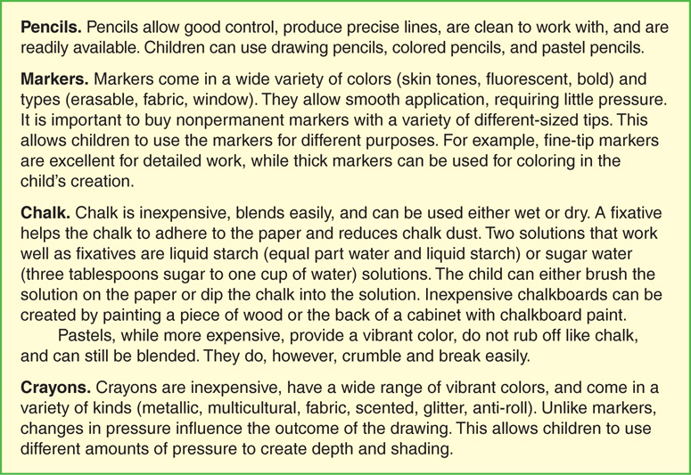

FIGURE 13.2 Drawing Materials

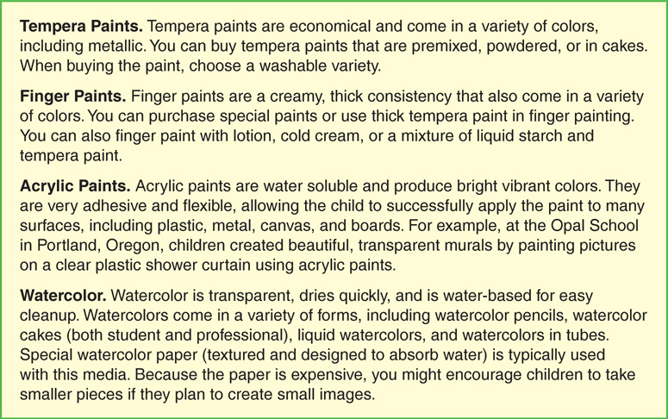

FIGURE 13.3 Types of Paint

What kind of lines can be produced with different size brushes? How can paint be made thicker (soap flakes), shiny (sugar), glittery (salt on wet paint), or gritty (sand)? What other substances can change the texture of the paint? What colors can be produced by mixing the paints? You can provide small clear glass or plastic containers for children to use for their experimentation. As children become more experienced, the teacher can also create mixing challenges such as trying to mix paint to match a paint chip. The mixed paints can be displayed in the art area and used for future paintings. The wide variety of hues in clear containers also adds an aesthetic element to the classroom.

When learning about the properties of watercolor paints, children can experiment with different size brushes, create shades by adding an increasing amount of water, and experiment with wet versus dry paper. Wet paper allows the paint to spread out and often creates a misty or hazy look ([Romberg, 2002](https://content.ashford.edu/books/Bullard.8406.19.1/sections/ref#ch13ref39)). As children become more familiar with the media, they may wish to produce special effects such as blotting with a sponge to create texture or overlaying colors (paint with one color, let the painting dry, and then paint over the picture with another color).

Providing a variety of paints allows children to experiment with the different properties of each. It also allows children to choose the most conducive paint for their specific purpose and surface. Many surfaces can be used for drawing and painting. See [Figure 13.4](https://content.ashford.edu/books/Bullard.8406.19.1/sections/ch13lev1sec4#ch13fig04) for a list of some possible surfaces.

It is critical to have quality brushes in a variety of sizes for children to paint with. The quality of the brush greatly influences the child’s ability to manipulate the paints. If the child wishes to create a special effect, you might provide other items to paint with, including sticks, pastry brushes, feathers, sponges, small paint rollers, makeup brushes, toothbrushes, and vegetable brushes. For example, toothbrushes may be effective in creating a background for snow scenes.

Provide Materials and Activities for Collage.

A collage, a composite of material or objects pasted onto a surface, can be two or three dimensional. Collage materials are often recycled or reclaimed items such as newspaper clippings, beads, buttons, wallpaper, fabric, and items from nature.

Collages may be created around a theme. For example, Sarah has children create “All about me” collages that include magazine pictures, drawings, and items representing themselves. One child loved apple juice and added a small juice box to his collage. Another child included a clay model of a ladybug because she liked to collect bugs.

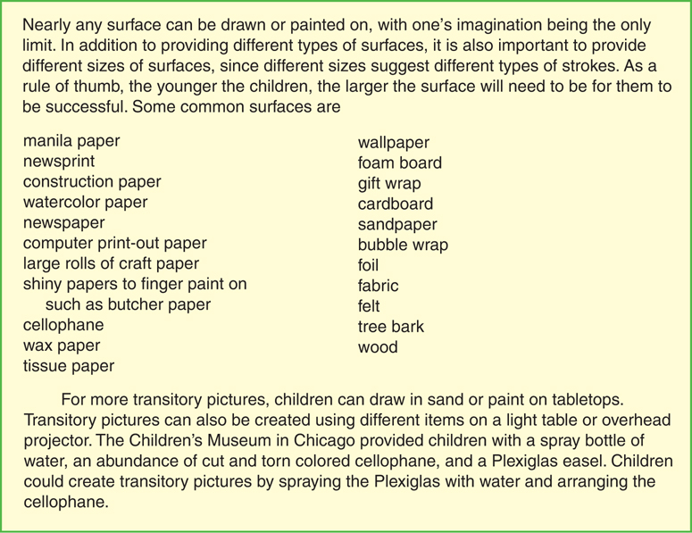

FIGURE 13.4 Surfaces to Draw and Paint On

Infants can make collages by sticking items to clear contact paper. When the child is done, the teacher can place another piece of contact paper over the top of the picture, sealing the materials between the two layers.

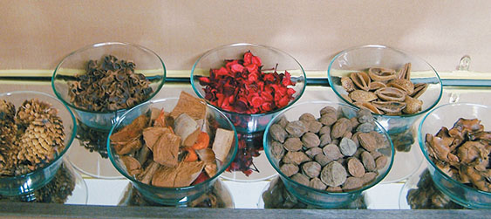

These natural collage materials become the focus of attention when they are displayed in the glass bowls. The mirror adds to the aesthetics on the display.

Julie Bullard

Provide Materials and Activities for Sculpture.

A sculpture is a three-dimensional figure. Like collages, they can be created from a variety of materials. Materials that are suitable for children include different sizes of wire, rolled-up newspaper, boxes, wood, papier-mâché, small appliance parts, and a variety of other recycled materials (see [Figure 13.5](https://content.ashford.edu/books/Bullard.8406.19.1/sections/ch13lev1sec4#ch13fig05) for ideas). You will also need the appropriate type of glue, tape, nails, and so forth to hold the sculpture together.

At the Mentor Graphics Child Development Center, children created bug sculptures following an in-depth study of insects. Children first drew their designs and then created the three-dimensional models using kitchen items such as forks, spoons, and colanders. After the bugs were completed, they were painted gold and were mounted to fence posts in the playground, becoming permanent art exhibits.

Provide Materials and Activities for Modeling.

Many early childhood programs provide Play-Doh for children to use in modeling. While Play-Doh allows children to experiment with modeling, clay provides several benefits not found with Play-Doh. Clay is a natural material, coming from the earth. It allows for more detail than Play-Doh and holds its shape, allowing the artist to create upright sculptures. Some teachers are concerned that young children may be unable to use clay successfully. However, in the book Poking, Pinching, and Pretending, Smith and Goldhaber ([2004](https://content.ashford.edu/books/Bullard.8406.19.1/sections/ref#ch13ref42)) demonstrate that even toddlers can successfully use this media. If you want a material for modeling that is nondrying, you might consider Plasticine.

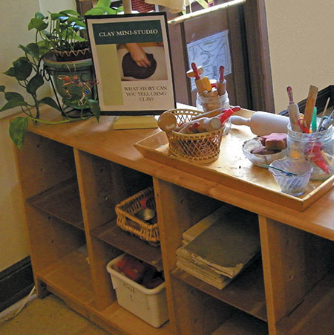

Notice that the clay mini studio provides children with tools that they can use to create their own three-dimensional designs. Clay boards help define space and make clean-up easier. They also allow a child to more easily move their design so that it can be stored and revisited later.

Julie Bullard

In introducing clay, let the children first experiment without using tools. For example, the teacher might sit with the children during center time and provide exploratory exercises to help children discover ways to change the shape of the clay. This might include using hands to change the surface of the clay (handprints, fingerprints), poking holes in the clay, squeezing the clay into tall shapes, breaking clay into pieces, and constructing balls, coils, and slabs ([Topal, 2006](https://content.ashford.edu/books/Bullard.8406.19.1/sections/ref#ch13ref47)). Children can also add water to the clay, experimenting with the different effects. Make sure you wedge (knead) the clay to mix it well before giving it to the children.

In many classrooms, children are given cookie cutters to use with clay or Play-Doh. However, Koster ([2015](https://content.ashford.edu/books/Bullard.8406.19.1/sections/ref#ch13ref29)), an early childhood art educator and author, equates this to giving children dittoes for drawing or coloring. Using cookie cutters often inhibits children from using the clay to develop three-dimensional models. It can also give children the impression that they are not capable of producing the items on their own. Instead, after you have introduced the clay, you can give the children cutting materials such as pizza cutters and plastic knives, rolling pins, ice cream scoops, cheese graters, and items to make impressions such as potato mashers. Or, you can introduce children to the tools that potters use. For example, you might introduce carving spatulas and scoring and scribing tools. As children become more proficient with the clay, you might want to introduce the idea of a wire armature or framework to provide stability for their vertical sculptures ([Wien, Keating, Comeau, & Bigelow, 2012](https://content.ashford.edu/books/Bullard.8406.19.1/sections/ref#ch13ref49)).

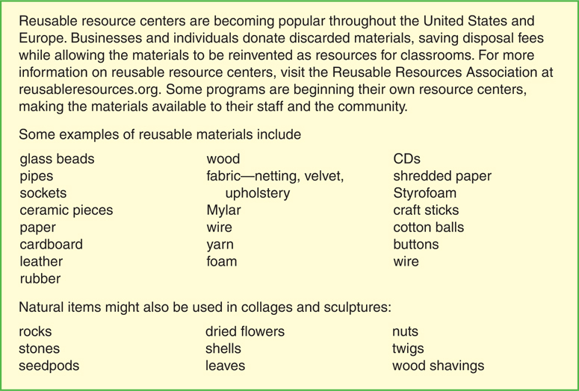

FIGURE 13.5 Reusable Materials for Art Activities

In addition to providing an art medium, clay provides a rich sensory experience. Clay also encourages experimentation and revisiting. As long as it is still soft, clay sculptures can easily be changed, added to, or reinvented.

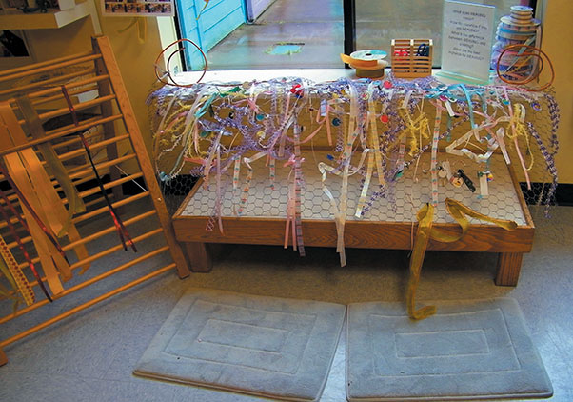

At Mentor Graphics Child Development Center, children are creating a group weaving using a chicken wire base. Ribbons for weaving are easily accessible from a nearby rack.

Julie Bullard

Provide Appropriate Art Tools and Paper.

In addition to providing drawing, painting, collage, sculpture, and modeling materials, you will also want to stock your art center with some basic materials and tools. Besides quality paintbrushes and clay tools, you will want:

Other basic tools (tape, stapler, hole punch, rulers, paper clips, glue and paste, and high-quality right- and left-handed scissors). Choose appropriate tools based upon the children’s developmental level and their interests.

Smocks to protect children’s clothing, freeing them to focus on their artwork rather than worrying about keeping their clothes clean.

A variety of types of paper (see [Figure 13.1](https://content.ashford.edu/books/Bullard.8406.19.1/sections/ch13lev1sec1#ch13fig01)).

The art center or studio for preschool and early-elementary-aged children needs to be well stocked with a variety of drawing, painting, collage, sculpture, and modeling materials that are aesthetically displayed. A variety of tools and types of paper will also be necessary. In addition, you might include materials for special projects such as printing, weaving, puppet-making, mask-making, beading, and jewelry-making.

Appropriate Materials and Activities for the Goal of Responding and Connecting to Art

Children need many opportunities to meet the art anchor standards of responding and connecting. This section will examine how the art center can assist in accomplishing these goals.

Art appreciation has a long history in the United States, having been first introduced in American elementary schools in the 1880s ([Kerlavage, 1995](https://content.ashford.edu/books/Bullard.8406.19.1/sections/ref#ch13ref25)). Today we know that even toddlers exhibit the ability to make aesthetic choices, often showing preferences for specific colors and textures ([Danko-McGhee & Shaffer, 2003](https://content.ashford.edu/books/Bullard.8406.19.1/sections/ref#ch13ref11)). Generally, young children tend to prefer bright, saturated colors, pictures that have a familiar subject (either abstract or realistic), and simple compositions ([Epstein & Trimis, 2002](https://content.ashford.edu/books/Bullard.8406.19.1/sections/ref#ch13ref15)).

Without adult guidance, children tend to focus on the subject matter when discussing a work of art ([Epstein & Trimis, 2002](https://content.ashford.edu/books/Bullard.8406.19.1/sections/ref#ch13ref15)). However, when supported through open-ended questions, children can be guided to consider multiple aspects of a picture.

Most early childhood art centers focus on art production. However, you can add many materials to your art center and throughout your classroom that also introduce children to famous works of art and art appreciation. Often these will relate to the topics, media, or subjects that the children are exploring in their art production. You can accomplish this by doing the following:

Display art from the community (weaving, pottery, quilts, and jewelry).

Over time provide a variety of art from different cultural groups and time periods featuring different art media and styles.

Provide postcards featuring art to match and classify. At first children may match identical cards or sort cards by the subject matter. However, with the opportunity to explore different types of art and through adult guidance they can learn to sort by the media or the type of art (oil, collage, drawing, fresco or wet plaster, pastel, print, sculpture, acrylic, mobile, or drawing) or by the broad subject (abstract, cityscape, interior, landscape, portrait, seascape, or still life) ([Koster, 2015](https://content.ashford.edu/books/Bullard.8406.19.1/sections/ref#ch13ref29)).

Provide books with famous art reproductions.

Use calendars of art prints to create puzzles.

Provide a peek-a-boo window over an art print. The peek-a-boo window piques curiosity and helps children to closely examine one small part of the picture.

Create bulletin boards of art featuring opposing concepts (realist/abstract) ([Schiller, 1995](https://content.ashford.edu/books/Bullard.8406.19.1/sections/ref#ch13ref40)).

Place a picture frame in the art area that allows children or teachers to feature pictures.

Set up an inspirational display of nature as art. For example, place rocks or shells in an interesting design or arrange a beautiful bouquet of flowers.

Create a masterpiece corner to highlight a featured piece of artwork ([Koster, 2015](https://content.ashford.edu/books/Bullard.8406.19.1/sections/ref#ch13ref29)).

Special Considerations and Materials for Infants and Toddlers

As soon as children begin to show interest, they are ready to begin drawing. For example, Dunst and Gorman ([2009](https://content.ashford.edu/books/Bullard.8406.19.1/sections/ref#ch13ref12)), examined 25 studies of infants’ and toddlers’ mark making and scribbling and found that even one-year-olds create marks. Infants’ and toddlers’ drawing was more complex and lasted for a longer duration if the writing material produced a more visual effect (markers, crayons, and digitalized computer pens), if the writing surface was slanted, and if a background of animals or people were used to draw on. As would be expected, the more opportunities the child had for drawing, the younger the child was when she moved into the preschematic stage of drawing. Beginning at the age of one, most children are also ready to make collages, paint, and model with clay or Play-Doh. By age two, most children are ready to explore printmaking, especially with body parts such as hands and feet ([Koster, 2015](https://content.ashford.edu/books/Bullard.8406.19.1/sections/ref#ch13ref29)).

One of the major art goals for children three and under is the exploration of media and tools. Toddlers need the opportunity to use paper and cardboard, clay, crayons and markers, and nontoxic paint. They can also begin to explore art elements, especially color ([Gandini, 2006](https://content.ashford.edu/books/Bullard.8406.19.1/sections/ref#ch13ref19)). If children have these opportunities as toddlers, they will be ready to use the media and tools to create representational and imaginative art when they are preschoolers. Since children this age may still be mouthing items, it is crucial that all materials are safe to ingest and do not pose a choking hazard.

At Helen Gordan Child Development center the teachers created a studio space for infants and toddlers. The studio space allows children to engage in in-depth investigation of an idea, concept, or material. Over the course of time this studio space has been used to explore paper, clay, painting, building, natural materials, sensory materials, dancing, sound, and rocking. For example, the rocking studio included a rocking boat, a child-sized rocking chair, a rocking horse, and other items that rocked.

TIP

To prevent marker tops from being a choking hazard for infants and toddlers, place the tops upright into a plaster of Paris mixture. After the mixture has dried, children can simply place markers onto the ummovable tops. Teachers at Playcare created the marker holder in a golden cookie tin and added glitter to the plaster to make it more attractive.

Even very young children can participate in long-term art explorations. For example, infants and toddlers in Reggio Emilia participated in an exploration of white. Young infants explored a multisensory landscape of white materials, each having different tactile and visual qualities. Children could crawl on the materials, try to tear them, mouth them, pick them up, and try to look through them. The toddler’s explorations of white began by focusing on the properties of a white paper napkin. They continued exploring a variety of white materials (wool, cotton, paper, paper towels, plastic, slick paper, corn paper, tissue paper, sheer fabric, satin, and more). After repeated opportunities to explore, each child made his own individual creations that were included in a large, beautifully displayed composition (Vecchi & Giudici, 2004).

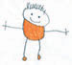Apply Your Knowledge

Early childhood educators using the Reggio Emilia approach believe in introducing a variety of art materials to children at a young age. For example, in Reggio Emilia, toddlers use beautifully displayed drawing materials, earth clay, wire, natural collage materials, and glass containers filled with paints. However, some early childhood educators question the safety and appropriateness of these practices. How do these practices reflect the Reggio Emilia philosophy (see [Chapter 1](https://content.ashford.edu/books/Bullard.8406.19.1/sections/ch01#ch01))? What would a teacher from Reggio Emilia say were the advantages of providing these materials to toddlers?

Special Considerations and Materials for School-Aged Children

Many elementary schools have art specialists. However, 88% of classroom teachers, understanding the value, also include art as part of their ongoing instruction ([National Coalition for Core Arts Standards, 2014](https://content.ashford.edu/books/Bullard.8406.19.1/sections/ref#ch13ref34)). The arts also play a prominent role in the Common Core State Standards for English Language Arts. A study examining this link discovered that of the 396 standards listed for reading, writing, and speaking and listening, 74 or 19% of these made direct reference to the arts. In the visual arts this includes standards on analyzing and interpreting images, creating images to tell a story, and using visuals when speaking ([The College Board, 2012](https://content.ashford.edu/books/Bullard.8406.19.1/sections/ref#ch13ref45)). For example, one of the common core writing standards for kindergarten states, “Use a combination of drawing, dictating, and writing to compose informative/explanatory texts in which they name what they are writing about and supply some information about the topic.” A speaking and listening standard for second-grade children states, “Create audio recordings of stories or poems; add drawings or other visual displays to stories or recounts of experiences when appropriate to clarify ideas, thoughts, and feelings” ([National Governors Association Center for Best Practices and Council of Chief State School Officers, 2010](https://content.ashford.edu/books/Bullard.8406.19.1/sections/ref#ch13ref35)).

The study also makes a link between the arts and the Standards for Mathematical Practice stating that the creative practices of imagine, investigate, construct, and reflect underlie both. For example, one of the mathematical practice standards is to model with mathematics. To do so a child must imagine (form a mental image or concept), investigate (observe or study through exploration or examination), construct (make or form by combining parts or elements), and reflect (think deeply or carefully about) ([The College Board, 2012](https://content.ashford.edu/books/Bullard.8406.19.1/sections/ref#ch13ref45), p. 65). This study reinforces the concept that while art has an intrinsic value of its own, it also plays an important role in other curricular areas.

In the next section, we will examine the teacher’s role in exposing children to art. As the teacher exposes children to art and then guides them to look at multiple aspects of a picture, children’s ability to meet the visual art standards of creating, presenting, responding, and connecting is enhanced.

**13.5 Teachers’ Facilitation of Learning in the Art Center**

The teacher is crucial in helping children gain optimal art skills, dispositions, and knowledge. She exposes children to different types of art, provides life experiences, discusses art with children, teaches children techniques, acknowledges the artist and his art, challenges children, and documents and assesses their learning. Through providing culturally relevant, developmentally appropriate materials and making modifications as needed, she also meets the needs of all learners.

**Expose Children to Art and Art Elements**

In literacy, we rarely question that it is essential that children see adults and older children modeling reading and writing. We also believe that children need abundant exposure to high-quality literature. The same is true for art. Children need artist models and abundant exposure to art from the masters. Invite artists, sculptors, and potters to visit your program. They can model creating art and describe problems encountered as they work ([Tarr, 1997](https://content.ashford.edu/books/Bullard.8406.19.1/sections/ref#ch13ref44)). The artists can also work directly with the children modeling teaching techniques, art techniques, and art language for teachers and children ([Bisgaier, Samaras, & Russo, 2005](https://content.ashford.edu/books/Bullard.8406.19.1/sections/ref#ch13ref3)). In some instances, artists may work on a cooperative project with children. You can also take children on field trips to art galleries and pottery studios.

Many children’s books have wonderful illustrations, providing another opportunity to expose children to art. For example, Caldecott-award-winning books are chosen based on their illustrations. When reading a book to children, discuss the pictures. What media or special techniques are used? How are color, line, shape, and texture used? How do the illustrations add to the story? Provide the background on the artist. Compare the illustrations in the book to illustrations in previous books you have read or to current work the children are engaged in. For example, Ezra Jack Keats uses a paper collage technique. When reading *The Snowy Day*, Lakisha discussed with the children how they also had been using the collage technique in creating pictures. She asked the children how their collages and Keats’s were similar and different. Lakisha used a Venn diagram as part of the discussion to help clarify and focus the conversation (see [Chapter 4](https://content.ashford.edu/books/Bullard.8406.19.1/sections/ch04#ch04) for information on Venn diagrams). The diagram was also a way to create documentation of the dialogue.

In addition, it is helpful to provide activities that allow children to explore and learn about different art elements such as color and line. See an example in the “Create Your Own Color-Matching Wreath” box.

**Display Works of Art**

The experiences children initially have with art will influence their tastes and preferences for art throughout their lives. These preferences are often resistant to change ([Gardner, 1991](https://content.ashford.edu/books/Bullard.8406.19.1/sections/ref#ch13ref20)). Therefore, you will want to expose children to a variety of art. For example, introduce children to male and female artists from different cultures and time periods. Study art from the masters as well as local art. Pottery, weavings, and baskets from local artisians might be displayed or used throughout the environment. High-quality reproductions of the masters can be obtained from many sources. You can obtain inexpensive art from calendars, prints of great artists, art books, or magazines such as *The Smithsonian*. Koster ([2012](https://content.ashford.edu/books/Bullard.8406.19.1/sections/ref#ch13ref28)) recommends that you carefully choose art that helps children to understand the following:

Discuss Art with Children

Talk to the children about the art that is displayed. Christine Mulcahey, a professor and art specialist at a lab school, says that you can begin by asking children what they see in the picture, how the artist made the picture appear as it did, and what they think the artist may have named the picture. You can then share the actual name of the picture and discuss this with the children ([Mulcahey, 2009](https://content.ashford.edu/books/Bullard.8406.19.1/sections/ref#ch13ref32)). You might also use a visible thinking routine (see [Chapter 3](https://content.ashford.edu/books/Bullard.8406.19.1/sections/ch03#ch03)) such as I see, I think, I wonder. During this routine, the children answer three questions about the art, “What do you see? What do you think about that? What does it make you wonder?”

You can also engage young children in art history. While art history is often reserved for older age levels, some art educators question this practice. Erickson ([1995](https://content.ashford.edu/books/Bullard.8406.19.1/sections/ref#ch13ref16)) researched second-grade students’ understanding of art history by asking three questions: “How was life different back then? How would life back then have made a difference in the way the painting looked? What question would you ask to help better understand the painting?” She found that children attempted to make sense of the subject matter, difficulty, and skill of the painter, and made hypotheses about why artists may have painted the way they did.

Teachers can also help children learn more about art history by learning as much as they can about the art, the artist, and the historical time period so that they have information to share with the children. “Teachers do not have to become art historians overnight, just experts on one piece of artwork at a time” ([Koster, 2005](https://content.ashford.edu/books/Bullard.8406.19.1/sections/ref#ch13ref27), p. 229). Some programs prepare a little informational card to go with a posted print, so that teachers and volunteers have the needed background knowledge.

Teachers can also engage children in art criticism or “provocative art dialogues” ([Cole & Schaefer, 1990](https://content.ashford.edu/books/Bullard.8406.19.1/sections/ref#ch13ref9); [Spodek, 2006](https://content.ashford.edu/books/Bullard.8406.19.1/sections/ref#ch13ref43)). According to Spodek ([2006](https://content.ashford.edu/books/Bullard.8406.19.1/sections/ref#ch13ref43)), art criticism includes the following four stages:

Description of the artwork—subject matter, elements, and medium.

Analysis—relationship between the elements.

Interpretation—ideas, feelings, and mood conveyed by the artwork.

Judgment—based upon description, analysis, and interpretation.

By using questioning, you can guide even young children through this process ([Epstein, 2005](https://content.ashford.edu/books/Bullard.8406.19.1/sections/ref#ch13ref14)). In discussing the art, you can discuss art elements and ask children questions about the subject, the artist’s intentions, and how the art was made. You can compare this art piece to other works of art. You can also ask children how the artwork makes them feel. Another technique is to encourage children to pick a spot in the painting and imagine they were there ([Newton, 1995](https://content.ashford.edu/books/Bullard.8406.19.1/sections/ref#ch13ref36)).

It is also important to discuss reasons people make art. For example, artists might be expressing an idea, illustrating a book, recording what they see, depicting an emotion, or exploring visual relationships ([Tarr, 1997](https://content.ashford.edu/books/Bullard.8406.19.1/sections/ref#ch13ref44), p. 3).

Provide Life Experiences

“To create art, children must first have a feeling, thought, or experience they want to express. Without meaningful and individual experiences, children tend to draw stereotypical objects” ([Epstein, 2005](https://content.ashford.edu/books/Bullard.8406.19.1/sections/ref#ch13ref14), p. 53). Rather than creating art activities that are isolated from the rest of the curriculum, teachers can tie art to other areas of learning.

Children at North Idaho College Children’s Center were completing a project on flowers. Their study included a field trip to a greenhouse, visiting a field of wildflowers, interviewing gardeners, reading and looking at flower books, and ultimately creating their own flowerbed at the childcare centers. The children watered, fertilized, and cared for their flowers. They studied the flowers they grew, learning which ones lasted if they were picked and brought inside, which could be eaten, and which could be dried to form permanent bouquets. Using magnifying glasses, they carefully examined different types of petals, leaf patterns, and stamen. They also created their flowers in a variety of media, including representational drawings, paintings, and three-dimensional models in clay. As winter approached, and with it freezing weather, children decided they wanted to preserve their garden by creating a mural. They drew sketches, transferred their sketches to canvas, and then painted their creation with acrylic paint, creating a beautiful, vibrant, permanent rendition of their flowerbed. Because children had participated in a long-term project studying flowers, the mural captured their in-depth knowledge of the subject as well as their feelings and experiences with their garden.

Teach Techniques and Scaffold Learning

Early childhood practitioners must teach children the art techniques they need to be successful. For example, children need to know how to create a slip of water and clay to hold clay together or how to wet the paper when using watercolors. You can learn techniques yourself by taking a class or watching a video on YouTube. You might also invite an art partner to assist. Local art groups may volunteer to help teachers and children learn art techniques.

Learning to use proper techniques assists children to advance their artistic skill, thereby allowing them the ability to express their creativity. For example, when children were given guided opportunities to experiment with clay, they created more advanced human figures than did children who had not had this exposure ([Grossman, 1980](https://content.ashford.edu/books/Bullard.8406.19.1/sections/ref#ch13ref22)).

Acknowledge Learners

There are many ways that we can acknowledge children’s creations. These include attractive classroom displays or art shows featuring children’s work, referring to children as artists, and discussing children’s art with them ([Thompson, 2005](https://content.ashford.edu/books/Bullard.8406.19.1/sections/ref#ch13ref46)).

Attractively displaying children’s work surrounds them with beauty, provides affirmation for the artists letting them know that they and their work is important, extends project work, provides a window into children’s thoughts and souls, and provides information to other children, parents, and administrators ([Seefeldt & Waites, 2002](https://content.ashford.edu/books/Bullard.8406.19.1/sections/ref#ch13ref41)).

Frame the art with a mat, place it in a purchased frame, or create your own tagboard picture frame.

Purchase several different sizes and colors of Plexiglas. Children’s pictures can easily be taped to and removed from this surface.

Use unusual backgrounds such as aluminum foil or newspaper, but only if it does not detract from the art.

Include photos of children creating the art with their masterpiece.

Include photos or still lifes that children were using for inspiration or references as they were drawing or painting along with their finished product.

Include a written description or dictation from the child about the artwork when you display it.

Allowing children to determine what to display causes them to reflect upon their work. You can help children learn about displays by discussing their purpose, visiting exhibits, and making a list of criteria to consider when creating your own display ([Clayton, 2002](https://content.ashford.edu/books/Bullard.8406.19.1/sections/ref#ch13ref7)). Establishing a framing center in the classroom is another way to encourage children to be actively involved in creating the display. In addition to displaying children’s art on bulletin boards, you might want to try one of the following:

Create pedestals by stacking boxes or crates. Boxes can be arranged in numerous ways, including pyramids or stair steps or by stacking the same-size boxes on top of each other at different angles. Boxes and crates allow you to display art on all four sides and when stacked often provide room for three-dimensional displays. It might be necessary to weight the boxes to make them less likely to tip over.

Use all available space. In small rooms, you may need to be creative. For example, consider using the backs of dividers for displays.

Clip children’s artwork to a clothesline hung across the wall or ceiling.

Create a mobile out of coat hangers by taping them together to create a triangle or square. Children can clip their artwork to the hangers.

Sew pockets on a clear shower curtain to display small works of art. These can be hung in a window or from the ceiling as a divider between centers.

Create albums of children’s work (include children’s drawings, paintings, and photos of three-dimensional work).

Use art as a permanent addition to the school. For example, children might make ceramic tables, sculptures, stepping stones, or placemats.

ImagesWatch the video to see an example of ways to display art. How does this display assist in acknowledging children’s artistic development?

<https://www.youtube.com/watch?v=tCCE_Szo2tQ&list=PLDCE28F176A432839&index=10>

Discuss Children’s Art

Another important way of acknowledging children is to talk to them about their creations. The discussion can also help children verbalize their intent and cause them to think more deeply about their art. Through the discussion, you can assess the child’s understanding and learning and provide additional relevant information. “For dialogue to promote learning, it needs to be thoughtfully structured around a sequence of questions that invite reflection” ([Burton, 2000](https://content.ashford.edu/books/Bullard.8406.19.1/sections/ref#ch13ref5), p. 330).

It is important to refrain from asking the child what the picture is or trying to guess what it is. Many of us have been in the embarrassing position of guessing incorrectly and disappointing a child. Also, avoid judgmental statements (beautiful, good job, nice painting). These are not helpful to the child and are often statements used by adults when they have not taken the time to examine the artwork carefully. In addition, children may be dissatisfied with the results and wonder about your judgment when you state the art is beautiful. Instead, there are several other ways you can discuss the work with the child.

Ask the child to describe his work.

Discuss the art elements; for example, line, color, shape, texture, form, pattern, and space (open area) ([Tarr, 1997](https://content.ashford.edu/books/Bullard.8406.19.1/sections/ref#ch13ref44), p. 3). When you are describing the work, use correct art terms when it is developmentally appropriate: tint (white added), shade (black added), primary color (red, yellow, blue), secondary color (purple, green, orange), hue (color), intensity (brightness or dullness of color), or symmetry (same on both sides).

Talk about the art subject (cityscape, landscape, portrait, abstract, or still life). What is the subject, and why was it chosen?

Discuss the technique that was used. “How did you get the two pieces of clay to stick together?” “What colors did you combine to create the goldenrod color?”

Discuss the effort the child put into the work. “You’ve worked on your clay bear for the last three days. Each day I’ve noticed that you’ve added new details like the lines for the fur.”

Discuss the artistic decisions ([Koster, 2015](https://content.ashford.edu/books/Bullard.8406.19.1/sections/ref#ch13ref29)). “You decided to use only yellow items in your collage.”

Describe your own feelings when looking at the work. “When I see your picture of the ocean, it reminds me of when I was young and would pick up seashells with my grandfather.”

Children Want You to Create for Them.

If children ask you to draw for them, begin by trying to determine what underlying needs the children have. Do they need help with a specific technique? Do they want your attention? Are they having trouble determining how to begin their project? You will provide a different response depending upon each child’s needs. For example, if the child does not know where to begin, you might offer suggestions or ask questions that will assist him. If he is drawing a person, you might suggest he begin with the head. You can then show him his face in a mirror, show him pictures, or discuss the facial features that can be added. In other cases, children might not understand the process. For example, they might be trying to paint at the easel and the paint runs because they are not wiping the brush after dipping it in the paint. In this case, it is important to teach children a more effective technique. Through careful analysis and problem solving, the teacher can alleviate many challenges.

Observe and Document Children’s Art Processes and Products

There are many ways you can document children’s artwork, such as keeping the actual artifact, taking photos of three-dimensional work, and saving children’s renditions of the same subject over time or the same idea in multiple media. Having older children write a description of why they chose the subject, the art process they used, and the challenges they encountered can add additional information. Younger children can be interviewed about their art piece and recorded, or the information can be written by an adult. You might save children’s artwork in portfolios, adding anecdotal records, photos of the child creating the work, and a description and analysis of the work. When observing and documenting children’s work, consider the following questions:

What ideas does the child express in her artwork? Is there a theme?

What media does the child prefer using? Is the child able to use the media successfully?

What art techniques does the child use?

What was the purpose of this specific piece of artwork?

Where did the idea for the art come from?

How long did the child work on the art? Did he revisit his creation? What changes were made as a result of the revisiting?

Did he produce the theme or idea in different media? How did the idea change when different media were used?

What is the child’s stage of art development?

Is the child able to describe the art? Does the child use any art terminology in the description?

What physical skills does the child demonstrate while completing her art (cutting on a line, using a pincer grasp)?

Assessing and documenting the child’s art development provide information to share with the child and family. Teachers can also use this information for planning appropriate materials and activities.

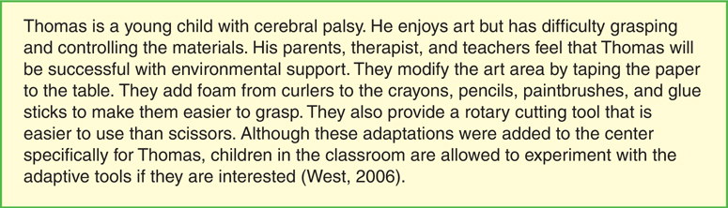

FIGURE 13.6 Meeting a Young Child’s Special Needs

Meet the Needs of All Learners

Teachers need to make sure that the art center and materials reflect cultural diversity and meet the needs of learners with differing abilities. Art provides a wonderful opportunity to expose children to local culture, their own unique culture, and the culture of others. One preschool program, surrounded by sheep growers, brought in local culture by providing a variety of types of wool (wool that was unprocessed, carded, spun, and felted) for children to use in their art.

Tonisha, a teacher of first-grade children, invites families to share artwork they have created or collected. One family brought in tole painting they created and sold. Another family brought in a collection of quilts, telling children the stories of the different designs. Still another family shared a collection of American Indian art.

Displaying and discussing professional works of art from different cultures and by people with disabilities is still another way that children can learn about their own and others’ cultures. Posting the picture of the artist with the work of art assists children to see this diversity.

Unfortunately, art activities can also perpetuate stereotypes. For example, some programs have children create totem poles when they study American Indians. This may cause children to think mistakenly that all American Indians created totem poles. Additionally, in some cultures the totem pole is sacred, and it is inappropriate for children to create one. Local artists or families from the culture being studied can often provide guidance on appropriate art activities.

We need to consider how to meet the needs of children with differing abilities, as well. See [Figure 13.6](https://content.ashford.edu/books/Bullard.8406.19.1/sections/ch13lev1sec5#ch13fig06) for an example of how one teacher met the needs of a young boy with cerebral palsy.

The teacher plays a crucial role in children’s art development in a variety of ways. She provides an aesthetic, well-stocked art center and interacts with children while they use the center—discussing art history and criticism, teaching techniques, providing challenges, acknowledging children’s work, and documenting their progress. The teacher provides background experiences and exposes children to art and artists.

In the art area, children participate in self-expression, create unique visual images of their ideas and thoughts, and engage in problem solving and inquiry. As children create and study art they take part in a universal language that breaks cultural barriers and transcends the changes of time.

Discussions

https://content.ashford.edu/images/search-loader.gifYour avatar

Top of Form



350  of 350 characters left 

Bottom of Form



[Previous section](https://content.ashford.edu/books/Bullard.8406.19.1/sections/ch13lev1sec4)13.5 Teachers’ Facilitation of Lea…[Next section](https://content.ashford.edu/books/Bullard.8406.19.1/sections/ch13lev1sec6)

Top of Form



Bottom of Form