The Success of Subaru’s “Love” Campaign:
The Power of Emotional Marketing in a Technical Industry

Melissa Barreto
Columbia University Portfolio Project
November 10, 2016
EXECUTIVE SUMMARY
In 2008, Subaru launched its “Love” campaign during a time of economic turmoil. Directed by the creative agency Carmichael Lynch, Subaru executed a communications strategy that emotionally appealed to consumers. “Love” resulted in company record sales – Subaru partnered with national and local organizations, revamped its website, produced heartwarming commercials, and created print and digital campaigns to strengthened its brand affinity and ultimately, grow its loyal fan base.
BACKGROUND
Subaru is the automobile manufacturing company of Fuji Heavy Industries, the twenty-second largest automaker company in the world. Founded in 1968, Subaru of America, Incorporated is in charge of the distribution, marketing, sales, and services of all Subaru vehicles in the United States. In 2004, Subaru became the first zero-landfill auto maker in the U.S. All Subaru cars come standard with all-wheel drive and uniquely designed boxer engines. Together, these two core features and the company’s commitment to the environment have established Subaru as a sustainable, safe, and reliable brand.
Subaru broke company record sales in the early 2000’s. The sales figures, however, only contributed to 1% of the U.S. market share. Subaru had a small, but loyal fan base among outdoor enthusiasts. The company’s marketing campaigns, however, failed to emotionally connect with new customers when Subaru introduced its sixth tagline, “It’s What Makes a Subaru, a Subaru” in 2006. Subaru turned to its former Marketing Director Tim Mahoney to take lead in the company’s promotional efforts as the new Chief Marketing Officer.
In the mid 2000’s, the economy started to head to a recession and the auto industry began to see an alarming decline in sales. Competition was stiff – The Detroit Three, consisting of General Motors, Ford, and Chrysler, were losing market share to foreign car brands like Toyota, Honda, and Hyundai. Mahoney reached out to the creative agency Carmichael Lynch to create a campaign that would not only result in an increase in sales, but would also triple Subaru’s market share in the U.S. automotive industry.
COMMUNICATIONS OPPORTUNITY
The Subaru Customer
In the 1990’s, Subaru conducted extensive research on its customer profile. Instead of marketing to a large demographic, Subaru found success in targeting a niche audience who were responsible for half of company sales. These customers were teachers and educators, healthcare professionals, outdoor enthusiasts, and IT specialists.
Moreover, Subaru found that the lesbian community were four times more likely than the average consumer to buy a Subaru. Companies were hesitant to market to the gay-lesbian community at that time. In reality, it was uncommon with the exception of Ikea. Subaru’s director of marketing went ahead and pitched the lesbian community as Subaru’s fifth segment to Subaru’s Japanese management. According to Reporter Ron Dicker from The Huffington Post,
When one Subaru ad man proposed the gay-targeting ads in talks with Japanese executives, the executives hurriedly looked up “gay” in their dictionaries. Upon reading the definition, they nodded at the idea enthusiastically. Who wouldn’t want happy or joyous advertising?

The lesbian community became Subaru’s fifth audience and the company partnered with The Rainbow Card to show its support to the community. However, Subaru’s marketing campaigns continued to be predominantly product focused. Despite Subaru having a robust understanding of its customers, the campaigns failed to engage consumers. According to Managing Director at Carmichael Lynch, “people who did not have an interaction with Subaru did not have an opinion on Subaru.”
When Subaru introduced its new tagline, “It’s What Makes a Subaru, a Subaru,” the advertisements included a crafted statement dedicated to one of the five target segments. For example, Subaru’s 2007 Outback commercial targeted people who enjoyed the outdoors. The commercial accentuated Subaru’s all-wheel drive feature by portraying the Outback in a mountainous region effortlessly driving through the mud. The commercial concluded with the statement “ready for adventure” along with the company’s new tagline. Subaru customer Gaffard Jean-Louis recalled the 2007 commercial but said, “it didn’t differ from any other car commercial at the time.”
Subaru’s sales were stagnant and Chief Marketing Officer Tim Mahoney knew that Subaru urgently needed an improved marketing strategy. Influenced by The 22 Immutable Laws of Marketing, Mahoney believed that the company needed to create a marketing campaign over time in order for the message to resonate with consumers.
Competitive Analysis
As the economy was heading to a recession, the demand for fuel-efficient vehicles intensified. This was an advantage for Subaru because its models, like the Outback and Legacy, were resourceful and environmentally friendly. Nevertheless, competition intensified as well. Competitors began producing more mid-size and compact vehicles; but similar to Subaru, competitors also focused on promoting the vehicle features. For example, Ford introduced its new Fusion by underlining the vehicle’s engine and torque power in its advertisements.
This is not to say that Subaru was the first car company to create a communications strategy with the goal of emotionally connecting with consumers. Chevrolet’s 2007 “Ain’t We Got Love” Super Bowl commercial targeted car lovers according to their music preferences by featuring R&B singer Mary J. Blige, country star Big & Rich, and rapper TI. The commercial was a success – Chevy received high acclaim and was regarded as one of the best Super Bowl car commercials by Complex Magazine.
Car Purchasing Behavior
Purchasing a vehicle is not an arbitrary decision. In fact, Google Inc data showed that 70% of buyers spend an average of 18 hours conducting online research before purchasing their next vehicle. This indicates that buyers have a rich idea of what car they want before stepping into a dealership. It was an opportunity for Subaru to create a campaign that would grasp consumers’ attention in the early stages of the car purchasing process.
Overall, Subaru faced numerous challenges. Internally, the brand needed to reach new customers by redefining its marketing strategy. Externally, the economy was in a recession and the government was investing in the Detroit Three to rescue the automotive industry.
SITUATIONAL ANALYSIS
The Automotive Industry Crisis Of 2008
The Great Recession of 2008 was a result of a world-wide economic decline. The deterioration of the housing market, high fuel prices, and tightening credit for car loans caused auto sales in the U.S. to plummet by 40%. The automotive industry witnessed an alarming double digit decline in sales – Ford reported a 34% drop, Chrysler 32.8%, Toyota 32.3%, and Honda 24%. This period is referred to as the “Automotive Industry Crisis of 2008” as it was the first time that the auto industry experienced a loss since 1993.
To avoid bankruptcy, the Detroit Three (who controlled 47% of U.S. auto sales at the time) asked Congress for a $50 billion loan. Americans, industry analysts, government officials, and economists questioned whether the government should intervene. Congress initially refused, but shortly after agreed to a $23.5 billion bailout in December of 2009. According to the former Chairman David E. Cole of Center of Automotive Research, the Federal Government agreed to a bailout "because the entire industry was in a depression, and it could have dragged the whole country into one."
In January 2009, the Federal Government created the Automotive Industry Finance Program with the objective to stabilize the economy. The bailout provided incentives for car buyers, including warranties and a bill that allowed buyers to deduct car sale taxes. In 2013, Treasury Secretary Jacob Lew announced that the government bailout was officially over. The U.S. spent a total of $80 billion to rescue the auto industry and it cost taxpayers about $9 billion.
The Demand For Fuel-Efficient Vehicles
During the Great Recession, gasoline prices skyrocketed to $4 a gallon in 2008. Consumers transitioned from purchasing trucks with high gas mileage to purchasing compact vehicles. Truck sales in the U.S. dropped by 41% in 2010 and the Detroit Three continued to lose market share to international competitors.
Additionally, heavy truck vehicles accounted for 23% of total U.S. transportation-related greenhouse gas emissions in 2010. President Barack Obama set fuel-efficiency standards for heavy-duty trucks and implemented the Car Allowance Rebate System to give consumers incentives for purchasing fuel-efficient vehicles.
As fuel standards and gas prices increased, the demand for fuel-efficient vehicles boosted as well. Car brands responded by producing more fuel-efficient, sub-compact, and compact vehicles, thus creating more competition for Subaru.
RELEVANT EXPERIENCE
Similar to Subaru’s goal to emotionally connect with consumers, Budweiser created heartwarming Super Bowl commercials in 2013, 2014, and 2015. The advertisements did not talk about the product at any time and rather focused on depicting the bond between a golden retriever puppy and a Clydesdale. Although the commercials did not have an extensively laid out communications strategy like the “Love” campaign, the advertisements pulled viewer’s heartstrings.
Nonetheless, the commercials achieved the brand’s goal. The ads created a strong and positive consumer sentiment. As Time Magazine stated, the commercials “point to a larger trend of ads aiming for emotional resonance rather than cheap laughs." Most of all, the commercials originated a large conversation about Budweiser across social channels. As a result, Budweiser even created a twitter account for the golden retriever puppy from the commercial.
SUBARU’S “LOVE” CAMPAIGN
Objective And Key Findings
In 2007, Subaru hired Carmichael Lynch to develop the company’s creative and marketing strategy. The agency spent a year researching the Subaru customer to find the central emotion that would guide the $150 million communications strategy. Subaru’s main objective of the “Love” campaign was to make an emotional connection to increase company sales.
In addition, Carmichael Lynch partnered with Harris Interactive to research Subaru’s brand affinity and customer profile. They encountered two key insights that prompted the “love” campaign: One, consumers that were aware of Subaru believed the brand produced good vehicles. However, 60% of consumers did not have an emotional attachment to the brand. The second finding revealed that Subaru had one of the highest loyalty rates in the country. Tim Mahoney found that despite Subaru’s small fan base, the customers were loyal and truly loved their vehicles. Subaru Sales Consultant Benjamin Atwell reconfirmed this finding when he described the dealership’s most loyal customer. Atwell told me,
I constantly meet Subaru owners who absolutely love their cars. Our most loyal customer is an 86-year-old grandmother who owns a Subaru with almost 300,000 miles. She says she won’t buy a new car until hers gives out, and then she will hurry to the dealership to buy a new car – a Subaru, of course.
These two insights prompted the “Love” campaign, a print and digital campaign that told the poignant stories of Subaru customers. The campaign is comprised of a manifesto, strategic partnerships with nonprofit organizations, commercials for the Outback, Impreza, Legacy, and Forester, a giving component called “Share the Love,” a new website, an integration with the show Portlandia, and a print and digital campaign called “Dear Subaru.”
Ultimately, the “love” campaign incorporated the three tiers of the vehicle purchasing process: the heart, the brain, and the wallet. As Subaru Director of Marketing Communications at Kevin Mayer stated, “in the past, a lot of work was done that spoke to the strong rational reasons for buying a Subaru -- now, we're adding a level of communication that focuses on the heart, or the emotional connection owners have with their Subaru." The “brain” tier covered the rational reasons why consumers should purchase Subaru vehicles, like safety and fuel-efficiency features. The “wallet” covered Subaru’s price and value, while the “love” tier demonstrated why people love their Subaru’s.
Target Audience
Subaru found that its customers are eco-friendly and value the freedom to go where they want, whenever they want. Subaru customers have an average household income of $88 thousand a year and are 25% more likely to have a college degree. Despite their income, they consider themselves “thrifty” and like to pay less than what they can afford.
Instead of marketing to its niche audience as Subaru did in the past, the company decided to redefine its strategy. Managing Director Bradford Williams defines Subaru’s target audience as “experience seekers, people who are looking for new experiences and want to get the most out of life.” They are people who look at a vehicle as more than a transportation medium, but as a co-conspirator that play an active role on the journey of a life well lived. This allowed Subaru to target consumers based on their behaviors and show consumers how Subaru vehicles give them the opportunity to experience new adventures.
The Love Promise
In A Theory of Human Motivation, Abraham Maslow defined the fundamental drives that motivate humans to satisfy their psychological needs. Instead of using fear as a drive during a time where there was financial hardship, Subaru decided to use hope as a motivator and thus executed the “Love” campaign.
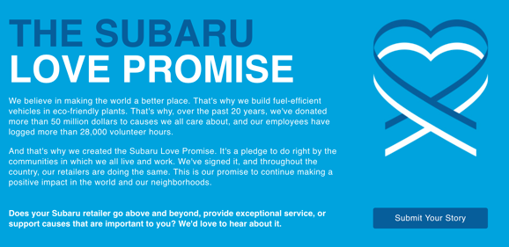
Screenshot of Subaru’s “Love Promise”
Source: http://www.subaru.com/love-promise.html
The first phase of the campaign was making a small, but essential change to Subaru’s tagline in 2008 to “Love. It’s What Makes a Subaru, a Subaru.” Then, the “Love Promise” came about. It is a manifesto featured in Subaru’s website that acts a guide for consumers to know what Subaru stands for and believes in.
New Partnerships
The campaign also included strategic partnerships with local and nation-wide organizations. Subaru identified five areas of focus or “passions” that the brand believes in and calls it, “Subaru Loves,” which includes pets, the Earth, learning, helping, and caring.
In 2004, Subaru became the first zero-landfill auto maker in the U.S. that works to preserve the outdoors. To demonstrate its love for the Earth, Subaru partnered with the National Park Foundation, American Forests, Ocean Conservancy, the American Canoe Association, Leave No Trace, United by Blue, National Wildlife Federation, and the International Mountain Bicycling Association.
It comes as no surprise that Subaru also partnered with the American Society for the Prevention of Cruelty to Animals (ASPCA) in 2008 after learning that 66% of Subaru drivers are dog owners. Subaru also partnered with Southeastern Guide Dogs, a nonprofit organization dedicated to helping visually impaired men and women with guide dogs.
Furthermore, Subaru prides in supporting education, and has partnered with Adopt-A-Classroom.org, the American Association for the Advancement of Science, Google Expeditions, and Team for America. “Subaru Loves Learning” also includes local partnerships with Garden State Discovery Museum, the Student Spaceflight Experiments Program, Center for Aquatics Sciences, and Kingsway Learning Center.
Additionally, Subaru believes that “a perfect world is possible,” and donates to Meals on Wheels America, the American Red Cross, Big Brothers Big Sisters, Boys and Girls Club, Habitat for Humanity, and USO. Local partnerships include Food Bank of South Jersey, New Visions Homeless Center, Philabundance Center, and Food Corp. “Subaru loves to help” commitment also created new initiatives, like Subaru Drive out Hunger, Subaru Choice Food Pantry at the Kroc Center, and Share the Garden.
Finally, Subaru believes that “we should all have a chance to lead a healthy life” and supports the Leukemia & Lymphoma Society, Make-A-Wish America, Alzheimer’s Association, Dining Out for Life, the Special Olympics, and Project Angel Heart.
“Share the love” Holiday Event
The partnerships validate Subaru’s “Love Promise” and play an essential part in its “Share the Love” holiday event. The event started in 2008 with the goal of turning buying into giving. From November to January, Subaru donates $250 to an organization selected by the customer. for every new purchased or leased vehicle. The customer can select from one of five organizations, including the ASPCA, Make-A-Wish, National Park Foundation, Meals on Wheels, or a fifth local organization picked by the dealership. The timing of the giving campaign was fundamental. According to Subaru’s Director of marketing Communications Kevin Mayer,
We wanted to create a program that not only stands out from the crowd, but is also relevant to our customer's value system - that of giving back to the community. The program is also timely in that many charities are feeling the effects of the recent economic troubles. So we are pleased to be helping charities during this difficult period.
The campaign includes a digital integration on the website and across social media channels, and yearly commercials that help promote Subaru’s “Love Promise.”
“Share the Love” social graphic
Source: http://www.waikemsubaru.com/blog/2015/november/19/waikem-subarus-share-the-love-campaign.htm
Subaru.com
To complement Subaru’s new branding strategy, Carmichael Lynch launched a new Subaru.com. The revamped website is dedicated to current customers and potential customers, with the objective of showcasing Subaru’s new vehicles. The website includes a page devoted to explaining “Why Subaru,” in addition to Subaru’s “Love Promise” and its digital campaign “Dear Subaru.”
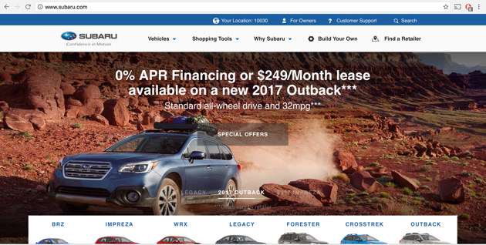
Screenshot of Subaru website
Source: www.subaru.com
Dear Subaru
Subaru created a print campaign called “Dear Subaru” to give customers a platform to share their passion for the brand. In an interview with Managing Director Bradford William, he told me that the campaign “ was an opportunity for Subaru to hone in on who their customers are and attract like-minded people.” The print campaign transitioned online and is currently active as a page in Subaru’s website.
“Dear Subaru” encourages Subaru owners to submit their story and view the collection of photos and videos submitted by other customers. Most importantly, the featured stories stay true to Subaru’s target audience, “experience seekers.” To illustrate, some drivers shared pictures of a camping trip, while some chose to share pictures of a collision to demonstrate the vehicle’s safety technology. Overall, the campaign turns Subaru owners into ambassadors with the ultimate goal of reinforcing brand affinity among consumers.
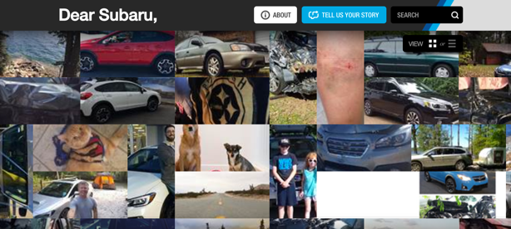
Screenshot of the “Dear Subaru” digital campaign
Source: http://www.subaru.com/why-subaru/dear-subaru.html
Additionally, Subaru created YouTube videos called “Subaru Owner Stories” that tell the stories of real Subaru customers. The videos helped Subaru reinforce the brand’s loyalty.
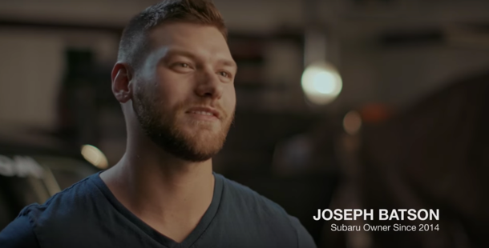
Still from Subaru’s YouTube video: Subaru Owner Stories Part 1
Source: www.youtube.com/watch?v=PERRNbsYo0k

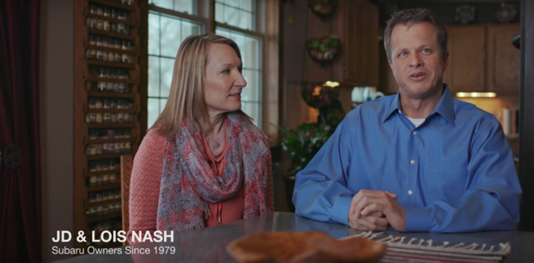
Still from Subaru’s YouTube video: Subaru Owner Stories Part 2
Source: www.youtube.com/watch?v=06HfS0HKpsM

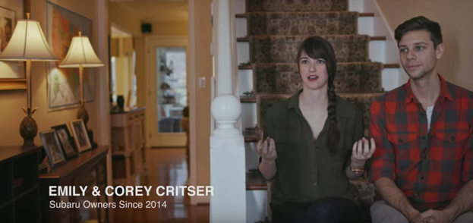
Still from Subaru’s YouTube video: Owner Stories Part 3
Source: https://www.youtube.com/watch?v=pJSxLlKQ7Ig
Portlandia
As Subaru customer Caitlin Matthews told me in an interview, “the Subaru stereotype is that it is a car brand for granola eating hippies who like to go camping.” After interviewing a few Subaru customers and people who know or have heard about Subaru, they all summarized the Subaru brand in one word: quirky. Subaru was well-aware of the stereotypes and decided to use the remarks to its advantage.
In 2014, Subaru integrated its vehicles in the comedy series Portlandia. The auto company previously ran commercials during the comedy series’ first season and decided to feature its vehicles in Portlandia’s fifth season. There were three integrations during the show’s 10-episode season at an attempt to reach consumers in Oregon and the Pacific states. Subaru also partnered with IFC, the television network, to sponsor online teasers for Portlandia’s new seasons.
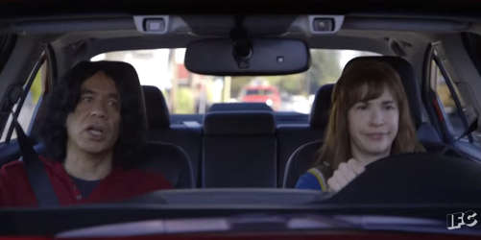
Still from Portandia’s “Ride Share: Sandra Drive” 2015 teaser
Source: https://www.youtube.com/watch?v=9u-BbROn3dg
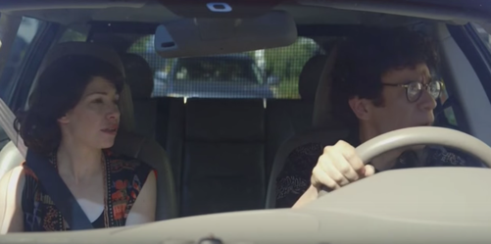
Still from Portlandia’s “Slow Driving” 2015 teaser
Source: https://www.youtube.com/watch?v=GuXXd8YEjnw

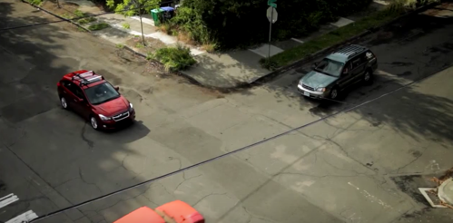
Still from Portlandia’s “Now You Go” 2015 teaser
Source: https://www.youtube.com/watch?v=8aIfarMPmPQ
Commercials
In 2009, Subaru found that it had the second-highest “recommend to a friend” rating in the auto industry, second to Lamborghini. Subaru owner Jessica Simon is one of the many Subaru customers that would not hesitate recommending the brand to a friend. In fact, her grandparents, parents, aunts, uncles, and husband all own Subaru vehicles just like her. “Subaru has proven to be a safe vehicle and I’ll even pass this knowledge down to my kids,” said Jessica. Subaru’s marketing team integrated this insight and incorporated the three tiers (love, brain, and wallet) in the commercials.
For example, the “love” and “brain” tier is evident in Subaru’s 2010 commercial of a father giving his daughter the keys to the vehicle. The commercial shows that the father still sees his teenage daughter as a young child (the love tier), but he confides in the Subaru brand to keep his daughter safe (the brain tier). “We knew this day was coming, that’s why we bought a Subaru,” said the voiceover in the commercial.
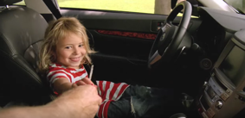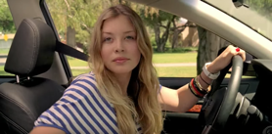
Stills from Subaru’s “Father-Daughter” Commercial
Source: https://www.youtube.com/watch?v=6F3-InOdMP4

RESULTS
Since the launch of the “Love” campaign in 2008, Subaru had six consecutive years of record sales growth and unit sales have nearly tripled. Subaru’s U.S. market share increased to 4.1% in 2015. Remarkably, Subaru is approaching its 2020 sales goals five years ahead of schedule. A 2015 Bloomberg article claimed Subaru as having the best profit margins in the industry, and reported that the automobile company is producing just enough vehicles to meet demand. Also, Subaru has been rated as the best-selling all-wheel drive car in the U.S. for the past six years.
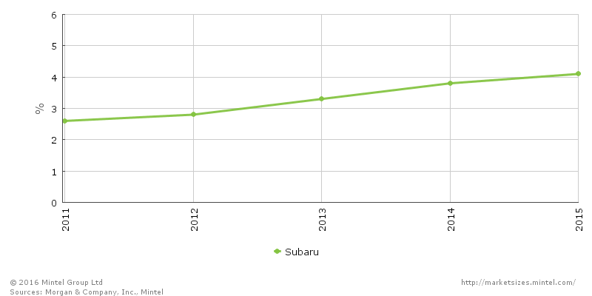
In addition to staggering sales figures, Subaru hopes to exceed a grand total of $90 million dollars in donations to its partner organizations by the end of this year’s “Share the Love” campaign. The donations have resulted in $16.5 million to the ASPCA, which helped support approximately 1,100 pet adoption events across the country, rising in more than 17,000 pets finding permanent homes. Moreover, Subaru has donated about $3 million to the National Parks Foundation, $3 million to Make-A-Wish, and approximately $7 million to Meals on Wheels. Finally, Kelley Blue Book named Subaru the Best Overall Brand and the Most Trusted Brand for 2016.
ASSESMENT
Indubitably, Subaru’s “Love” campaign was a success – Insofar that the campaign is still running eight years later. Taking a look at the brand’s growing sales figures reveal the campaign’s triumph. Tripling company unit sales and U.S. market share in a span of eight years is unparalleled. Although Subaru has yet to reach production numbers compared to the Detroit Three, the brand has created a stronger brand affinity among consumers stemming from the company’s clear understanding of its customers.
Through targeting consumers based on their behaviors, Subaru was able to attract new customers while staying true to its brand identity. Every aspect of the “Love” campaign emotionally appealed to consumers because Subaru trusted in its loyal fan base to show the value of the vehicles beyond their monetary significance. Most significantly, Subaru’s “Love” campaign demonstrates the effectiveness of emotional branding. The campaign efficaciously altered Subaru’s advertising from product focused to emotionally centered. The fact that Subaru drivers eagerly shared their stories and enthusiastically recommend the brand to friends translate into unwavering consumer loyalty.
Furthermore, “Love” was able to showcase the company’s origins of its all-wheel drive and boxer engine features by translating the features to qualities that consumers would regard as highly important. These aforementioned efforts helped further establish the brand as safe, reliable, and environmentally sustainable.
Finally, the “Love” campaign enabled the company to establish an identity, connect with customers and new consumers, and exceed company sales. Subaru has the best profit margin in the industry thanks to the “Love” campaign, which now puts the company in a new standstill. The automobile company is now faced with the challenge of defining the type of company it wants to be: Will Subaru choose to expand its manufacturing to meet demands, or will the company decide to produce to their current capabilities?

APPENDIX
Exhibit A: Detroit Three
The Dictionary of Finance and Investment terms define the Detroit Three, or Big Three, as:
- The three large automobile manufacturers in America, which are Chrysler, Ford, and General Motors. Since the automobile business has such major influence on the American economy, the Big Three are closely followed by investors, analysts, and economists. Because auto company profits rise and fall with the economy, they are considered CYCLICAL STOCKS. Both GM and Chrysler survived bankruptcy reorganizations with government help in 2009. Chrysler first merged with Daimler-Benz in 2007 and then 2009 with the Italian automaker Fiat. Ford remained strong throughout the economic turmoil, and today all three companies are again thriving.
Source: http://search.credoreference.com.ezproxy.cul.columbia.edu/content/entry/barronsfin/big_three/0

Exhibit B: Subaru Brand Regarded As Reliable, Safe, Sustainable, And Quirky
Evidence:
- In-person interview with Subaru owner Jessica Simon:
“After a recent traumatic car accident with my Subaru, I was unharmed and the vehicle kept me safe. Not only do I own a Subaru because I come from a family that owns them, but they have proven to be reliable cars.”
“I love Subaru’s personality. It’s a quirky brand and I’m proud to own one.”
- In-person interview with Subaru owner Gaffard Jean Louis:
“Subaru is not a luxury vehicle, but the cars keep you safe. They won’t leave you stranded in the middle of nowhere. I trust in the Subaru brand to take me where I need to go.”
“When I think of Subaru, I think of Oregon. Maybe it’s Oregon’s nature, it’s people, I’m not sure, but I see Subaru as a quirky brand and it’s a good thing.”
- In-person interview with Subaru Sales Consultant Benjamin Atwell:
“My customers, even if they already own a Subaru or they are first-time Subaru buyers, they are all driven by Subaru’s safety engineering. My customers know that they are purchasing a car they can trust.”
- In-person interview with Subaru owner Caitlin Matthews:
“One word to describe Subaru: Quirky. I would even add fun and possibly even mainstream in recent years.”
- 2004, Subaru became the first automotive production company in the United States to have zero-landfill.
Source: http://www.subaru.com/csr/environment.html#!/2016/05/25
- Subaru models with EyeSight® received the 2016 rating for front crash prevention from IIHS. Subaru was named Kelley Blue Book’s 2016 Most Trusted Brand.
Source: http://www.subaru.com/safety

Exhibit C: Ford Fusion Advertisement
Ford’s advertisement is product focused. The ad dubs the vehicle the “No Nonsense Car” and states the car features, instead of emotionally connecting with consumers. This serves as an example of how car brands have promoted their vehicles in the past.
Exhibit D: “Dear” Subaru Print Campaign
The “Dear Subaru” print campaign portrayed the stories submitted by Subaru customers, below is an example of a story featured in the campaign.
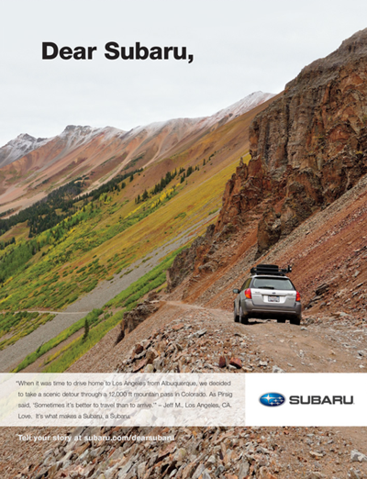
Exhibit E: Budweiser Super Bowl Commercials
- Budweiser 2013 Super Bowl Commercial – Clydesdales Brotherhood
Source: https://www.youtube.com/watch?v=E0HI4DAmVDo
- Budweiser 2014 Super Bowl Commercial – Puppy Love
Source: https://www.youtube.com/watch?v=dlNO2trC-mk
- Budweiser 2015 Super Bowl Commercial – Lost Dog
- Source: https://www.youtube.com/watch?v=otCxSnu_HXA

SOURCES CITED
Primary
- Email conversation with Diane Anton, Corporate Communications Manager, Subaru of America, Inc. Conducted November 8, 2016.
- In-person interview with Bradford Williams, Managing Director, Carmichael Lynch. Conducted November 1, 2016.
- In-person interview with Benjamin Atwell, Subaru Sales Consultant at Koeppel Subaru. Conducted November 5, 2016.
- In-person interview with Caitlin Matthews, Subaru Owner. Conducted October 27, 2016.
- In-person interview with Gaffard Jean-Louis, Subaru Owner. Conducted October 29, 2016.
- In-person interview with Jessica Simon, Subaru Owner. Conducted November 7, 2016.
Secondary – Websites & Reports
- " Auto Industry." U.S. Department Of The Treasure. Accessed November 1, 2016. https://www.treasury.gov/initiatives/financial-stability/TARP-Programs/automotive-programs/Pages/default.aspx.
- "Subaru Share The Love Event Returns for its Eight." Subaru Media. October 23, 2015. Accessed November 3, 2016. http://media.subaru.com/newsrelease.do?id=818&mid=1&allImage=1&teaser=subaru-share-love-event-returns-its-eighth-year.
- "2016 Love Promise Retailer of the Year – Evanston Subaru of Skokie, IL." The Subaru Love Promise. Accessed November 1, 2016. http://www.subaru.com/love-promise.html.
- "Average CAFE Standards of U.S. Passenger Cars from MY 2010 to MY 2014 (in Miles per Gallon)." Statista. Accessed October 27, 2016. https://www-statista-com.ezproxy.cul.columbia.edu/statistics/557230/us-passenger-cars-average-fuel-economy-standards/.
- "Budweiser Commercials." Super Bowl Commercials. Accessed November 1, 2016. https://superbowlcommercials.tv/tag/budweiser.
- "Case Study: Subaru." Marketing The Rainbow. Accessed November 2, 2016. http://marketingtherainbow.info/case studies/subaru.html.
- "Corporate Partners." Subaru of America. Accessed November 1, 2016. https://www.nationalparks.org/about-foundation/partnerships/corporate-partnerships/corporate-partners.
- "Company." Subaru of America. Accessed October 28, 2016. http://www.subaru.com/company.html.
- "Economic Analysis of the Car Allowance Rebate System ("Cash for Clunkers")." The White House. Accessed November 1, 2016. https://www.whitehouse.gov/administration/eop/cea/CarAllowanceRebateSystem/.
- "Environment." Environment. Accessed October 29, 2016. http://www.subaru.com/csr/environment.html#!/2016/05/25.
- "Gas Prices Put Detroit Three In Crisis Mode." NBC News. June 1, 2008. Accessed November 2, 2016. http://www.nbcnews.com/id/24896359/#.WCT1eHeZPoy.
- "Improving The Fuel Efficiency of American Trucks." The White House. February 2014. Accessed November 3, 2016. https://www.whitehouse.gov/sites/default/files/docs/finaltrucksreport.pdf.
- "Industry Reviews & Awards." Subaru Brand Reviews and Awards. Accessed November 3, 2016. http://www.subaru.com/why-subaru/reviews-awards/subaru.html.
- "Love | Subaru | Carmichael Lynch." Carmichael Lynch. Accessed November 3, 2016. http://carmichaellynch.com/work/subaru-love/.
- "Our Pet Causes | Subaru Loves Pets | Subaru." Our Pet Causes | Subaru Loves Pets | Subaru. Accessed November 3, 2016. http://www.subaru.com/pets/pet-causes.html.
- "Our Pet Causes." Subaru Loves Pets. Accessed November 4, 2016. http://www.subaru.com/pets/pet-causes.html.
- "Our Subaru Loves Learning Causes | Subaru." Our Subaru Loves Learning Causes | Subaru. Accessed November 4, 2016. http://www.subaru.com/education/education-causes.html.
- "Our Subaru Loves to Help Causes |Subaru." Subaru of America. Accessed November 3, 2016. http://www.subaru.com/community/community-causes.html.
- "Resurgence of the American - The White House." The White House. June 2011. Accessed October 28, 2016. https://www.whitehouse.gov/sites/default/files/uploads/auto_report_06_01_11.pdf.
- "Subaru Hands Over $5 Million to 'Share the Love' Charities." PRNewswire. February 12, 2009. Accessed October 21, 2016. http://www.prnewswire.com/news-releases/subaru-hands-over-5-million-to-share-the-love-charities-65728272.html.
- "Subaru Loves to Care Causes | Subaru." Subaru Of America. Accessed November 1, 2016. http://www.subaru.com/content/subaru/en/love-promise/health-causes.html.
- "Subaru of America, Inc. Unveils New Marketing Campaign." PRNewswire. April 24, 2008. Accessed November 1, 2016. http://www.prnewswire.com/news-releases/subaru-of-america-inc-unveils-new-marketing-campaign-57519372.html.
- "Subaru Share The Love Event Returns for its Eight." Subaru Media. October 23, 2015. Accessed November 3, 2016. http://media.subaru.com/newsrelease.do?id=818&mid=1&allImage=1&teaser=subaru-share-love-event-returns-its-eighth-year.
- "Subaru to Share Zero Landfill Expertise with National Park Service to Reduce Park Waste." National Parks Conservation Association. June 8, 2015. Accessed November 4, 2016. https://www.npca.org/articles/808-subaru-to-share-zero-landfill-expertise-with-national-park-service-to.
- "Subaru US Car Sales Figures." LeftLanecom. Accessed October 28, 2016. http://left-lane.com/us-car-sales-data/subaru/.
- “Subaru of Keene.” Subaru of America. http://www.subaruofkeene.com/subaru-competitive-edge.htm (accessed, October 28, 2016)
- Amadeo, Kimberly. "Was the Big 3 Auto Bailout Worth It?" The Balance. September 21, 2016. Accessed November 3, 2016. https://www.thebalance.com/auto-industry-bailout-gm-ford-chrysler-3305670.
- Arlington, Adam. "Estimating Costs And Benefits Of The Auto Bailout." Marketplace. December 30, 2014. Accessed October 29, 2016. https://www.marketplace.org/2014/12/30/business/estimating-costs-and-benefits-auto-bailout.
- Dicker, Ron. "Tim Bennett, John Nash Call For A Unified Gay Pride Holiday, New Marketing Strategy." The Huffington Post. June 18, 2012. Accessed November 1, 2016. http://www.huffingtonpost.com/2012/06/16/tim-bennett-john-nash-gay-pride-advertising_n_1591457.html.
- Elliot, Stuart. "Subaru’s Ride with ‘Portlandia’ Is a Playful One - The New ..." The New York Times. December 9, 2014. Accessed November 1, 2016. http://www.nytimes.com/2014/12/10/business/media/subarus-ride-with-portlandia-is-a-playful-one.html.
- Halliday., Jean. "Subaru Drops DDB, Taps Carmichael Lynch for $150M Account." Advertising Age Agency News RSS. October 16, 2007. Accessed November 10, 2016. http://adage.com/article/agency-news/subaru-drops-ddb-taps-carmichael-lynch-150m-account/121191/.
- Hammonds, D. For subaru, different is good. August 6, 2009. Accessed November 1, 2016 McClatchy - Tribune Business News Retrieved from http://ezproxy.cul.columbia.edu/login?url=http://search.proquest.com.ezproxy.cul.columbia.edu/docview/457845077?accountid=10226
- Jones, Roland. "Road Ahead For Automotive Industry Still Bumpy." NBC News. January 23, 2006. Accessed October 25, 2016. http://www.nbcnews.com/id/10576399/ns/business-the_driver_seat/t/road-ahead-automotive-industry-still-bumpy/#.WBvQYOErLow.
- Kiley, David. "Tim Mahoney, Subaru." AdWeek. Accessed October 26, 2016. http://www.adweek.com/news/2010/tim-mahoney-subaru-94412.
- Kiley, David. "Tim Mahoney, Subaru." AdWeek. Accessed October 26, 2016. http://www.adweek.com/news/2010/tim-mahoney-subaru-94412.
- Klier, Thomas, and James Rubenstein. Detroit Back From The Brink? Auto Industry Crisis And Restructuring, 2008–11. Report. Federal Reserve Bank Of Chicago. 35-54.
- LaReau, Jamie. "Subaru Ad Agency's Pet Project." Automotive News. May 9, 2016. Accessed November 1, 2016. http://www.autonews.com/article/20160509/RETAIL03/305099991/subaru-ad-agencys-pet-project.
- Luckerson, Vick. "This Was the Most Successful Commercial of the Super Bowl." Time. February 3, 2014. Accessed November 10, 2016. http://time.com/3870/budweiser-puppy-love-super-bowl-commercial/.
- Maslow, Abraham H. A Theory of Human Motivation. Mansfield Center, CT: Martino Publishing, 2013.
- Mayyasi, Alex. "How an Ad Campaign Made Lesbians Fall in Love with Subaru." Priceonomics. Accessed November 1, 2016. https://priceonomics.com/how-an-ad-campaign-made-lesbians-fall-in-love-with/.
- Mayyasi, Alex. "How an Ad Campaign Made Lesbians Fall in Love with Subaru." Priceonomics. Accessed November 1, 2016. https://priceonomics.com/how-an-ad-campaign-made-lesbians-fall-in-love-with/.
- Mayyasi, Alex. "How Lesbians Became Subaru's 'Perfect Customers'" Business Insider. June 25, 2016. Accessed November 1, 2016. http://www.businessinsider.com/how-lesbians-became-subarus-perfect-customers-2016-6?utm_source=feedburner&utm_medium=referral&utm_medium=feed&utm_campaign=Feed: businessinsider (Business Insider)&IR=T.
- McHale, Michael. "Subaru Of America, Inc. Corporate Timeline." Subaru Media. Accessed October 27, 2016. http://media.subaru.com/print.do?id=334.
- Ohnsman, Alan, and Jeff Green. "At Subaru, Sharing the Love Is a Market Strategy." Bloomberg.com. May 20, 2010. Accessed November 3, 2016. http://www.bloomberg.com/news/articles/2010-05-20/at-subaru-sharing-the-love-is-a-market-strategy.
- Phillip Huhn. "Top 100 Automotive & Automotive Part Companies (Global).” Statista. Accessed November 1, 2016. https://www.statista.com/study/30861/top-100-automotive-and-automotive-part-companies-global/.
- Rode, Izzy. "Outward Explainer: What’s With Lesbians and Subarus?" Slate Magazine. January 02, 2014. Accessed November 1, 2016. http://www.slate.com/blogs/outward/2014/01/02/lesbians_and_subarus_why_do_lesbians_love_outbacks_and_foresters.html.
- Stock, Kyle. "Subaru Sells Out: Will A Fast-Growing Carmaker Decide to Stay Small?" Bloomberg.com. June 8, 2915. Accessed November 4, 2016. http://www.bloomberg.com/news/features/2015-06-08/subaru-sells-out-will-one-of-the-fastest-growing-carmakers-decide-to-stay-small-.
- Subaru campaign demonstrates jumpstart's ability to drive car shoppers to point of purchase. December 1, 2010. Accessed October 29, 2016. Business Wire Retrieved from http://ezproxy.cul.columbia.edu/login?url=http://search.proquest.com.ezproxy.cul.columbia.edu/docview/815193823?accountid=10226
- Subaru of America: Subaru Owner Love. Report. New York, New York: Advertising Research Foundation.
- Sullivan, Danny. "The Budweiser #BestBuds Puppy Gets His Own Twitter Account." Marketing Land. January 30, 2014. Accessed November 6, 2016. http://marketingland.com/budweiser-bestbuds-pup-seizes-control-buds-twitter-account-72455.
- Vlasic, Bill, and Annie Lowrey. "U.S. Ends Bailout Of G.M., Selling Last Shares Of Stock." The New York Times. December 9, 2013. Accessed October 26, 2016. http://dealbook.nytimes.com/2013/12/09/u-s-sells-remaining-stake-in-gm/?hpw&rref=business.
- Vlasic, Bill, and Nick Bukley. "Hazardous Conditions For The Auto Industry." The New York Times. October 1, 2008. Accessed November 3, 2016. http://www.nytimes.com/2008/10/02/business/02sales.html.
- White, Joseph B. "New Ways to Cut the Car-Buying Pain." Wall Street Journal. February 26, 2013. Accessed November 2, 2016. http://www.wsj.com/articles/SB10001424127887324338604578328214064885782.
- Z, Alex. "The 50 Best Super Bowl Car Ads32. Release The Hounds." Complex. February 2, 2012. Accessed November 10, 2016. http://www.complex.com/sports/2012/02/the-50-best-super-bowl-car-ads/sb-32.
- Zeese, Kevin. "The Causes Of The Auto Crisis." Www.counterpunch.org. November 24, 2008. Accessed November 1, 2016. http://www.counterpunch.org/2008/11/24/the-causes-of-the-auto-crisis/.
Secondary – YouTube Videos
- Ricky Subaru Commercial. June 28, 2007. Accessed October 26, 2016. https://www.youtube.com/watch?v=ziYpzMoC7UU.
- Subaru Commercial Father-Daughter. August 31, 2010. Accessed November 1, 2016. https://www.youtube.com/watch?v=6F3-InOdMP4.
- Chevrolet 2007 Super Bowl Commercial - "Ain't We Got Love" February 2, 2007. Accessed October 28, 2016. https://www.youtube.com/watch?v=BoApXpIymdE.

ENDNOTES

Phillip Huhn. "Top 100 Automotive & Automotive Part Companies (Global).” Statista. Accessed November 1, 2016. https://www.statista.com/study/30861/top-100-automotive-and-automotive-part-companies-global/.
"Company." Subaru of America. Accessed October 28, 2016. http://www.subaru.com/company.html.
"Environment." Environment. Accessed October 29, 2016. http://www.subaru.com/csr/environment.html#!/2016/05/25.
“Subaru of Keene.” Subaru of America. http://www.subaruofkeene.com/subaru-competitive-edge.htm (accessed, October 28, 2016)
"Subaru US Car Sales Figures." LeftLanecom. Accessed October 28, 2016. http://left-lane.com/us-car-sales-data/subaru/.
McHale, Michael. "Subaru Of America, Inc. Corporate Timeline." Subaru Media. Accessed October 27, 2016. http://media.subaru.com/print.do?id=334.
Kiley, David. "Tim Mahoney, Subaru." AdWeek. Accessed October 26, 2016. http://www.adweek.com/news/2010/tim-mahoney-subaru-94412.
"Resurgence of the American - The White House." The White House. June 2011. Accessed October 28, 2016. https://www.whitehouse.gov/sites/default/files/uploads/auto_report_06_01_11.pdf.
Jones, Roland. "Road Ahead For Automotive Industry Still Bumpy." NBC News. January 23, 2006. Accessed October 25, 2016. http://www.nbcnews.com/id/10576399/ns/business-the_driver_seat/t/road-ahead-automotive-industry-still-bumpy/#.WBvQYOErLow.
Mayyasi, Alex. "How an Ad Campaign Made Lesbians Fall in Love with Subaru." Priceonomics. Accessed November 1, 2016. https://priceonomics.com/how-an-ad-campaign-made-lesbians-fall-in-love-with/.
Mayyasi, Alex. "How an Ad Campaign Made Lesbians Fall in Love with Subaru." Priceonomics. Accessed November 1, 2016. https://priceonomics.com/how-an-ad-campaign-made-lesbians-fall-in-love-with/.
Rode, Izzy. "Outward Explainer: What’s With Lesbians and Subarus?" Slate Magazine. January 02, 2014. Accessed November 1, 2016. http://www.slate.com/blogs/outward/2014/01/02/lesbians_and_subarus_why_do_lesbians_love_outbacks_and_foresters.html.
Mayyasi, Alex. "How Lesbians Became Subaru's 'Perfect Customers'" Business Insider. June 25, 2016. Accessed November 1, 2016. http://www.businessinsider.com/how-lesbians-became-subarus-perfect-customers-2016-6?utm_source=feedburner&utm_medium=referral&utm_medium=feed&utm_campaign=Feed: businessinsider (Business Insider)&IR=T.
Dicker, Ron. "Tim Bennett, John Nash Call For A Unified Gay Pride Holiday, New Marketing Strategy." The Huffington Post. June 18, 2012. Accessed November 1, 2016. http://www.huffingtonpost.com/2012/06/16/tim-bennett-john-nash-gay-pride-advertising_n_1591457.html.
"Case Study: Subaru." Marketing The Rainbow. Accessed November 2, 2016. http://marketingtherainbow.info/case studies/subaru.html.
In-person interview with Bradford Williams, Managing Director, Carmichael Lynch. Conducted November 1, 2016.
Ricky Subaru Commercial. June 28, 2007. Accessed October 26, 2016. https://www.youtube.com/watch?v=ziYpzMoC7UU.
In-person interview with Gaffard Jean-Louis, Subaru Owner. Conducted October 29, 2016.
Kiley, David. "Tim Mahoney, Subaru." AdWeek. Accessed October 26, 2016. http://www.adweek.com/news/2010/tim-mahoney-subaru-94412.
Chevrolet 2007 Super Bowl Commercial - "Ain't We Got Love" February 2, 2007. Accessed October 28, 2016. https://www.youtube.com/watch?v=BoApXpIymdE.
Z, Alex. "The 50 Best Super Bowl Car Ads32. Release The Hounds." Complex. February 2, 2012. Accessed November 10, 2016. http://www.complex.com/sports/2012/02/the-50-best-super-bowl-car-ads/sb-32.
White, Joseph B. "New Ways to Cut the Car-Buying Pain." Wall Street Journal. February 26, 2013. Accessed November 2, 2016. http://www.wsj.com/articles/SB10001424127887324338604578328214064885782.
Subaru campaign demonstrates jumpstart's ability to drive car shoppers to point of purchase. December 1, 2010. Accessed October 29, 2016. Business Wire Retrieved from http://ezproxy.cul.columbia.edu/login?url=http://search.proquest.com.ezproxy.cul.columbia.edu/docview/815193823?accountid=10226
"Resurgence of the American - The White House." The White House. June 2011. Accessed October 28, 2016. https://www.whitehouse.gov/sites/default/files/uploads/auto_report_06_01_11.pdf.
Vlasic, Bill, and Nick Bukley. "Hazardous Conditions For The Auto Industry." The New York Times. October 1, 2008. Accessed November 3, 2016. http://www.nytimes.com/2008/10/02/business/02sales.html.
Zeese, Kevin. "The Causes Of The Auto Crisis." Www.counterpunch.org. November 24, 2008. Accessed November 1, 2016. http://www.counterpunch.org/2008/11/24/the-causes-of-the-auto-crisis/.
Amadeo, Kimberly. "Was the Big 3 Auto Bailout Worth It?" The Balance. September 21, 2016. Accessed November 3, 2016. https://www.thebalance.com/auto-industry-bailout-gm-ford-chrysler-3305670.
Amadeo, Kimberly. "Was the Big 3 Auto Bailout Worth It?" The Balance. September 21, 2016. Accessed November 3, 2016. https://www.thebalance.com/auto-industry-bailout-gm-ford-chrysler-3305670.
Vlasic, Bill, and Annie Lowrey. "U.S. Ends Bailout Of G.M., Selling Last Shares Of Stock." The New York Times. December 9, 2013. Accessed October 26, 2016. http://dealbook.nytimes.com/2013/12/09/u-s-sells-remaining-stake-in-gm/?hpw&rref=business.
" Auto Industry." U.S. Department Of The Treasure. Accessed November 1, 2016. https://www.treasury.gov/initiatives/financial-stability/TARP-Programs/automotive-programs/Pages/default.aspx.
Arlington, Adam. "Estimating Costs And Benefits Of The Auto Bailout." Marketplace. December 30, 2014. Accessed October 29, 2016. https://www.marketplace.org/2014/12/30/business/estimating-costs-and-benefits-auto-bailout.
Klier, Thomas, and James Rubenstein. Detroit Back From The Brink? Auto Industry Crisis And Restructuring, 2008–11. Report. Federal Reserve Bank Of Chicago. 35-54.
"Gas Prices Put Detroit Three In Crisis Mode." NBC News. June 1, 2008. Accessed November 2, 2016. http://www.nbcnews.com/id/24896359/#.WCT1eHeZPoy.
"Improving The Fuel Efficiency of American Trucks." The White House. February 2014. Accessed November 3, 2016. https://www.whitehouse.gov/sites/default/files/docs/finaltrucksreport.pdf.
"Economic Analysis of the Car Allowance Rebate System ("Cash for Clunkers")." The White House. Accessed November 1, 2016. https://www.whitehouse.gov/administration/eop/cea/CarAllowanceRebateSystem/.
"Average CAFE Standards of U.S. Passenger Cars from MY 2010 to MY 2014 (in Miles per Gallon)." Statista. Accessed October 27, 2016. https://www-statista-com.ezproxy.cul.columbia.edu/statistics/557230/us-passenger-cars-average-fuel-economy-standards/.
"Budweiser Commercials." Super Bowl Commmercials. Accessed November 1, 2016. https://superbowlcommercials.tv/tag/budweiser.
Luckerson, Vick. "This Was the Most Successful Commercial of the Super Bowl." Time. February 3, 2014. Accessed November 10, 2016. http://time.com/3870/budweiser-puppy-love-super-bowl-commercial/.
Sullivan, Danny. "The Budweiser #BestBuds Puppy Gets His Own Twitter Account." Marketing Land. January 30, 2014. Accessed November 6, 2016. http://marketingland.com/budweiser-bestbuds-pup-seizes-control-buds-twitter-account-72455.
Halliday., Jean. "Subaru Drops DDB, Taps Carmichael Lynch for $150M Account." Advertising Age Agency News RSS. October 16, 2007. Accessed November 10, 2016. http://adage.com/article/agency-news/subaru-drops-ddb-taps-carmichael-lynch-150m-account/121191/.
In-person interview with Bradford Williams, Managing Director, Carmichael Lynch. Conducted November 1, 2016.
Subaru of America: Subaru Owner Love. Report. New York, New York: Advertising Research Foundation.
Subaru of America: Subaru Owner Love. Report. New York, New York: Advertising Research Foundation.
In-person interview with Benjamin Atwell, Subaru Sales Consultant at Koeppel Subaru. Conducted November 5, 2016.
Subaru of America: Subaru Owner Love. Report. New York, New York: Advertising Research Foundation.
"Subaru of America, Inc. Unveils New Marketing Campaign." PRNewswire. April 24, 2008. Accessed November 1, 2016. http://www.prnewswire.com/news-releases/subaru-of-america-inc-unveils-new-marketing-campaign-57519372.html.
In-person interview with Bradford Williams, Managing Director, Carmichael Lynch. Conducted November 1, 2016.
Ohnsman, Alan, and Jeff Green. "At Subaru, Sharing the Love Is a Market Strategy." Bloomberg.com. May 20, 2010. Accessed November 3, 2016. http://www.bloomberg.com/news/articles/2010-05-20/at-subaru-sharing-the-love-is-a-market-strategy.
In-person interview with Bradford Williams, Managing Director, Carmichael Lynch. Conducted November 1, 2016.
In-person interview with Bradford Williams, Managing Director, Carmichael Lynch. Conducted November 1, 2016.
Email conversation with Diane Anton, Corporate Communications Manager, Subaru of America, Inc. Conducted November 8, 2016.
Maslow, Abraham H. A Theory of Human Motivation. Mansfield Center, CT: Martino Publishing, 2013.
Subaru of America: Subaru Owner Love. Report. New York, New York: Advertising Research Foundation.
"2016 Love Promise Retailer of the Year – Evanston Subaru of Skokie, IL." The Subaru Love Promise. Accessed November 1, 2016. http://www.subaru.com/love-promise.html.
"2016 Love Promise Retailer of the Year – Evanston Subaru of Skokie, IL." The Subaru Love Promise. Accessed November 1, 2016. http://www.subaru.com/love-promise.html.
"Subaru to Share Zero Landfill Expertise with National Park Service to Reduce Park Waste." National Parks Conservation Association. June 8, 2015. Accessed November 4, 2016. https://www.npca.org/articles/808-subaru-to-share-zero-landfill-expertise-with-national-park-service-to.
"2016 Love Promise Retailer of the Year – Evanston Subaru of Skokie, IL." The Subaru Love Promise. Accessed November 1, 2016. http://www.subaru.com/love-promise.html.
LaReau, Jamie. "Subaru Ad Agency's Pet Project." Automotive News. May 9, 2016. Accessed November 1, 2016. http://www.autonews.com/article/20160509/RETAIL03/305099991/subaru-ad-agencys-pet-project.
"Our Pet Causes | Subaru Loves Pets | Subaru." Our Pet Causes | Subaru Loves Pets | Subaru. Accessed November 3, 2016. http://www.subaru.com/pets/pet-causes.html.
"Our Subaru Loves Learning Causes | Subaru." Our Subaru Loves Learning Causes | Subaru. Accessed November 4, 2016. http://www.subaru.com/education/education-causes.html.
"Our Subaru Loves Learning Causes | Subaru." Our Subaru Loves Learning Causes | Subaru. Accessed November 4, 2016. http://www.subaru.com/education/education-causes.html.
"Our Subaru Loves to Help Causes |Subaru." Subaru of America. Accessed November 3, 2016. http://www.subaru.com/community/community-causes.html.
"Our Subaru Loves to Help Causes |Subaru." Subaru of America. Accessed November 3, 2016. http://www.subaru.com/community/community-causes.html.
"Subaru Loves to Care Causes | Subaru." Subaru Of America. Accessed November 1, 2016. http://www.subaru.com/content/subaru/en/love-promise/health-causes.html.
"Love | Subaru | Carmichael Lynch." Carmichael Lynch. Accessed November 3, 2016. http://carmichaellynch.com/work/subaru-love/.
"Subaru Share The Love Event Returns for its Eight." Subaru Media. October 23, 2015. Accessed November 3, 2016. http://media.subaru.com/newsrelease.do?id=818&mid=1&allImage=1&teaser=subaru-share-love-event-returns-its-eighth-year.
" Subaru Share The Love Event Returns for its Eight." Subaru Media. October 23, 2015. Accessed November 3, 2016. http://media.subaru.com/newsrelease.do?id=818&mid=1&allImage=1&teaser=subaru-share-love-event-returns-its-eighth-year.
"Subaru Hands Over $5 Million to 'Share the Love' Charities." PRNewswire. February 12, 2009. Accessed October 21, 2016. http://www.prnewswire.com/news-releases/subaru-hands-over-5-million-to-share-the-love-charities-65728272.html.
In-person interview with Bradford Williams, Managing Director, Carmichael Lynch. Conducted November 1, 2016.
In-person interview with Caitlin Matthews, Subaru Owner. Conducted October 27, 2016.
Elliot, Stuart. "Subaru’s Ride with ‘Portlandia’ Is a Playful One - The New ..." The New York Times. December 9, 2014. Accessed November 1, 2016. http://www.nytimes.com/2014/12/10/business/media/subarus-ride-with-portlandia-is-a-playful-one.html.
Elliot, Stuart. "Subaru’s Ride with ‘Portlandia’ Is a Playful One - The New ..." The New York Times. December 9, 2014. Accessed November 1, 2016. http://www.nytimes.com/2014/12/10/business/media/subarus-ride-with-portlandia-is-a-playful-one.html.
http://www.imdb.com/news/ni59415106/
Elliot, Stuart. "Subaru’s Ride with ‘Portlandia’ Is a Playful One - The New ..." The New York Times. December 9, 2014. Accessed November 1, 2016. http://www.nytimes.com/2014/12/10/business/media/subarus-ride-with-portlandia-is-a-playful-one.html.
Hammonds, D. For subaru, different is good. August 6, 2009. Accessed November 1, 2016 McClatchy - Tribune Business News Retrieved from http://ezproxy.cul.columbia.edu/login?url=http://search.proquest.com.ezproxy.cul.columbia.edu/docview/457845077?accountid=10226
In-person interview with Jessica Simon, Subaru Owner. Conducted November 7, 2016.
Subaru Commercial Father-Daughter. August 31, 2010. Accessed November 1, 2016. https://www.youtube.com/watch?v=6F3-InOdMP4.
Email conversation with Diane Anton, Corporate Communications Manager, Subaru of America, Inc. Conducted November 8, 2016.
Email conversation with Diane Anton, Corporate Communications Manager, Subaru of America, Inc. Conducted November 8, 2016.
Stock, Kyle. "Subaru Sells Out: Will A Fast-Growing Carmaker Decide to Stay Small?" Bloomberg.com. June 8, 2915. Accessed November 4, 2016. http://www.bloomberg.com/news/features/2015-06-08/subaru-sells-out-will-one-of-the-fastest-growing-carmakers-decide-to-stay-small-.
"Industry Reviews & Awards." Subaru Brand Reviews and Awards. Accessed November 5, 2016. http://www.subaru.com/why-subaru/reviews-awards/subaru.html.
Email conversation with Diane Anton, Corporate Communications Manager, Subaru of America, Inc. Conducted November 8, 2016.
"Our Pet Causes." Subaru Loves Pets. Accessed November 4, 2016. http://www.subaru.com/pets/pet-causes.html.
"Corporate Partners." Subaru of America. Accessed November 1, 2016. https://www.nationalparks.org/about-foundation/partnerships/corporate-partnerships/corporate-partners.
"Industry Reviews & Awards." Subaru Brand Reviews and Awards. Accessed November 3, 2016. http://www.subaru.com/why-subaru/reviews-awards/subaru.html.

