*Shirley Harvey Experience Event Planning*

[Final Project Milestone One: Operations Management](https://learn.snhu.edu/d2l/le/content/137567/viewContent/3222129/View" \o "'3-1 Final Project Milestone One: Operations Management' - Assignment)

Shirley Brite Harvey

January 15, 2019

The history and trends of operations management of the Shirley Harvey Experience

Operations management refers to the planning, actualizing and controlling everyday activities of a business to ensure the goods and services offered are desirable to the target market and as a result, maximizing profit. It also helps in the implementation of the business plan. The main purpose of operations management is to ensure that the goods and services offered by an entity suite the market. This means that modifications are made from time to time to achieve this goal. This is the only way a business is going to succeed. The figure below shows the role played by operations management in a business. It is through it that the input of a business can be converted into the much desired output ready for the market. Other underlying factors include cost, variability and quality

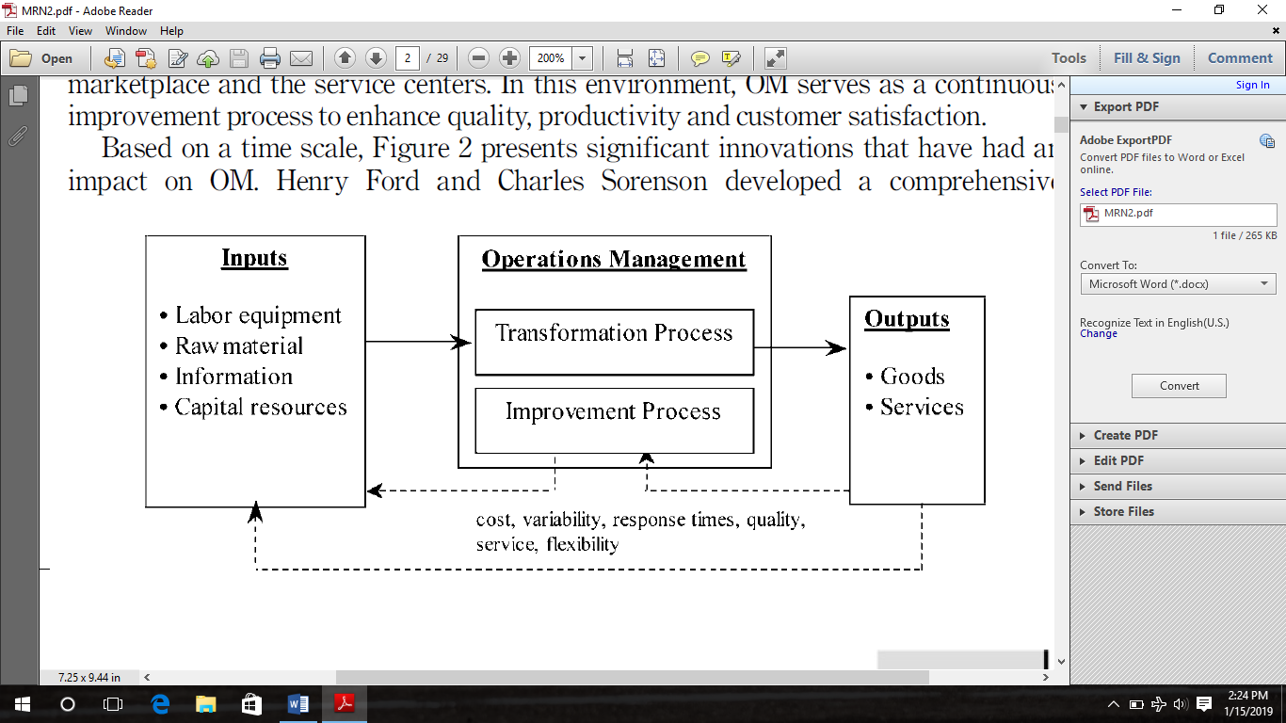

Evolution of operations management: past, present and future by Bayraktar *et al*, (2007).

There are various forces that have shaped the operations management of S.H.E. They include the following: competition, quality of goods and services and their costs, customer care services, the fast advancement of technology, expansion of the service sector over time, social responsibility of the business and shortage of resources to run the business.

Competition is one of the major driving forces that have shaped operations management in this company. The market for event organization is crowded with business owners also venturing into event planning and organizing. S.H.E. has managed to stay relevant by offering unique services tailored to every client’s needs. S.H.E. targets the high class and middle class population as they discovered a gap in the market as most of the individuals in this category have the resources to hold events but rarely have the time to plan one. These include: families, couples and individuals, private and public organizations.

When it comes to quality, the team makes sure the client is satisfied as they all end up getting what they wanted in the first place by providing quality services. This is done by offering state of the art forms of decor. In addition to this, clients are given the chance to select the theme and layout of the event hence giving the client a sense of control of the service he is paying for.

S.H.E also has a team of grounds men who gather information on preferences from the client before implementing. And all of this is done at a reasonable cost. In regards to customer service, each client is given priority and consideration when they require services from S.H.E. The owner takes it upon herself to personally follow up on every event ensuring customer satisfaction is achieved even contacting clients directly.

Reasonable pricing is part of the mission statement at S.H.E and it remains a priority with every client interaction. This ensures that we have consistent clients that can trust us and rely on us. The price is consistent and is relatively low as compared to the ones charged by other event organizers. The prices charged are dependent on a number of factors such as, how many guests are attending, locality of the event and the nature of the decoration required by the client.

In terms of future goals for expansion, S.H.E has set aside goals which are intended to be achieved over time. One short-term goal is acquiring a suitable office place from which the business can operate from. One long-term goal is to become a leading service provider in the events organization sector where it will be a preferred choice to potential customers.

It is inevitable for any business to thrive without experiencing a number of obstacles. Along the way, S.H.E has experienced quite a number of obstacles hindering its growth either to a small or large extent. However, S.H.E strives to identify such obstacles and plan on how to work around them so as to avoid the performance of the business being negatively affected (Gilboa, *et al*. 2008). Such obstacles can be categorized into; information-related, equipment-related, materials and supplies related and work-environment related.

Information-related operational failures occur when crucial data or information concerning the client’s needs specialization is mishandled or is misunderstood. An example of such a case scenario is when a client requests a certain type of color theme, for instance burgundy, and ends up getting crimson red. It is very crucial to get the specifics of a client’s needs. S.H.E. can curb information-related obstacles by hiring competent workers and training them constantly to ensure they remain competent even with shifting market demands. Follow up and close supervision by the owner or the managers from time to time.

Equipment-related obstacles may occur when certain equipment or tools are needed in order to pull off the event but they are unavailable. These obstacles can be curbed by assessing the market so as to identify the common equipment and tools required for service delivery so as to prevent any inconveniences or losses. Proper handling and maintenance of the equipment to avoid losses or breakage.

Materials and supplies related obstacles occur when there is a shortage of supplies needed for a certain job due to loss, unavailability or mismanagement. It is key to assess the market in order to curb materials and supplies related obstacles. This will enable one to be well stocked with the right materials and supplies at all times.

Work-environment related obstacles refer to the general conditions at the work place. This mostly affects the staff. Good examples of this kind of obstacle include worker satisfaction and consistent pay. In the event where workers are not satisfied and are not treated well by their employer, their output may be negatively affected. This eventually affects the business negatively. This kind of obstacles can be curbed by motivating workers using incentives such as bonuses and even raises. Team building exercises can also be organized to boost worker morale and promote team spirit. The owner should ensure that the working environment is conducive for all the workers and no form of discrimination is taking place.

The event market, together with all other business environments, are always changing. Change is inevitable in this kind of business. It is therefore important that one ensures that they stay ahead in their game by constantly researching on trends. This helps one know how to maneuver the market and maximize profit. Present day operations management is a bit more convenient especially with the current form of technologies and globalization taking place. For example, use of e-business, strategies put to place based on gathered information from external sources.

Skinner (1985) states that operation management was first adopted into business in the year1890 to 1920. At this period, the main objective of OM was Improve the production of labor. This form of operation management was became dominant in the 1960s. In the late 1960s, computers started being introduced into businesses for accounting purposes. In the 1970s, the use of databases and information systems were being applied into businesses also. By 1980s, operational management had attained wide recognition and also accepted as a key part in a business or entity.

In the present day, globalization has greatly affected businesses as it has been changing and adapting over time. Especially with the introduction of new innovations such as e-business which will possibly revolutionize business in a positive way.

S.H.E. applies various business and organizational processes in order to enable the proper functioning of the company. The event management business process of an event business is comprised of four major steps: plan; invite and register; execute and convert; analyze. These have been derived from the general organizational process; review plans and objectives as well as determine the work activities necessary to accomplish objectives.

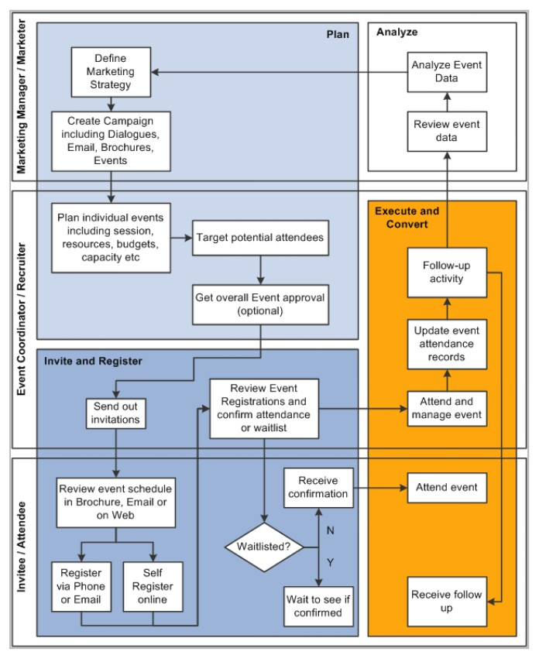

Event management business process by the Oracle, (2017).

The figure above elaborately illustrates the different event planning business processes. The first stage, the planning phase, is all about formulating the way forward by maximizing on market gaps and curbing different challenges. The first process is defining the market strategy. The company needs to find the appropriate means to tap into the target market. The second stage, inviting and registering, entails sending invitations to guests through various media and coming up with a list of those who will be attending, for the purpose of budgeting. The third stage is to execute and convert data from stage two into an actual event. In event planning, numbers are everything. The fourth and the last stage is analyzing data. Data from the event that just passed is very useful in the planning of future ones. We learn from the mistakes made and adopt new practices that proved useful and efficient. S.H.E. is all about getting better and tailoring services to every client’s specific needs.

The business operations do support the strategic plan, mission and vision of the company in the following ways: in the planning phase, budgeting is a key aspect. The mission of the company is to ensure it provides exceptional event designing & planning at a reasonable cost. Budgeting ensures that the prices are affordable. The strategic plan and goals of the company can be met by consistent practice execution and conversion of the event and also analysis of the data and information gathered at previous events. This will help S.H.E. become a better company in terms of giving better services and will be able to get an office for its operation.

Factors that affect productivity and profitability include: pricing of goods and services, limited financial resources, poor management of the business entity leads to lower profit margins and eventually losses, availability of demand because no business can thrive without a growing client base, poor planning which results in failure, unskilled labor puts the business at a greater risk of losing profits as it is good for every employee to understand the details of the business, unavailability of technical expertise and poor marketing strategies.

The key trends in production, quality, resource and information management include Business Process Engineering, employee involvement, sustainability and behavioral operations management among others. Business Process Engineering (BPR) dwells on providing more value to your customer. S.H.E incorporates use of BPR by providing state of the art event planning at a cheaper price as compared to its competitors.

Another key trend is employee involvement. This can be achieved by involving employees in key decisions done in the company. This will provide a better working environment for the employees and boost productivity of the business as a whole since it will increase employee morale. Employee involvement also creates a good employer-employee relationship. S.H.E promotes employee involvement by promoting employer-employee interactions and employees are involved in decision making.

Sustainability is also another emerging trend. This refers to the impact a business has to the environment. S.H.E meets the environmental regulations as the business only uses environmental friendly material.

Works cited

Bayraktar E., Jothishankar M. C., Tatoglu E. & Wu T. (2007). Evolution of operations

Management: past, present and future. *Evolution of operations management,* 30 (11),

pp. 843-871. Retrieved from

https://www.researchgate.net/profile/Ekrem_Tatoglu/publication/235288470__Evolution_of_operations_management_Past_present_and_future/links/00b4951af9bc393d29000000/Evolution-of-operations-management-Past-present-and-future.pdf?origin=publication_detail

Gilboa S., Shirom A., Fried Y. & Cooper C. (2008). A meta-analysis of work demand stressors

And job performance: Examining main and moderating effects. *Personnel psychology,* 62

(2), pp. 227-271.

Heisler W. S., Janisse L. D. & Tucker A. L. (2013). Organizational factors that contribute to

Operational failures in hospital. Working paper. *Harvard business school.* Retrieved from

https://http://www.hbs.edu/faculty/Publication%2520Files/14-023_f68586ef-ffd3-4147-8178-0053916c0af8.pdf&ved=2ahUKEwjVgMv_we_fAhWzShUIHeUsDvOQFjAMegQIChAB&usg=AOvVaw1_l3fFJJqL4_DrAnSb3NF3&cshid=1547546005012

Oracle. (2019). Event management business process. Retrieved from

https://docs.oracle.com/cd/E83913_01/crm92pbr9/eng/crm/cevm/concept_EventManagementBusinessProcess-867fda.html

Kenton W. (2018). Operations management. Retrieved from

https://www.investopedia/terms/0/operations-management.asp