Chapter 16 Lean Operations

Chapter Outline Global Company Profile: Toyota Motor Corporation
- Lean Operations 638
- Lean and Just-in-Time 640
- Lean and the Toyota Production System 649
- Lean Organizations 650
- Lean in Services 652

10 OM Strategy Decisions
- Design of Goods and Services
- Managing Quality
- Process Strategy
- Location Strategies
- Layout Strategies
- Human Resources
- Supply-Chain Management
- Inventory Management
  - Independent Demand (Ch. 12)
  - Dependent Demand (Ch. 14)
  - Lean Operations (Ch. 16)
- Scheduling
- Maintenance

Chapter 16 Achieving Competitive Advantage with Lean Operations at Toyota Motor Corporation

Global Company Profile Toyota Motor Corporation
Toyota Motor Corporation, with $250 billion in annual sales of over 9 million cars and trucks, is one of the largest vehicle manufacturers in the world. Two Lean techniques, just-in-time (JIT) and the Toyota Production System (TPS), have been instrumental in its growth. Toyota, with a wide range of vehicles, competes head-to-head with successful, long-established companies in Europe and the U.S. Taiichi Ohno, a former vice president of Toyota, created the basic framework for two of the world’s most discussed systems for improving productivity, JIT and TPS. These two concepts provide much of the foundation for Lean operations:
- Central to JIT is a philosophy of continuous problem solving. In practice, JIT means making only what is needed, when it is needed. JIT provides an excellent vehicle for finding and eliminating problems because problems are easy to find in a system that eliminates the slack that inventory generates. When excess inventory is eliminated, shortcomings related to quality, layout, scheduling, and supplier performance become immediately evident—as does excess production.
- Central to TPS is employee learning and a continuing effort to create and produce products under ideal conditions. Ideal conditions exist only when management brings facilities, machines, and people together to add value without waste. Waste undermines productivity by diverting resources to excess inventory, unnecessary processing, and poor quality. Respect for people, extensive training, cross-training, and standard work practices of empowered employees focusing on driving out waste are fundamental to TPS.
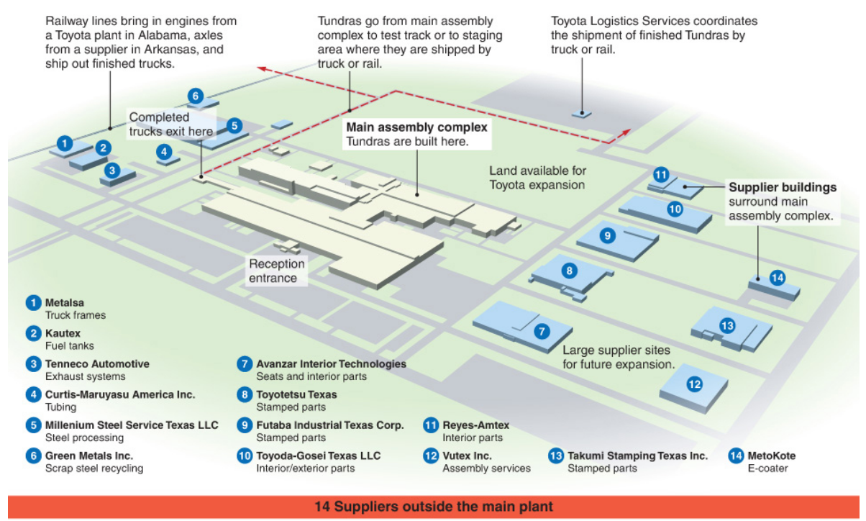
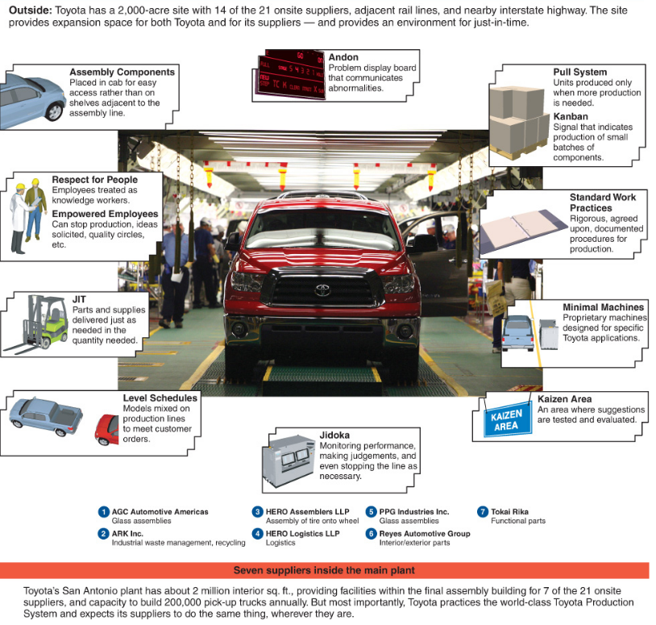

Toyota’s implementation of TPS and JIT is present at its 2,000-acre San Antonio, Texas, facility, the largest Toyota land site for an automobile assembly plant in the U.S. Interestingly, despite its large site and annual production capability of 200,000, a throughput time of 20 ½ hours, and the output of a truck every 63 seconds, the building itself is one of the smallest in the industry. Modern automobiles have 30,000 parts, but at Toyota, independent suppliers combine many of these parts into subassemblies. Twenty-one of these suppliers are on site at the San Antonio facility and transfer components to the assembly line on a JIT basis.
Operations such as these taking place in the San Antonio plant are why Toyota continues to perform near the top in quality and maintain the lowest labor-hour assembly time in the industry. Lean operations do work—and they provide a competitive advantage for Toyota Motor Corporation.

