1. **Week Three Written Assignment: Inclusive and Differentiated Learning and Assessments WLO 3 CLO 2,4.**

As you learned in the Iris Center module titled *Universal Design for Learning: Creating a Learning Environment that Challenges and Engages All Students*, assessment is one of the four key curricular components. Along with using assessments to make informed decisions about meeting the needs of children, you will also encounter the use of standardized assessments in your work with learners with exceptionalities. Currently there is a lot of controversy surrounding assessments and the role that they should play when working with young learners. Whether you agree or disagree with this practice, it is important that you know how to make sure you are using standardized assessments in the most appropriate way possible when working with diverse learners in inclusive environments.

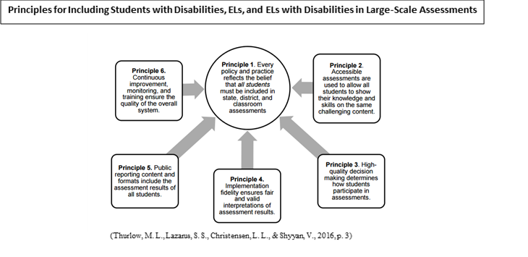

To prepare for this assignment,

* Please refer to the Week Three Guidance for further tips and examples that will support your success on this assignment.
* Read [Principles and Characteristics of Inclusive Assessment Systems in a Changing Assessment Landscape](https://nceo.umn.edu/docs/OnlinePubs/Report400/NCEOReport400.pdf).

For your assignment, imagine that you have been asked to be a part of a task force for determining which standardized assessments your school or center will be using. Your supervisor has asked you to create an 8- to 10-slide presentation, to share with your colleagues, highlighting the key factors that need to be taken into account when selecting a standardized assessment that addresses the needs of all learners.

In your presentation,

* Describe how you will ensure that all students are included in assessments and how you will make decisions about how children participate in assessments. (Principles 1 and 3)
* Summarize how you will make sure that the assessments are designed for accessibility by all. (Principle 2)
* Explain how you make sure the assessment results are fair and valid and the importance of reporting results of the assessment for all students. (Principle 4 and 5)
* Examine how you will continually evaluate the assessment process to improve it and ensure student success. (Principle 6)
* Explain your rationale, based on the age of children you plan to work with, the reasons why you would use standardized assessments. Some reasons might be programmatic planning, differentiating instruction, identifying individual needs, and ensuring alignment with standards. Make sure to support your reasoning with at least one scholarly source.
* Discuss how as an early childhood educator, you will collaborate with your colleagues to differentiate the assessment tools you will use to support the children you work with.

The Inclusive and Differentiated Learning and Assessments presentation

* Must be 8 to 10 slides in length (not including title and references slides) and formatted according to APA style as outlined in the [Ashford Writing Center](https://awc.ashford.edu/index.html).
* Must include a separate title slide with the following:
  + Title of presentation
  + Student’s name
  + Course name and number
  + Instructor’s name
  + Date submitted
* Must use at least three scholarly resources in addition to the course text.
  + The [Scholarly, Peer Reviewed, and Other Credible Sources](https://bridgepoint.equella.ecollege.com/curriculum/file/b2d6fb25-629e-42e1-a13e-43bf67043c8a/1/Scholarly%2C%20Peer%20Reviewed%2C%20and%20Other%20Credible%20Sources.docx) table offers additional guidance on appropriate source types. If you have questions about whether a specific source is appropriate for this assignment, please contact your instructor. Your instructor has the final say about the appropriateness of a specific source for a particular assignment.
* Must document all sources in APA style as outlined in the Ashford Writing Center. For help with using PowerPoint to create an effective presentation, please see [How to Make a PowerPoint Presentation](https://bridgepoint.equella.ecollege.com/curriculum/file/fef61570-ccce-4c4d-96f0-72673893bba9/1/PowerPoint%20Tips%20Tricks%20PDF%20Final%20Version_final.pdf).
* Must include a separate references page that is formatted according to APA style as outlined in the [Ashford Writing Center](https://awc.ashford.edu/cd-apa-checklist.html).