1.1 Trends
Trends: Future Prediction
• Develop the ability to face uncertainty, disruption and chaos.
• Fast changing trends must be integrated into business strategy.
• Understand KEY future trends driving opportunity
21st Century Organization
• Changing consumer demographic
• Workforce shifts to attract talent
• Top technology and business processes
• Economic trends affecting markets • Globalization
• Building agile organizations and navigating uncertainty
(Future: China, Nanotech, Quantum, Time, DNA )
Future Leader
• Leaders need to anticipate future trends and change will be key for survival.
• Technology changing everything! • Speed, Connectivity, Innovation and Quality
• Compete for talent in the workforce
• Political, Economic, Social, Technical, Environmental Forces (external) in constant change
Mega Trends
• Technological Developments
Mobile, Robotics, Information
• Globalization
Emerging countries: innovation and low-cost manufacturing, Population, Trade, Labor.
• Demographic Changes
Workforce:
Specialists vs generalist
• Shift gears • Team skills • Connecting networks
• Quality of experience • Shape work/life balance • Higher autonomy(自主) • Free job
10 Ability (Linked ln)
•Time Management • Adaptability • Collaboration • Persuasion • Creativity • UX Design
•People Management • Analytical • AI • Cloud
Consumer
• Reaching real-time consumers
•High expectations of service, search for the best deal, and we want it NOW.
• Culturally diverse consumers -- • Global diversity
• Aging Baby Boomers -- • Health care, workforce, society
• Societal Trends
• Individualistic • Going green • Smaller footprints • Work-Life Balance • Adaptability
• Low Carbon Development
Education
• Occupations requiring a Master’s degree will grow by 21.7% by 2020.
• IT and Business Professionals will increase 25.9%
• Globalization and Digital technology
• Big Data, Management, Computer Engineering, Entrepreneurship, Finance, Healthcare
Economic:
Renewable energy • Community Energy Ownership •US Dominance is over. • home-spital • Eating less meat • refugees – CEO

2.2 Leadership
Leader: Someone who can influence others and who has managerial authority
Leadership: The process of influencing individuals or groups toward the achievement of goal

Early Leadership Theories
Trait Theories(1920-30)
-Focus on personal characteristics, different leaders
-Identified 8 Traits with successful leadership
1.Drive 2. Desire to lead 3.Honesty and integrity 4.Self-confidence 5.Intelligence
6.Job-relevant knowledge 7. Extraversion 8.Proneness to guilt
Behavioural Theories (1940-60s)
1. University of Iowa Studies (Kurt Lewin)
  - Identified three leadership styles (专制 民主 放任)
    - Autocratic style: leader tends to centralize authority, dictate work methods, make unilateral decisions, and limit employee participation
    - Democratic style: leader tends to involve employees in decision making, delegate authority, encourage participation in deciding work methods and goals, and use feedback as an opportunity for coaching employees
    - Laissez-faire style: leader tends to give the group complete freedom to make decisions and complete the work in whatever way it sees fit.
    - [No specific style was consistently better for producing better performance, Workers prefer to Democratic one]
2. Ohio State Studies
  - Identified two dimensions of leader behavior out of 1000.
    - Initiating structure: leader defines his or her role and the roles of group members in attaining goals.
    - Consideration: leader has work relationships characterized by mutual trust and respect for group members’ ideas and feelings.
    - High-high: high in both initiating structure and consideration behaviours
    - Findings:
      - High-high leaders generally, but not always, achieved high group task performance and satisfaction.
      - Evidence indicated that situational factors appeared to strongly influence leadership effectiveness.
3. University of Michigan Studies
  - Identified two dimensions of leader behaviour
    - Employee oriented: emphasizing personal relationships.
    - Production oriented: emphasizing task accomplishment.
  - Research findings:
    - Leaders who are employee oriented are strongly associated with high group productivity and high job satisfaction.
Contingency Theories of Leadership
- The Fiedler Model
Depended on the proper match between a leader’s style and the degree to which the situation allowed the leader to control and influence
  - Assumptions:
    - Different situations require different leadership styles
    - Leaders do not readily change leadership styles
Fiedler’s Research
key situational factors in leader effectiveness:
  - Leader–member relations - The degree of confidence, trust, and respect
  - Task structure - The degree to which job assignments were formalized and structured;
  - Position power - The degree of influence a leader had over activities such as hiring, firing, promotions, and salary increases;
- Situational leadership® theory (SLT): Theory that focuses on followers’ readiness.
(Are followers’ task oriented or relationship orientated.)
- Hersey and Blanchard’s Situational Leadership® Theory
Four Leadership styles -- Fiedler’s two leadership dimensions:
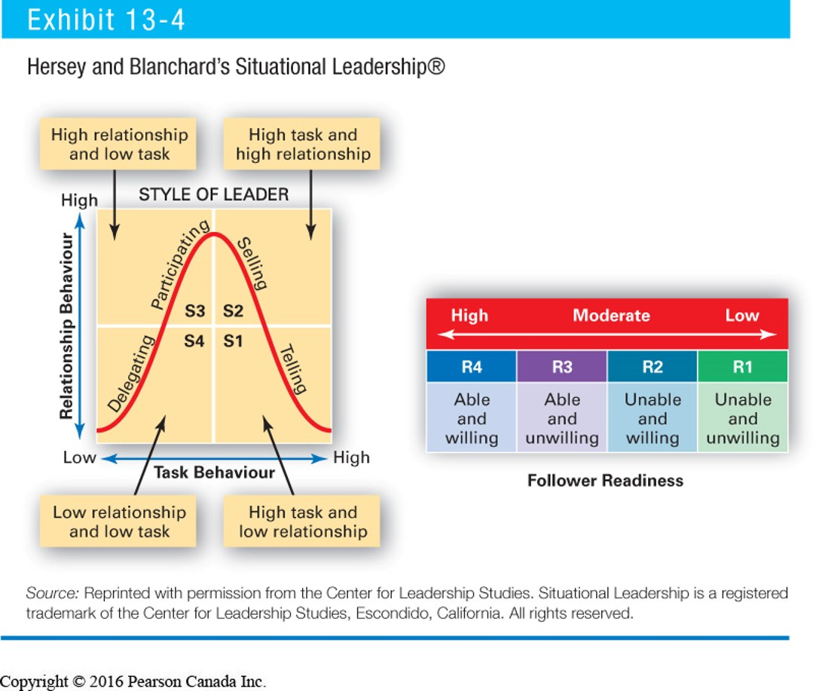
- Path-Goal Theory (SLT) :
Leader’s job is to
1. Assist followers in attaining their goals
2. Provide direction or support to ensure that their goals are compatible
Path-Goal Model
  - Leader’s job is to assist followers in achieving organizational goals.
  - Leader’s style depends on the situation:
    - Directive | Supportive | Participative | Achievement-oriented
Environmental Contingency Factors: Task Structure, work group, Authority system
Subordinate Factors: Locus of Control, Experience, Perceived Ability
Predictions
- Directive leadership Greater when tasks are ambiguous or stressful than when they are highly structured and well laid out.
  - leadership is less imp with high perceived ability or with considerable experience
  - Better when there is substantive conflict within a work group.
- Supportive leadership results in high employee performance and satisfaction when subordinates are performing structured tasks.
  - When formal authority relationships is higher, leaders should exhibit supportive behavior and de-emphasize directive behavior.
- Achievement-oriented leadership will increase subordinates’ expectations that effort will lead to high performance when tasks are ambiguously structured.
  - Subordinates with an external locus of control - directive style.
  - Subordinates with an internal locus of control - participative style.
Contemporary Views of Leadership
Transactional Leadership:
Leaders who guide or motivate their followers in the direction of established goals by clarifying role and task requirements.
Transformational Leadership: -- built on top of transactional leadership.
Leaders who inspire followers to go beyond their own self-interests
Leaders who have a profound and extraordinary effect on their followers.
How to be a Transformational Leader
- Individualized consideration: Pay attention to the needs of individual followers
- Intellectual stimulation: Provide ways and reasons for followers to change the way they think about
- Inspirational motivation: “Set an example of hard work, remain confidence with crisis.”
- Idealized influence: Show respect for others, building confidence and trust
Charismatic Leadership （Jobs）-Envisioning, Energy, Enable
  - have a high level of confidence
  - possess a strong need to influence others
  - communicate high expectations of wokers
  - generally, more successful at influencing workers

Characteristics of Charismatic leaders:
    - Have a vision and Are able to articulate the vision
    - Are willing to take risks to achieve the vision
    - Are sensitive to the environment and to follower needs
    - Exhibit behaviors that are out of the ordinary
Effects of Charismatic Leadership:
    - Increased motivation, greater satisfaction
    - More profitable companies
    - Downside:
      - Ethics crisis -- CEOs with less vision, and more ethical and corporate responsibility, might be more desirable
Visionary Leadership:
Ability to create a realistic, credible vision of the future that improves on the present situation.
    - Explain the vision to others
    - Express the vision not just verbally but through behaviour
    - Extend or apply the vision to different leadership contexts
Team Leadership Characteristics
  - Having patience to share information
  - Being able to trust others and to give up authority
  - Understanding when to intervene
Team Leader’s Job
  - Managing the team’s external boundary
  - Facilitating the team process
Developing Trust
Credibility (of a Leader)
  - The degree to followers perceive someone as honest, competent, and able to inspire.
Trust The belief in the integrity, character, and ability of a leader
(Open, Fair, Truth, Speak your feelings, show consistency, Fulfill promises, Confidence,
Demonstrate)
Issues:
Providing Ethical leadership is more than being ethical.
  - Includes reinforcing ethics through organizational mechanisms.
Empowering Employees:
- Giving more authority to employees to make decisions (Faster responses and decisions)
Cautions:
  - Clear definition of company’s values and mission
  - Employees have relevant skills
  - Employees need to be supported, and need to be recognized for their efforts
GLOBE Study - Universal Elements of Effective Leadership
Vision Foresight Proactive Encourage Trust Positive
Leaders are people with power: To direct, to make decisions, and to influence decisions of others
  - Org: balance Individual / system, Subjective / intersubjective, Material / ideal
  - Person: seeking to influence other individuals, but working within an organization
  - Legitimacy as moral right to power, authority as granting of legitimacy

3.1 Group:
The abilities of the group’s members
The size of the group, the level of conflict
The internal pressures on members
Group Member Resources Knowledge, skills, abilities, and personality traits
Interpersonal skills: conflict management, collaborative problem solving, communication
Personality traits: Strongly influence how an individual will interact with other members
Groups vs. Teams
Groups share information and to make decisions to help each member do his or her job more efficiently and effectively.
Teams work intensely on a specific, common goal using their complementary skills
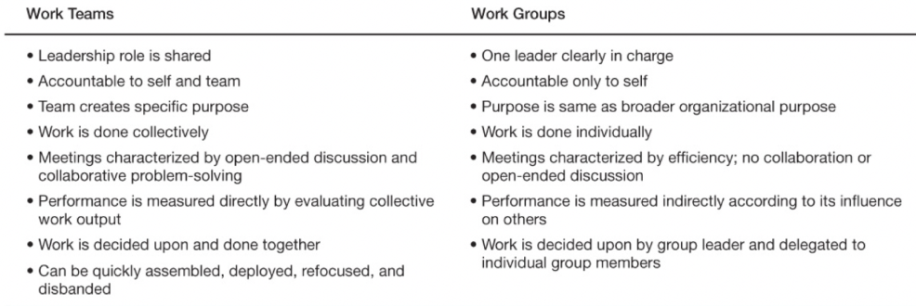
Tuckman’s Five-Stage Model
1.Forming: Little agreement/Unclear Purpose/Guidance and direction
2.Storming: Conflict increased/Power Struggles/Coaching
3.Norming: Agreement/Clear roles/Sample and clear
4.Performing: Clear purpose/Focus on goals/Delegation
5.Adjouring: Task complete/Recognition/Good feels
Group Size –impacts performance and satisfaction
Small groups are faster at completing tasks than are larger ones.
Large groups get better results than smaller ones in terms of problem-solving.
Smaller groups (5 –7 members) are better at doing something productive with facts
Large groups (12 or more members) are good for getting diverse input and gathering facts.

Characteristics: Norm-规范
- Clear Purpose and Mission
- Behavioral Norms: Well-understood standards of behaviour within a group
- Productivity Norms: May be consistent with organization’s productivity standards
- Group Cohesion 凝聚力
  - Less anxiety and tension
  - Less variability in production
  - Better satisfaction, communication
  - Influenced by time, size, level of team, external pressure, internal competition

Tips for Managers: Increasing Group Cohesiveness
•Increasing socio-emotional /instrumental cohesiveness.
•Keep the group relatively small.
•Encourage interaction and cooperation.
•Emphasize members’ common interests.
•Point out environmental threats
•Regularly update and clarify the group’s goal(s).
•Combine each group member’s special talents toward the common goal(s).
•Frequently remind group members they need each other to get the job done
Team Advantages/Challengens
•Advantages
1.Make better decisions, products/services
2.Better information sharing
3.Increase employee motivation/engagement
•Challenges
1.Process losses –resources needed for team maintenance
2.Social loafing –members potentially exert less works in teams than alone
3.Brooks’ Law –Adding more people to a software project only makes it late
Team effective when its benefits the organization, members and its own survival
(Internal/External Support, Clear goals, skills, Trust, Communication, Leadership,)
Challenges:
Group Member Resources in Global Teams
Group Structure (conformity, status, social loafing, cohesiveness)
Group Processes
The Manager’s Role
Global: dis: Dislike, Mistrust, Communication, Stress
Adv: Diversity of ideas, increased attention on understanding others ideas.

A compelling direction
A strong structure
A supportive context
A shared mindset
(Report, sub-task, common word)

3.2 Complex Environmental issue
Definition of Interdisciplinary 跨学科
A process of answering a question, solving a problem, that is too complex to be sloved by a single discipline, so that we need integrate their insights to get a better understanding.”

Strong teams of researchers bringing diverse backgrounds and tools to bear on different facets of an environmental issue
Key Traits of Interdisciplinary
  - Occurs when researchers identify limitations of their own disciplinary perspective
  - Often independent disciplines combine at the end in an unsystematic manner
  - Researchers from all disciplines need to participate equally
  - Team leader required to promote in-team communication

- Substantive focus on a complex problem
- Extends beyond a single disciplinary perspective
- Has integration as its goal
- Advancement in the form of a new understanding of environmental management

- Entrepreneurial - see possibilities in complex problems
- Jack of all trades - know limitations of a discipline
- Appreciation of diversity - acknowledge different view points
- Willingness to collaborate - insights from disciplinary experts
- Receptive to other disciplines - openness to different disciplinary perspectives
- Tolerance for ambiguity - to see all sides of an issue
- Communicative competence - making technical jargon comprehensible to others
- creative thinking - new ways to see the ‘big picture’
Interdisciplinary teams are not multidisciplinary teams
- Multidisciplinary – insights from two or more disciplines, but are not integrated
- Interdisciplinary – insights from two or more disciplines are integrated
  - Answers complex questions
  - Single disciplines can be too narrowly focused
  - Specialization produces narrower fields
  - Single disciplines leave gaps in knowledge （exp. Food security/Ocean）
Interdisciplinary Environmental Management
Policy, Phyical, Chemical, Biological, Economic, Law, Engineering
Global issue requires Open data sharing
- PREDICTS: PREDICTS truly captures key traits of interdisciplinarity
- Large team collaboration (NGO NARWS, Fishing industries)
- Many disciplines required to study this complex biophysical issue
Individual—Unit—Functional—Corporate—Miision
→Increase Strategic / Decrease detail
Building Interdisciplinary Teams - starts with an RFP
- highly technical?
- Will technical team members be enough to win and execute the project?
- What technical teams are required and who manages or oversees this?
Managing Interdisciplinary Project Schedules
Managing Complex EIAs
Managing EIA Teams requires interdisciplinary teams working together for a common goal
Surveys about: Vegetation, Birds, Fish
In an ideal world biophysical data…
Would be collected by thorough desktop reviews
Budget & time constraints
In an ideal world timing of EIA preparation…
Data collection, reporting, would be better
Longer schedules preferred by consultants, regulators & reviewers
In an ideal world socio-economic data…
Would more open houses, information sessions, longer public review periods
Budget & time constraints
- Summary: Key traits
  - Two or more disciplines required to address complex issues
  - Has integration as the goal
  - Strong collaboration required
  - Different disciplines required early in research design – not at end
- Incorporating interdisciplinarity into your teams
  - Build teams from different disciplines
  - Learn and incorporate new skills
  - Data sharing
  - Engage in discussions with experts from other disciplines

4.1 Organizational Design and Structure
The organizational structure is designed to prevent chaos through an orderly set of reporting relationships and communication channels.
It determines:
  - what people do.
  - what skills they need in their position.
  - with whom they interact.
  - what information they have access to.
  - who they are accountable to.
Organizational Design
- The process of constructing and adjusting an organization’s structure to achieve its goals.
An Organization’s structure
- The linking of departments and jobs within an organization
Nowadays:
- Coordination
- More specialization = greater capacity and less connection to overall goal
- Organizational Structure = specialization + coordination, and is expected to derive from the goals / purpose of the organization

Organization in 5 parts
- Strategic Apex
  - Decides what the organization will do, sets goals
- Middle Line
  - Mediates / interprets between Apex and Core, line management
- Operating Core
  - Performs the task of the organization
- Technostructure
  - Planning, coordination, standardization
- Support Staff
  - Logistics; keeping the lights on
?? Structural Aspects Shown on Organizational Chart
- Formal lines of authority & responsibility (reporting relationships are visible)
- Formal systems of communication, coordination and integration (typical interactions)
Technical considerations
- Coordination must come from the centre, but the resources of the centre are finite
  - The center only does what only the centre can do
Core functions of central management
- Manage the process of decision making
- Referee the process – Process for decision
- Manage decision makers’ time
- Manage conflict
- Promote the collective view
- The devil’s advocate -- Why say yes, why not say no
Modes of Coordination
- Adjustment 2. Monitor 3.Standardization (Work Process/Outputs/Skills and values)
Positive vs. negative (Invest)
  - Spending / allocating resources as a way of checking priorities
    - Pouring money in doesn’t means effective action
    - Distributing money on basis of priority
    - NO budget is a rational process (doesn’t start from zero)
  - Imposing limits
    - Limiting the flow of resources will influence outcomes
    - Making sure they’re the outcomes you want
    - Limits need to be set by center, not influenced or shaped by others
    - Application / impact of limits needs to be review by centre
Differentiation
- The process of deciding how to divide work in the organization
Integration
- The process of coordinating the different parts of the organization

Basic Structural Dimensions
- Formalization – The degree to which the organization has official rules and procedures
- Centralization – The degree to which decisions are made at the top of the organization
- Specialization – The degree to which jobs are narrowly defined
- Standardization – The degree to which work activities are finished in a ordered fashion
- Complexity – The degree to different types of activities occur in the organization
- Hierarchy of Authority – The degree of levels of management
- Span of Control –The number of employees reporting to a Monitror.
Basic organizational structures
Simple Structure – A centralized form of organization
Direct supervision and low transmission
Functional Structure –Groups people according to the function they perform
（Marketing, Finance, HR）
Divisional Structure – Groups employees according to product, client, or geography
(Support, Repiar, Internet) (Ottawa, China, Halifax)
Matrix Structure – A dual-authority form of structure that
combines functional and divisional structures
Traditional Organization
- Hierarchical structure
- Decision making flows from the top
Flat Organization
- Flat management organizational structures remove many layers and remains only a few with wider spans of control
  - Employees have ability to work with multiple teams across various projects, sharing skills, data and responsibilities
  - Everyone is considered equal, job skills and data are shared
Variables that influence organizational structure.
Size
Small org: Less formalization, specialization, standardization and complexity, High Centralization and flat Hierarchy
Big org: More formalization, specialization, standardization and complexity, Low Centralization and Tall Hierachy

Tech
- Woodward – the more complex the technology, the more complex the structure
- Thompson – the greater the interrelatedness of the technological elements, the greater the complexity of structure and need for decentralization
- Perrow – structure varies with task variability and problem difficulty
Strategy
Emphasis on efficiency—Mechanistic
Emphasis on innovation—Organic
Environment
In Certain Environment:
- Functional structure
- Mechanistic features
In Uncertain Environment:
- Divisional structure
- Organic features
Structure Affects Decisions
As formalization increases:
- More reactive than proactive
- Differentiation not balanced with integration
- Strategic moves incremental
As centralization increases:
- Decisions goal-oriented & rational
- Strategic decisions influenced by the limitations of decision maker
As complexity increases:
- Strategic decision process more politicized
- More difficult to recognize threats and opportunities in environment
Forces Reshaping Organizations
- Globalization
- international business structure is based on:
- The level of vertical and horizontal differentiation.
- The degree of formalization, specialization, standardization, and centralization.
- Changes in Information Technologies
  - The level of authority has been removed
  - The basis of centralization has been changed.
    - They use technology to acquire more information and make more decisions thus decrease centralization.
  - People with high information technologies have more complex jobs
    - Therefore, Less specialization and standardization are needed

- Demands on Organizational Processes
  - To meet these conflicting demands -- need to become “dynamically stable.”
  - Managers must combine long-term thinking with flexible and quick responses.
  - 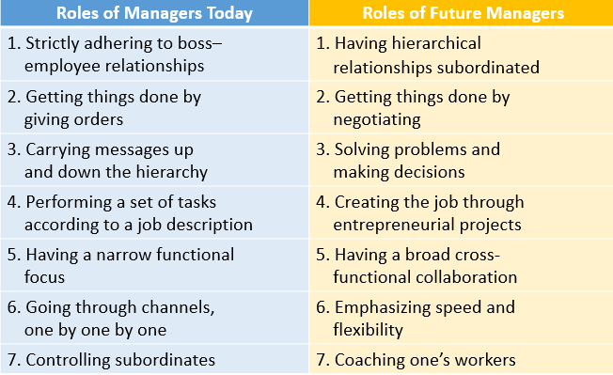
5.1 Change
Why-Survive and advance
•External forces:
•Customers, competitors, shareholders, technology, government, CSR, resource scarcity...
•Internal forces:
•Capacity, capabilities, dissatisfaction, desire, R&D
•Entropy: Your organization will change whether you want it to or not.
Change management
is managing the “people side of change”
•Making changes in a systematic, planned and organized manner
•Effective leadership of organizational change
•Communicating, controlling and supporting the process of change
•Often a process undertaken within an organization
Why resist
•People resist change when they perceive that the change is a threat to them in some way
They may not understand what why how it will change
Or they understand but try to avoid them (Fear)
•They don’t understand the need for change
•They are not fully informed about the change
•Their personal security is threatened
•The change is happening too quickly
•The organization may not be ready for change
Theoretical Models of Change
•Based on reality, of course, but not always accurate.
•Some examine change from organizational side, others from personal side
Precontemplation—Contemplation—Determation—Acrion—Replace—Maintenance—
Awareness of change / Desire to support change / Knowledge of how to change / Ability / Reinforcement after change ADKAR
Kotter’s Model: Create—Build—Form—Enlist—Enable—Generate—Sustain—Institute
Creating an Urgency for Change
•Inform employees about driving forces
•Most difficult when organization is doing well
•May need to create urgency to change without external driver
Lewin’s Force Field Analysis Model
•Driving forces
•Push organizations toward change
•External forces
•Restraining forces
•Resistance to change –employee behaviors that block the change process
Reducing it
- Communication
  - Highest priority and first strategy for change
  - Reduces uncertainty
  - Problems: time consuming and costly
- Learning
  - Provides new knowledge/skills
  - Helps break old routines and adopt new roles
  - Problems: potentially time consuming and cost
- Involvement: Reduce fear of unknown, same problems
- Stress management •When previous strategies do not minimize stress enough
- Negotiation-Problems: expensive, gains compliance, not commitment
- Coercion-Problems: Reduce trust
General advice from the models
•Establish a clear goal, make it a crisis-level response.
•Find the Fears
•Ease Expectations
•Tweak your Timing
•Bring Benefits Early
•Communicate
Dealing with resistance to change
•Education and communication
•Participation and empowerment
•Support•Facilitation
•Employee Assistance Programs
Types of change: Evolutionary change and Revolutionary change
“Risk culture”
•Positive risk culture allows for learning from mistakes -> good risk management
•Promotes and supports innovation and failure
•Negative risk culture results in hiding of mistakes to avoid punishment
•Can result in unexpected crises
IT: Barrier, Driver, Aid to change
Starbucks: •Improving the current state of the U.S. business
•Get our emotional attachment with our customers
•Building for long-term
•Global expansion

5.2 Climate
Melting Polar Ice
- Could mean a sovereignty problem for Canada in the Arctic
    - Increasing Military spending
    - Increase in Arctic oil & gas developments
    - Weather Disasters
Melting Himalayan Glacier
- ¼ of global wheat production 小麦
- Influence on Canadian wheat prices?
  - Could be good for Canadian Farmers
  - Could be bad for you at the store
Managing for Climate Change means expand your ‘decision making’ comfort zone…
Domains of “Experts”
Need to “analyze” situation and then respond
Realm of “known unknowns”
Domains of “Emergence”
Need to respond to emerging parts
“Pattern-based realm”
Domains of “Best Practices”
Clear “cause and effect relationships
Realm of “known knowns”
Domain of “Thinking on Your Feet”
Completely unpredictable outcomes
Realm of “unknowables”
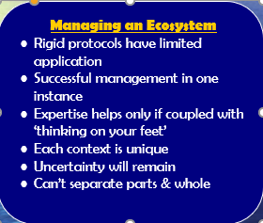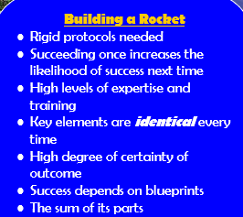
Complicated View
To understand the natural world in terms of mechanistic consistency -- humans will be able to dominate nature
However
In reality most systems do NOT follow this
Economic, natural and social systems… are NOT mechanistic
Outcomes cannot be predicted
Changes in the Climatic System
- However, climate change - objectively - is neither good nor bad
- - Always been climate change
    - Species adapt
    - Natural system adjusts
Good Managers
- Management includes 3 aspects:
  - Control Adaptation Resiliency
Climate change case:
Resiliency (sucker punch)Giving yourself enough wiggle-room to ‘adapt’ very quickly
Control (Mitigation) (internal)
GHG Management
  - Increase Carbon Sinks (Reforestation)
  - Resource Efficiency / Eco-Efficiency / Energy Efficiency
Adaptation (external)
- Precautionary Principle
  - Protect yourself
  - Install protective technologies
  - Changing to heat tolerant tree
  - Rainwater storage
  - Changing to water permeable ground
Benefits/Challenges (Internal)
- Reduced energy costs (saving $$) / operation costs (saving $$)
- Opportunities for renewable energy
- Cost / benefit of ‘first adopters’

Risk and Oppo
Adaptation Understanding opportunities and risks
- General risks:
  - Reduced yields / Insecurity of supply / Reduced ecosystem
- Opportunities
  - New businesses, products and services
  - Reduced costs through energy efficiency
  - Enhanced reputation as climate friendly company
Water:
- Risks
  - Unpredictable water supply
  - Rising water “management” costs
- Oppo
- Improved efficiency & technologies
- New product & process design
Biodiversity
- Increased consumer acceptance for environmental companies
- Technical services
- New markets for ecosystem services
Conclusion
We need increases in resource efficiency
    - Those who can use resources efficiently – may benefit
    - Those who can’t – energy prices and carbon taxes ;c
- Managing for climate change – can be both an opportunity and a challenge
- Resiliency and adaptability is important

