Group



**Group**

**Processes**



Social psychology is all about how other people affect how we think, feel and behave. So far in this textbook we have looked at mental representations of the self, how we process information, form attitudes about ourselves and others; but we have not yet looked at what happens when people are physically in a group, interacting with others. We have already discussed a broad type of group - social categories - in Chapter 3. Here the focus is on the effects of physically interacting (for instance in a tutorial group, a sports team or at work). We will focus on how groups affect productivity and decision-making in the first half of the chapter, and in the second half on how leaders emerge.

**GROUPS What is a Group?**

What do we mean by a group? We all kind-of know what we mean when we talk about groups, but for the purposes of this chapter we need a more concrete definition. Previously, social psychologists have talked about how groups can be defined in a number of ways. **Cohesiveness** is one way of thinking about groups. Social cohesion increases as individuals start to think and act more in line with a collection of other people (Fine & Holyfield, 1996). Cohesive groups tend to exert more social influence (see Chapter 6) and their members are typically more committed to the group. There is an inverse correlation between group size and cohesiveness; as more and more members join a group, it becomes more difficult to maintain cohesion.

We can also think about groups in terms of similarity and interconnectedness.

We discussed in Chapter 3 how category formation tends to emphasize similarities

**128** Essential Social Psychology



**GROU**

|  |  |  |
| --- | --- | --- |
|  | Type of group | Examples |
|  | Intimacy groups (most group-like) | Family, Partners in a romantic relationship, Friends |
| 2 | Task groups | Colleagues, Committees, Work groups |
| 3 | Social categories | Women, Muslim, British |
| 4 | Loose associations (least group-like) | People who live on the same street, people who like rock music |

**Figure 5.1** Four types of group of increasing entitativity, from Lickel et al. (2000)

and de-emphasize differences within categories, and the same is true within physi­ cal groups (Jackson et al., 1991). In a physical group this makes sense; groups usually come together because they have a common goal, which is a *de facto* basis for similarity.

**Entitativity**

One way of defining groups that encompasses all of the qualities outlined above is in terms of **entitativity.** Entitativity refers to the extent to which any collec­ tion of individuals can be perceived as 'groupy'. Although definitions vary, it is generally agreed that entitativity encompasses concepts like *cohesiveness, inter­ connectedness, similarity* and *common goals* as well as *importance* of the group and the tendency for group members to physically *interact* with one another. The more a collection of individuals exhibits these characteristics, the more they can be described as a group. Lickel et al. (2000) found that it was possible to divide a wide range of groups into four types of increasing entitativity: loose collections of people (e.g. people standing at a bus stop, people who listen to thrash-metal), social categories (e.g. nationality, race), task groups (e.g. colleagues), and finally intimacy groups (e.g. friends)- see Figure 5.1.

Lickel et al.'s taxonomy provides the perfect way to think about the types of group we will discuss in this chapter. We are going to discuss the effects of the pres­ ence of others where there is no prior relationship or interconnectedness between the people involved, but we are also going to talk about task groups, such as work groups that have specific goals. We will not be talking here about social categories (we did this in Chapter 3) or high intimacy groups (we discuss the inter-individual processes involved in friendships groups and romantic partners in Chapter 12).

------------------------------------



Group Processes 129

**GROUP PRODUCTIVITY**

**Social Facilitation and Social Inhibition**

In this section we focus on groups of low entitativity. In fact, these groups are in some ways not groups at all. Rather, in this section we will examine the impact of the *presence* of other people on an individual's performance. Do we perform better or worse in the presence of others? We can all think of examples where we've had to perform in front of someone else, whether a student project presentation or a sport­ ing event at school. Do audiences help or hinder us?

Floyd Allport (1920) coined the term **social facilitation** to describe the ten­

dency for people to perform better when in front of an audience (an effect origi­ nally observed by Triplett, 1897). Social facilitation was one of the most researched effects in the early days of social psychology, with demonstrations not only with people but with a wide variety of animals (from cockroaches to chickens) perform­ ing a wide variety of behaviours (from running faster to eating more; e.g. Chen,

1937). Importantly, however, the *type* of task is an essential determinant of whether social facilitation will occur. Indeed, sometimes the opposite effect is observed: a detriment in performance when an audience is present, something we can refer to as **social inhibition.**



It became apparent that while the presence of others increases performance on simple tasks (e.g. running, eating, shouting), it inhibits performance on more com­ plex tasks (e.g. solving maths problems, answering questions on a presentation you have just given; Allport, 1920; Bond & Titus, 1983; Travis, 1925). Just think for a moment about tasks you have had to carry out in the past. At school, it is likely that you ran faster on the sports track when there were other people running with you: a simple task and a well-learned response. In contrast, completing those maths questions in an examination room, with lots of people around you, probably seemed more difficult than when you were revising them at home on your own; this is a complex task and one that is difficult to make a well-learned response. The key question that emerged from this research was *why* the presence of others had these opposite effects depending upon *task complexity.* We discuss below three theories that attempt to provide some answers.

**Explanations of Facilitation and Inhibition**

In this section we discuss the three key theories that have been offered as explana­ tions for why the presence of others apparently facilitates performance on easy tasks but inhibits performance on more complex or difficult tasks: *drive theory, evalua­ tion apprehension,* and *distraction conflict.*

130 Essential Social Psychology



**Drive Theory**

We first met Zajonc in our discussion of attitude formation in Chapter 4. In 1965 he also offered an explanation of social facilitation and inhibition effects. According to Zajonc both facilitation and inhibition effects can be explained by physiological arousal. The theory goes like this. First, the mere presence of others increases physi­ ological arousal. This is an evolutionary idea; it makes sense for all organisms to experience a heightened sense of physiological readiness when other organisms are present, because these other organisms could represent either a threat to survival, or an opportunity to reproduce. A state of physiological arousal is therefore useful in both scenarios. The second part of the model rests upon the assumption that physi­ ological arousal enhances the performance of dominant, or well-learned, response tendencies (Hull, 1943). This second component also makes sense. We know that some types of arousal (e.g. anxiety) narrow the focus of attention (Kahneman, 1973) and reduce processing capacity (Mueller & Thompson, 1984). This lends support to the idea that arousal activates the autonomic nervous system such that internal cues compete with task demands for processing capacity (Mandler, 1975). Arousal can therefore lead to increased reliance on automatic processing (Ingram & Kend­ all, 1987) or, in other words, increased dependence on dominant and well-learned responses (see Chapters 3 and 7 for discussion of *automaticity).*

Whether social facilitation or inhibition occurs, therefore, all depends on whether the dominant response that is evoked by physiological arousal is correct or incorrect for the task at hand. For instance, if the task is running - a well­ practised activity - then drive theory predicts that we should run faster in the presence of an audience, because the audience will increase physiological arousal and improve that well-learned, dominant response. If, however, the task is to solve a maths problem - something that for most of us may not be particularly well learned - then the physiological arousal (and restriction of cognitive resources) that comes with the presence of an audience may inhibit our ability to solve the problem.

What is important about drive theory is that it is not whether the task at hand is simple or complex that determines whether social facilitation or inhibition occurs, but the match between the dominant response and the task requirements. In most cases, however, these two things will co-vary; dominant and well-learned responses will be more likely on simple tasks (like riding a bike) but not on more complex tasks (like solving maths questions). A good test of drive theory will therefore involve participants who have *dominant* responses on *complex* tasks. If facilitation or inhibition effects are dependent not on task complexity *per se* but determined instead by whether the person has a fitting dominant response for the task at hand, then experts should show facilitation, not inhibition, on complex tasks. This is because experts should have well-learned responses to the relevant

100

90

80

70

> 60

tJ

Cll

:;

50

tJ

tJ

**<C** 40

30

20

10

0

Group Processes 131

Below average Above average

**Ability**

I •On own D With audience I

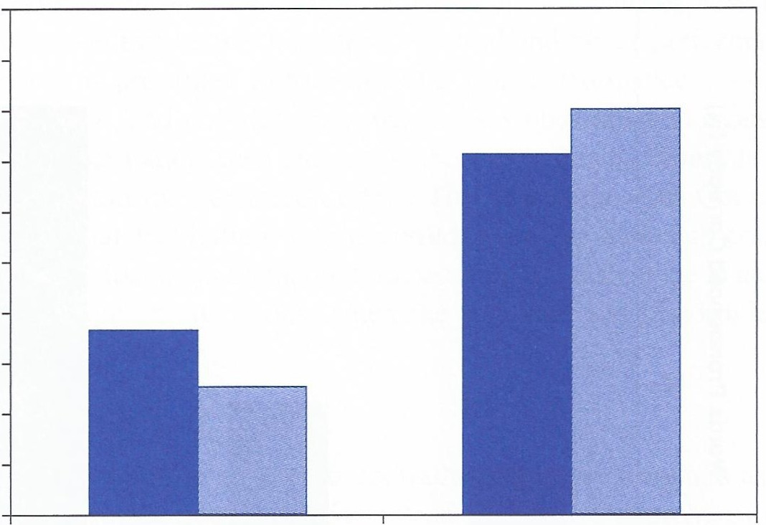

**Figure 5.2** Pool players' accuracy as a function of audience presence and ability. Data from Michaels et al. (1982)

complex problems. For instance, we would expect, on the basis of drive theory, that most of us may show social inhibition in the presence of others when carrying out a maths test. But what about maths experts? Think about maths professors at a university. It's likely that these individuals are so well-versed in solving maths problems that for them such tasks are well learned. They should therefore perform better with an audience (e.g. when giving a lecture).

Michaels et al. (1982) provided empirical evidence for the idea that experts *do*

perform better with an audience. After first assessing the ability of a selection of pool players at a college student union, their shooting accuracy was assessed with and without an audience present. Michaels and colleagues found that, in line with drive theory, while below average players' performance decreased with an audience present (a typical audience inhibition effect for a complex task), above average players' performance *increased* with an audience present (see Figure 5.2).

**Evaluation Apprehension**

This second explanation for social facilitation and inhibition effects does not dis­ pute that it is physiological arousal that increases the tendency to make well-learned responses (typically the correct response on simple tasks and the incorrect response

**132** Essential Social Psychology

;g

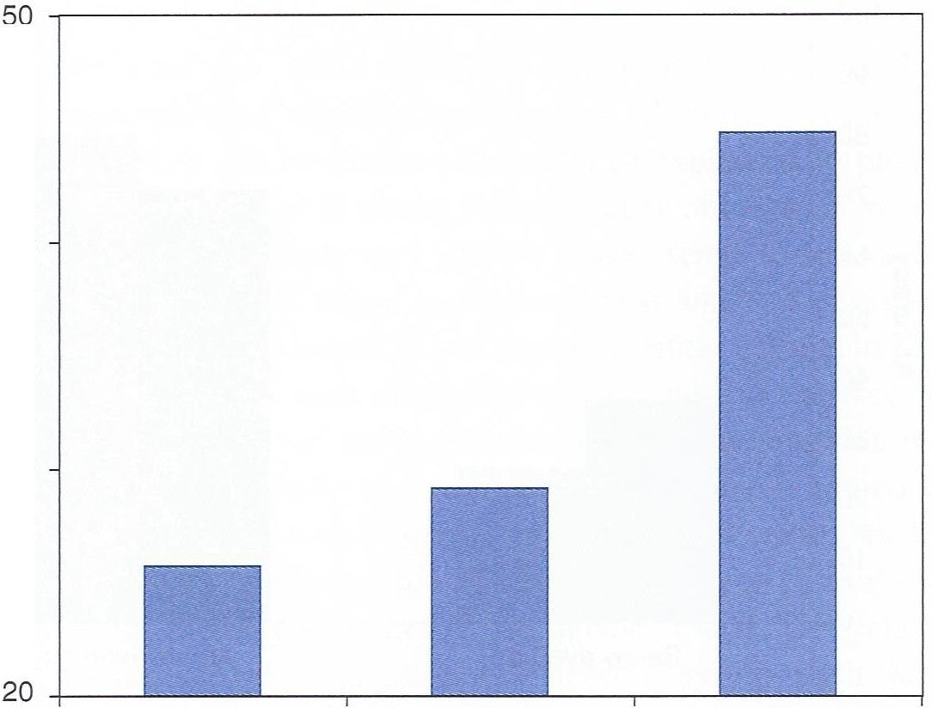

>

***'a***

**Q**..**l**. 40

**0**

(.)

**"0**

**Ql**

**u**

**s::::**

**:I**

**0**

**s::::**

**a0:** 30

*en*

**"**.**0**..

**0**

**3:**

Alone Audience

Blindfolded

Audience Not

Blindfolded



**Figure 5.3** The effect of mere presence versus an audience on performance. Data from Cottrell et al. (1968)

on complex tasks), but it does argue against the idea that it is the *mere presence* of others that causes this arousal. Instead, some theorists have argued that it is *evalua­ tion apprehension* that causes physiological arousal in the presence of others. **Eval­ uation apprehension** is concern about being evaluated by others (Cottrell, 1972). In the presence of others, this evaluation apprehension can translate into being con­ cerned that you will look stupid in front of the people watching you - you'll be apprehensive about being evaluated (negatively) by them.

Cottrell and colleagues (1968) carried out a clever experiment that distinguished between the mere presence and evaluation apprehension explanations of social facilitation. In this experiment participants had to complete a simple task (pro­ nounce out loud nonsense words that appeared every four seconds on a screen) either on their own or in the presence of an audience. The key manipulation here was that some of the participants carried out the task in front of a blindfolded audi­ ence, while some carried out the task in front of an audience who could see them. The non-blindfolded participants showed the typical social facilitation effect on the easy task: they performed better in the presence of an audience. According to Zajonc's (1968) drive theory, the same effect should be observed when the audience is blindfolded - the mere *presence* of others should lead to physiologi­ cal arousal that should then lead to dominant response facilitation on this simple

Group Processes 133



task. According to Cottrell and colleagues, however, it is not mere presence but evaluation apprehension that causes heightened arousal and better performance. A blindfolded audience is prevented from evaluating your performance. As such, if evaluation apprehension, and not mere presence, causes physiological arousal and subsequent response facilitation, then preventing this evaluation by blindfolding the audience should wipe out the facilitation effect. This is exactly what Cottrell and colleagues found. Social facilitation only occurred when the audience could see (and evaluate) the participant, but no facilitation occurred (no difference in audience present and audience absent conditions) when the audience was blindfolded (see

Figure 5.3).

**Distraction Conflict**

Cottrell et al.'s (1968) findings appear to contradict the mere presence assump­ tion of drive theory, suggesting that it is instead evaluation apprehension that causes physiological arousal and subsequent social facilitation and inhibition effects. However, evaluation apprehension cannot explain all social facilitation and inhibition effects. In particular, it has considerable difficulty in explaining social facilitation effects that have been observed in animals (Chen, 1937; Gates

& Allee, 1933). Chickens are probably not laying lots of eggs because they are worried about what other chickens think of them! So, while evaluation apprehen­ sion offers a good explanation for social facilitation effects with people, only drive theory can account for animal findings. A third theory attempts to reconcile the findings from human and animal studies with an alternative explanation: **dis­ traction conflict** (Baron, 1986).

According to distraction conflict theory it is neither mere presence nor evalua­ tion apprehension that causes the physiological arousal that leads to facilitation or inhibition effects, but conflict experienced between the task at hand and attending to others in the immediate surroundings. The appeal of this explanation is that it can explain the heightened arousal caused by an audience in both animals and humans. Conflict between attending to different things in one's immediate sur­ roundings is well-established as a source of arousal for both animal and humans. Moreover, that conflict does not even have to be other people or animals, but can be any conflict-inducing stimulus (e.g. loud noises, flashing lights; Sanders & Baron, 1975).

Should we therefore conclude that distraction conflict is the only explanation for social facilitation and inhibition effects? Although it can explain a wide variety of these phenomena, what is important is that there is yet to be any conclusive evidence that argues in favour of distraction conflict at the expense of mere presence or evalu­ ation apprehension. As such, the most sensible conclusion is that in any particular situation any combination of these three explanations may be applicable, or even all

134 Essential Social Psychology



three simultaneously. They are not necessarily mutually exclusive. In sum, it seems that the mere presence of others, the ability of others to evaluate your performance, and the distraction caused by others being present all contribute to social facilitation and inhibition effects.

**Social Loafing**

So far, we know that individuals appear to work harder when others are present because of physiological arousal caused by their presence, attentional conflict and, for humans at least, evaluation apprehension. Concern over how other people will evaluate you appears to make people work harder on simple tasks. All of this research focuses on what happens to an individual 's performance when in front of an audience. But what happens when we are working as a *team?* Does the presence of others make us work harder? Research suggests that this is, in fact, not the case; in teamwork people appear to put in *less* effort. This phenomenon is called **social loafing** (Karau & Williams, 1995).

The key difference between work on social facilitation and work on social loaf­



ing is the unit of assessment. In contrast to social facilitation and inhibition effects, which apply when the individual's *own* specific performance is evaluated by others, social loafing applies when the unit of assessment is the *group* product. In other words, social loafing occurs when each person 's individual contribution to the out­ put is pooled.

A classic study of social loafing was provided by Latane et al. (1979). In this study six blindfolded participants had to sit in a semicircle wearing headphones that played a recording of people shouting into their ears. Participants were asked to shout as loudly as possible while listening to the shouts coming through into their headphones. In one condition participants were told that they were shout­ ing alone. In a second condition they were told that they were shouting with five other people. In fact, only the participant was shouting on any one trial. The intensity of their shouts was the dependent measure. The findings can be seen in Figure 5.4.

These findings illustrate the social loafing effect. Participants who believed they were shouting in a group shouted with less intensity than participants who believed they were shouting alone. Importantly, this difference in intensity can only be attrib­ uted to the different information participants were given about the number of people who were joining in with them during the task. In both conditions participants were blindfolded, so could not see who else was taking part, and in both conditions the same shouting noises were being played through their earphones. The only differ­ ence was whether participants thought they were solely responsible for the shouting task, or whether other people were also responsible.

80



e...

**i!'**

..

**·u;** 75

**c:**

**Q)**

**.5**

70

Told shouting with one other person

Group Processes **135**

Told shouting in group

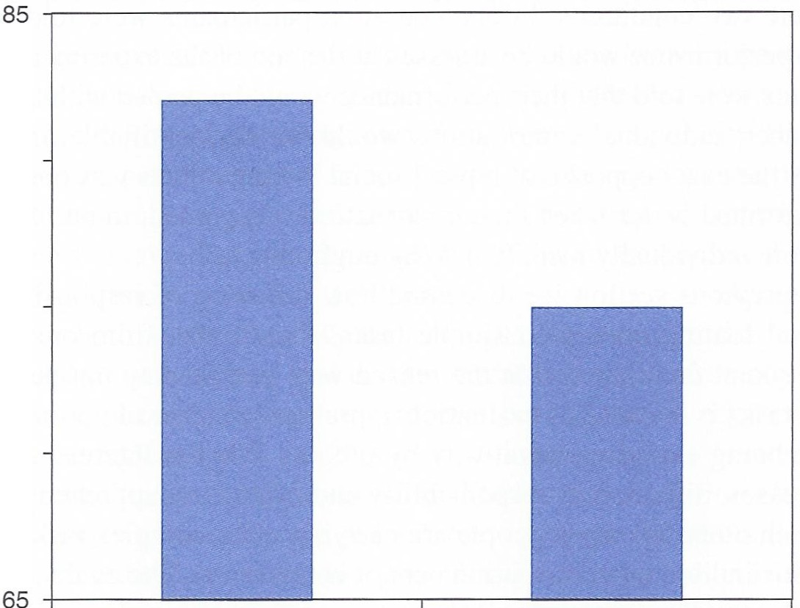

**Figure 5.4** Social loafing. Data from Latane et al. (1979)

How can we explain this social loafing effect? What appears to be happening in these situations is that participants experience a **diffusion of responsibility** (Comer,

1995). This term describes how people in a group feel individually less personally responsible for any task at hand- their contribution is literally 'lost in the crowd'. This same process can inhibit people from helping others in emergency situations (see Chapter 10 on prosocial behaviour) and has resulted in collective acts of aggres­ sion (see Chapter 9 on aggression).

**Diffusion of Responsibility**

Recall our discussion of social facilitation and inhibition effects above. The impact of an audience on individuals' productivity appeared to depend on the type of task: simple or complex (assuming people's dominant response was usually only helpful on simple tasks). Interestingly, the work on social loafing that we have just dis­ cussed focuses on simple tasks - such as shouting loudly. Would social loafing occur even on complex tasks? On such tasks when people's performance is being individually judged there is an inhibitory effect - they perform worse than if they would carry out the same task on their own. Does working on a complex task in a group also lead to poorer performance?



Jackson and Williams (1985) carried out a task to investigate this possibility. The task was complex, involving navigation of a computer maze with oneother person.

136 Essential Social Psychology



There were two conditions. In one condition participants were told that each co­ worker's performance would be assessed at the end of the experiment. In the other, participants were told that their performance would be pooled with their co-worker and that their individual contributions would not be identifiable. Interestingly, in this study the exact opposite of typical social loafing effects was observed: partici­ pants performed *better* when their contribution was pooled, rather than when their efforts were individually identified. Why might this be?

In the previous section we discussed how diffusion of responsibility explains

why social loafing occurs on simple tasks. Recall also from our discussion of work on social facilitation that the reason why people may not perform well on complex tasks is because of evaluation apprehension (fear of getting it wrong and therefore being evaluated negatively by others). What is interesting is that these two processes, diffusion of responsibility and evaluation apprehension, appear to cancel each other out when people are carrying out a complex task, but in a team where their individual contribution cannot be assessed. The evaluation apprehen­ sion that normally causes the detriment to performance when people are being individually assessed on a complex task is removed when they are just one of a team working on the problem because this diffusion of responsibility makes them less responsible for the outcome - reducing any anxiety they might feel about

'being in the spotlight'.

**Summary**

In this section we have looked at the impact of others on individual and group productivity. We have seen how when an individual's productivity is individually judged in front of an audience then they tend to perform better on *simple* tasks (such as clapping), but not so well on *complex* tasks (such as maths problems). These ten­ dencies can be referred to as *social facilitation* and *social inhibition* respectively.

Three theories try to account for whether social facilitation or social inhibi­

tion will be observed. All of these theories argue that *physiological arousal* is the key process, but differ in what they specify causes such arousal. Zajonc's *drive theory* argues that the mere presence of others causes physiological arousal, which is consistent with an evolutionary explanation and can account for both *animal* and *human* social facilitation effects. The idea here is that physiological arousal increases tendencies to make a dominant response, which is usually the response that enables better performance on simple tasks, and accounts for why people don't do well with an audience on complex tasks (unless they are an expert, in which case complex responses are the *dominant, well-learned* response).

Group Processes

However, the mere presence explanation cannot account for why people do not show social facilitation effects when audiences are blindfolded. Here, *evaluation apprehension* is a better explanation: blindfolds remove the ability for an audi­ ence to evaluate the performance of an individual, so they remove the physiologi­ cal arousal that facilitates simple task performance, but they disrupt performance on complex tasks. Evaluation apprehension cannot, however, explain the observa­ tion of social facilitation in animals. *Distraction conflict* offers an explanation that can account for both animal and human findings. According to this theory, any stimulus - social or non-social - that divides attention can increase physiological arousal. However, because there is no evidence that distraction conflict rules out either alternative explanation it is likely that all three apply to a greater or lesser extent in different situations. While social facilitation and inhibition effects apply when an individual's performance is judged in the presence of others, *social loaf­ ing* applies when individual efforts are pooled and a group product is the unit of assessment. In this situation each individual's performance declines because of a *diffusion of responsibility.* However, this same diffusion of responsibility can prevent evaluation apprehension that can occur when individuals are being judged in front of an audience on a difficult (complex) task. An integration of these ideas regarding the impact of task complexity and unit of assessment can be seen in Figure 5.5.

Having examined the impact of others on individual performance, and the per­

formance of groups on simple and complex tasks, we now turn to another important determinant of group productivity: the characteristics of the group's *leader.*

**LEADERSHIP**

137



If you were asked to think of a public figure who you particularly admire, what would you say? Maybe you would suggest Nelson Mandela, or Martin Luther King. Or maybe you would say that Mahatma Gandhi is the person you admire the most. These people are admirable for different reasons, but they all share one thing in common: they can all be described as leaders. A leader is the most influ­ ential or powerful individual in a group, the person who is primarily responsible for determining a group's direction and goals. As we shall discuss in this section, leadership can take many different forms. There may be one leader who takes complete control, or multiple leaders who are responsible for controlling differ­ ent aspects of the group. There are also many different styles of leadership, from relaxed and person-oriented to strict and task-oriented. But regardless of the form