|  |  |
| --- | --- |
| **Close Read: Union vs Confederacy** | |
| **CR**  Objective | *On the eve of the US Civil war, what were some of the differences between the Union & the Confederate States of America?* |

|  |
| --- |
| ***Figure 1 - Map of the Union[1] and Confederacy*** |

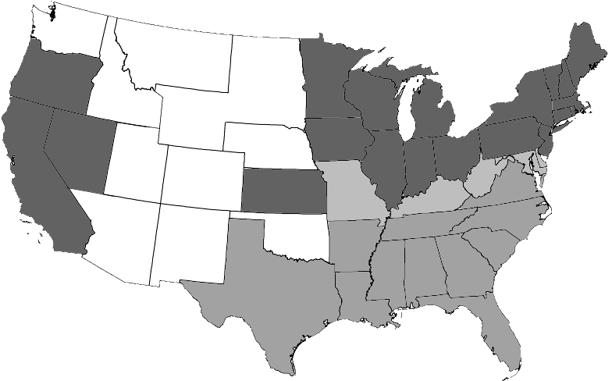

**Union & Confederacy - 1861**

Union states that banned slavery

Union states that permitted slavery

Confederate States of America

Unorganized Federal Lands

1. List the states in the Confederate States of America. How many total states are there in the Confederacy?
2. List the states in the Union. How many total states are there in the Union?
3. Which has more states - the Union or the Confederacy? What does this comparison suggest to you about which side might have an advantage in the war? Support your claim with reasoning.

|  |
| --- |
| **Figure 2a *- Population in the Union and Confederacy*** |

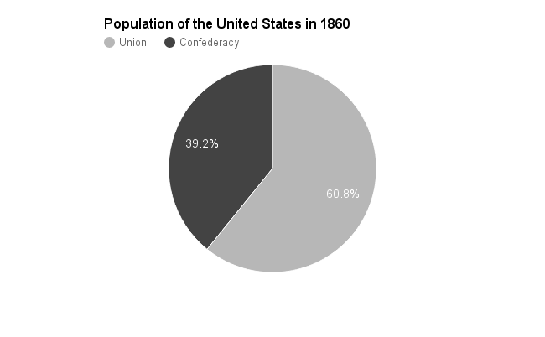

1. Using the data in this graph, predict whether the Union or Confederacy will have a larger army. Explain how you arrived at this prediction.

|  |
| --- |
| **Figure 2b - *Union & Confederate Armies*** |

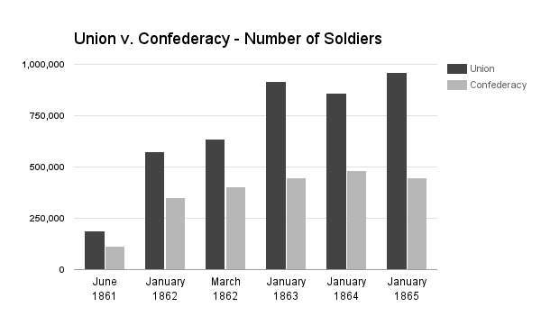

1. Given the information about population in Figure 2, are you surprised by difference in size of the two armies (as represented in Figure 2b)? Why or why not?

|  |
| --- |
| **Figure 3** - ***Railroad Mileage - 1860*** |

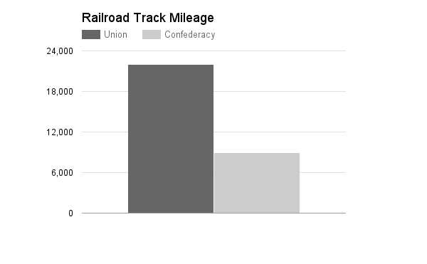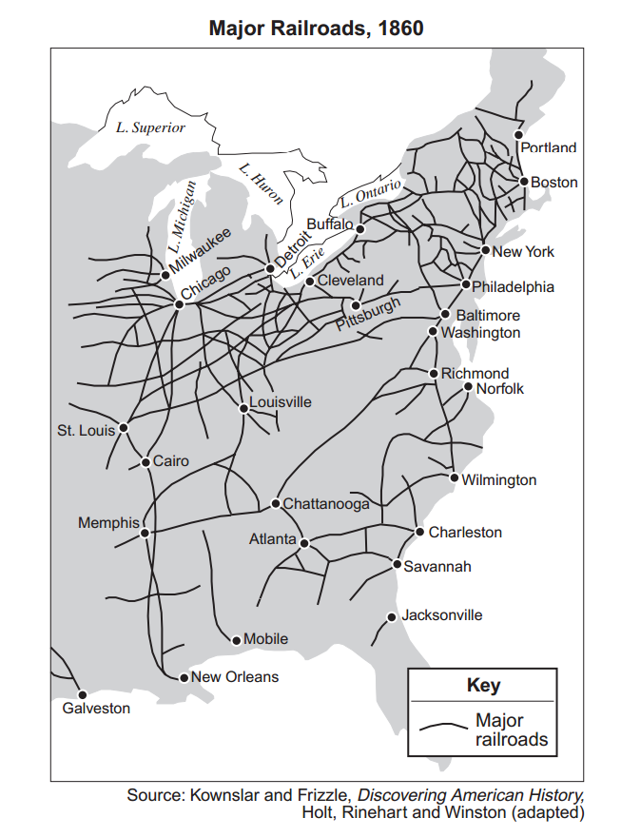

1. How could having more railroad tracks be advantageous during a war?

2) Where are the majority of the railroad tracks?

3) Does the Union or Confederacy have more railroad track miles in 1860?

|  |
| --- |
| **Figure 4 - *Farm Acreage - 1860*** |

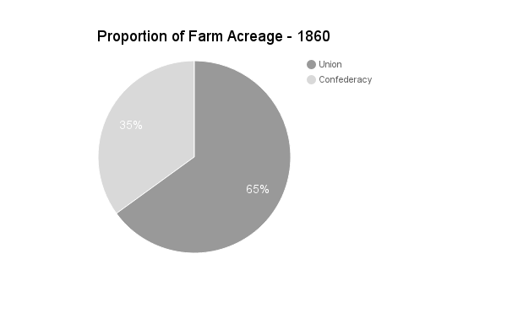

1. How could having more farmland provide an advantage during a war?
2. Did the Union or Confederacy have more farm acreage in 1860?

|  |
| --- |
| **Figure 5a - *Manufacturing Output*** |

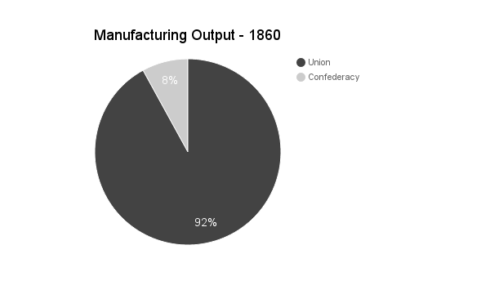

|  |
| --- |
| **Figure 5b - *Number of Factories*** |

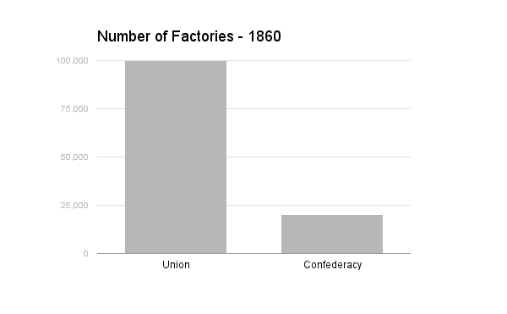

1. What could you use factories to manufacture in large quantities during a war?
2. How could having more factories be an advantage during war time?
3. Based on 5a & 5b, does the Union or Confederacy have a greater manufacturing capacity?

1. Throughout this resource, the United States of America is referred to as the Union