Module 2 - Background

STOCK AND BOND VALUATION

Required Reading
Start off with these two tutorials that will give you an overview of the basic methods of valuing stocks and bonds from Subjectmoney:
Subjectmoney. (2013, January 2). How to price/value bonds - formula, annual, semi-annual, market value, accrued interest [Video file]. Retrieved from https://www.youtube.com/watch?v=7zCqoED8MVk

Subjectmoney. (2013, January 3). Dividend discount model (DDM) - constant growth dividend discount model - how to value stocks [Video file]. Retrieved from https://www.youtube.com/watch?v=n76Pz3HOBPo
Now dig much deeper into bond and stock valuation with the following books chapters. They cover not only the computational methods but also provide a general overview of stock and bond markets:
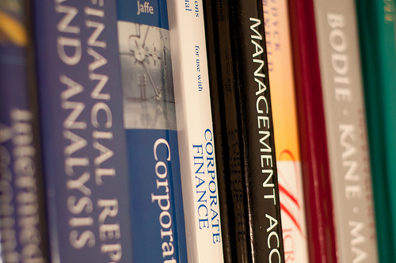

Ross, S., Westerfield, R., & Jordan, B. (2007). Chapter 6: Interest rates and bond valuation. Essentials of Corporate Finance. McGraw Hill. Retrieved from http://novellaqalive2.mhhe.com/sites/dl/free/007000000x/484691/Part4_Chap6.pdf [If this link is down, click Interest Rates and Bond Valuation for an alternative link.]



Gitman, L. (2005). Chapter 7: Stock valuation. Principles of Managerial Finance. Pearson Education. Retrieved from http://wps.aw.com/wps/media/objects/222/227412/ebook/ch07/chapter07.pdf [If the link is down, click Stock Valuation or Managerial Finance for an alternative link.]

Finally, for some examples of valuation calculations in Excel see the following videos:
Moy, M. (2014). Bond valuation in Excel. Retrieved from https://www.youtube.com/watch?v=H-_NP0UxX_U
Girvin, M. (2010). Stock valuation with dividend growth model. ExcellsFun. Retrieved from https://www.youtube.com/watch?v=cbRIhwkGAnQ
Girvin, M. (2010). Stock value based on present value of future dividend cash flows. ExcellsFun. Retrieved from https://www.youtube.com/watch?v=G2VIY5E3I3s&t=163s

Optional Reading
Davis, A. (2016). Bond pricing. Retrieved from https://www.youtube.com/watch?v=-DnARyndirI
Ahmad, A. (n.d.). Bonds part II: Pricing. Coursera. Retrieved from https://www.coursera.org/learn/finance-markets/lecture/EpByC/bonds-part-ii-pricing
Ozoguz, A. (n.d.) Basics of equity valuation. Coursera. Retrieved from https://www.coursera.org/learn/global-financial-markets-instruments/lecture/vHPRN/basics-of-equity-valuation
Gitman, L. (2005). Chapter 6: Interest rates and bond valuation. Principles of Managerial Finance. Pearson Education. Retrieved from http://wps.aw.com/wps/media/objects/222/227412/ebook/ch06/chapter06.pdf [If the link is down click Interest Rates and Bond Valuation or Managerial Finance for an alternative link. For a video PowerPoint version of this chapter, click Interest Rates and Bond Valuation]
Ross, S., Westerfield, R., & Jordan, B. (2007) Chapter 7: Equity markets and stock valuation. Essentials of Corporate Finance. McGraw Hill. Retrieved from novellaqalive2.mhhe.com/sites/dl/free/007000000x/484691/Chap7_EquityMkts.pdf

