Analysis Worksheet: Sample Instruction Set

Consider these questions as you review the sample instruction set below. Although you do not need to submit your answers, working through these questions will enable you to do a better job with your planning worksheet and assignment.

- Who is the audience for this instruction set? How can you tell? What does the instruction set enable the audience to accomplish?

- What is the context for the instruction set? That is, what are the conditions under which the instruction set would be used?

- Look globally at the document. What are the sections of the instruction set? What is the purpose of each section?

- How does the writer handle potentially dangerous situations?

- Which technical writing conventions does the writer employ in the instruction set?

- What roles do the images play in the instruction set? Be sure to comment on the captions and their role.
How to Make an Ice Candle
With Your Kids

By: Name

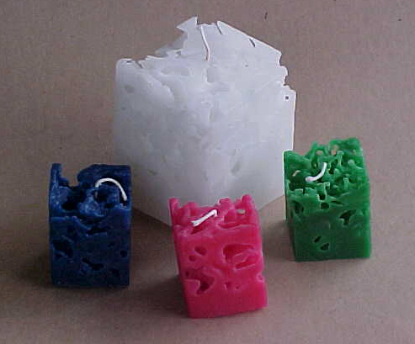

Have you been looking for a fun and creative craft to do with your kids? Making ice candles just might be the perfect solution. Children will love this hands-on craft that is easy to learn. They can be creative with the colors they choose, with every candle turning out different from the next. For you as a parent, this could be an inexpensive and enjoyable way to create gifts for others.

Ice candles are given this name because the last step actually requires pouring melted wax around chunks of ice. The ice melts and is drained out, leaving a candle with an interesting final appearance that to some people looks like a block of Swiss cheese.

There are four basic steps to make an ice candle:
- Prepare the Wax
- Make the Core Candle
- Make the Candle Base
- Fill in the Body

Making an ice candle takes approximately 2 hours plus time for wax hardening. All supplies for this project can be found at your local craft store. Some supplies, such as coffee cans and juice cartons, can probably be found around your house, making it unnecessary to purchase any expensive candle making equipment. It is best to make these candles in a place that can get a little messy, such as a garage. They can be made in kitchens or other places like this, but proper preparations should be made to cover all important surfaces with thick cloth or aluminum foil before beginning.
Candle-Making Terms You Might Not Recognize

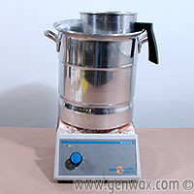
Double Burner – This is the setup often used to melt wax in a way to prevent it from catching on fire. Basically it is a small can placed inside a larger can, with a little bit of water in between. This two-can setup is placed on a burner and wax is placed inside the smaller can as seen in figure 1. This prevents the wax from ever catching fire because the layer of water insulates the wax from the burner surface.
Figure 1: Double Boiler

Core Candle – The core candle is a tall, cylindrical candle containing the wick. It is placed in the middle of the ice candle so that there is always plenty of wax around the wick to keep it burning. Without this core candle, the holes in the body would allow all of the melted wax to drain away from the wick, causing the fire to go out.

Candle Base – The base is simply a thin layer of wax poured into the milk carton with the core candle placed upright in the center of it. When this layer hardens, it serves as a solid base to hold the core candle in position when the body is filled in around it later.

Candle Body – This is the part of the candle that surrounds the core candle and has the distinct holy appearance. It is the last part of this candle to be made, and is done so by filling the carton with ice chunks and pouring hot wax over them.

Warning! Fire Hazard: Do not allow the wax to touch the direct heating surface at any time in this process. You must use a double burner. Wax will typically begin to burn at 300 degrees. Water boils at only 212 degrees (and therefore will not get any hotter). A double burner assures that your wax will not encounter temperatures above 212 degrees, and will not catch fire.

Warning! Burn Hazard: Burner surfaces, melted wax, and coffee cans placed on the burner are extremely hot objects. Be sure to instruct any children not to touch these items at any point in this process. All wax heating and pouring should be done by adults only.

What You Will Need

- Paraffin Wax (about 3-4 lbs/candle)
- 10” of Medium Wick (for 4” diameter candle)
- Candle Dye (color of your choice)
- Stovetop or portable burner
- 1 large coffee can (8” tall, 8” wide)
- 1 smaller coffee can (8” tall, 6” wide)
- Pitcher full of cold water
- Scissors
- Pot Holders or Insulated Gloves
- Half-Gallon Paper Milk or Juice Carton (Empty)
- Masking Tape
- Ice Cubes (enough to fill 2 half gallon milk cartons)
- Two 1-Gallon Sealable Plastic Bags
- Hammer
- Metal Coat Hanger
- Thick Cloth or Aluminum Foil (optional)

Step 1: Preparing the Wax

Note: The handling of hot wax can be extremely messy and can ruin any surfaces the wax touches. Therefore you should wear old clothes or an apron while handling wax. All surfaces that you would like protected in the vicinity, such as tables, chairs, and floors, should be covered with thick cloth or aluminum foil. Proper preparation will lead to easier cleanup at the end.

- Set up the double burner by placing the larger of the two coffee cans on the burner.

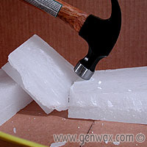
- Fill the large coffee can with 1” to 2” of water. Then place the smaller coffee can inside the larger coffee can making sure to not get any water inside the smaller can. Note: The smaller can will float on the water until you place the wax chunks inside of it.

- Use a hammer to break the wax into small chunks as shown in figure 2. Place the chunks of wax into the smaller coffee can as you go, making sure to fill it to the top with wax chunks.
Figure 2: Breaking the Wax

Warning! Fire Hazard: Make sure all paper or plastic labels are removed from the cans before turning on the burner. Failure to do so could cause a fire.

Warning! Do not leave the burner area once it has been turned on. Fire or burn injury to children in the area could occur.

- Turn on the stove or burner to a setting of 150º F if there are temperature settings available. If there are no temperature settings, turn the burner to a low setting and monitor the water to make sure that it does not boil. If the water does start to boil at any point, simply turn down the heat setting.

- Wax will take 30 to 60 minutes to fully melt. The water in the larger can will start to evaporate as the wax heats; therefore add water periodically to make sure that there is always at least 1” of water in the larger can. Failure to do so can lead to fire.

Note: You may increase the heat setting of the burner slightly if the wax does not seem to be melting, but make sure to keep the setting low enough that the water in the can does not boil.

- As the wax melts, add additional chunks so that the level of wax in the can is about 6 or seven inches high.

- With the wax fully melted, add candle dye. Add the dye slowly, asking your kids how light or dark they want the color to be. Stir with a bent metal coat hanger until dye is fully blended.

Step 2: Making the Core Candle

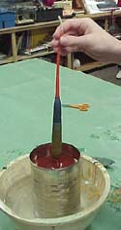
- Begin by placing the pitcher of cold water on a flat surface near the melted wax. Keep it close enough so that the children will be able to dip their candle into the wax and then dip it into the cold water without having to move too much. This will avoid excessive dripping in between.
Figure 3: Dipping the Candle

- Cut a piece of wick to approximately 10 inches in length. To make it easier for your kids to hold on to in the dipping process, tie a small loop at one end.

- As seen in figure 3, hold the end with the loop to dip the wick approximately 6” straight down into the wax and pull out the same way. Dipping motions should be quick, but not too quick that you splash hot wax on yourself or others.

- After pulling the wick out of the wax, dip it into the cold water, completely submerging the wax on the wick. This will help cool the candle after each dip so that you don’t have to wait for extended periods of time in between each dip.

- Repeat steps 3 & 4 until the candle grows to approximately 1.5” to 2” in diameter. On each dip in the wax, make sure that you are dipping to the same height on the wick each time so that you don’t start to have a tapered candle.

Note: After each dip of the candle into the hot wax, make sure that it maintains a straight shape. If you see that your child’s candle starts to bend in any way, remember that the candle is not totally hardened yet. Slide your fingers along its length after a dip in the hot wax, removing any bends that may be present.

Note: As you continue to dip the candle, some wax will tend to accumulate below the bottom of the wick. This is perfectly normal. You can cut this portion off with scissors as you go, or wait until the end to cut it off.

- When the candle reaches 1.5” to 2” in diameter, submerge the candle in cold water for a couple minutes to harden it up. Hang the candle on a nail or set it aside until it is needed in the next step.

Step 3: Making the Base

Warning! Injury Hazard: Make sure your children stay clear of the knife used in the next step. Sharp objects can lead to serious injury if not used properly.

- Use a knife to cut off the top section of the milk or juice carton, allowing enough remaining height so the core candle you just made can be placed completely inside. This process is demonstrated in figure 4.

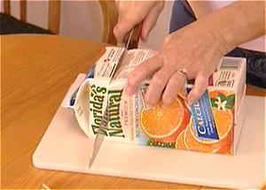
Figure 4: Carefully Cut Off the Carton Top
Warning! Burn Hazard: This next step requires the pouring of hot wax, which can splash or drip in the process. All persons except the one doing the pouring should back away from the area when the pouring takes place. The person doing the pouring should only touch the hot cans using pot holders or insulated gloves.

- Lift the small can of wax and pour about a half of an inch of hot wax into the carton. Then carefully set the can back inside the larger can.
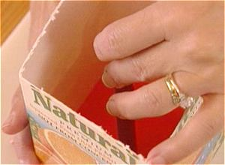
Figure 5: Secure the Core Candle to the Base
- As shown in figure 5, place the dipped candle into the carton so that its base is centered in the wax you just poured.

- Now secure the top of the dipped candle using strips of masking tape so that the candle stands perfectly straight up and down.. An easy way to do this is to create an “X” with masking tape across the open top of the carton so that the wick is attached at the middle of the “X”.

- Allow this setup to stand for approximately 1 hour or until the base has hardened completely. Be sure to check on it periodically to ensure that the core candle remains secured in an upright position.

Suggestion: While waiting for the base to harden, it can be fun to play a board game or any other game with your kids.

Step 4: Filling the Body

- Fill each of the two 1-gallon plastic bags with equal amounts of ice cubes. Place the bags on a hard surface such as a concrete floor that won’t be damaged when crushing the ice.

- Repeatedly and lightly strike each bag of ice with the broad side of the hammer until the cubes are crushed into slightly smaller pieces. You want there to be plenty of chunks averaging about a half inch in length to fill the carton.

- Fill the carton with various sized pieces of crushed ice (about a half inch long on average) so that the level of ice is the same as that of the dipped candle you made earlier. You will have lots of ice left over, this is normal.

- Being just as careful as before, pour hot wax into the carton so that the level of wax comes precisely to the top of the dipped candle (figure 6).

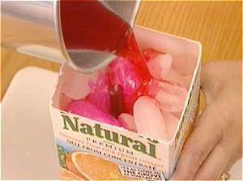
Figure 6: Pour Wax over the Ice Chunks

- Set the small coffee can back into the large can and turn off the burner.

- Allow your candle to harden overnight.

Note: This next step should be performed outside or over a sink because water from the melted ice cubes will rush out of the carton as it is peeled away.

- After the candle has totally hardened, remove the carton by carefully tearing it from top to bottom.

- Remove the candle completely from the carton and cut the wick so that only one half inch of wick remains exposed. If the candle wobbles at all when placing it on a flat surface, you may want to shave a little bit of wax off of the bottom to level it out.

Your beautiful ice candle is now complete and ready to light or give to someone else as a special homemade gift! If all steps went well, your candle should look similar to the ones in figure 7.
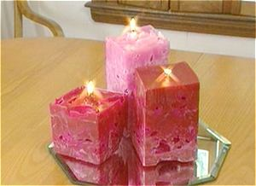
Figure 7: The Finished Product

Additional Suggestions

  - To avoid having all the down time in between steps, you could make several candles at the same time. Doing this will require the wax can to be periodically refilled if dipping and pouring out of the same can. Be careful to add the appropriate amounts of coloring each time if you are trying to maintain a consistent color.
  - You could try mixing more than one color when filling the body to create a blended final appearance. An example of this is shown if figure 8. This process will take a little experimentation, but can lead to some fantastic candle designs.

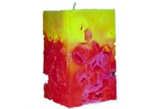
Figure 8: Two-Color Blended Ice Candle

Pictures Courtesy of:
http://www.diynetwork.com/

http://candles.genwax.com/candle_instructions

