ILS 4130 Digital Art

**Public Art Project**

Conduct a personal field trip solo or with a friend. Locate public art. In most every town and city there are numerous examples of historic public art and monuments. Take pictures and try to research the nature of the monument or art. Many are commemorative pieces remember wars, conflicts, soldiers and hero’s. Research what these events were and who the people were. Try to find public-private art. If you go into corporate office, mall, airport or some related structure, you will find examples of art, maybe even digital art. Today, the ‘lobby’ has become the new public gather space, so investigate and see what you find. For this project you will:

* Create and submit visual essay
* Use powerpoint or some other related presentation software
  + You may use anything you wish such as Photoshop or Illustrator. Sometimes hand done collages and high quality scans work very well to.
* Prepare a 10-12 slide presentation, each slide should have perfect layout and visual information
* Along with visuals add a narrative voice over, use select captions and text when necessary
* You may include a soundtrack and other effects
* You may include digital art such as a music, video, motion glitch art,url links or other distortions to create your analysis
* The combined effect should be either a
  + critical analysis of the art
  + oryour personal visualinterpretation of the art
* Either way, a viewer should take away an appreciation of the art, its origin, its purpose and intent

***Add a twist:***

Take a ***virtual*** field trip. Use the web and various tools such as Google earth, street view and so on to explore unique international public art sites. Find online museums, virtual spaces and immersive public art experience and report on those. Use image capture to create your visual essay. (See attached URL for a quirky take on a virtual digital image expedition)

<http://www.digitaltrends.com/web/artists-collection-of-bizarre-street-view-glitches-might-actually-spook-you-out/>

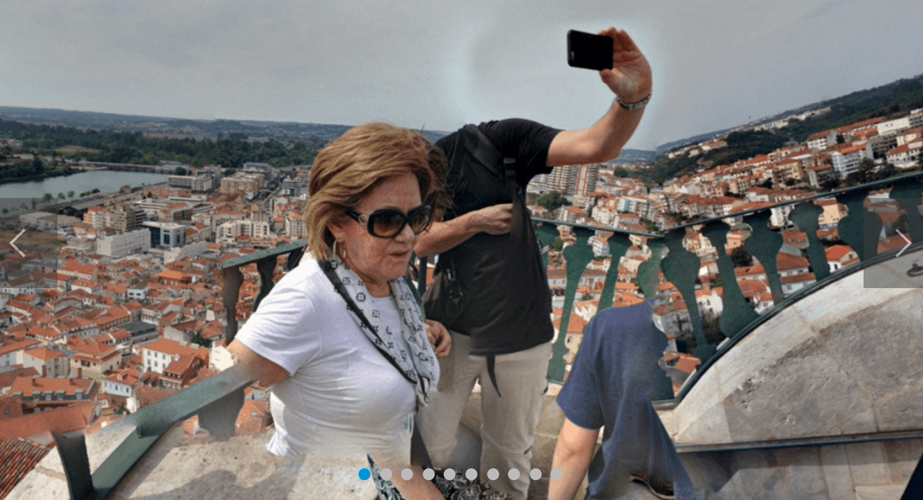

An example of ‘found art’ in street view

ILS 4130 Digital Art

**Public Art Project**

Grading Rubric –Public Art Visual Essay

|  |  |
| --- | --- |
| Item | Points |
| Demonstrates understanding of project. Prepares and submits work in a timely manner | 2.5 |
| Includes 10-12 well crafted slides on relevant subject | 2.5 |
| Offers individual insight and analysis through visual research | 3.5 |
|  | 8.5 |