# Human Resource Roles & Job Requirements

# Jennifer Irizarry

# HRM/300

Monday January 23, 2017

Linda Begley

University of Phoenix

# **Human Resource Roles and Job Requirements**

Managers and Human Resources have the important task of organizing people so that they can successfully carry out activities and perform their jobs. The role of human resources within an organization is to advise the management team on how to strategically manage employees and collaborate to aid in developing long-term plans for the growth and development of the company. However, the major functional areas can be perceived as planning, staffing, employee development and employee maintenance. “These four areas and their related functions share the common objective of an adequate number of competent employees with the skills, abilities, knowledge, and experience needed for further organizational goals (Human Resource Managment Functions, 2017).” These areas can be broken down even further, as illustrated below:

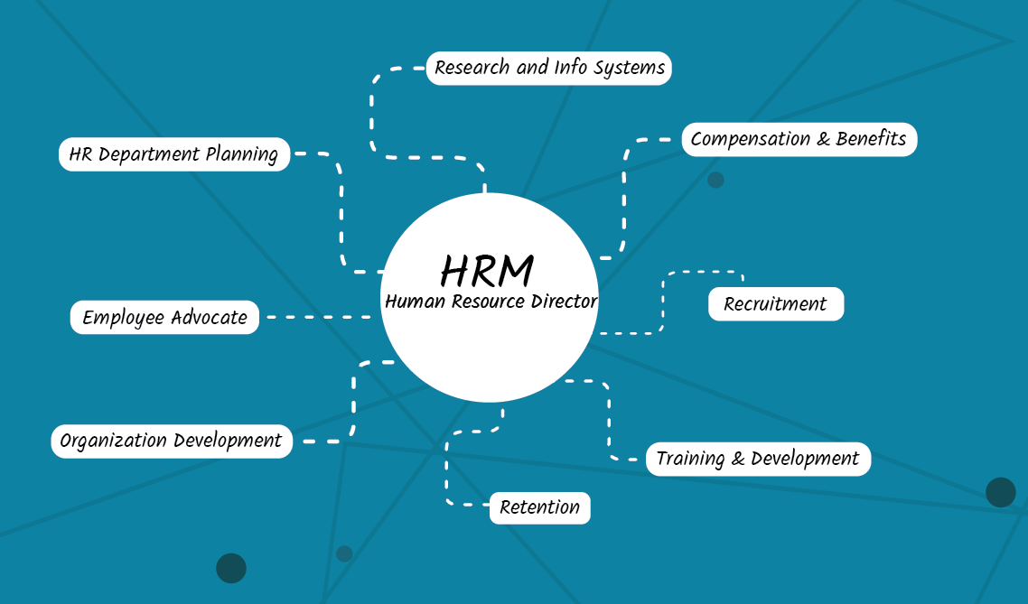

**Recruitment.** As a prospective employee, the first point of contact with a company is generally through the Human Resource department. This area of HR is crucial to an organization as the people who are tasked with this role are responsible for finding the right talent for the job a company seeks. Think of them as organizational matchmakers, but with a deadline. Two of the most common job titles in this area of HR is the Hiring Manager and the Recruitment Specialist.

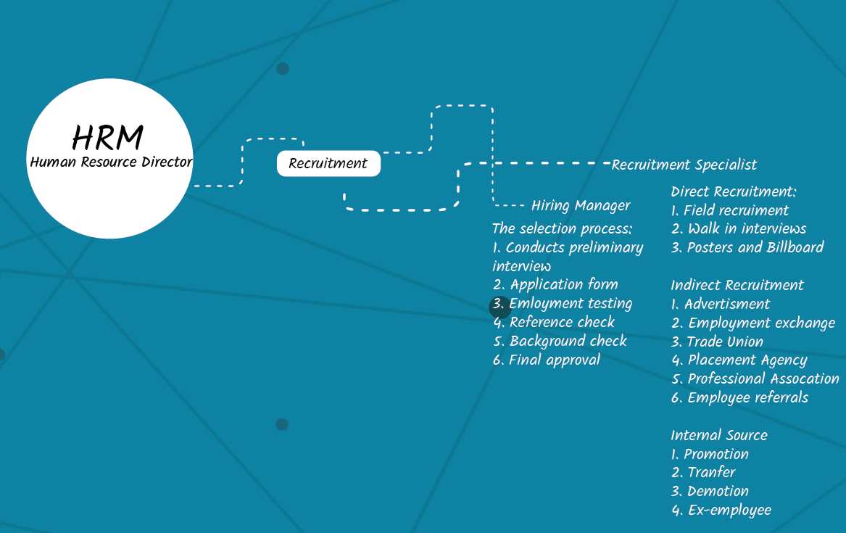

**Job Title:** Hiring Manager

**Department:** Human Resources

**Reports To:** HR Director

**Job Purpose:**

The Hiring Manager oversees the candidate selection process and conducts preliminary interviews. Identifies hiring needs, and develops the position description. Develops and implements a recruitment plan, application process, organizational chart, and other recruitment related documents. Will complete all reference and background checks for potential candidates and delivers the final approval of a new hire. They may at times serve as Search Committee Chair and identifies Search Committee members. Works closely with the Recruitment Specialist to ensure good faith efforts to broaden diversity. Ensures understanding of collective bargaining agreements’ specific provisions with respect to filling of bargaining unit positions.

**Essential Functions:**

* Manage talent acquisition from start to finish focusing on unique and creative approaches to attracting top talent
* Ensure job requisitions are approved in a timely manner and screen qualified candidates for positions
* Ensures all new hire paperwork are collected and completed in its entirety
* Verify and maintain Form I-9s. Responsible for I-9 compliance
* Maintains OSHA Accident Reports. Maintains records, reports, and logs pertaining to claims.
* Creates and maintains employee personnel files (both active and terminated files) to ensure timely and accurate record keeping
* Keep the corporate shared HR drive up to date
* Perform a variety of general office support duties; make copies; fax documents; and maintain calendar of activities, meetings, and various events for the department
* Provide counsel to deliver HR solutions that enable a high-performance culture that supports the Company’s positive work environment and business objectives
* Stays informed of developments in wages and salaries, employee benefits and general human resource policies
* Must work collaboratively with the Recruitment Specialist and have the desire to be part of a dynamic team
* Will advise management and line supervision about the application of rules and policies, handle employee complaints, and second step grievances.
* Represent the company in a positive and professional manner
* And other assigned duties, tasks and responsibilities

**Organizational Relationship**

Has frequent contact and communicates continuously with potential candidates, the Recruitment Specialist, vendors and visitors.

**QUALIFICATIONS GUIDELINES**

**Experience/Training/Education:**

**Required:**

* BS/BA in Human Resources or related field
* Master’s or professional degree preferred
* Minimum of 5 years’ experience working in HR with a solid background in talent acquisition and recruitment
* Solid understanding of CA labor laws and demonstrates strong HR sensibility and critical thinking

**Knowledge/Skills/Abilities:**

* Ability to communicate clearly, professional, and courteously in writing and verbally
* Strong organization skills with an attention to detail
* Willingness to “roll up the sleeves” and do what it takes to get the job done
* Works well on a team and collaborates with others but also be able to work independently.
* Finger dexterity to operate standard office equipment including telephones, calculators, copiers, and facsimile equipment
* Ability to effectively manage tasks with minimal supervision
* Must be diligent and persistent in follow-up and completion
* Capable of multi-tasking and meeting tight deadlines.
* Able to function in a fast-paced environment with tight and changing deadlines
* Strong working knowledge of Windows/Mac operating system-experience.
* Requires proficiency in Microsoft Office applications
* Ability to type at a net rate of 35 wpm using a computer keyboard

**Physical Demands & Work Environment:**

The Hiring Manager must be able to bend, stoop, stand, and sit for various lengths of time. They must be able to lift and carry items up to 20 lbs. A clear speaking voice is necessary along with the ability to communicate clearly.

This is primarily a sedentary office classification and employees work in an office with moderate noise levels, controlled temperature conditions, and no direct exposure to hazardous physical substances.

**Cognitive Demands:**

The Hiring Manager must be able to multi-task various projects in a fast-paced environment with tight deadlines while maintaining a customer-centric, friendly, and professional demeanor.

**Job Title:** Recruitment Specialist

**Department:** Human Resources

**Reports To:** HR Director

**Job Purpose:**

The Recruitment Specialist will lead all aspects of recruiting and play a key role in the company’s talent acquisition strategy. Will partners with the HR Director and Hiring Manager to refine recruiting processes and staffing reporting and metrics. Strategize talent acquisition, assessment, development, and retention.

**Essential Functions:**

* Responsible for attracting top talent and managing the recurring function as it relates to: workforce planning, full-cycle recruitment, candidate pipeline management, employment branding, intern program, university/community program, workforce diversity, and HR operational efficiency specific to hiring.
* Collaborate with business leaders (Finance, Marketing, etc.) to design, develop, communicate, and implement an effective recruiting strategy and corresponding policy
* Develop a strategy for candidate pipeline development and sourcing by utilizing all available tools, including company website, social media, job boards, employee referrals, recruiting tools and agencies/others.
* Manage applicant tracking system, related data and reporting.
* Ensure recruiting related metrics are tracked and reported (e.g. cost per hire, hiring cycle time, quality of hire, turnover, competitive hiring measures, etc.).
* Pro-actively identify trends and proposed recommended solutions.
* Manage and participate in special projects as needed.
* Build a culture of performance, results and positive employee relations.
* Introduce infrastructure, system and tools to drive organizational effectiveness.
* Establish and implement short-term and long-term strategies to drive business profitable growth and results

**Organizational Relationship**

Has frequent contact and communicates continuously with potential candidates, the Hiring Manager, vendors and visitors.

**QUALIFICATIONS GUIDELINES**

**Experience/Training/Education:**

**Required:**

* BS/BA in Human Resources or related field
* Minimum of 5 years’ experience working in HR with a solid background in talent acquisition and recruitment
* Solid understanding of CA labor laws and demonstrates strong HR sensibility and critical thinking.
* and execute changes

**Knowledge/Skills/Abilities:**

* Prior experience in a fast-paced high tech environment preferred
* Strong oral, written and interpersonal communication skills
* Proven skills to build and manage relationships, collaborate, influence and negotiate across all levels within an organization.
* Excellent project management skills and ability to manage multiple searches, projects and client relationships.
* Experience in managing applicant tracking systems.
* Possess strong analytical skills and ability to work with metrics, numbers and trends with deep detail orientation skills.
* Self-directed, self-starter with ability to be strategic, identify and solve problems, deliver solutions

**Physical Demands & Work Environment:**

The Recruitment Specialist must be able to bend, stoop, stand, and sit for various lengths of time. They must be able to lift and carry items up to 20 lbs. A clear speaking voice is necessary along with the ability to communicate clearly.

This is primarily a sedentary office classification and employees work in an office with moderate noise levels, controlled temperature conditions, and no direct exposure to hazardous physical substances.

**Cognitive Demands:**

The Recruitment Specialist must be able to multi-task various projects in a fast-paced environment with tight deadlines while maintaining a customer-centric, friendly, and professional demeanor.

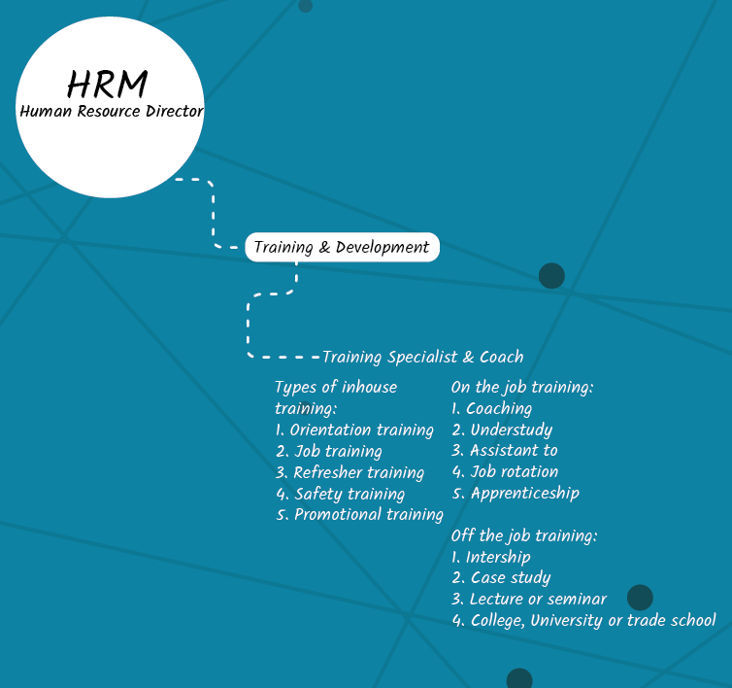 **Training and Development.** Another very important area of HR is training and development. Training provides an opportunity to expand the skill set of all employees. Some organizations refrain from offering training and development due to incurring costs. But if they viewed employees as assets and invest, they would see the benefits are far greater than the cost. A development program brings all employees to a higher level so they all have similar skills and knowledge. This helps reduce any weak links within the company who rely heavily on others to complete basic work tasks. It improves employee performance, structures consistency and employee satisfaction. One job title within training and development is the Training Specialist or Coach, depending on the type of business. Some business like the Real Estate industry work closely with Independent Contractors, so a Training Specialist would not necessarily fit to work environment, however, a Coach would. A Training Specialist is more fitted to train and develop company staff.

**Job Title:** Training Specialist

**Department:** Human Resources

**Reports To:** HR Director

**Job Purpose:**

The Training Specialist will coordinate the delivery of company-wide staffing training, conduct the New Hire Orientation and training on knowledge, skills and procedures for all departments and work culture. Will provide on-going staff training and coordination of trainings per department as needed. Will work closely with departmental heads to ensure policies and procedures are kept current for training material. Willingness to work some evenings and weekends and travel between company branches.

**Essential Functions:**

* Conduct in-field training and support for new and current staff members
* Provide coordination to all aspects of company-wide training programs, include scheduling, reserving conference rooms, preparing material, tracking participation and maintain program supplies and materials
* Maintain a database to track staffing training participation and completion of requirements. This may include communicating with mentors or supervisors and administering surveys
* Regularly update training lesson plans to ensure content is accurate and up to date per company policy
* Track expenses of training activities
* Develop resources for learning and training, as needed

**Organizational Relationship**

Has frequent contact and communicates continuously with department heads, HR Director and staff.

**QUALIFICATIONS GUIDELINES**

**Experience/Training/Education:**

**Required:**

* Bachelor’s Degree or equivalent work experience required
* Experience providing education, training, supervision and/or mentoring to other staff
* Familiarity with a Learning Management System preferred

**Knowledge/Skills/Abilities:**

* Prior experience in a fast-paced high tech environment preferred
* Strong oral, written and interpersonal communication skills
* Proven skills to build and manage relationships, collaborate, influence and negotiate across all levels within an organization.
* Excellent project management skills and ability to manage multiple searches, projects and client relationships.
* Experience in managing applicant tracking systems.
* Possess strong analytical skills and ability to work with metrics, numbers and trends with deep detail orientation skills.
* Self-directed, self-starter with ability to be strategic, identify and solve problems, deliver solutions

**Physical Demands & Work Environment:**

The Training Specialist must be able to bend, stoop, stand, and sit for various lengths of time. They must be able to lift and carry items up to 20 lbs. A clear speaking voice is necessary along with the ability to communicate clearly.

This is primarily a sedentary office classification and employees work in an office with moderate noise levels, controlled temperature conditions, and no direct exposure to hazardous physical substances.

**Cognitive Demands:**

The Training Specialist must be able to multi-task various projects in a fast-paced environment with tight deadlines while maintaining a customer-centric, friendly, and professional demeanor.

These were only three of the many job titles that fall within the Human Resource department; The Hiring Manager, The Recruitment Specialist and the Training Specialist or Coach. However, all are just as important as the other. HR professionals have an all-encompassing role because they are the connection between an organization and its employees. They are required to have a thorough knowledge of the organization as a whole, the infrastructure and the culture. And to offer support to managers while ensuring all polices in place fall within the overall company’s goal as well as the safety of the employee.

# References

*Human Resource Managment Functions*. (2017, January ). Retrieved from What is Human Resource: http://www.whatishumanresource.com/Human-Resource-Management-functions