Researching Theory

DEFINITIONS OF THEORY
A theory is a set of interrelated constructs (variables), definitions, and propositions that presents a systematic view of phenomena by specifying relations among variables, with the purpose of explaining natural phenomena.
Kerlinger, Fred Nichols (1979) Behavioral Research: a conceptual approach. New York: Holt Rinehart, and Winston.

The advancement of theory is a key goal of science. Ideally, theory is aimed at addressing the "how and why" of particular events and phenomena to help us find the underlying "truth", beyond surface appearances. Theory helps us see the coherent structures in seemingly chaotic phenomena and make inroads into previously uncharted domains thus affording progress in the way we understand the world around us. Because it elucidates the causal mechanisms that produce manifest effects, theory points to ways of intervening in phenomena and changing the course of events; hence, theory is of essential pragmatic value and constitutes an indispensable tool for application.
Van Lange, Paul A.M. (2013). What we should expect from theories in Social Psychology: truth, abstraction, progress, and applicability as standards. (TAPAS).Personality and Social Psychology Review, 17 (1), 40-55.

We arrive at scientific laws or theories through a process of logic and evidence. Logic (theories) and evidence (observation) are the two, and only two, pillars upon which scientific knowledge is based. In science, theories and observations are interrelated and cannot exist without each other. Theories provide meaning and significance to what we observe, and observations help validate or refine existing theory or construct new theory. Any other means of knowledge acquisition, such as faith or authority cannot be considered science.
Bhattacherjee, Anol. (2012). Social Science Research: Principles, Methods and Practices. Retrieved from http://scholarcommons.usf.edu/oa_textbooks/3

What makes a theory useful? Whether one is evaluating and investigating one's own or another's theory, there are some useful lessons to keep in mind. One lesson is that the reason a "good" theory should be testable, be coherent, be economical, be generalizable, and explain known findings is that all of these characteristics serve the primary function of a theory--to be generative of new ideas and new discoveries.
Higgins, E.Tory (2004). Making a Theory Useful: Lessons Handed Down. Personality and Social Psychology Review, 8 (2) 138-145.

TERMINOLOGY OF THEORY
Authors will not always refer directly to "the theory of....". Therefore, it's useful to know what other terminology to look for--what words will signal discussion or use of theory.
- Theoretical framework. Theory is often described as a framework, which can be a good way of thinking about it--as a kind of structure of ideas, fitting together to create a coherent whole.
- Theoretical lens. Theory is often described as the "lens" through which a researcher will examine his or her research problem. That particular lens provides a focus to the data which may not otherwise have been captured.
- In quantitative studies theory is often stated explicitly. It may be posed as the hypothesis (the IF-THEN statement) that the study will confirm, or not.
- In qualitative studies the author may use the term concept, or pattern, or model, or rationale, or refer to a prediction, a hierarchy, a paradigm or a taxonomy
Even if the word "theory" does not appear at all, a true research study is always designed to propose, test, develop, replicate, validate, extend, question, improve, or disprove theory.

THEORY AND YOUR DISSERTATION

Why does my dissertation need a theory?
Every school at Capella requires that learners include discussion of theory, or a theoretical framework in their PhD. dissertation. Without theory, your research is not considered a dissertation. Depending upon your discipline, your topic and your methodology, you may rely on theory to a greater or lesser extent in your dissertation, but you will always need some theory. This is good news, because identifying and structuring your dissertation around a theory will give your research--and your search for research articles for your dissertation literature review--focus.

How do I find out about a theory?
It may be best to use reference sources* to find out about a theory. We have very good scholarly encyclopedia and handbooks in our reference databases. Search by name of theory or theorist.
*Use the left tabs in this guide to look at Researching a theory, and the list of Ebooks about theories.

What if I don't have a theory?
First of all, you probably have been working with a theory or theorist, even if you are not aware of it. Most of the research articles you have found contain theory, or the authors whose names appear frequently are theorists in the field.
You almost certainly covered theory--at least some theory--in your course work, so start there. If you still have your textbooks, use them to find theories/theorists within a discipline.
- What were the theories discussed?
- Who were the authors who created important theories?
- Carefully reread a few of the articles you have found with an eagle eye for theoretical explanations.
- Your mentor may suggest a theory, or several theories, you can explore.
- If you are completely theory-less, use the left tab in this guide, Searching for an appropriate theory.

How and where do I use theory in my dissertation?
You must be sure you understand the specific requirements of research in your school. Each school positions the use of a theoretical framework in the PhD. dissertation slightly differently. Carefully read the Dissertation Guide for your school. It will explain how theory should be discussed in your dissertation. Beyond this, the specifics of exactly where discussions of theory should go in a dissertation can vary, and may depend on your methodology. Check the suggestions from the research design texts you used, or read some dissertations that use your methodology.

RESEARCHING A THEORY

Reference Sources:
Scholarly encyclopedias, dictionaries, and handbooks can be rich sources of information about theories. Capella Library has several excellent reference databases, which should be considered required reading about particular theories and/or theorists. Our reference databases are not made up of articles--you may find yourself reading a chapter in a book, an entry from an encyclopedia or looking at a mind map that visually traces the influences of a theorist. These databases can offer overviews describing the intellectual history of a theory, or delineating a theorist's contributions. The entries are written by scholars in the field (Oxford Handbook articles are all peer-reviewed) and have bibliographies for further reading.
- Credo Reference
  - This link opens in a new window
- Gale Virtual Reference Library
  - This link opens in a new window
- Oxford Handbooks Online
- SAGE Knowledge

Summon is a good tool to use to find books about theory:
Books often have good, extensive background and contextual information about theories. One way to find helpful books--or, more importantly, book chapters--is to use Summon--that single search box on the front page of the Library's homepage. Put the name of your theory in quotation marks to keep the words together.


Once you have your results list, look at the left-hand column, and check the Book / eBook box, and refine your search. (Some of the books you find may be in the reference collections listed above.)


FINDING THEORIES USED IN ARTICLES AND DISSERTATIONS

Journal Databases:
As mentioned above, searching the journal databases using the name of a theorist or a theory in the AB Abstract, will bring up scholarly articles that are about the theory, or that use the theory as a framework for research. Reading research articles that use your theory can be very valuable. Try to find articles incorporating your theory and facets of your research.
Example keyword search:
- 1st search line: "social learning theory" (in AB Abstract or Author-Supplied Abstract)
- 2nd search line: teen* or adolescent
Database used: Education Research Complete
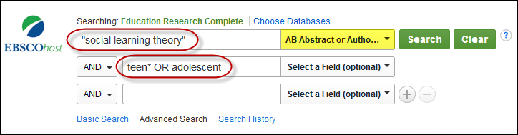

Dissertations:
The same ideas apply to searching the Dissertations and Theses Global database. Searching dissertations for information about a theory can yield rich results. Dissertation authors nearly always include discussion about the theoretical framework used for their research. Helpfully, they will usually name the theories they use in the dissertation abstract. Try adding different aspects of your topic to the search.
Example keyword search:
- 1st search line: "technology acceptance model" (in Abstract-AB)
- 2nd search line: handheld or wireless or mobile (in Anywhere except full text-ALL)
Database used: Dissertations and Theses Global
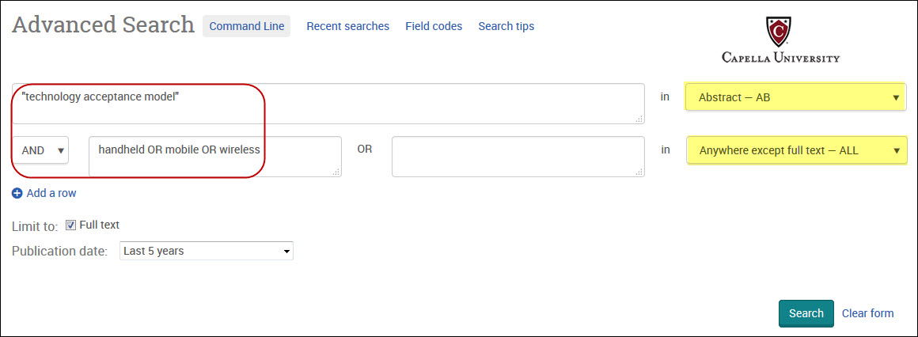

SEARCHING FOR POSSIBLE THEORIES
Here is one way to use our databases to help you see lists of possible theories. Select an EBSCOHost Database that covers your discipline (or choose Academic Search Premier):
- Business Source Complete
- CINAHL
- Computers & Allied Sciences Complete
- Education Research Complete
- International Security and Counter Terrorism Reference Center
- LGBT Life with Full-Text
- PsycINFO
- SocIndex with Full-text

Once you have selected and opened your database, look along the top blue bar, and click on Thesaurus (or, Subjects).
*EXAMPLE USING EDUCATION RESEARCH COMPLETE:


*EXAMPLE USING SOCINDEX WITH FULL TEXT:


*EXAMPLE USING COMPUTERS & APPLIED SCIENCES COMPLETE:


In the Thesaurus Browse box, type theory and click Term Contains button. Browse.
*EXAMPLE USING PsycINFO:
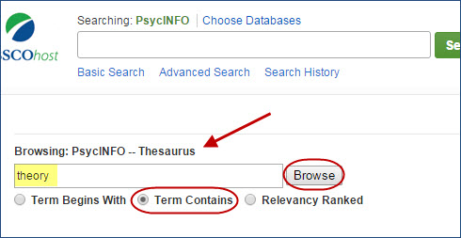

You will see many--in some databases, very many--theories listed as subject terms. To find out more about a particular theory, click on the term...
*EXAMPLE RESULT OF SUBJECT TERMS IN SOCINDEX WITH FULL TEXT:
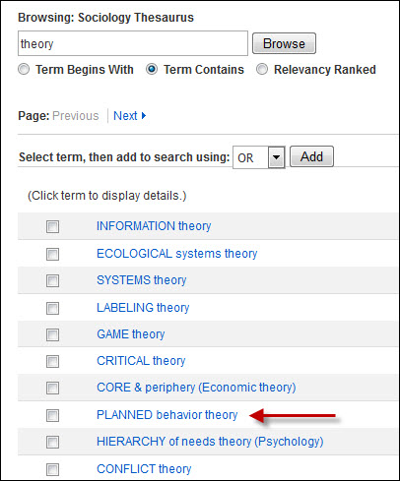

and read the short scope note describing the theory. If you want to pursue this theory, check the box next to the theory/subject term, and click ADD. The theory name will then be selected as a subject term, and you can search the database to find all the articles with that theory as a subject term.
*EXAMPLE SHOWING SEARCHING A SELECTED SUBJECT TERM IN SOCINDEX WITH FULL TEXT
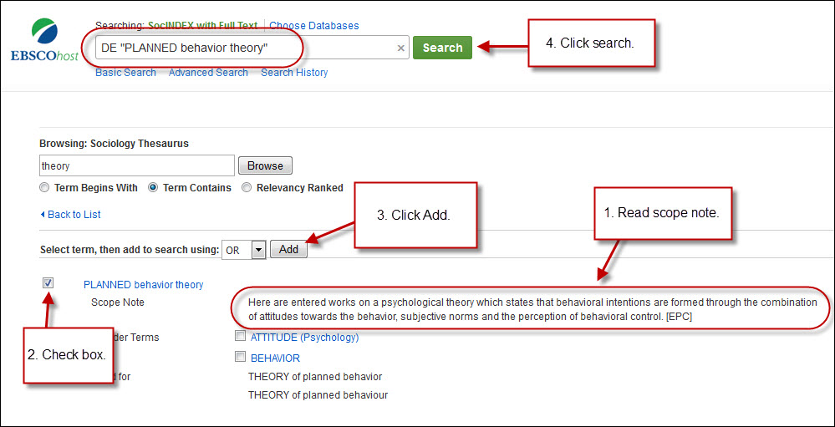

This can be an illuminating way to see what topics this particular theory may address, however, this method of finding a theory can be quite time-consuming. Again, a reminder to check with your mentor to make sure any theory you select in this manner is appropriate to your dissertation research question.

