Lab assignment
Deadline 3hrs

Lab 5: Human Osteology (Make-Up)

The goal of this lab is to familiarize yourself with the bones of the skeleton. You should work on memorizing all the names of the different bones. After the lab, you can continue to study bones using the images in www.eskeletons.org or www.innerbody.com.

I. The Skull

Station 1: Bones of the Skull

Instructions: Examine the skull at this station noting that the skull is made up of
many bones joined by sutures.

- Label the following bones on the skulls below:

frontal, mandible, maxilla, nasal, occipital, parietal, temporal, zygomatic

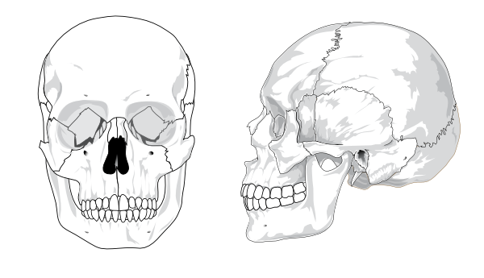

- Which bones make up the cranial vault (bones surrounding the brain)?

- Which bones house the teeth?

4. If someone punches you in the eye, which bones are potentially going to get broken?

5. On this picture of a human skull, label the two main chewing muscles:

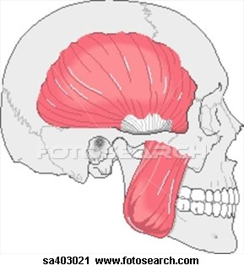

Station 2: Dentition
Using the charts provided at the station, answer the following questions.

- List the four types of permanent, adult teeth.

- Here is a picture of a human mouth. Label all four canines on the picture.

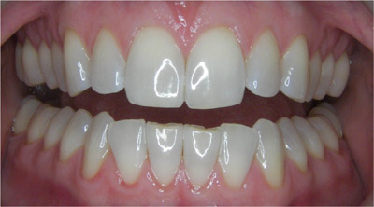

3. List the three types of deciduous (baby) teeth.

- This is a chart showing when each deciduous tooth erupts, and then when each permanent tooth erupts. When the tooth emerges from the bone, it is considered erupted - on this chart, that means it has broken through the line that represents either the mandible or maxilla. Using the chart, at approximately what age have all the deciduous (baby) teeth erupted?

________________ years

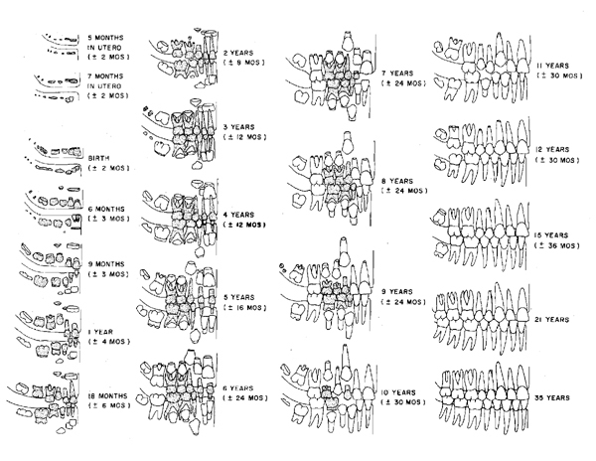5. The dental formula is the number of each type of teeth in the maxilla and/or the mandible, in one of the four quadrants. Give the dental formula of these three primates.

Human __________________ (you can look in your own mouth!)

Gorilla (only the set of teeth in the MIDDLE) __________________

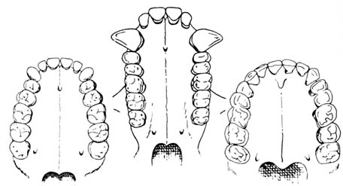

Spider Monkey __________________
(I know this one’s hard to see - just try your best)

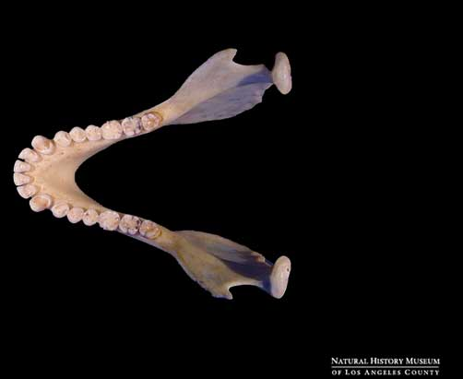

Station 3: Skull Landmarks
Certain features, or landmarks, on the skull vary between species and can be used to tell these species apart. It is important to be familiar with these features so that you will be able to tell the difference between skulls you will look at later in the semester.
1. Using the picture on p.9, write the bone that each of these features is located on.

-brow ridges ______________ -foramen magnum ____________

-sagittal area ______________ -zygomatic arch _____________

-mandibular symphysis _____________ -mastoid process _____________

-nuchal region ______________

- What important soft tissue structure passes through the foramen magnum?

II. The Postcranial Skeleton
Station 4: Bones of the Hindlimb

- On page 10 there is a diagram of a skeleton. Which numbers on the diagram correspond with these hindlimb bones?

femur _____
fibula _____
metatarsals _____
patella _____
phalanges (foot) _____
tarsals _____
tibia _____

- This is a femur, viewed from the back side (posterior). Think about how this femur fits into the hip. Determine whether this femur comes from the right or left side (circle one):
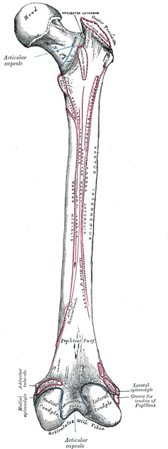

right left

Station 5: Bones of the Hindlimb
Each pelvis is composed of two innominate bones and the sacrum (part of the vertebral column). Each innominate bone is composed of three bones that fuse together in adulthood. There are two important landmarks on the innominate bones as well. Use the illustration at this station to fill in the names of the parts of the innominate and the landmarks next to the corresponding letter.

- What are the three different bones of the innominate?

- What is the large circular dip in the innominate called?

- What bone fits into this “dip”? Hint: it’s a leg bone.

- Using the following diagram, label the three bones of the innominate:

Bone 2: __________

Bone 3: __________

Bone 4: __________

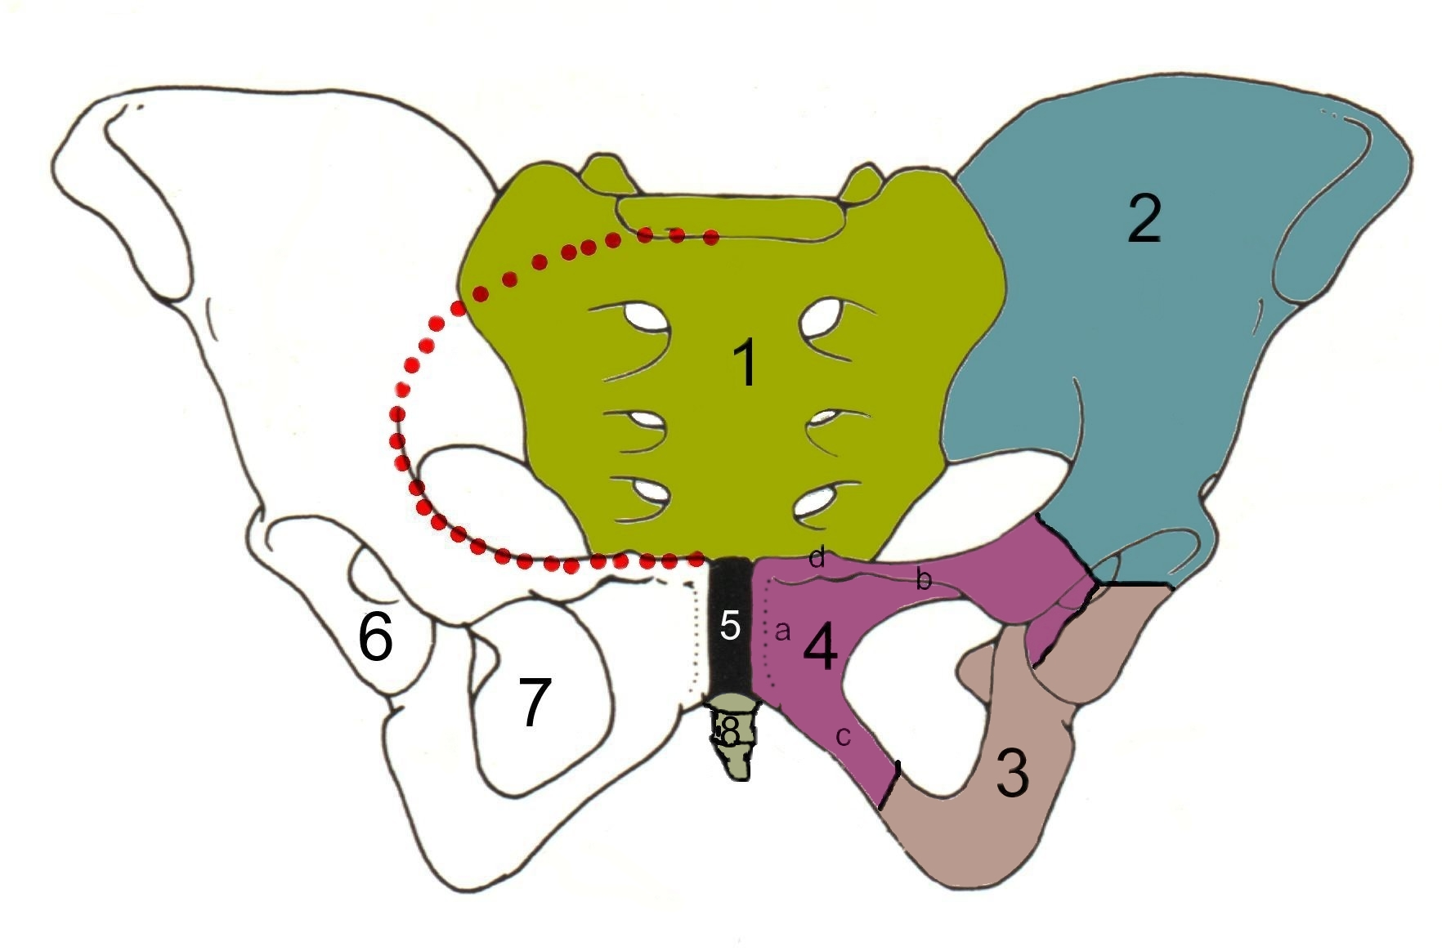

Bone 1 is the sacrum. It is actually part of the vertebral column. Bone 8 is the coccyx. It attaches to the sacrum.

Station 6. Bones of the Forelimb

- On page 10, look again at your diagram of a skeleton. Which numbers on the diagram correspond with these forelimb bones?

carpals _____
clavicle _____
humerus _____
radius _____
metacarpals and phalanges _____
scapula _____
ulna _____

Station 7: Bony Landmarks
Besides knowing the names of bones, it is also important to know the names of different features on the bones. Many of these landmarks are bumps or ridges on the bones where muscles attach. The following are some important landmarks on the bones of the postcranial skeleton that you will need to know.

1. Using the diagrams below, label with each letter the part of the bone where each landmark is located. You may need to look at diagrams in books or do research on the internet to find these!

-head of humerus A -spine of scapula D

-olecranon process (ulna) B -head of femur E

-greater trochanter (femur) C

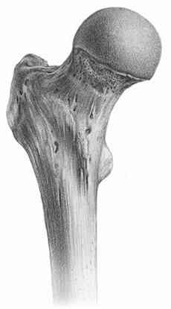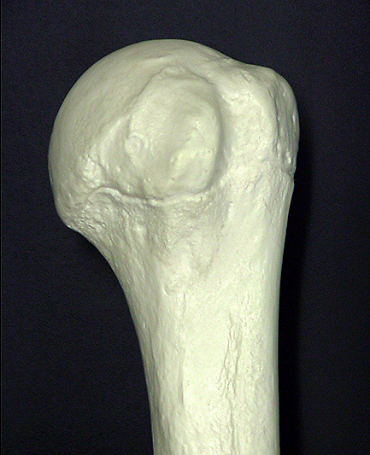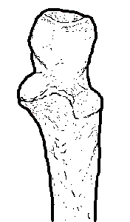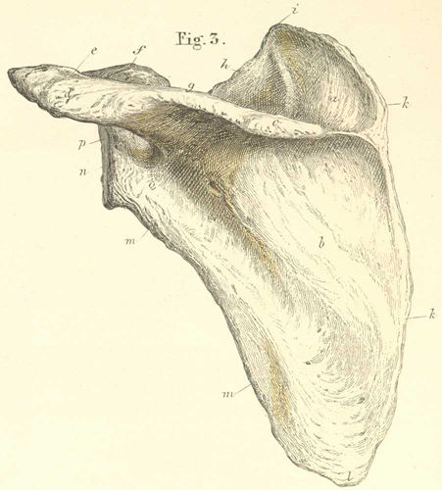

proximal femur proximal humerus proximal ulna posterior scapula

- The greater trochanter is a feature where muscles of the hip attach. Muscles leave attachment marks on the surface of bones. What might you be able to infer about the lifestyle of a person who has a very large, roughed up greater trochanter?

Station 8: Bones of the Axial Skeleton
At this station you are looking at the bones of the axial skeleton. The vertebral column consists of different types of vertebrae stacked together. Look at the vertebral column on the skeleton and try to identify the different types of vertebrae. A letter is placed on one of each type of vertebrae: cervical, thoracic, lumbar, and the sacrum.

- On page 10, look again at your diagram of a skeleton. Which numbers on the diagram correspond with these types of vertebrae bones?

cervical _____
lumbar _____

Thoracic vertebrae aren’t numbered on your diagram. Are they above (superior) or below (inferior) the cervical vertebrae?

Is the sacrum above (superior) or below (inferior) the lumbar vertebrae?

3. What type of vertebrae are found only in non-human primates?

___________________

- How many ribs are normally present on each side of the human skeleton?

How many of these ribs are attached to the sternum?

