**Introduction to Homeland Security and Defense**

**Week 3 Strategy Alignment Graphic Assignment**

**Assignment Instructions**

Drawings upon this week’s readings, and remembering the hierarchical structure of strategies, construct a graphic which depicts the alignment of the goals, objective and enabling activities for the following strategic plans.

* National Security Strategy
* Department of Homeland Security Strategic Plan
* Border Patrol Strategic Plan

Appendix

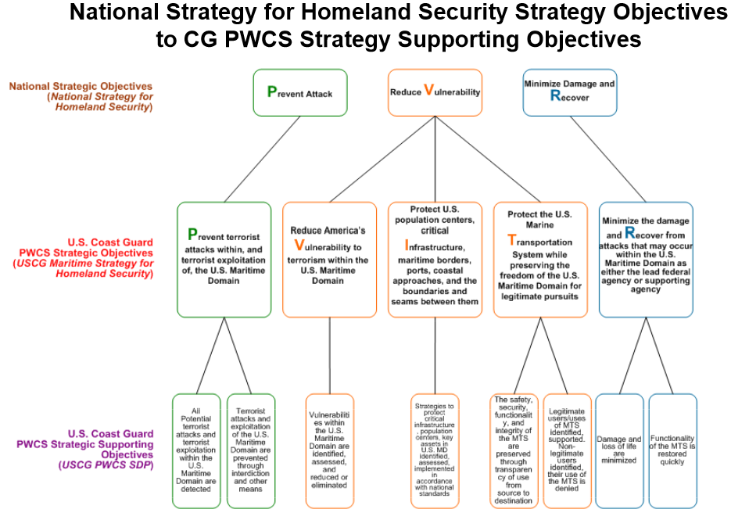

**Week 5 Sector Specific Summaries**

***Background***

The critical infrastructure of the United States has been segmented into 18 different sectors. However, like many things, one will find that no one sector really can be viewed independently in planning for reducing vulnerabilities of that sector or the employment of that sector to mitigate an event. This concept of dependency and interdependencies is clearly stated by the Department of Homeland Security who observed:

Many assets within the ESS [Emergency Services Sector] depend on multiple elements and systems from other CIKR [critical infrastructure/key resources] sectors to maintain functionality. In some cases, a failure in one sector will have a significant impact on the ability of another sector to perform necessary func­tions. Reliance on another sector is called a dependency. A dependency is a linkage or connection between two infrastructure, through which the state of one infrastructure influences or is correlated to the state of the other. For example, under normal operating conditions, an ESS facility requires electricity, natural gas, and water to function. It requires IT and telecommunications to carry out necessary operations and functions, as well as transportation to move employees to and from the site to continue essential functions. If two assets are dependent on one another, then they are interdependent.

It is extremely important to identify dependencies and interdependencies, both at the sector and asset levels, to comprehend completely the consequences of a successful attack on an asset and to identify the manner in which attacks on other sector assets could impact a dependent or interdependent asset. Today’s infrastructure has become so interconnected and interdependent that every action sends ripples throughout multiple domains. Understanding dependencies and interdependencies ensures safe, secure, and resilient infrastructure. (U.S. Department of Homeland Security 2010, 20-21).

**Assignment**

This week you have examined the National Infrastructure Protection Plan and several sector specific plans. Your assignment is to select two sector specific plans (it can be two from the readings) and describe how those two sectors are dependent or interdependent on each other. Your response should be between 300 and 400 words and you need to create a reference list at the end of your answer.

**Reference**

U.S. Department of Homeland Security. 2010. *Emergency Services Sector-Specific Plan*. Washington, DC: Government Printing Office. <http://www.dhs.gov/xlibrary/assets/nipp-ssp-emergency-services.pdf>. (accessed August 10, 2012).