Researched Exploratory Study Writing Project #2

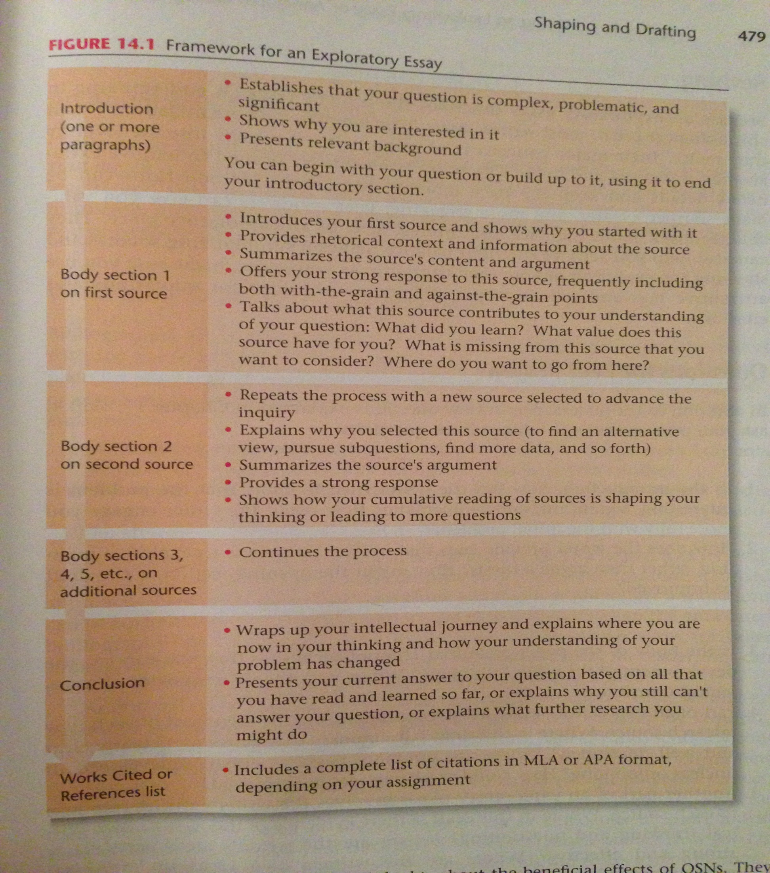

This essay, though it is meant to be written and read as a stand-alone piece, will also help you get started on your final assignment for this class, which will be a researched argumentative issue-solving proposal. For now, though, your exploratory study will aid you to spend time researching and thinking **dialectically,** or in consideration of multiple aspects in a **critical** manner, about a problem or question that you would like to tackle in that later assignment.

The exploratory study, then, should be a 6 page (not including title page or Works Cited page, and 3 pages + 1 sentence **does not** = 6 pages) **thesis-seeking narrative** of your thinking and research process as you explore and reflect upon your research question. The essay should mainly reflect the “retrospective” organization strategy defined on p. 478 of the *Allyn& Bacon* text, and it might end with a tentative solution to the problem or answer to the question that you will argue in your subsequent essay, or else conclude with plans for further investigation. Consider your **audience** for this paper to be members of the academic community here at FIU. In this paper, you are developing the authority to speak on the topic of your choice, with which your readers are not necessarily familiar.

In pursuit of this authority, you are required to do research. **You should provide at least 4 sources in your Works Cited page** – whether periodicals, books, newspaper articles, or magazine stories; however, **you may use only 1 (*credible*) website** (ask me if you have questions about credibility) **and 1 reference source (**encyclopedia, etc.–consult me if there are any questions**)**. You should enter the research and writing process with **a clear research question** and the goal of using **critical thinking** to create a view based on a combination of both your research and experiences–particularly to give background information on the conversation you are joining.

This assignment differs from the first one you’ve written in this class, as a polished thesis statement does not control the organization and development of ideas. Instead, a compelling **thesis-*seeking*** question guides the paper’s development, and the exploration of it serves as the essay’s **purpose**. By way of illustration, you should read the student sample in the book on pp. 485-90. In the manner it provides some rationale as to why the question is relevant and timely and narrates the critical thinking process as to how it explores and researches the issue, I think the piece offers a pretty good model as to my expectations for this assignment (though it is not a perfect sample–see third helpful tip pointed out later on).

On pp. 475-77 of *Allyn and Bacon*, you’ll find further explanation of the exploratory writing project and research log that you’ll need to use for successful completion of this unit. **Pages 474-80** provide more guidance for choosing a topic, shaping, and revising. (You might also want to use “Generating and Exploring Ideas” on **p. 515-17** in Ch.16 to settle on an issue in conjunction with the final project. **The questions under “Exploring Proposal Writing” on pp. 508-09 also provide further guidance/potential topic choices.)**

**Helpful tips (and elements I’ll consider as I read your essay):**

• Even exploratory essays are persuasive. You want your readers to see you as a deliberate, purposeful, and critical thinker and researcher. You want them to see you as fair and open to considering **multiple views**. As you revise your essay, think about establishing your credibility and authority in this way.

• Take time to select a question or problem that really does interest you and that has significance for your chosen audience. You’ll be spending a lot of time on this, so you’ll benefit by thinking carefully about topic choice. *If you have trouble coming up with a topic, please contact me as soon as possible, as the next few units will move quickly.*

• Unlike the textbook suggests, I am **not** looking for you to tell me much about the actual physical act of how and where you did your research, unless absolutely necessary. Instead, incorporate the **contents of the data** gathered from sources into your own critical thinking. **Remember**: this paper is **not** a story about how you did research; it **is** a narrative of your exploratory **thinking process**.

• The essay should be organized chronologically and indicate the gradual development of your thinking. It should have clear transitions and show logical development.

• As you detail your research process, you’ll include brief summaries of and responses to the articles and books you’ve read. Your summaries should be clear and well-developed enough to be representative of your original source, and your responses to the arguments should also be fully developed, indicating your own critical thinking.

• The paper’s conclusion should provide closure for your reader.

• The paper should follow MLA guidelines for citing sources parenthetically and indicate your skills in source selection. (Your ability to find credible sources further enhances your scholarly **ethos**.)

• Your essay should reflect rules of standard edited English. Grammatical/mechanical mistakes will hinder you from communicating your ideas and will diminish your credibility.

• Show overall evidence of an effective writing process **(see above and unit schedule for due dates)**

**By the end of this unit, you should have**

--explored a problematic, significant and interesting problem from multiple perspectives, investigating alternative solutions and reflecting on the feasibility of each;

--conducted relevant research (taking detailed notes while rhetorically locating, evaluating and analyzing sources);

--chosen sources purposefully and reflectively, rather than randomly;

--understood and synthesized the ideas of others into your own work through careful integration of sources;

--employed dialectic thinking using thesis, antithesis, and synthesis;

--demonstrated engagement with sources and wrestling with ideas to explore the problem;

--combined open- and closed-form characteristics to suit a rhetorical purpose (page 478);

--documented the evolution of your thinking by recounting the research process and subsequent analysis;

--employed editing strategies appropriate to the audience and purpose.

**As per your syllabus, the paper should be double spaced, 12pt Times New Roman, and in MLA format**. Save your notes, drafts, peer comments, **library visit reflection (see unit schedule)**, etc. to submit in **portfolio format** (drafts, peer reviews, pre-writing work, library visit reflection, and **first page of each source**in one pocket; final draft, grading rubric and **self-evaluation done at home** in the other).