Maasai culture

Name:

Institution:

The Maasai is a seminomadic community that is located in the heart of East of Africa along the Kenya and Tanzania borders. History predicts that they emanated from the Nile plains regions in the Sahara where cattle were initially domesticated about 7000 years. They moved south and along the way they displaced tribes that settled there prior to their arrival. Well known as for keeping large herds of cattle whereby a man’s wealth was determined by the amount of cattle one had as well as the number of children one had sired. If a man had below 100 cattle he was regarded as poor, while the middle-class had between 100-500 cattle and last but not least those with 500 or more were considered as considerably wealthy. Their main source of livelihood was their cattle whereas their delicacies mainly constituted of meat, milk and blood.

The Maasai children also played ancient mankala games but only upon permission of the elders. The community is very patriarchal with men holding all leadership positions. The laws in were only verbally implemented with most of them being enforced by the senior chiefs. Fines were mostly implemented through one being told to produce a certain number of cattle, sheep or goats either to group of elders or the person they wronged. Leadership was mostly passed on from one age-set to the next.

The Maasai folk tales mainly revolved around prowess in war and accumulation of wealth by bravery of warriors. However there were various themes that were part of the folk tales such as ogres and monsters, love and beauty just to mention but a few. These folk tales were mainly used to educate children of a certain moral lesson or about their preceding ancestors. The folk tales were mainly narrated to children by their grandparents mostly during bed time. One of the folk tales my grandfather narrated to me that he said was his best was about the ‘The Warrior Who Had Eight Lover’ otherwise known as Olmurranionyorintoyieisiet in the local dialect. This folk song mainly emphasized on never giving up hope in anyone or anything that one was doing.

The tale tells of a warrior whose bravery and good features led to eight girls in the village competing for his hand in matrimony. A challenge was therefore put in place whereby all the eight women composed songs and poems. However, the youngest lady in the group composed an outstanding song that melted the warrior’s heart into butter with its strong words that were based upon her declaration of love to him as well posing a challenge which led to her being his wife. Due to their warriors prowess in war and unconceivable bravery he was planning to carry out a lone raid. He instructed his wife to put milk in the calabash on the morning of his departure whereby the color it turned would determine the turn of events in his raid and if it turned red it would indicate he had been slain. A couple of days after his departure the milk began turning red. The wife sobbed bitterly of her husband’s demise and resorted to the woods to look for his corpse.

While in the woods she sang a song and one day it was met by the warrior’s reply. He lay under a tree fatally wounded with his great shield, long sharp sword and spear lay beside him. He was slowly dying and his last words to his wife were “You have accomplished a feat no other woman would attempt. Your love and concern are registered forever in my heart. When I am finished, and it will not be long, take my weapons home and give them to our unborn son that he may succeed where I failed!”. She was determined not to lose him and she headed to the words hunt with his war gear his words and her courage giving her the courage of a Maasai warrior.

For months she took care of him nursing his wounds until he finally got healed and regained his strength. Back in the village nobody knew of her whereabouts and her family had given up hope and thought she had died in the woods hence prompting them to perform burial rights. The warrior’s father had remained resilient on not performing burial rights for his son hoping that he would soon show up some day. However he was put between a rock and a hard place when one of his young sons was to be circumcised and that could only be done if he first performs the warrior’s burial rights. He gave in and on the day of the burial as the ceremony was about to begin as people mourned and consoled the bereaved the heard faint voices of a man and a woman singing war songs, As time elapsed the voices became louder with the bells of the herds of cattle they had raided on the way rang in rhythm as well. They then realized that it was the warrior and his wife and that they had survived the ordeal that the community had preconceived.

The women in the Maasaicommunity were tasked in carrying out house chores such as cooking, fetching firewood, milk cows, clean gourds, decorate them with leather and beads(Finke, 2003) and build the house which was known as a manyatta or boma. The ladies underwent circumcision which was a rite of passage from childhood to adulthood for both males and females. However, the circumcision of women is against the law in the current millennium. The girls were married off at a tender age to older men. The bridal price was in form of cattle, goats and sheep. The women were allowed tom practice polyandry whereby upon marrying the member of an age-set it was equivalent to marrying the whole age-set. This was especially seen when a guest of the same age-set as the husband made a visit the husband was to leave their bed for them and the woman would solely decide whether to join the guest in bed or not. If any children were sired in the process they would belong to the husband.

The boys underwent circumcision which in the local dialect is known as Emuratare which was regarded as the most vital rite of passage that most boys highly anticipated. It was regarded integral since prior to the circumcision the boys had to prove themselves to the community by herding large herds of cattle for seven consecutive days(Maimai).The circumcision process normally took place slightly before sun rise.During this time the women i.e the mothers of the initiates built manyattas that would serve as shelter for the new initiates during their healing process which would take approximately 3-4 months but the boys were to remain in black clothing for about 4-8 months(Maimai). The houses are built in a cluster of about 20 or 40 houses. During the initiates stay at the camp, a flag of the maasai was hoisted to a pole in the middle of the camp(Maimai). During their stay they receive numerous lessons such as animal husbandry, sense of brotherhood in the age-set etc that equip them with appropriate skills that will enable them to perform their role as a military force.

There were also eating traditions whereby upon the slaughtering of an animal certain parts were given to certain groups. It was however regarded as a taboo that morans should not eat before women(Faustine K. BEE, 2002). A group of men especially the elderly and the morans practice a ceremony known as Orpul(Faustine K. BEE, 2002) would also head to the bush whereby a ceremony is carried and cows and goat are slaughtered while there. They may stay for a while depending upon the number of animals they are to slaughter. Members of the community are not allowed to go to the region where the men have occupied during this ceremony.

The sick, elderly and wounded morans would be fed with foods rich in proteins such as meat, milk, soup as well as fats. This would be done through the slaughtering of a goat and would depend upon every individual’s size of cattle. Women who had just delivered would be served with the same cuisine as well blood to help them recover from the blood loss as well as replenish their energy. Traditional food preservation techniques were as well practiced such as the drying of meat or even being preserved in animal fat for future consumption. Children born with defects were as well covered in white sheets covered with blood and left out to the vultures to feed on since they viewed as a sign of bad omen to the community.

The Maasai used herbs for treatments which proved to be rather effective. They mostly use the barks, seeds, leaves and roots for medicinal purposes e.gcommiphora tree (Commiphorazimmermannii). It is used as medicine for children, the roots for treatment of snake bit, and the leaves infused in water and the liquid drunk in case of fever. The leaf stalks heated in the fire are chewed to relieve tooth ache. The bark cooked with meat is said to prevent indigestion. The bark is also chewed and the juices swallowed to relieve constipation, abdominal pain and stomach ache (MAASAI FOOD & DIET). During traditional occasion the preferred drink mostly consumed by men was the traditionally fermented beer which brewed using honey (often today fortified with commercial sugar as well), the seeds of specific trees and herbs

The maasai lived in clusters of huts that were known as kraals. They were made out of cow dung with sticks serving as the supporting foundation. These kraals included shelters for the cattle within them which are usually centrally located to keep them from harm’s way such as wild animals(Maasai History,Culture & Tradition, 2005). The houses in the kraal were built in accordance to circular pattern depending upon its shape. Every woman owned their home with the first wife’s house on the right as one enters the boma whereas the second wife’shouse is located on the left(Faustine K. BEE, 2002) and if additional wives came along they also followed suit in the same pattern.

The removal of the lower teeth of the Maasai seemed as enigma to me but upon enquiry it was all crystal clear. They remove the deciduous canine belief due to their strong belief that diarrhea, vomiting and other diseases in the early childhood were related to gingival swelling over the canine region which is believed to contain ‘worms’. This tradition is still practiced up-to-date.

The adage beauty lies in the eyes of the beholder. They viewed beauty in terms of ornamentation of their body. The women mostly performed this task whereby they wove and bead jewelry(Maasai History,Culture & Tradition, 2005). Both men and women wear bracelets (Maasai History,Culture & Tradition, 2005). The women would also pierce and stretch their ear lobes through application of various modes such as through use of elephant tasks, stones, empty film canisters etc. Ochre, is a reddish mineral which is usually ground and mixed with animal fat and was used to create beautiful artistic designs on the face. This gave individuals a sense of belonging to the community and was used to express joy and togetherness in the community. This mode of generating beauty has for decades been passed from one generation to the next and was mostly applied during ceremonies.

The maasai community are putting much effort in ensuring that their traditions do not fade away however their efforts have been met with major obstacles some beyond their control. Human-animal conflict is currently the leading cause of death of wild animals in the East African as well as poaching. The Kenyan and Tanzanian governments are highly encouraging the maasai people to seek shelter in other regions i.e the cities away from their original areas of settlement. This is so because of the rampant killing of lions especially during the initiation period of the maasai that has largely caused the decline in number of lions which are a huge tourist attraction. Land politics and industrialization have also played a big role in the displacement of the maasaipeople hence prompting them to abandon their traditional way of living and move into the cities to seek employment as well as shelter. Land politics and industrialization are forcing many Maasai into the cities, to work as security guards, construction workers and hawkers, abandoning their traditional livelihoods as modernity come to East Africa (Robinson, 2013).

The current government laws are also posing as a great hindrance to the continuity of the maasai traditions. A current law has empowered women by giving them the right to equality something that are highly against the patriarchal maasai traditions. He explains how a Kenyan law giving equal rights to women, while imperative in many Western cultures, has had an adverse impact on Maasai society (Robinson, 2013). The education system as well has replaced the traditional tales that were used to educate the children hence most modern maasai children know very little of nothing at all about their traditions nor about their predecessors. The school system is equally relatively expensive for the maasai people with the majority of them being majorly in the lower class level.

. Like many other eroding Maasai cultural customs, the emanyatta is not left unscathed (Maimai).The maasai househas been left out and replaced with the current households. This is so as most individuals opt for modernity viewing the making of a house out of cow dung and sticks as sheer backwardness. The traditional mode of circumcision is also being abandoned as people opt to go to hospitals for the minor surgery. Hospitals are preferred so as to decrease the chances of the spread of HIV/AIDS epidemic as well as other infections that traditional modes circumcision predisposes one to.

In conclusion, the Maasaitradition has lived on for centuries but is slowly getting eroded by mostly the influence from the west region. The current changes in the current world especiallyin terms of climate; they have been forced to look for other means of livelihood such as farming owing to the decrease of their cattle due to drought. They are as well sorting out for formal education so as to be globally marketable especially with the statutory laws that deem primary and secondary education as compulsory. The female circumcision was a negative practice in the traditions since it led to many girls losing their lives to the dreaded blade. Discrimination against women was highly. This strongly opposed since everyone is equal irrespective of their gender. All in all the tradition promoted togetherness within the community and provided a platform whereby one would have a sense of belonging. The numerous tales as well instilled discipline in children from a tender age.

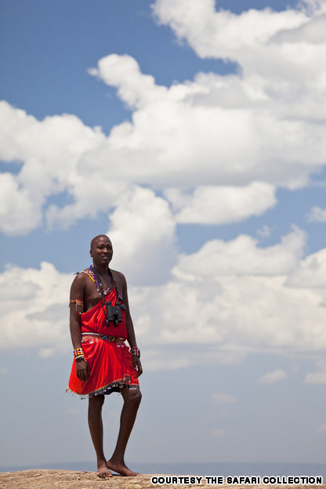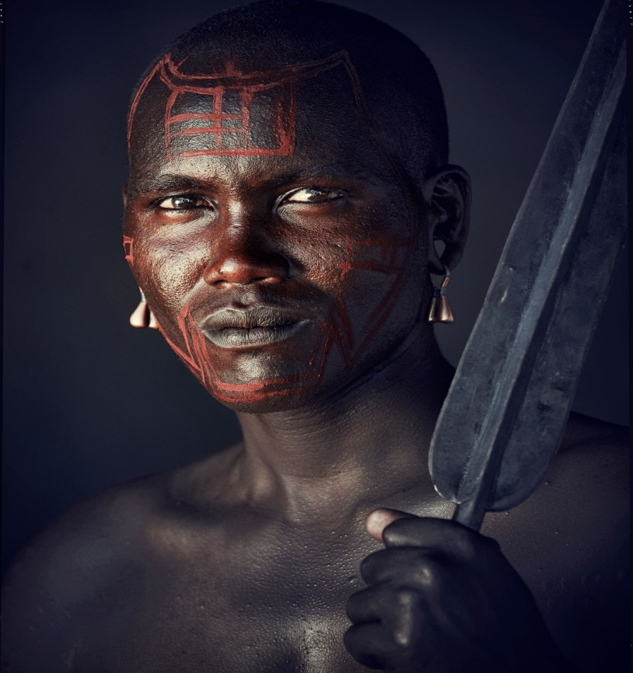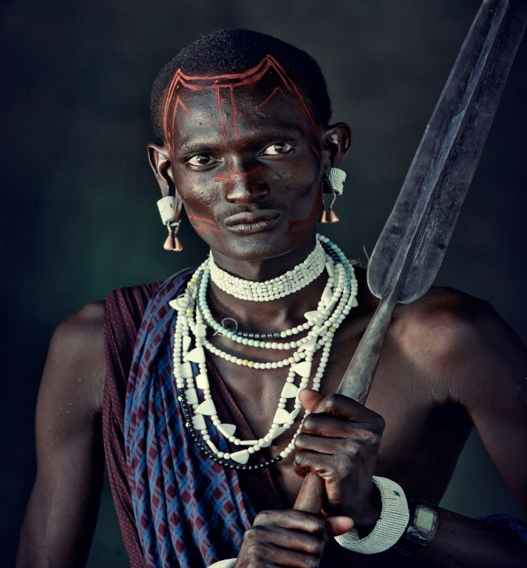

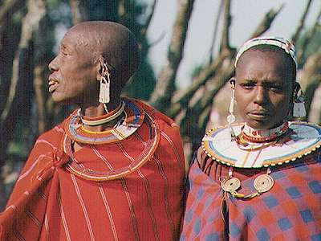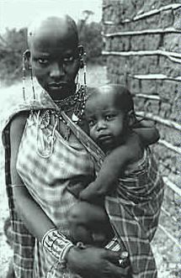

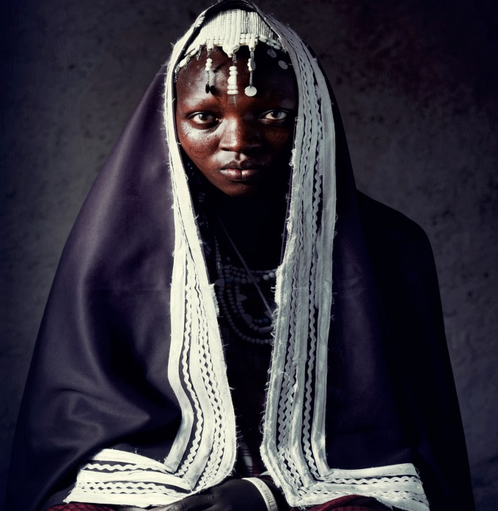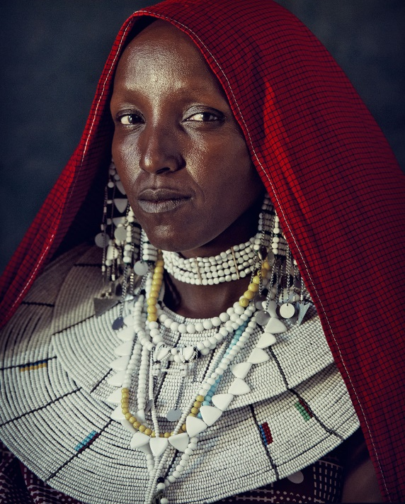

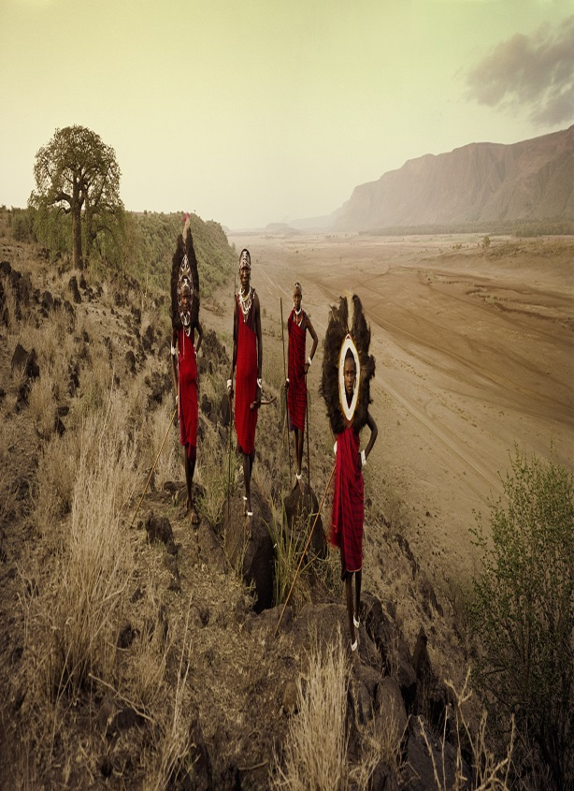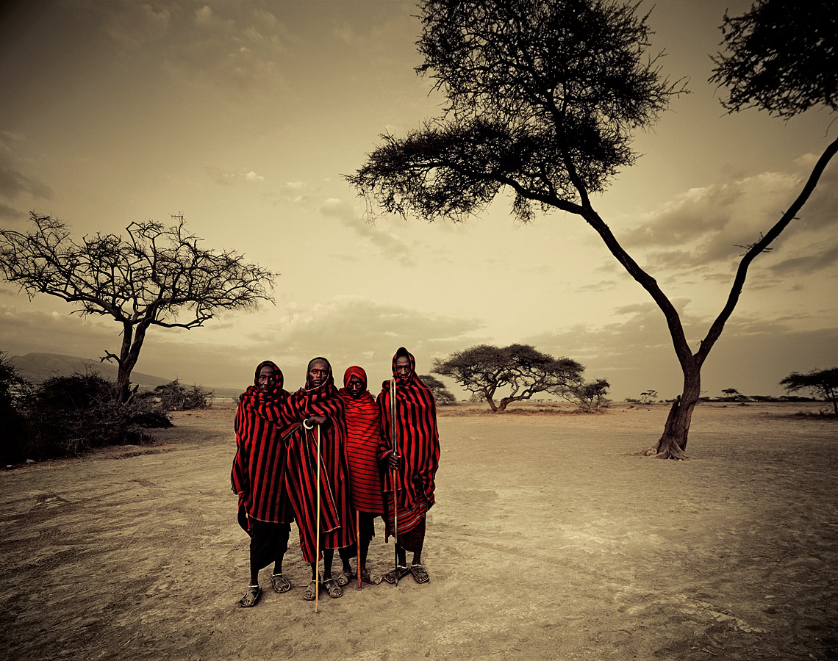

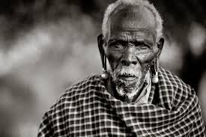

REFERENCES

MaasaiHistory,Culture& Tradition. (2005). Retrieved 2013, from Kivulini Safaris: <http://www.kivulinisafaris.com/kenya/maasai-history-culture-a-tradition>

Faustine K. BEE, M. L. (2002). CHALLENGES TO TRADITIONAL LIVELIHOODS AND NEWLY.

(2003). Maasai - Clans and Families.In J. Finke, Traditionsl Music and Cultures of Kenya.MAASAI FOOD & DIET.(n.d.). Retrieved from [www.masaikenya.org/MAASAI_FOOD___DIET.pdf](http://www.masaikenya.org/MAASAI_FOOD___DIET.pdf)

Maimai, O. (n.d.). Maasai Ceremonies and Rituals. Retrieved from Maasai Association: <http://www.maasai-association.org/ceremonies.html>

Robinson, O. (2013, July 9). CNN travel. Retrieved from Will the Maasai Survive Modernity?: http://travel.cnn.com/my-first-maasai-094676