**Introduction**

The use of digital media within organizations has transformed how organizations communicate with prospective and current customers. Digital media such as: web videos, e-books, and social media have each shaped the communication strategies organizations employ to engage customers. More and more organizations are using digital media tools in unique and creative ways.  It’s a rare that any organization isn’t using some form of digital media these days.

According to a survey, those companies which were deeply engaged in social media grew revenues by 36% over last year and those companies which were least engaged in social media has dropped by 12% on an average.

**Synopsis/ Executive Summary**

This case study demonstrates different examples of organization that use digital media to communicate and to get more customer interactions and 'buzz' around their product.

It focuses on the use of social media as digital media of an organization. It demonstrates the organization goal for using social media, different strategies to employ social media. Organization benefit of using social media, strategic goals or purposes social media could be used; different ways social media could help support or implement the organization’s business strategy, sufficient resources to appropriately implement and maintain social media.

For organizations planning to use social media for human resource, marketing or other purposes, the process must begin with defining goals and identifying metrics. Align the new social media policy with any existing corporate privacy policies. Set timelines and deliverables. Estimate the amount of time needed to implement the plan and identify specific deliverables expected. Monitor progress. Evaluate the effectiveness of social media activities on an ongoing basis and regularly measure progress against the metrics defined. Make course corrections as needed.

Organization use social media for:

* Targeted recruiting, and sourcing passive and active applicants, when consistent with the organization’s brand and strategy.
* Knowledge sharing, and training and development when the medium is consistent with the types of information to be shared or learned.
* Reinforcing identification with the organization and promoting the brand.

Organization can build the business case for social media. If it is sufficiently compelling, then organization can develop strategy and implement it. Then regularly monitor its effectiveness against specific goals and metrics. Using effectively, social media promises the opportunity to communicate with and engage an organization’s employees and customers in exciting new ways.

Let’s take an example of “CISCO Social Media Journey” for communicating and interactions with customers.

**Organization Goal**

CISCO is a well known organization. The journey towards social media was a step towards increasing the customer, generating revenue and spreading the knowledge about their products. After implementing social media, company leads in most popularity in terms of products promotions, products knowledge, customer relationship and communication within the organization.

Major goal of the organization was:

* Solving business problems
* Uncovering opportunities
* Reducing cost on technical objects
* Extending reach over the globe
* Engaging customers.

**Social Media**

Social media is revolutionizing the way people connect and share information. LinkedIn, Facebook, YouTube, Twitter and other social media are changing the way we interact, and many organizations are struggling to respond. Even companies attempting to use social media altogether are recognizing that many of their employees and customers are using it, which can directly affect the organization.

According to CISCO organization Social Media is:

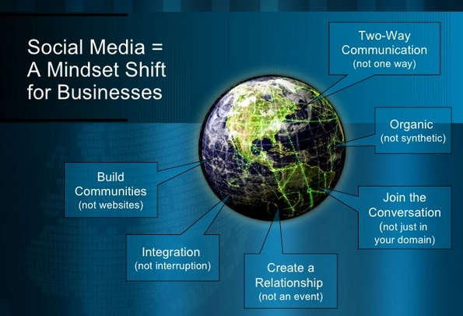

Figure : 1 Courtesy by *Cisco Social Media and case study*

**CISCO SOCIAL MEDIA STRATEGY**

Cisco social media strategy involves many factors in it. It faces some challenges like inconsistent social media practices, inconsistent opportunities for learning, lack of consistent governance/ stewardship around practices, metric and accountability. The journey continues through commitment to and investment in social media such as turning challenges into opportunities. For this purpose it creates a social media organization model which consists of 3 hubs that work with functional groups and a social media advisory council helps with alignment and promotes collaboration. It is shown by the following diagram.

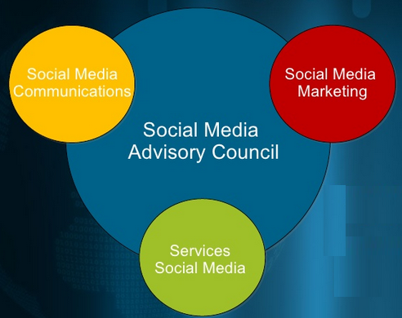

Cisco Social Media Strategy focus on “The enablement of employees through resources, tools, and education, so they feel empowered to engage in social media, and through evangelism of lessons learned and best practices”. This will accomplish through the four pillars of organization.

1. **Social Media Education**
   * Introducing Social Media Certification program
   * Organizing monthly social media roundtables
   * Organizing workshops and international summits
2. **Social Media Enablement**
   * Introducing social media playbook
   * Planning and metrics template
   * Social media listening program
   * Policies and governance
   * Infrastructure and tools
3. **Social Media Consulting**
   * Consulting on strategies and tactics
   * Consulting on tools and application
   * Case studies and best practices
   * Business case development
   * Heath assessment
4. **Social Media Management**
   * Brand Campaign and Planning execution
   * Corporate blog program
   * Online community program
   * YouTube community management

First of all plan for change internally and for that communication is the first step to change management. Then encourage participation externally because it creates conversation with customers, partners, employees, and public. This also provide platform to discuss the role of a network and a thoughtful leadership. Encourage participation externally will accomplish by extensive use of videos that will increases engagement of people and integration with communication campaigns. The following figure:2 demonstrates use of the Cisco social media technologies that involves Facebook, Twitter, Google, YouTube, Blogs, Community and Cisco Buzz.

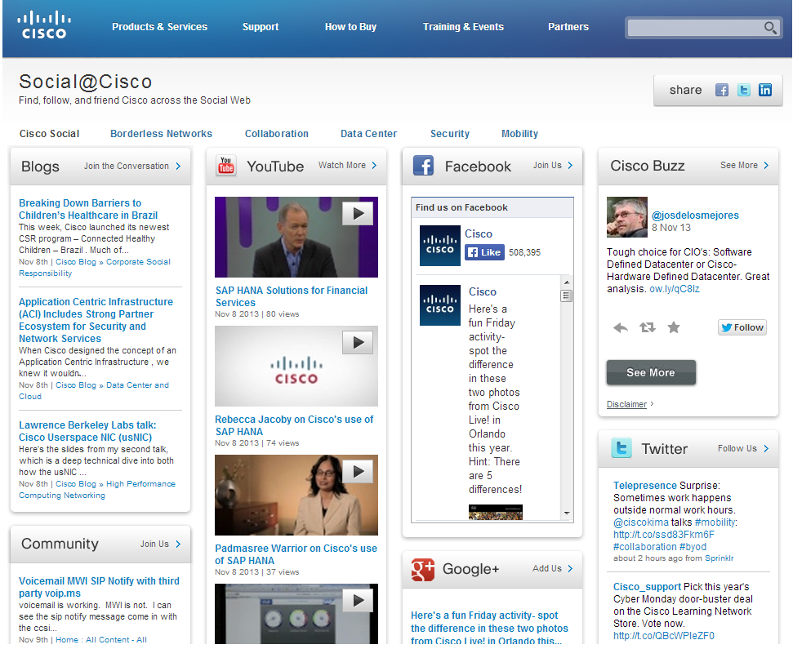

Figure : 2 Cisco Social media web page [*http://socialmedia.cisco.com/*](http://socialmedia.cisco.com/)

Third factor of CISCO Social media strategy involves drive engagement through an integrated strategy in which participation is the currency of the new economy. This involves three meaningful conversations:

* Listen
  + Listen to customer, interact with them and change perception
  + Monitor conversations
  + Identify influences
  + Engage in discussions
  + Invite to comment
* Measure
  + Measure Conversation Impact
  + Track Sentiment
  + Analyze trends
* Engage
  + Share ideas, knowledge and valuable objects
  + Converse
  + Integrate
  + Excite, embrace
  + Nurture
  + Branded channels

**Measurable Success**

Critical Factors to consider are; social media goal alignment to business objectives, expectation setting, platform, tools identified, purpose defined, planning and engagement practices.

These strategies results in success of using social media, some of the success shown in the following figures 3, 4, and 5.

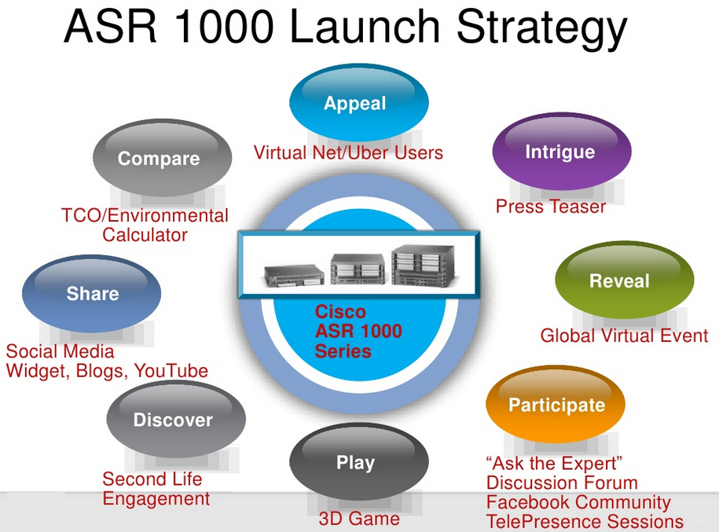

Figure: 3 *Demonstrating Launch Strategy of Product*

This launch using social media was the great success as launch reaches more, and costs less. It could be analyzed by previous launches of the product.

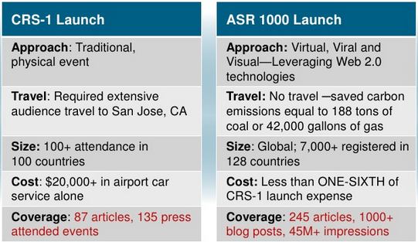

Figure: 4 *Traditional Launch v/s Social Media Launch*

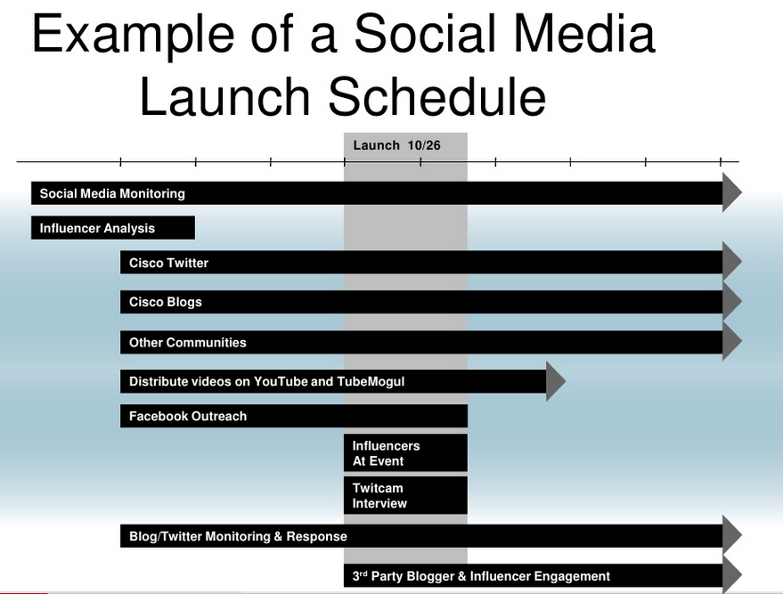

Figure : 5 *Social Media Launch of CISCO ‘ASR 1000’ product*

**Crowd Sourcing**

Crowd sourcing is also a social media technology in which people from different communities and different technologies come together and share their ideas to innovate, promote and motivate objects. One of the examples of crowd sourcing shown in figure:6 that how people from different domain interact with each other.

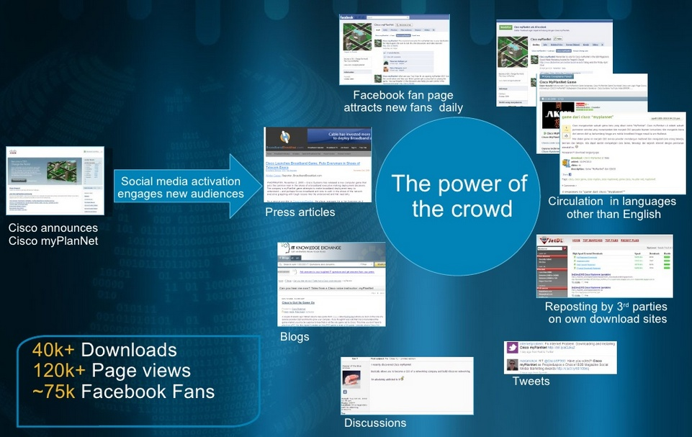

Figure : 6 *Cisco facility of crowd sourcing*

**Web-Video**

‘Cisco Channel Chat’ web video provides a monthly video broadcast on Ustream with Cisco executives and experts covering partner-focused topics. Cisco provide this facility to engage Cisco partners around the globe, interact using video, social media, and free tools, different session with thousands of live views and many replies.

**Cisco Networking Academy**

Cisco networking academy is one of the digital media tool in organization which provides facility to learn Cisco products. Different member ambassadors of Cisco organization, and Cisco ambassadors spreading the knowledge together and motivating people to use Cisco products.

Another example of Cisco product ‘Linksys’, have a success story. Many technical fans on facebook help and challenge each other on the promotion of the product. Since social media provide peer-to-peer enablement by relaxing control thus it encourages participation of many people. Since fans on Facebook challenge each other provide significant spikes in new fans, interactions and sales. As Community responses the query of customers thus it increased the satisfaction among customers therefore customers remained loyal to the organization and becomes the factor to spread the good aspect of the organization which leads to the increment of customer. This is a very good example that how the Cisco organization has utilized the Facebook as social hub for increasing its customer, promoting products, spreading knowledge and developing good relationship.

**Conclusion**

Digital media is a global phenomenon that continues to grow. Managers must recognize that digital media touches all parts of their organization. For example, the website, an employee feedback and job seeker forum site, allows members to provide “inside” information on company cultures, employees and salaries. Members rate their own organizations on various characteristics, and objects. Customers and clients also help shape a company’s brand and image via social media. Customers frequently go online to rate products and services. Positive word of mouth, a vital means of growing customers and profits, becomes infinitely more powerful in the digital world. Examples range from product reviews on retail websites, to postings on consumer websites such as blogs, tweets and Facebook posts.

Organizations themselves often leverage social media to help in recruiting, advertising and branding. These efforts can influence customers and potential job applicants, and can also affect the organization’s brand and reputation. Many organizations use Facebook to notify “friends” of discounts or special promotions. No other advertising platform can reach such a massive audience at little or no direct cost. Building such social media relationships can enhance customer loyalty and brand identification and may even is used as a source of passive job candidates.

Formal applications of social media can include the following:

* Recruitment and selection.
* Socialization and onboarding.
* Training and development.
* Knowledge sharing and transfer
* Branding and marketing.
* Creativity and problem solving.
* Influencing organizational culture.

We are living in a new economy – powered by technology, fueled by information, and driven by knowledge. The influence of technology will go beyond new equipment and faster communications, as work and skills will be redefined and reorganized.

**Bibliography**

1. <http://www.slideshare.net/petra1400/ciscos-social-media-organization-and-case-studies>
2. <http://www.slideshare.net/petra1400/the-evolution-and-state-of-social-media-through-cisco-case-studies>
3. <http://www.slideshare.net/petra1400/ciscos-social-media-evolution-and-case-studies-focus-presentation-5324800>
4. socialmedia.cisco.com