STAGE 2 PHYSICS

Investigations Folio: Issues Investigation

Part A: Guiding Question

How do cyclotrons and synchrotrons compare and which should the South Australian government consider investing in?

Part B: Information Search and Analysis

STAGE 2 PHYSICS Information Search and Analysis – Source 1

Student name: _______________________________
Topic: Comparison of cyclotrons and synchrotrons

Required content of the Information Search and Analysis
Source type: (e.g. internet, journal, newspaper article, book, video):
Internet
Information source (correctly referenced):
Uses of the Cyclotron, How the cyclotron works, Problems solved by the cyclotron, 2009. retrieved 3 April, 2009, from http://encyclopedia.stateuniversity.com/pages/5327/cyclotron.html

Key points:
- machine for accelerating charged particles
- developed by Ernest Lawrence and others in 1931
- now largely superseded in particle physics by the synchrotron
- acceleration is provided by an oscillating electric field
- a large constant magnetic field guides particles in a spiral path, having a radius that increases as particle velocity increases
- used to treat cancer (nuclear medicine.)
bias  refers to prejudiced or partial viewpoint that would affect someone's interpretation of the issue – how do you decide this? | - independent webpage with unbiased depiction of cyclotron with both advantages and disadvantages  - little mention of synchrotrons hence biased in favour of cyclotrons  - overall a low degree of bias
credibility  the trustworthiness (credentials, education, experience, etc.) of the source- what do you base this decision on? | - given it is an independent site drawing material from a variety of different US universities and academic facilities, reasonable to assume information is credible and accurate
accuracy  refers to the truthfulness and correctness of the information – what evidence is there for this? | - See above
suitability  Is the source suitable for you to use? Why or why not? | - Unbiased, detailed and relevant information regarding how cyclotron works and uses  - thorough explanation of relevant physics and mathematics, uses and limitations  Therefore suitable to use.
Investigation
Evidence of critical and logical selection and appropriate acknowledgement of information about physics and issues in physics from a range of sources.

STAGE 2 PHYSICS Information Search and Analysis – Source 2

Student name: _______________________________
Topic:
Investigaion
Critical evaluation to formulate a conclusion about the quality of each source of information with evidence of an understanding of the influences on bias and credibility.

Required content of the Information Search and Analysis
Source type: (e.g. internet, journal, newspaper article, book, video):
Book
Information source (correctly referenced):
Newton, D 1989, ‘Particle Accelerators: From the cyclotron to the super colliding super collider,’ Juvenile Literature, USA.
Key points:
- cyclotrons are compact & widely produced
- complications such as mass increase of faster moving particles and the cost of large magnets can yield low energies in cyclotrons
- synchrotrons achieve higher energies with cheaper magnets
- hollow dees in an evacuated chamber accelerate charged particles across the gap between the dees
- alternating the charge between the dees will continue to accelerate the particle until it eventually exits through an exit window
- in synchrotrons, particles travel in an evacuated ring. The particles enter a synchrotron having already been accelerated to a high speed in a smaller accelerator
- synchrotrons maintain a path of equal radius while accelerating the particle by increasing the magnetic field strength with time
bias  refers to prejudiced or partial viewpoint that would affect someone's interpretation of the issue – how do you decide this? | - Both advantages and disadvantages of both considered, hence not very biased  - Author gives more time to explanation of modern synchrotron and future benefits for research – thus slightly biased in favour of synchrotron.  - Independent author gives reasonably even view of both technologies
credibility  the trustworthiness (credentials, education, experience, etc.) of the source- what do you base this decision on? | - Independent author of widely read and reviewed book provides credible information  - Original sources likely to have come from very reliable academic sources  - Author is experienced in the field  - Hence can be considered credible.
accuracy  refers to the truthfulness and correctness of the information – what evidence is there for this? | - Information is consistent with other sources so probably accurate
suitability  Is the source suitable for you to use? Why or why not? | - Highly relevant – considers both cyclotrons and synchrotrons, explains physics behind both types  - Illustrates advantages and disadvantages and problems with both so suitable to use

STAGE 2 PHYSICS Information Search and Analysis – Source 3

Student name: _______________________________
Topic:

Required content of the Information Search and Analysis
Source type: (e.g. internet, journal, newspaper article, book, video):
Fact sheet / pamphlet
Information source (correctly referenced):
Australian Synchrotron, the brightest new tool for industry innovation, 2005, Department of Innovation, Industry and Regional Development, Victoria, retrieved 10 April, 2009, from http://www.synchrotron.vic.gov.au

Key points:
- synchrotron is a machine that accelerates charged particles such as electrons to extremely high energies
- use of a synchrotron includes agriculture, manufacturing and research
- particles accelerated in a synchrotron emit electromagnetic radiation
- radiation can be used as a powerful research tool
relevance  the degree to which a source addresses the topic (eg relevant physics, correct physics) | - highly detailed description of physics behind the Australian Synchrotron, functions and uses, thus highly relevant  - lacks any information on cyclotrons so not relevant to learning about them
bias  refers to a prejudiced or partial viewpoint that would affect someone's interpretation of the topic or related issues | - pamphlet produced by Victorian Government, which is funding the project, thus source likely to be biased in favour of the synchrotron project  - Hence only considers uses and benefits to industrial developments  - No consideration of cyclotrons and relative merits of other technologies  - Source is very biased in favour of Australian synchrotron
credibility  the trustworthiness (credentials, education, experience, etc.) of the source | - As the Victorian government and scientists behind the project produced the pamphlet, information is very credible  - Those providing information are very experienced and involved with functioning of synchrotrons  - Information is taken from results of projects performed at the facility by experienced scientists  - Hence source is highly credible, if very biased

Part C: Written Summary
(Part C (Written Summary) was completed under direct supervision in order to assure the integrity of the student work. Students were allowed to bring a hardcopy of their references plus their Information Search and Analysis.)
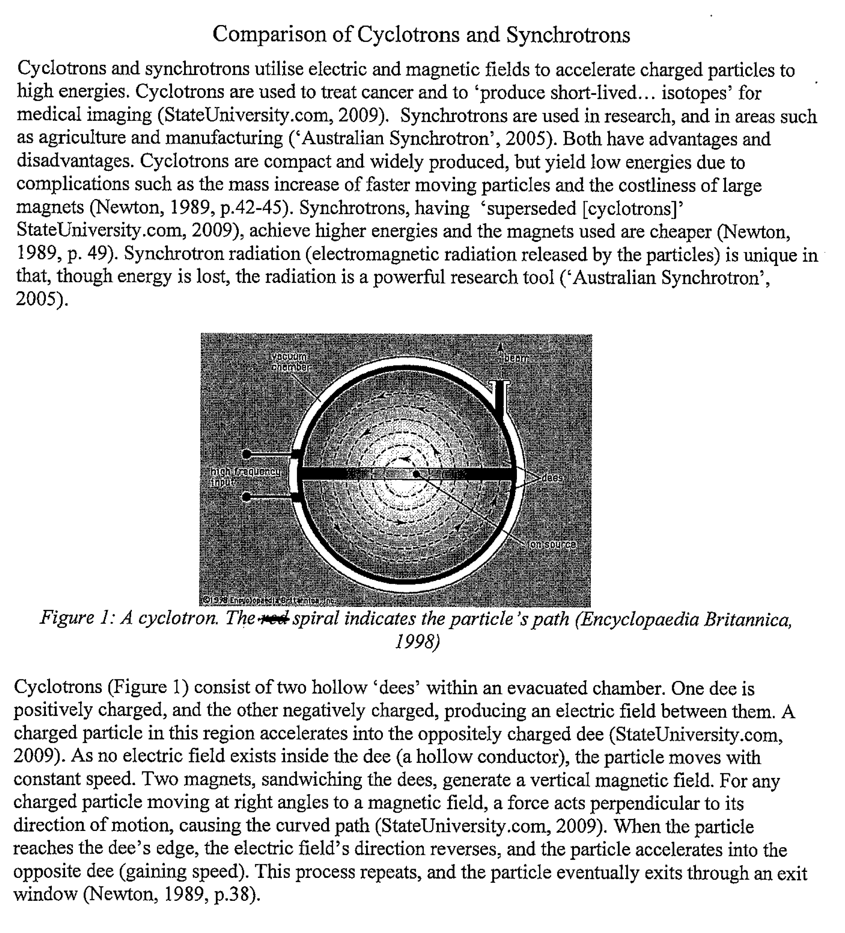
Application
Evidence of the application of physics concepts and evidence from investigations to suggest solutions to a complex problem.
Knowledge and Understanding
Evidence of deep and broad knowledge of the physics concepts relevant to the operation of both contemporary applications. Demonstrated by the ability to explain the operation of each concept clearly and concisely. Written text is used effectively and efficiently both to describe and explain the topic.
Application
Applies physics concepts and evidence from investigations to suggest solutions to complex problems.

Analysis and Evaluation
Critically and systematically analyses data formulate logical and perceptive conclusions and make relvant predictions.
Part D: ICT Presentation
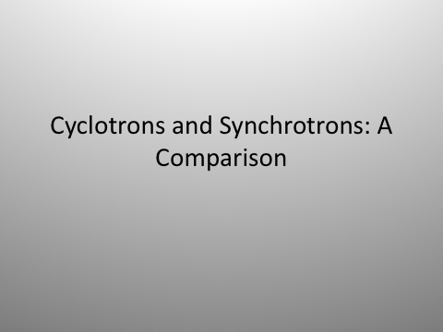

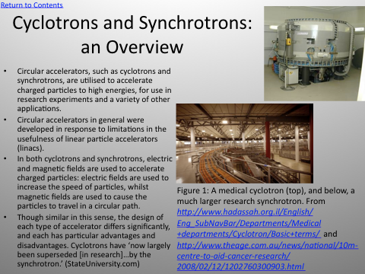

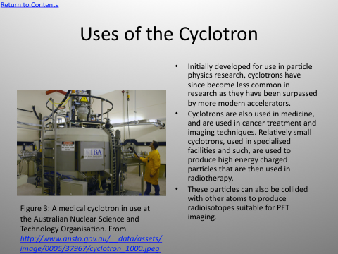
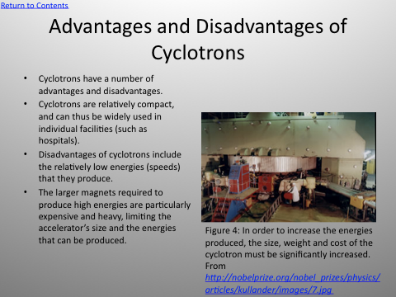

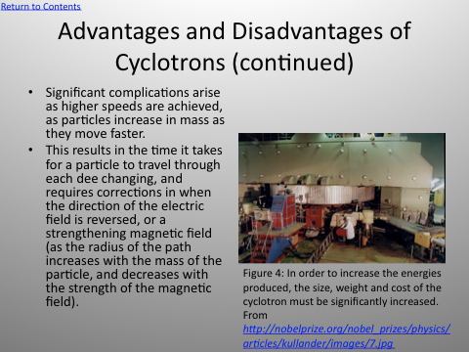

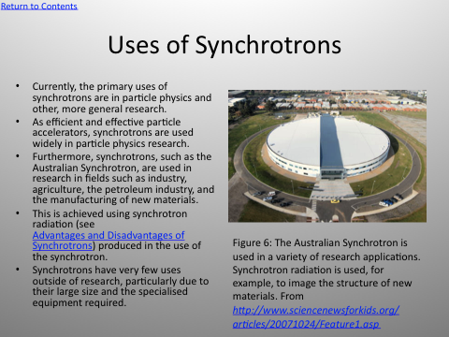

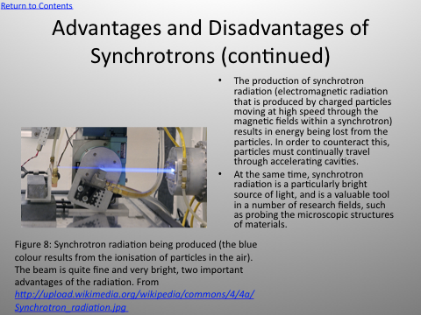

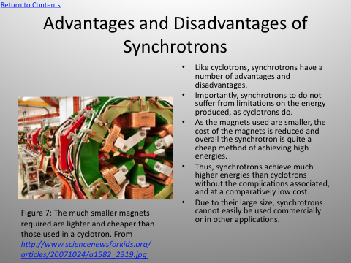
Knowledge and Understanding
Although the text is dense, it does provide evidence of a coherent and effective ICT presentation that makes use of hyperlinks and images.

Additional comments
A review of the student’s work provides evidence of critical and systematical analysis of data and their connections with concepts to formulate logical and perceptive conclusions. (Analysis and Evaluation)
On balance the student shows evidence of using a variety of formats to communicate knowledge and understanding of physics coherently and effectively. (Knowledge and Understanding)
Evidence in this assessment contributes to an overall decision for the Investigations Folio about the student’s:
- consistent demonstration of deep and broad knowledge and understanding of a range of physics concepts. (Knowledge and Understanding)
- use of knowledge of physics perceptively and logically to understand and explain contemporary issues and applications. (Knowledge and Understanding)

Performance Standards for Stage 2 Physics
 | Investigation | Analysis and Evaluation | Application | Knowledge and Understanding
A | Designs logical, coherent, and detailed physics investigations.  Critically and logically selects and consistently and appropriately acknowledges information about physics and issues in physics from a range of sources.  Manipulates apparatus and technological tools carefully and highly effectively to implement well-organised safe and ethical investigation procedures.  Obtains, records, and displays findings of investigations using appropriate conventions and formats accurately and highly effectively. | Critically and systematically analyses data and their connections with concepts to formulate logical and perceptive conclusions and make relevant predictions.  Critically and logically evaluates procedures and suggests a range of appropriate improvements. | Applies physics concepts and evidence from investigations to suggest solutions to complex problems in new and familiar contexts.  Uses appropriate physics terms, conventions, formulae, and equations highly effectively.  Demonstrates initiative in applying constructive and focused individual and collaborative work skills. | Consistently demonstrates a deep and broad knowledge and understanding of a range of physics concepts.  Uses knowledge of physics perceptively and logically to understand and explain contemporary issues and applications.  Uses a variety of formats to communicate knowledge and understanding of physics coherently and highly effectively.
B | Designs well-considered and clear physics investigations.  Logically selects and appropriately acknowledges information about physics and issues in physics from different sources.  Manipulates apparatus and technological tools carefully and mostly effectively to implement organised safe and ethical work investigation procedures.  Obtains, records, and displays findings of investigations using appropriate conventions and formats mostly accurately and effectively. | Clearly and logically analyses data and their connections with concepts to formulate consistent conclusions and make mostly relevant predictions.  Logically evaluates procedures and suggests some appropriate improvements. | Applies physics concepts and evidence from investigations to suggest solutions to problems in new and familiar contexts.  Uses appropriate physics terms, conventions, formulae, and equations effectively.  Applies mostly constructive and focused individual and collaborative work skills. | Demonstrates some depth and breadth of knowledge and understanding of a range of physics concepts.  Uses knowledge of physics logically to understand and explain issues and contemporary applications.  Uses a variety of formats to communicate knowledge and understanding of physics coherently and effectively.
C | Designs considered and generally clear physics investigations.  Selects with some focus, and mostly appropriately acknowledges, information about physics and issues in physics from different sources.  Manipulates apparatus and technological tools generally carefully and effectively to implement safe and ethical investigation procedures.  Obtains, records, and displays findings of investigations using generally appropriate conventions and formats with some errors but generally accurately and effectively. | Analyses data and their connections with concepts to formulate generally appropriate conclusions and make simple predictions with some relevance.  Evaluates some procedures in physics and suggests some improvements that are generally appropriate. | Applies physics concepts and evidence from investigations to suggest some solutions to basic problems in new or familiar contexts.  Uses generally appropriate physics terms, conventions, formulae, and equations with some general effectiveness.  Applies generally constructive individual and collaborative work skills. | Demonstrates knowledge and understanding of a general range of physics concepts.  Uses knowledge of physics with some logic to understand and explain one or more contemporary issues and applications.  Uses different formats to communicate knowledge and understanding of physics with some general effectiveness.
D | Prepares the outline of one or more physics investigations.  Selects and may partly acknowledge one or more sources of information about physics or an issue in physics.  Uses apparatus and technological tools with inconsistent care and effectiveness and attempts to implement safe and ethical investigation procedures.  Obtains, records, and displays findings of investigations using conventions and formats inconsistently, with occasional accuracy and effectiveness. | Describes basic connections between some data and concepts and attempts to formulate a conclusion and make a simple prediction that may be relevant.  For some procedures, identifies improvements that may be made. | Applies some evidence to describe some basic problems and identify one or more simple solutions, in familiar contexts.  Attempts to use some physics terms, conventions, formulae, and equations that may be appropriate.  Attempts individual work inconsistently, and contributes superficially to aspects of collaborative work. | Demonstrates some basic knowledge and partial understanding of physics concepts.  Identifies and explains some physics information that is relevant to one or more contemporary issues and / or applications.  Communicates basic information to others using one or more formats.
E | Identifies a simple procedure for a physics investigation.  Identifies a source of information about physics or an issue in physics.  Attempts to use apparatus and technological tools with limited effectiveness or attention to safe or ethical investigation procedures.  Attempts to record and display some descriptive information about an investigation, with limited accuracy or effectiveness. | Attempts to connect data with concepts, formulate a conclusion and make a prediction.  Acknowledges the need for improvements in one or more procedures. | Identifies a basic problem and attempts to identify a solution in a familiar context.  Uses some physics terms or formulae.  Shows emerging skills in individual and collaborative work. | Demonstrates some limited recognition and awareness of physics concepts.  Shows an emerging understanding that some physics information is relevant to contemporary issues or applications.  Attempts to communicate information about physics.

